


Research & Development of a Winterized Shelter Solution
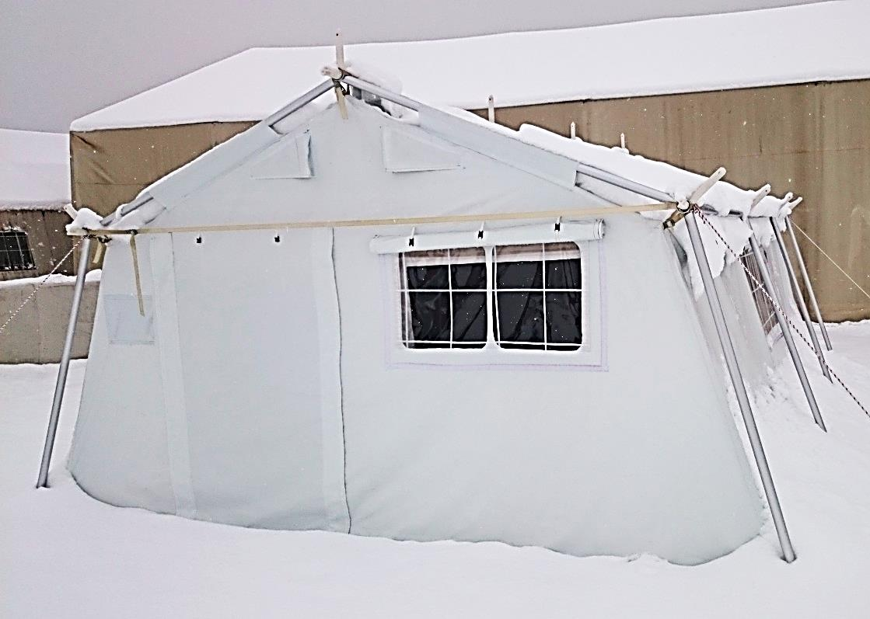
Final Project Report
Project name as per MoU: “R&D for Winterized Shelter Solution for emergencies in extreme cold climates”
Research started in January 2014 in the scope of the preparedness program for Mongolia and was finalized in 2016 to be a global solution for cold climate operations.


Funded by

Production of prototypes by:
Mongolian Red Cross Society
Field testing support by:

Table of contents:
1. Introduction 3
1.1. Context and needs assessment 3
1.2. Project objectives 3
2. Research methodology 4
2.1. defining thermal comfort 4
2.2. Thermodynamic simulation as tool for shelter R&D 4
2.3. Simulation and analysis of the standard tent with winterisation kit to establish baseline 5
2.4. Simulations of different shelter typologies 6
2.5. first outputs and conclusions 7
3. Product development 9
3.1. setting design criteria 9
3.2. design of winter tent for mongolia 10
3.3. Pre-Selection of Solutions for prototyping 13
3.4. Decisions taken and Changes to the initial project proposal 14
4. Prototyping 15
4.1. Production 15
4.2. important Learning: 17
4.3. Achievements 18
5. Testing 18
5.1. test methodology 18
5.2. testing under Real conditions 19
5.3. complemtary lab tests 24
5.4. Analysis field test data 24
6. Conclusion of Phase 1 25
6.1. setting priorities for the evaluation criteria 25
6.2. Final evaluation 31
6.2. consolidation of test-results into design of a final prototype 37
7. Way forward 37

- Introduction
  - Context and needs assessment
BRC is supporting MRCS in their disaster contingency planning, especially the scenario of an earthquake hitting the capital city of Ulaan Baatar with some 1.6mio inhabitants. In the worst case scenario 70%-80% of the cities housing stock is expected to collapse leaving some 100,000 people without shelter. In the Mongolian climate, where average temperatures are well below 0⁰C for 9 months of the year, a well insulated shelter is critical for survival. The traditional Gers still used by large parts of the Mongolian population are well adapted to the Mongolian climate and correspond to the cultural habits. However after a first assessment and consultation with Mongolian Red Cross Society (MRCS) and representatives of the National Emergency Management Agency (NEMA) in February 2013, the following reasons identify the ger not suitable as a solution to be used in emergency response (see also ANNEX 3 exploratory mission field report) :
- Difficult to stock due to limited durability/shelf-life and large volume
- difficult to stock and transport because of heavy weight from 300kg up to 500kg per unit and big volume
- Too expensive, minimum price per unit 1200€
- Too long set-up time of minimum 2 hours
- Due to long production time supply cannot be assured in a larger emergency.
A first desk review of the items specified in the EIC as well as of cold climate shelters available on the market clearly identified a gap in the area of emergency response shelter solutions suitable for extreme cold climates.
  - Project objectives
The overall objective of this technical research and development project as defined in the PP is to review the shelter items defined in the IFRC EIC, namely the standard family tent and the winterisation kit and, taking those specifications as a starting point, develop new solutions suitable to protect affected population from extreme cold climate conditions.
Although the research takes the Mongolian context and the concrete disaster preparedness needs specified for Ulaan Baatar as main reference, the final goal is develop a Family shelter that can be used globally to provide protection against cold climate to populations affected by disaster.
At present there is no adequate solution existing for humanitarian sheltering in cold climate and this research aims to fill this gap.
The specifications for the new solution shall be submitted for inclusion in the IFRC EIC as winter shelter and/or winterization kit for cold climate.

- Research methodology
  - defining thermal comfort
Although thermal comfort is critical for the health and well-being of human beings, thermal comfort cannot be clearly defined. Whether a person feels warm of cold depends on a whole variety of conditions, their general physical and health condition, their mood, their clothing and of course the external temperature. But even the same temperature is perceived differently for example when felt as drought or as radiation from a surface. To better understand thermal comfort and the conditions that influence it, in depth review of scientific literature on thermal comfort including references like the WHO was undertaken. Based on this research some clear criteria were set up to measure whether the thermal performance of the developed shelter would assure sufficient thermal comfort for the beneficiaries. Furthermore recommendations given for critical Non Food Items (NFI) that would be critical to keep people warm in addition to the shelter (see ANNEX1 presentation of conclusions on thermal comfort for meeting April 25 2014).
  - Thermodynamic simulation as tool for shelter R&D
Thermodynamic simulation is a tool very commonly used by architects and engineers in the design process, to simulate thermal performance of buildings.
SRU proposed to use thermodynamic simulation for the development process of the cold climate shelter to have a tool that would help verify the thermal performance of the new developments without having to build and test a prototype for each option. However, as the standard software and programs used for simulating thermal performance are all developed for the architectural field, the challenge was to fine tune the thermal simulation software that is commonly used for buildings with massive and rather airtight walls, to work with thin layers of air-permeable fabrics. Collaboration with the University of Louvain la Neuve department “architecture et climat”, experts in the field of thermodynamic modelling, was established at the very beginning of the project, to give professional support in the development and use of the software for the simulation.
The following “input” is needed to feed the simulation software in order to get realistic results:
All material specifications of the materials used in the shelter need to be available especially the specifications for thermal performance. If the specs are not available from the supplier, the tests to obtain the needed specs costs between 620€ and 1000€ per material.
3D CAD drawings of the shelter to be simulated are needed for the simulation. If such drawings are not provided by the supplier to the needed detail (which is usually the case) precise measurements have to be taken on a real model and the drawings prepared, which means quite some time implication.
For new designs the drawings where drawings will be prepared anyway by the designer, the simulation is more feasible.
If all the necessary input is given, the simulation can give sufficiently precise results of what heating capacity (KW) is needed to obtain a set inner temperature while taking into account the thermal performance of the materials used in the shelter and the external environment (from weather data obtained).
However the simulation cannot clearly identify where are the weaknesses of the solutions or point out the elements that need review. This means for each new material and/or design the simulation has to be run again to verify the impact of the change.
To run a full simulation will take about three days. One day to enter all the parameters (provided specifications and CAD drawings are available), one day to run the simulation and another day to analyse and interpret the data.
  - Simulation and analysis of the standard tent with winterisation kit to establish baseline
The first and basic part of the research methodology was to establish a baseline to measure the achieved improvement against.
As the standard family tent is the most used tent in emergency-responses worldwide, by IFRC, ICRC as well as UNHCR this tent model with the corresponding winter-kit was chosen to serve as reference model. However, as this tent is not particularly designed to withstand cold climates, the specifications do not include indications of the thermal performance as for example insulation values or air-permeability of the different materials use in the tent.
Therefore, all these materials had to be lab-tested to define the materials’ performance for the properties needed to feed the simulation program.
The laboratory tests were performed by IFTH (Institut Français Textile Habillement,)
All these criteria are not included in the current specifications of the tents in the EIC, but are critical to define the insulation capacity/thermal performance of a material.
The below table summarizes the material properties tested as well as the tests undertaken with reference to the respective norms.
Material property | Used Norm
thickness | NF EN ISO 5084 (November 1996)
Density =ƥ | NF EN 12127 (March 1998)  or ISO 3801-5
Conductivity =ƛ; Thermal Resistance | ISO 11092 + A1 (2012))
Specific Heat = Heat capacity | ISO 5085-1 (November 1989  or ISO 11357
Air permeability | NF EN ISO 9237 (August1995)
Light transmission | NF G07-162 (Septembre 1988)  Or EN 410
Figure 1 : table of tests (and respective norms) conducted on the standards family tent materials
After obtaining the results form the laboratory, the software was re-programmed and calibrated by comparing the results of the simulation of the standard family tent, with measurements taken in the real situation in a standard family tent with winter kit, installed near to the weather station that provided the data for the simulation.
The accuracy of the simulation was confirmed through this comparison showing only 2% difference in results.
Once the accuracy of the simulations was proven, the simulations of the thermal performance of the standard tent + winterization kit was run with the weather data for the Mongolian context for a full year.
The analysis of the simulation pointed out the following results:
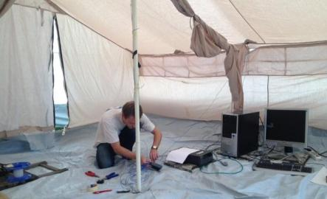
Foto 1: At University of Louvain la Neuve, setting up the equipment to compare the performance measured in reality with the computer simulation.
To achieve 15C the standard family tent will need a heater of 8KW
For 1 year the expected heating cost in fuel would be app. 480€ (using index mundi for fuel, TBC with price as of local fuel)
With the assumption of a full year’s heating period and using the index mundi price for gasoline the winter kit does not have enough impact to reduce the heating cost by more than the price of the winter-kit; that means that using the tent without winter-kit and spending a bit more on fuel is still cheaper, when looking at one year of use.
The simulation clearly showed that there is no feasible way to improve or upgrade the existing standard family tent, as initially assumed, by adding a better winter kit or improving the materials.
  - Simulations of different shelter typologies
After confirming that the standard family tent could not be improved to withstand extreme cold climates, further simulation were run to check, whether a family unit tent is really the most cost-effective solutions to shelter people in cold climate contexts or whether containers or collective shelters would not be more efficient. Therefore other solutions were included in the study. Using the same weather data and time span simulations were run for:
Standard family tent, for five people
Standard family tent with winter kit, for five people
Generic 16m2 prefab/container unit, for five people
40m2 multipurpose tent from Ferrino (because it has an optional winterisation upgrade), meant to be used as collective canter for twelve people.
40m2 multipurpose tent from Ferrino, with winter- upgrade.
These five units were compared with regard to:
Unit price
Cost for the stove
Fuel consumption over a year period with Lebanon climate as reference, index mundi 2014 for kerosene as reference fuel price
The below graphic shows the cost implications of the stove, the related fuel cost as well as the price for the shelter structure and additional cost for winterisation upgrades

Figure 2: cost comparison between different shelter types
The comparison of the four shelter typologies clearly showed that when taking into account the unit-price and the heating cost over one year, the family size tent unit does offer the most cost-effective solution (lowest cost per person sheltered).
Unfortunately it was impossible to include the logistics cost for fuel distribution in the calculation as we could not obtain any data. The higher the fuel cost and related logistics implications and the longer the time span of the shelter operations, the more interesting do prefab solutions become as they do assure better thermal comfort and longer durability. But even with logistics cost having a considerable effect on the comparison the family tent solution will be the most feasible in the largest number of cases.
  - first outputs and conclusions
Outputs
Literature review on criteria for thermal comfort
Thermodynamic modelling software optimized for use on tents, with only 2. % deviation from the real life measurements
“State of the Art” market study of existing winter-shelter solutions
Various tent materials lab-tested for the thermal performance criteria
Simulation of the standard family tent in Mongolia context
Simulation and cost-performance comparison of 4 different shelter solution typologies, including purchase and heating cost
The idea from the project proposal to test the tents in two different locations in Mongolia was field visit was discarded following discussions during the first field visit to Mongolia in Feb. 2014 as there is no particular added value to test in two settings of the same climate
First conclusions:
REG 2.1 defining thermal comfort
The shelter alone will not be sufficient to protect health and well-being of affected people in a cold climate context. Additional NFI such as warm clothes, beds, mattresses and blankets as well as adequate heating provisions are critical to assure thermal comfort.
As performance criteria 15C was identified as reasonable to assure that a basic thermal comfort is provided:
REG 2.2 Thermodynamic simulation as a tool
The simulation software can serve as a tool to simulate any tent or other shelter structure in any kind of climate in order to test performance of a model at a lower cost than producing a prototype and field testing it. However it needs quite some experience and technical knowledge in order to be used efficiently and the effort is still quite high, when extensive materials testing and/ or producing CAD drawings have to be included in the preparations.
Thermal simulation cannot replace field testing at a final stage, which is still needed to test practical criteria, verify the performance and capture beneficiary feedback
REG 2.3 baseline study
The simulation clearly showed that there is no feasible way to improve or upgrade the existing standard family tent, as initially assumed, by adding a better winter kit or improving the materials. However the performance identified for the standards family tent will be used as baseline to measure the improvements of the solutions to be developed.
Furthermore some design criteria, like inner height of the tent and living area need to be reviewed to better reflect cold context requirements. The inner height was set to 2m at 80% of the covered surface and the living area increased to 22m2 to respect UNHCR emergency shelter standards proposed for winter climate.
REG 2.4 comparison of different shelter solutions
The cost-performance comparison clearly showed, that the 5-person family unit tent is the most feasible emergency shelter typology but that new development of a family tent unit for winter conditions is needed
All the findings of the preparatory research and the simulation were presented and discussed at a milestone meeting in London on April 25th 2014 to review and confirm the design criteria stated in the initial Terms of Reference for the research. (see ANNEX 1 presentation 1rst milestone meeting winterized shelter Mongolia 2014 04 25 and ANNEX 2 notes 1rst milestone meeting winterized shelter Mongolia 24 04 2014).
- Product development
  - setting design criteria
Based on the first conclusions of the simulation of the standard family tent, as well as the input gathered during the first field visit to Mongolia in February 2014, namely from MRCS and NEMA, the generic specifications used as point of departure for the Project Proposal were reviewed during the first milestone meeting on April 24th 2014 in LONDON to include some practical criteria as well cultural preferences.
conclusions
It was found that the IFRC standards for the family tents are not all useful for a cold climate tent. For example the minimum inner height of the tent, set at 2,4m increases the volume to be heated substantially causing additional cost without much added value. Reducing the minimum height to 2m while keeping a height of 1,8m in 80% of the surface was decided to be a good compromise.
Final criteria of the achieved design see table page 24-27 under -6.1 setting priorities for evaluation criteria.
decisions
The following decisions were taken during the meeting for the next steps of the design process:
Identify a good self-standing frame tent that could be used as structure and only design the cover using new materials
Go for the synthetic felt identified as highly performing and low cost insulation material
Contact Turkish RC to ask if they are willing to support the production of the prototype; explore potential interest from Ferrino.
The tent R&D would serve to establish more clear the performance of an efficient stove
Furthermore it was decided that the stove research and development needed the attention of a separate project with some additional expertise. The criteria for the stoves to be used in the Mongolia testing and as reference for the tent design were defined as shown in below table:

criteria for stove to be used in the Mongolia tests and reference for the designing
Large enough to heat designed shelter space | critical | To be defined in function of the selected tent
Should be used for heating and cooking | important | No modifications
Fuel material: wood/coal | important | No modifications; Although not the most efficient fuel-material
Weight < 35kg | important | No modifications
Volume for storage < 0,1m3 | important | No modifications
Good resistance for transportation (no fragile pieces) | important | No modifications
Appropriate to be used indoors (tent) – fire safe | critical | No modifications but to be specified in more detail for a future development project
Flu to height of shelter and appropriate insulated (avoid fire risk) | important | No modifications
Fuel efficient consumption | important | It was noted that he chosen fuel material coal and wood was not the most efficient
Take into consideration environmental impact | important | No modifications
Adaptable to locally available fuels, ensuring a low cost of heating | important | No modifications; already taken into account with fixing wood and coal

  - design of winter tent for Mongolia
Based on the updated specifications SRU started the design process for a new winter tent adapted to Mongolian Context.
The design went forward with a hexagonal shape, based on the simulations that had indicated this shape as most feasible in terms of thermal

Performance.
Further consideration in the design was combination of materials to assure thermal comfort and durability, intelligent detailing for user friendliness, cultural acceptance as well as easy production. Simple structural design for robustness and easy set-up while keeping the defined weight and unit price.
In parallel, as decided in the project meeting in April, different self-standing tents were assessed to identify possible frame solutions that could be used to support a heavier tent cladding as well as the necessary wind- and snow-loads.
Furthermore extensive material research and testing continued to identify the materials with best cost-performance balance.
Different tent producers were contacted to explore collaboration opportunities for the production of prototypes for the field testing in Mongolia.
creating Synergies with other projects and Partners:
After first contact with Turkish Red Crescent tent production facilities, a project meeting in Ankara on July 3rd was confirmed to present the project and confirm TRC collaboration for prototyping.
Different meetings were organised with the relevant representatives of Turkish Red Crescent:
Hassan Sivrikaya, Vice Director General
Seval Güzelkılınç, Head of International Programmes
Kamil Erdem Güler, Executive Officer of International Programs
Mehmet Çebi, Head of tent production enterprise
From the project side the following participated in the meetings:
From BRC:
Razmi Farook, East and Southeast Asia Representative
Nancy Kourdouli, Project Support Officer
Sonia Molina, Shelter Advisor
From IFRC-SRU:
Cecilia Braedt, Coordinator
Vincent Virgo, Research Officer
Daniel Ledesma, Research Officer
The meetings in Ankara concluded with the clear expression from TRC side to support with the production of prototypes for the Mongolia winter tent project.
Given the positive response, the collaboration possibility with Ferrino was not further explored.
During the on-going design process and preparation for the field testing, number of synergies with other projects and initiatives were created:
TRC agreed to contribute (at their own cost) winterized tent solutions that they had been developing with SRU support and the textile development department of Marmara University, for the Syria crisis response.
A producer of new insulation materials (SION), collaborating with SRU in the Speed kits project, agreed to contribute two “winter rooms” made from the most promising and performant insulation material, to be inserted into standard TRC tents.
The market leader (“Design Shelter”) in polar expedition tents agreed to donate one 17m2 tent to serve as “target” baseline to compare the new developments against
SRU, collaborating with the consortium of IFRC/ICRC/UNHCR working on the development of an improved standard family tent, was able to receive a first prototype of the improved standard family tent with winter kit to include it in the testing.

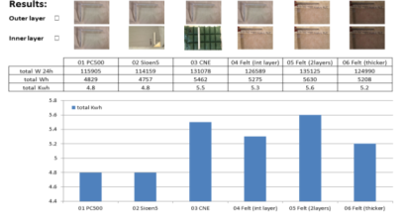
Materials research
The research on materials was extended to explore insulation qualities of a variety of low cost materials that could be used for insulation layers and to inform the design process.
Figure 3: Thermal performance of different material combinations

stove comparison:
Stove research was also deepened and a comparison of performance and cost prepared to further inform the discussion.
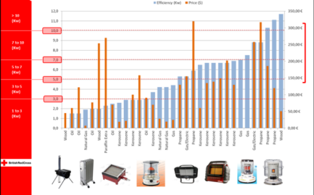
The on-going research was also discussed at a meeting in Geneva with Corinne Treherne, Senior Shelter Advisor and responsible for R&D at the Shelter and Settlements Department, and Patrick Elliott, IFRC Shelter Focal Point for the Asia zone: Participants from BRC: Sonia Molina and from SRU Cecilia Braedt (see ANNEX 5 Winterized Shelter Geneva meeting Minutes – 140611)
Figure 4: stove comparison
  - Pre-Selection of Solutions for prototyping
The 2nd milestone meeting on September 15th 2014 took place on London to present, discuss, and evaluate the proposed designs (see ANNEX 4 presentation 2nd milestone meeting winterized shelter 2014 09 15):
- From BRC:
Inmaculada Lopez De La Cova Pena,
Razmi Farook, East and Southeast Asia Representative
Nancy Koudouli, Project Support Officer
Eve Leonard, Shelter Advisor
Rowan Johnson, Partnership Advisor
From IFRC-SRU:
Cecilia Braedt, Coordinator
Vincent Virgo, Research Officer

- Further meetings were organized with Rowan Johnson (BRC; Funding ad corporate partnerships), and Foster& Partner Architects)

During the September meeting the deepened stove and material research was presented together wit h different design and proposals. The following designs were presented to select the model to be prototyped:
- Four variations of the Turkish Red Crescent (TRC) tent frame, experimenting with different layers of newly developed innovative insulating materials from different suppliers
- The final prototype of the TRC winter tent for Syria context, developed by SRU
- The winter tent developed by SRU for the cold climate context in Mongolia.

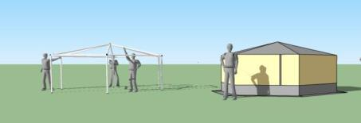
Figure 5: Hexagonal design

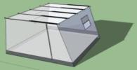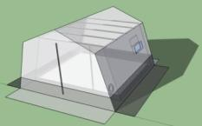
Figure 6: “winter room” installed in standard TRC tent

To evaluate and select the designs to be prototyped and tested the following criteria were applied:
3.4. Decisions taken and Changes to the initial project proposal
Following the evaluation and discussion it was decided, that instead of choosing one design for testing, it would be more interesting to rather look at different solutions and do comparative testing of all the proposed design.
The tents agreed to be included in the field testing in Mongolia were the following:
  - The standard family tent, as minimum reference to be improved against
  - The improved dome tent with winter kit, (the improved family tent under development by a consortium of UNHCR/IFRC/ICRC to become the new standard)
  - A winter-tent solutions donated by the Canadian supplier “Design Shelter” as “maximum performance” reference
  - -7. Four variations of the Turkish Red Crescent (TRC) tent frame, experimenting with different layers of innovative insulating materials.
- The final prototype of the TRC winter tent developed by SRU
- The prototype of the winter tent developed by SRU for the cold climate context in Mongolia.
- A new design that would be proposed by Foster & Partner Architects with whom BRC had established contact and raised their interest in the project.

- It was decided to jointly explore how a collaboration with F&P, the renown architecture practice, to whom BRC had established contact , with the idea to leverage pro bono support and maybe further funding for the winter tent project.
- Given the change from one new design to be tested to 7 designs, the beneficiary satisfaction survey would not make sense at this stage in the way stated in the protocol. It was discussed that the test protocols need to be adapted accordingly.
- It was decided to test the 10 tents only in one location instead of initially planned two. The little added value of testing in two locations did not compare to the considerable additional logistics and cost implications

- Compliance to the technical and design criteria as specified in the review meeting in April 24th.
- The unit-price, taking into account heating cost (fuel consumption) for the proposed solutions
- Easy to store (volume and durability
- As secondary criterion, cultural acceptance should be taken into account, to ensure ‘beneficiaries’ can easily construct and live comfortably in the shelter solutions.

Time and cost implications for the decided changes:
It was stated and understood that the decisions taken would have cost and time implications:
Changing from 3 tents of the same design to be tested as initially planned to finally 10 prototypes to be tested and compared would increase cost for logistics (shipment) test equipment needed, as well as the time to conduct the test in the field and to evaluate the data (over three times as much data to evaluate).
The beneficiary satisfaction survey would have to be postponed to a second phase when a final design was concluded after analysis of the comparative tests.
Implication of F&P in the project would need dedication of some extra time from SRU to bring the up to speed on the project, and wait for their design (prototype production one months delayed), involve them more through telcos, workshops etc.

- Prototyping
  - Production
Production of the SRU prototypes took place at the TRC factory in Ankara under the supervision of SRU research officer Vincent Virgo in the week of October 20th. Together with the workers of the production facility technical detailing was discussed, to find the most feasible production modalities.
A working meeting and presentation on October 30th 2014 at the TRC factory was held with key representatives of TRC, the developer of the new materials (University of Marmara ), the material producers (Hassan
textile ind..)To discuss important specificities of the materials in the production process. Furthermore F&P were introduced to TRC and presented their design proposal.
From BRC:
Eve Leonard, Shelter Advisor
From IFRC-SRU:
Daniel Ledesma, Research Officer
Vincent Virgo, Research Officer

From Fosters and Partners
Antonio Mularoni
Rafe Bertram, Senior Partner
A second visit to the Ankara factory was scheduled for the week of the 17th November to support the F&P architect with the production of the F&P prototype. The later production of the F&P prototype delayed the shipping of all prototypes from Ankara to Ulaan Baatar by one month. Given the tight time frame meant the shipping had to be done by airfreight instead of over land with the additional cost
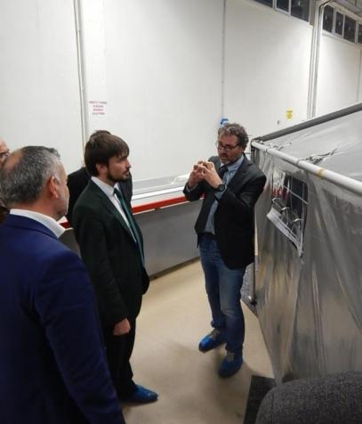
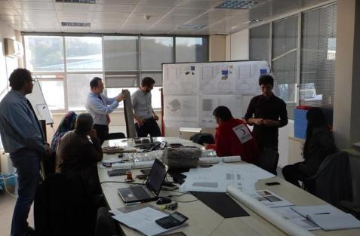
Foto2: presentation of F&P design at TRC in Ankara
Foto 3: Vincent Virgo, SRU presenting hexagonal tent prototype in presence of TRC Director General Mehmet Güllüoglu.
Foto 4&5 s: production of prototypes in TRC factory.
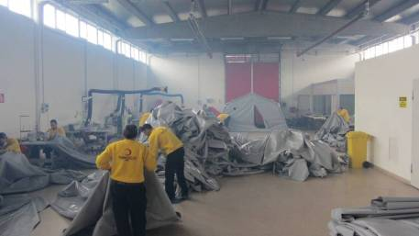
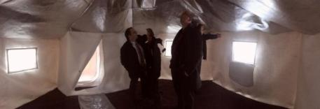
Foto 6: inner view of hexagonal tent prototype

  - important Learning:
We learned that we quite underestimated the prototyping part of the project. Although all detailed drawings were prepared and materials clarified, a lot of collaboration was necessary with the factory workers to explain the design drawings, get the cutting patterns right, understanding the different techniques to join the pieces depending on the materials (differing types of welding, sewing or gluing, etc.) as well as to modify details and adjust them to the production process. (See also ANNEX 6 presentation prototype production.)
Through the prototyping process it also became clear that to get a final design ready for mass production would be more complex than the production of one prototype basically “made by hand” and would require more time investment to work with the production facility.
This was taken as learning to be addressed for the second phase of the project after the testing and finalisation of the design.
  - Achievements
collaboration with TRC established and successfully
Collaboration with F&P established
Three prototypes of new designs produced in TRC factory:
    - Hexagonal tent
    - TRCC improved winter tent
    - F&P design
Two inner tents “winter-rooms” produced by project partner from Speed kits SION and shipped to Mongolia from Belgium (at their own cost).
One polar expedition tent obtained as free sample and shipped to Mongolia form Canada at charge of supplier.
Standard family tent and prototype of new dome tent obtained by SRU through the project consortium IFRC/ICRC/UNHCR and shipped to Mongolia from Luxemburg-
- Testing
As defined in the PP, the field testing should take place during the coldest time of Mongolian winter, that is January February.
Support from Mongolian Red Cross Society (MRCS) and general modalities had already been confirmed during a first field visit in February 2014 (see ANNEX 3 Mongolia exploratory mission report). During the same field visit good contacts had been established to the National Emergency Management Agency (NEMA) who had expressed their interest in the field testing and proposed different test-sites to conduct the tests. As of the Milestone Meeting in September 15th 2014 Foster & Partners had proposed additional support, to confirm test methodology and to provide a volunteer to assist in the field during the testing phase.
  - test methodology
The main reference for the methodology was the standard test procedure developed by SRU, for the testing of prototypes designed within the Consortium IFRC/ICRC/UNHCR, and proposed by IFRC as standard methodology.
The Methodology combines the collection of quantitative as well as qualitative data in order to evaluate the performance of the tents within three main categories logistics, technical, human comfort.
For the testing in Mongolia, this basic methodology, designed for testing in hot climates had to be reviewed and adapted to cold climate, including tests with heaters and particular attention to confirming air-exchange/air tightness and air quality etc.
The established methodology consisted of three main parts:
Practical testing for functionality and logistics:
For the logistics part the measurable criteria like weight, volume and unit price are recorded for each of the models.
Furthermore important practical criteria are assessed how to transport and handle the package and how fast the shelters can be set-up by unskilled volunteers with only the tools provided with the package of the shelter. These indicators are recorded through observations by SRU, questionnaires with the volunteers involved, as well recording the set-up time for each model.
Technical testing on THE PERFORMANCE CRITERIA:
The technical testing represents the most important part of the tests. It includes a whole series of data-recordings and measurements taken, always during the same time-span in all tents to be comparable.
The following data/criteria were measured/recorded:
- Temperature, automatically recorded every 30mins in different positions of each tent (on the ground, at 50cm at 1.8m in all corners).
- Humidity recorded in the air and measured on the different fabrics at different times of the day (to check for condensation), also related to thermal comfort
- Airspeed inside the tent (draught)
- Particles in the air for air quality
- CO2 values for air quality
- Daylight-levels (lux) in the tents
- Sound insulation capacities of the tents (decibel)
- Blower door test to confirm air-exchange rates and identify air leakages
A small weather station installed on the test ground would deliver reference weather data (outside temperatures, wind speeds, humidity, etc.) to compare to the valued measured inside the tents.
Beneficiary feedback on thermal comfort and livability
according the established methodology beneficiary satisfaction feedback is collected from beneficiaries that volunteer to live in the tents for a t least a months’ time, document their findings and fill in a detailed questionnaire after the testing period. However this test is designed to be conducted in settings was beneficiaries are already living in emergency shelters (camps) and some can volunteer to live in the tent models to be tested.
However, as decided in the September Milestone meeting , beneficiary satisfaction survey would only make sense once a final model chosen/designed and could be tested in a setting (existing camp or similar) where this test set-up would be feasible.
Fro the Mongolia field test it was chosen to only collect some “spot-check” feedback from volunteers that would sleep in the tent for one night.
(fro more detail see ANNEX 7 2015 field test protocol for Mongolia)
  - testing under Real conditions
During the testing mission in Ulaan Bataar from 26.01.2015 to 13.02.2015 the SRU team spent three weeks in temperatures between -15°C and -30°C down to a perceived -40°C (with a wind chill factor of -44°C).
From BRC: Stephen Cox, Nancy Kourdouli Eve Leonard, and Shelter Advisor
F&P: Antonio Mulatoni contributed to first part of the testing period
The practical testing during the tent set-up took two full days, with some 10 volunteers participating gin different shifts.
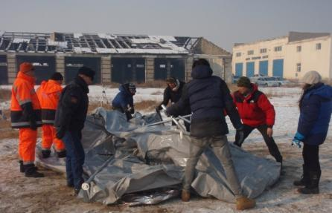
Foto 7: MRCS and NEMA volunteers setting up tent Nr. 8 (F&P design)

Figure 7: weight and setup-time per tent
In parallel to the setting up of the tents, the following logistics were arranged:
- Purchase of 10 coals stove with all complementary fittings, chimney etc.
- Purchase of 20 2KW (Kilowatt) electrical heaters, with watt-meters to measure the power-consumption.
- Organization to purchase a generator to supply the 20 electrical heaters. Finally the generator was only rented for the two days test period with electric heaters.
- Test-run with one stove to see how long one full coal load of 8kg could last; according to the duration of app. 3 hours burning time Preparation of 8 loads of 4kg coal portions were prepared for each tent to fire the stoves during the heating test cycles. The coal was provided by NEMA on the test site.
Setting up and calibrating the weather station

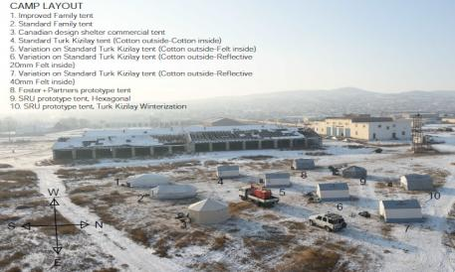
Foto 8: test field with all ten tents installed and the generator in the middle (on the truck) during test with eclectic heaters
Following the established methodology a variety of different measurements were taken in different test configurations (see graphic of test schedule)
For the thermal performance, the air temperature and humidity was recorded over several 12h periods in different locations in each tent, at ground level, at 50cm and at 1.8meters height. The temperature test cycles were run over 12h periods from late evening to early morning in order to capture all the coldest periods of the night. The first test cycle was run with electrical heaters to record the exact KW input to reach a certain temperature.
Further thermal performance test were run with locally procured commonly used coal stoves all fired with the same amount of coal (pre-weighed portions) at the same intervals of time.

Figure 8: Temperature recording at ground level, at 50 cm and at 1.8m
Furthermore surface temperature and humidity of the different materials were measured and recorded at different times of the day to give insight on condensation as well as the transmissivity of the materials.
To assure appropriate air-quality inside the tents with burning stoves the CO2 and CO levels, as well as ventilation rate were recorded.
The thermal performance tests were first run in empty but heated tents, to assure that minimum values were achieved, especially the set minimum temperature of 15C. All tents that did not reach the required temperature were rejected for the testing with people.
Only two tents reached all the technical parameter especially the thermal performance, the hexagonal model (Nr. 9 developed by Vincent Virgo) and the improved TRC winter tent (Nr. 10 developed by Daniel Ledesma).

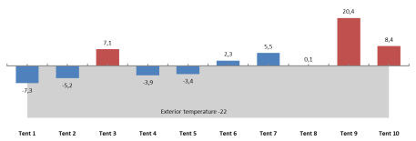
Figure 9: Average temperatures recorded in the ten tents during the electric heater tests.
The polar expedition tent (Nr. 3) did not perform as well as expected, probably due to some mistakes in the set-up. However, if this meant that the volunteer teams were not able to set up the tent correctly even with using the included guidance, the tent is to be considered too complicated for emergency situations
In the two selected tents, another nights test cycle was run with teams of 5 persons, volunteers from the NEMA sleeping in each of the tents, while the
Data-recording of temperature, humidity, CO2 etc. continued. Special CO2 loggers were installed with integrated alarm-function should CO2 levels drop below healthy values. The recording with and without people are compared in the analysis. Stove and practical features of the tent.
The volunteers documented the times when the stove was re-fired, when doors were opened etc. Furthermore they answered the beneficiary satisfaction questionnaires on a whole set of comfort and usability parameters after spending the night in the tent.
Finally additional test were run to investigate interior illumination as well as noise levels. Parameters that are not critical for survival but quite elementary for overall comfort and frequently flagged in beneficiary feedback collected throughout previous tests.
The Data-recording was continued over some extra cycles to test the impact of different “upgrades” to the coal stoves used, to explore how to improve the heat retaining capacity (inertia) of the stoves with simple “field” means to increase performance.
Altogether 18 different tests were conducted and over 300, 000 measurements recorded to large part by automatic data loggers and the weather station that was et up on the site to provide the reference temperature and humidity data.
During the testing mission daily mail-updates were sent to Eve Leonard, Steve Cox, Gregory Rose and Nancy Kourdouli
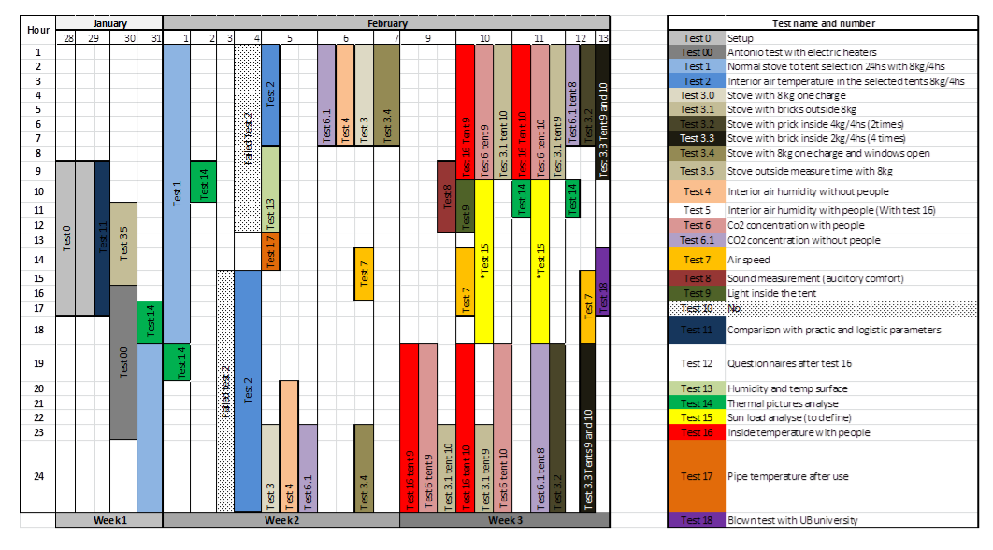
Figure 10: field testing schedule

  - complemtary lab tests
IN addition to the extensive field testing a number of test needed to be conducted through respective test-laboratories. In the first phase of the project, all the tests on the materials to establish their thermal performance parameters were done through the IFTH lab. These parameters were used for the simulations and at the final stage are critical to draft the specifications of the materials.
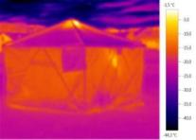
A number of other lab-tests are necessary to fulfil the requirements of the specifications for the emergency Items Catalogue such as tear resistance, water-proof or flame retardency of materials.
To save time and cost these tests were conducted only on the materials used in the prototypes and using laboratories in Turkey where the materials were produced.
The test results confirmed the necessary qualities of the materials so that the materials could be used for the prototypes.
It was flagged, that in order to draft the final specifications for the tent, all materials once confirmed after field testing, would need to be re-tested in one of the two laboratories accredited by the Federation, otherwise the results would not be accepted for the EIC.

  - Analysis field test data
Returned from the field the recorded data and documentation was processed by the SRU team and presented at a workshop on March 9-10 2015 in Luxemburg to jointly analyse the data.
Participants to the workshop:
From Shelter Research Unit (SRU):
Cecilia Braedt,
Vincent Virgo
Daniel Ledesma
From BRC:
Stephen Cox
From Foster and Partners (F+P):
Laura Smith
Antonio Mularoni

See ANNEX 8 presentation workshop data analysis 2015 09 03 and ANNEX9 data analysis workshop Notes 2015 03 10
Figures 11 & 12 Thermal camera picture and graphic representation of temperature data

- Conclusion of Phase 1
  - setting priorities for the evaluation criteria
The analysis of the field testing was presented at the final project meeting on in May 5th to 7th in London. To conclude the analysis and
and to evaluate the test results, the evaluation criteria were discussed and priorities given to the most important criteria to be rated higher. To prioritize in a realistic manner, colleges from BRC logistics and operations joined the discussion to give their input (see ANNEX 10 presentation project recap 2015 05 06-08, ANNEX 11 presentation field testing 2015 04 17 )
This workshop sought to break down the project into two phases to conclude the first stage of the development in 2015 with clear deliverables.
The finalisation of details, full scale beneficiary satisfaction survey and drafting the generic specifications would be considered in a Phase II.
(see ANNEX 12 Notes from Winterisation workshop, 6-8 May 2015)

Participants to the workshop

From Shelter Research Unit (SRU):
Cecilia Braedt
Vincent Virgo
Daniel Ledesma

From IFRC:
Corinne Treherne

From BRC:
Eve Leonard, Miia Pollanen, Alastair Punch, Rowan Johnson
Sarah Wilson, Stephan Cox, Inmaculada Lopez De La Cova

From Foster and Partners (F+P):
Laura Smith
Antonio Mularoni
Rafe Bertram
(
Shelter Design

The table below summarizes the specifications from the ToR and modifications or details revised throughout the project and agreed on during the working meeting in London on May 6th to 8th 2015. Furthermore a rating of criteria was also applied to set the main priorities for the evaluation of the tents tested.
Shelter Design
Logistics | priority | Modified specification:
Weight of packages < 30 kg to be carried by 2 people (max 3 packages per shelter – stove not included) | critical | After joint discussion with BRC logistics the following criteria were Agreed:  120kg maximum weight  Only one package including everything (also tools)  Assumption: should be carried by 4 people (30kg max per person)
Simple to erect quickly in dark cold conditions by 3 people | important | The maximum set-up time was fixed at 4 hours assuming 4 people day time hours; clear instructions and available tools.  the goal is to not have more that one hours set-up time
Able to be erected in urban and rural context (appropriate anchoring solution) | important | No modifications
Take into consideration environmental impact | Nice to have | No modifications but clarification that this could not be defined clearly enough at this point to be part of technical specifications
Expected lifespan in extreme weather condition >1 year | important | No modifications  clarification that for the life-span specs the following lab-tests would be required:  - UV resistance  - Soil burial test
Volume for storage < 0,2m3 per package (stove not included) | important | No modifications ;  BRC logistics confirmed that package size was not a critical factor Only maximum container dimensions 6 x 2.5 x 2.4 needed to be taken into consideration to determine the package lengths.  The goal is to keep the package as small and easy to handle as possible
Storage durability of materials (shelf life)> 5 years (taken into consideration extreme heat or cold storage - assume infestation risk) | important | No modifications  it was specified that there are no clear specs or reliable tests that can realistically confirm this criteria.  It was decided that the Lab-tests generally used for testing life-span of materials will be used to cover this criteria
All necessary tools to construct shelter should be included in the kit | important | No modifications  Ideally there should be no tools needed
Include in all packages detailed packing list, assembly instruction and maintenance guideline in the UN languages and pictorially | important | No modifications
Unit price | critical | The unit price was added as critical criteria and that should not surpass 1200€ in order to be feasible for NS to consider stockpiling.
Design criteria
Inner space > 18m2 (to house 5 people and a stove for cooking and heating) | Important | It was confirmed that the minimum living space should be 18m2
Centre high > 240cm | Not critical | Instead of fixing the centre height at 240cm, it was decided to fix 1,80m considered as standing height, for 60% of the living area.  This should strike a good balance between providing the comfort of being able to stand up in the larger part of the tent, while keeping the volume at a minimum in order to save heating cost.
Easy accessible for people with disability: avoid steps, access door min wide 80cm, door high 160cm | Not critical | No modifications
Include 2 opposite doors (fire evacuation) which can be locked from the inside and outside (security) | Not critical | The obligation to have two doors was judged as not obligatory for the following reasons:  - very dependant on cultural preferences; the traditional Mongolian Ger has only one door; two doors are not wanted  - reduce air-leakage and heat loss  - no need for fire-evacuation if proper fire-retardant materials are used
Shelter material should be opaque for privacy | important | No modifications
Allow possibility to include an inside partition | important | No modifications
Thermal isolation from ground | Critical | No modifications but no exact values of what insulation factor would be recommendable for the ground sheet.
Include chimney opening with heat resistant fabric (min 900°C) | important | No modifications
Hanging attachments with safe clearance for lighting | important | No modifications

Performance | priority | modifications
Insulated shelter solution should comfortably withstand outside temperatures < -35°C (including stove and winterization kit). It will be an added value if the shelter/tent can withstand outside temperatures of > +30°C providing an adequate inside thermal comfort (18-25°C). | Critical | It was agreed to set the following criteria to determine the thermal performance:  Minimum: 15 degrees Celsius for 8 hours average temperature  15°Cwas fixed based on the review of respective scientific literature on minimum temperature to guarantee thermal comfort.
Min Wind load resistance > 10m/s (36km/h) | important | No modifications
Min Snow load 300N/m2 | important | No modifications
Ensure sufficient ventilation and natural light | Ventilation Critical/  Light important | Sufficient ventilation is critical to ensure a safe and healthy air quality inside the tent, especially when using combustion stoves;  To determine the air quality the CO2 levels were agreed as indicator and a maximum of 3000ppm after a period of 8 hours inhabited shelter. This is taken from recommendations for living spaces in buildings  For lighting the values were not fixed
Fire retardency | critical | No modifications
Waterproof | critical | No modifications

All ten tents were evaluated according to the established criteria and the defined rating applied. Criteria defined as “critical” were rated with 3 when the criteria were fully achieved and 0 if not. The criteria rated as” important” were given a 2 and the criteria rated as “not critical” or “nice to have” were given a 1.
Due to this rating, tents that had performed excellent for the technical test, especially in thermal performance were discarded because of being too heavy or costly. This applies for example for the “design Shelter” polar expedition tent but also for the SRU prototype designed for the project.
The tent with best cost-performance ration was the improved TRC winter tent also designed by SRU.
With this rating even the new dome tent, which had not achieved the minimum temperature of 15C was rated 3rd because of very low weight and comparably low price. Although the rating clearly does not give highest credit to the best technical performance it does very much reflect the realities where compromises have to be made on quality in favour of lower cost or less weight or easier handling.
Firgure 11 : rating applied to the different evaluation criteria

6.2. Final evaluation
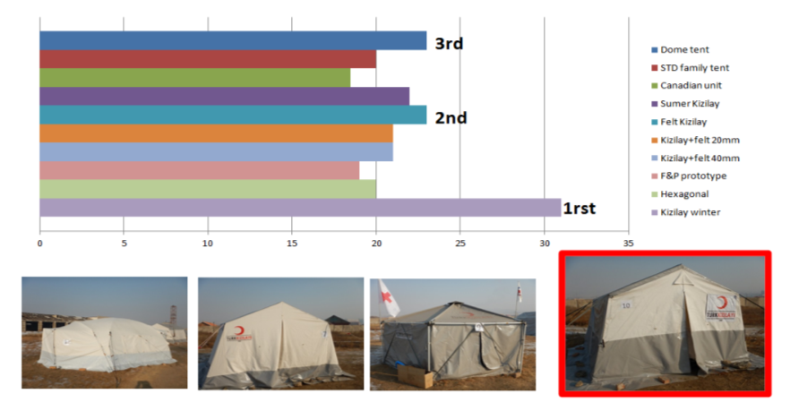
Figure 12: Evaluation of final results; due to prioritization logistics criteria weight and cost, the thermally best performing tent (Nr. 9) was discarded
  - consolidation of test-results into design of a final prototype
Concluding the meeting in London the following points were decided to conclude a final prototype, based on the improved TRC winter tent and modify according the findings from the test analysis:
- Increase the living surface of the tent to 22m2 in order full fill the recommendations of 4,5m2 per person as proposed in the standards
- According to the larger size (and consequently larger span), rework the frame elements to standardize to have all same length
- Structural calculations to explore whether structural elements can still be reduced and support necessary wind and snow loads
- Include all details and improvements in the new design that have been identified during the testing (e.g. design door opening so that accessible for wheelchair.
After concluding the “tweaks” and design improvements, produce 3 final prototypes at the TRC factory.
Finally draft the preliminary specifications so that they can be shared with other suppliers.
NOTE: It was flagged that for the final specifications to be entered into the EIC, all materials used in the tent would still need to be lab-tested in one of the laboratories accredited by the Federation to confirm regarding an the relevant criteria (tear-resistance, waterproofness, airtightness, UV-resistance, Fire-retardency, etc.). It was decided to postpone this final lab-testing to the follow up project (Phase II).
Activities | Responsible | Duration | Timeline (2015)
Tweak prototype after analysing data | SRU | 2 months | May-end of June
MOU with TRCs | BRC | 3/4 months | May-end of August
Sourcing materials | TRCs/SRU | 3 months | June-end of August
Structural calculations | F&P | 1 month | May-end of June
Final version of specification | SRU | 2 month | May-end of June
Share specification with manufacturers | SRU/BRC | 1 month | July-end of August
Production of prototype x,y,z | SRU | 1 month | End of September
Figure 13: time schedule for finalization of the project phase I, as agreed during London meeting May 6th to 8th 2015
design improvements and material sourcing
The project conclusion phase progressed as planned regarding the improvements on the design. In Parallel SRU worked with TRC to confirm the sourcing of materials for the final prototype and the possible timeslots in the factory for the production.
structural calculations
Structural calculations from F&P were a delayed due to the summer break and lack of availability. A workshop on September 1rst and 2nd 2015 was held in Luxemburg to discuss the different options for improvements on the frame which was not yet fully concluded. (See ANNEX 13 presentation) and already discuss the way forward for phase II (see ANNEX 14 meeting notes)
Participants to the workshop:
From Shelter Research Unit (SRU):
Cecilia Braedt,
Vincent Virgo
Daniel Ledesma

From BRC:
Louise Daintry

From IFRC: Corinne Treherne

From Foster and Partners (F+P):
Laura Smith
Antonio Mularoni
It was decided to produce the prototype as planned by end September without changing the dimensions of the structural elements. If F&P could give specification s of the optional elements Daniel would try to procure them in Ankara during his time in Ankara and. TRC would be able to adapt the connectors to the new tubes for the prototype.
F&P also committed to produce the set-up manual for the tent.
production of final prototype
Production of the final prototype took place in September as planned without the structural modifications. Structural calculation was provided by F&P in November 2015.
After production one prototype was shipped directly to Berlin to be displayed at the Humanitarian Congress, another one to London and the third to Luxemburg. The final prototype was presented at the following events:
- Berlin: Humanitarian Congress, October 9th & 10th 2015
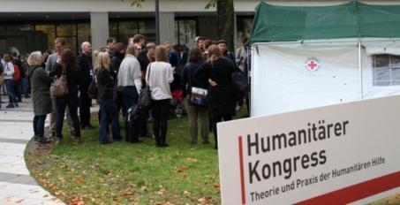
Foto 7 winter tent presented at the Humanitarian Congress 9-10 October 2015
- London: UK Shelter Forum at the Barbican centre, November 13th 2015
- Geneva: RCRC GA and conference December 04th to 11th 2015

foto 9: Tent exhibited in front of the conference venue during the RC Movement GA and conference 4-11 December 2015
preliminary specifications:
The finalized design with the full set of CAD drawings and technical specifications was shared with BRC and F&P by end August (see Annex 15 preliminary specifications and technical drawings)
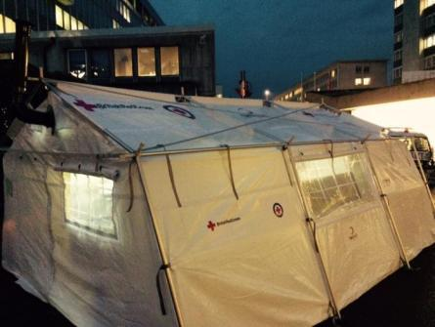
These Specifications do not yet include possible structural changes as they were not confirmed by F&P and would also need some redesign on the connectors.
Sharing specifications with suppliers
A first batch of 100 tents was ordered by Luxemburg Red Cross from TRC according the preliminary specs.
important note: TRC opened a call to source the materials for the tent. The offers received for the newly developed synthetic felt varied so greatly in price and quality that it indicates the specifications need to be r and précised. This can only be done based on the results of the lab-tests of the materials as planned in the Phase II.
In the meanwhile TRC is producing the tents with the materials sourced from the supplier who was involved in the development of the materials, in order to guarantee the wanted quality.

- Way forward
The way forward after the conclusion of the phase I of the project was discussed during the meeting on London in May. A fist draft concept note to start discussing the way forward had been shared on February 27th 2015. It was discussed during the May 2105 workshop in London and deepened with F&P during the workshop in September 2015 in Luxemburg. A more elaborate project proposal was submitted for the Phase II in December (see ANNEX 16 concept note winterized shelter-phase2 2015 12 21)
The main points to be addressed in a second phase being:
Fine-tuning and optimization of design: as discussed with F&P during the September 2015 workshop: F&P would like to work on the frame, zippers, connectors etc.; SRU would still like to optimize detailing of the shade net, the connections between inner and outer tent, and the floor insulation.
Material testing to confirm specifications as critical to draft the final specifications
Beneficiary satisfaction survey. According to establishes protocols this included at least ten beneficiaries (families) living in the tents for at least a month’s (that is two field visits and remote monitoring of trained field staff over at least a month, questionnaires at begin and end of the test phase, then analysis of the questionnaires etc.). However this requires field operations or set-up with good field support from a NS.
In the case such set-up cannot be identified this point will need to be reviewed to find other means to collect relevant beneficiary feedback.
Performance verification as three-seasonal solution would be interesting to confirm the suitability of the tent also for summer climates
Fine-tuning of production process to establish clear pricing. This requires close collaboration with TRC
Explore Material Sourcing options and other Manufacturers. This will be an added value but is mainly under procurement and logistics.
writing up of final specifications including the detailed material specs to be submitted for entry into the EIC.

List of Annexes:
ANNEX1: presentation 1rst milestone meeting April 25 2014
ANNEX 2 notes 1rst milestone meeting winterized shelter Mongolia 24 04 2014
ANNEX 3 Mongolia exploratory mission report
ANNEX 4 presentation 2nd milestone meeting winterized shelter 2014 09 15
ANNEX 5 Winterized Shelter Geneva meeting Minutes – 140611
ANNEX 7 presentation prototype production
ANNEX 8 presentation workshop data analysis 2015 09 03
ANNEX 9 data analysis workshop Notes 2015 03 10
ANNEX 10 presentation project recap 2015 05 06-08
ANNEX 11 presentation field testing 2015 05 06-08
ANNEX 12 Notes from Winterization workshop, 6-8 May 2015
ANNEX 13 presentation recap timeline & evaluation criteria
ANNEX 14 meeting notes 02.09.15
ANNEX 15 tent specifications
ANNEX 16 Concept Note Phase II

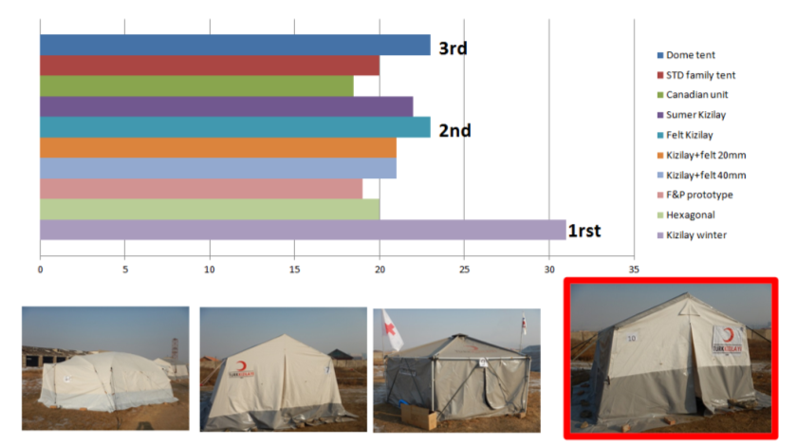
6.2. Final evaluation

Figure 12: Evaluation of final results; due to prioritization logistics criteria weight and cost, the thermally best performing tent (Nr. 9) was discarded
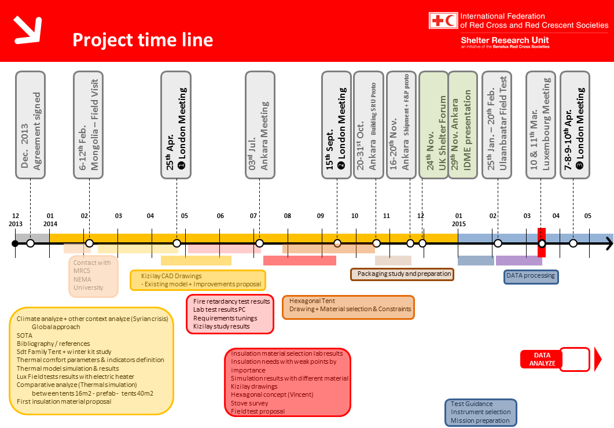
  - consolidation of test-results into design of a final prototype
Concluding the meeting in London the following points were decided to conclude a final prototype, based on the improved TRC winter tent and modify according the findings from the test analysis:
Increase the living surface of the tent to 22m2 in order full fill the recommendations of 4,5m2 per person as proposed in the standards
According to the larger size (and consequently larger span), rework the frame elements to standardize to have all same length
Structural calculations to explore whether structural elements can still be reduced and support necessary wind and snow loads
Include all details and improvements in the new design that have been identified during the testing (e.g. design door opening so that accessible for wheelchair.
After concluding the “tweaks” and design improvements, produce 3 final prototypes at the TRC factory.
Finally draft the preliminary specifications so that they can be shared with other suppliers.
NOTE: It was flagged that for the final specifications to be entered into the EIC, all materials used in the tent would still need to be lab-tested in one of the laboratories accredited by the Federation to confirm regarding an the relevant criteria (tear-resistance, waterproofness, airtightness, UV-resistance, Fire-retardency, etc.). It was decided to postpone this final lab-testing to the follow up project (Phase II).
Activities | Responsible | Duration | Timeline (2015)
Tweak prototype after analysing data | SRU | 2 months | May-end of June
MOU with TRCs | BRC | 3/4 months | May-end of August
Sourcing materials | TRCs/SRU | 3 months | June-end of August
Structural calculations | F&P | 1 month | May-end of June
Final version of specification | SRU | 2 month | May-end of June
Share specification with manufacturers | SRU/BRC | 1 month | July-end of August
Production of prototype x,y,z | SRU | 1 month | End of September
Figure 13: time schedule for finalization of the project phase I, as agreed during London meeting May 6th to 8th 2015
design improvments and material sourcing
The project conclusion phase progressed as planned regarding the improvements on the design. In Parallel SRU worked with TRC to confirm the sourcing of materials for the final prototype and the possible timeslots in the factory for the production.
structural calculations
Structural calculations from F&P were a delayed due to the summer break and lack of availability. A workshop on September 1rst and 2nd 2015 was held in Luxemburg to discuss the different options for improvements on the frame which was not yet fully concluded. (See ANNEX 11 presentation and ANNEX 12 meeting notes)
Participants to the workshop:
From Shelter Research Unit (SRU):
Cecilia Braedt,
Vincent Virgo
Daniel Ledesma

From BRC:
Louise Daintry
Eve Leonard (excused)

From Foster and Partners (F+P):
Laura Smith
Antonio Mularoni
It was decided to produce the prototype as planned by end September without changing the dimensions of the structural elements. If F&P could give specification s of the optional elements Daniel would try to procure them in Ankara during his time in Ankara and. TRC would be able to adapt the connectors to the new tubes for the prototype.
F&P also committed to produce the set-up manual for the tent.
production of final prototype
Production of the final prototype took place in September as planned without the structural modifications. Structural calculation were provided by F&P in November 2015.
After production one prototype was shipped directly to Berlin to be displayed at the Humanitarian Congress, another one to London and the third to Luxemburg. The final prototype was presented at the following events:
Berlin: Humanitarian Congress, October 9th & 10th 2015
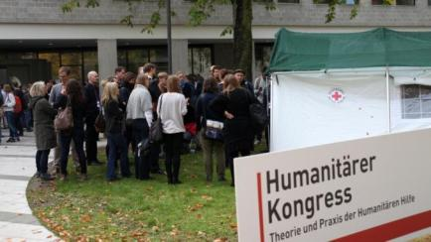
Foto 7 winter tent presented at the Humanitarian Congress 9-10 October 2015
London: UK Shelter Forum, November 13th 2015

Geneva: RCRC GA and conference December 04th to 11th 2015
(see ANNEX14 presentation for side event at GVA)
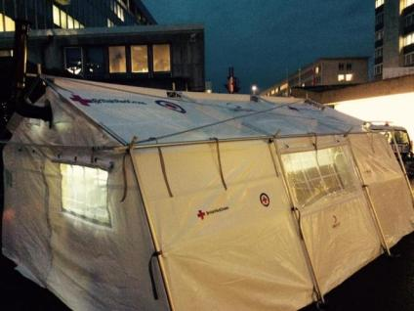
foto 9: Tent exhibited in front of the conference venue during the RC Movement GA and conference 4-11 December 2015

preliminary specifications:
The finalized design with the full set of CAD drawings and technical specifications was shared with BRC and F&P on …
These Specifications do not yet include possible structural changes as they were not confirmed by F&P and would also need some redesign on the connectors.
Sharing specifications with suppliers
A first batch of 100 tents was ordered by Luxemburg Red Cross from TRC according the preliminary specs.
important note: TRC opened a call to source the materials for the tent. The offers received for the newly developed synthetic felt varied so greatly in price and quality that it indicates the specifications need to be r and précised. This can only be done based on the results of the lab-tests of the materials as planned in the Phase II.
In the meanwhile TRC is producing the tents with the materials sourced from the supplier who was involved in the development of the materials, in order to guarantee the wanted quality.

- Way forward
The way forward after the conclusion of the phase I of the project was discussed during the meeting on London in May. It was deepened with F&P during the workshop in September in Luxemburg and a project proposal submitted for the Phase II in December (see ANNEX 15 concept Note phase II)
The main points to be addressed in a second phase being:
Fine-tuning and optimization of design: as discussed with F&P during the September 2015 workshop: F&P would like to work on the frame, zippers, connectors etc.; SRU would still like to optimize detailing of the shade net, the connections between inner and outer tent, and the floor insulation.
Material testing to confirm specifications as critical to draft the final specifications
Beneficiary satisfaction survey. According to establishes protocols this included at least ten beneficiaries (families) living in the tents for at least a months (that is two field visits and remote monitoring of trained field staff over at least a month, questionnaires at begin and end of the test phase, then analysis of the questionnaires etc.). However this requires field operations or set-up with good field support from a NS.
In the case such set-up cannot be identified this point will need to be reviewed to find other means to collect relevant beneficiary feedback.
Performance verification as three-seasonal solution would be interesting to confirm the suitability of the tent also for summer climates
Fine-tuning of production process to establish clear pricing. This requires close collaboration with TRC
Explore Material Sourcing options and other Manufacturers. This will be an added value but is mainly under procurement and logistics.
writing up of final specifications including the detailed material specs to be submitted for entry into the EIC.

List of Annexes:
ANNEX1: presentation milestone meeting April 25 2014
ANNEX 2 meeting points April 25 2014
ANNEX 5 meeting points Ankara July 3rd 2014
ANNEX 3 Presentation milestone meeting September 15th 2014
ANNEX 4 meeting points September 15th 2014
ANNEX 6 fields Test methodology
ANNEX 7 presentation March workshops
ANNEX 8 meeting notes March workshop
ANNEX 9 presentations London
ANNEX 10 London meeting points
ANNEX 11 presentation September workshops Luxemburg
ANNEX 12 meeting notes September workshop Luxemburg
ANNEX 13 tent specifications
ANNEX 14 Presentation GVA side events at GA

