“To Row or not to Row? A Flood Resilience Game”

Description
A fast-paced game on Climate Risk Management for crowd or auditorium settings.
Participants take the role of disaster managers working together in teams (represented by rows in the auditorium or groups in a crowd).
Each year, players must decide between investing in taking early action for flood preparedness, or whether to invest in planning and capacity building, while hoping for no floods.
Information about likely future conditions can change over time. “Failing to act” forces players to have to deal with crises, but “acting in vain” gets players a ‘vote of no confidence’ (or ‘fired’, depending on cultural sensitivities).

Why This Game?
To quickly convey the value and limitations of science-based predictions, to energize a large group, and to establish a shared understanding of basic tradeoffs in climate risk reduction.

Facilitator Skill Level
2 out of 5

Intended Audience
Applicable to any audience interested in climate and disasters, the game is particularly suitable for short sessions during large events and quickly getting a crowd to focus.

Number of Players:
15 to 1,000+ people, in teams by seating row or informal groups
1 Game Facilitator

Time Needed for gameplay/discussion
15 to 45 minutes (depending on experience of facilitator, group size, and desired level
of discussion during gameplay)

Materials
- 1 large die
- 1 frisbee or large disc
- 1 “climate change” cone
- Group prize for the winning team (group or row)

Playspace Requirements
Any room or outdoor space where participants sit in rows or can form distinct groups

Setup
If playspace is sparsely populated, invite participants to converge in teams – invite people to change seats and populate a few rows to increase their chances of winning. Although exact numbers are not necessary, adjust teams to ensure that no teams have too many more or too many fewer players than other rows/groups.

How To Win
After 7 rounds, or when time is up, the row with the most players still standing wins the prize.

Facilitation (base script)
Game can be played with or without accompanying powerpoint presentation.
Begin by introducing the climate change context.
The one thing we know about global climate change, which the IPCC has reported with a high degree of certainty, is that the hydrological cycle is intensifying. This is already being manifested in changes in the patterns of precipitation, more extremes of flooding and drought, and the most recent IPCC report underscores how this translates into humanitarian risk - and especially for the most vulnerable.

Explain: In this game, you are all disaster managers: each row/group is a municipal team, with many different areas of expertise. You are confronting both the need to build your community’s capacity for long-term disaster risk reduction and also to address the uncertainty of extreme events. Due to the intensification of the hydrological cycle we are especially concerned with rainfall extremes & rising flood risk in the years ahead!

The game is played in 7 rounds representing 7 years (e.g. from 2014-2020) so we need to think about the near future. Take a minute now to look down your row (around your group), quickly introduce yourselves and agree on a name for your team.

To start the game, All players stand up.
Why? Sitting down means elimination!

This is a game about making investment decisions to reduce disaster risk – so if you squander that investment, or fail to avert a humanitarian crisis, you’re not going to hold the confidence of your community to keep making these critical decisions! You might even be excused from the community disaster risk reduction team for making a terribly bad decision and squandering your part of the community budget!

How do you win the game? The winning team is the row with the most players still standing at the end of the game: your community has become the most resilient by most successfully managing flood risk!

Every year, each of you has a portion of the community budget that you are responsible for allocating.
So how will you make these critical annual investment decisions?
Each year, before the arrival of the rainy season (represented by a countdown), scientists share information about seasonal flood risk.
Then each team member must decide between 2 choices:

- investing in municipal capacity: by holding up one hand with a “thumbs up”
or
- investing in flood preparedness: by raising both hands to form a “tent” over your head.

Give participants a few moments to decide: You may consult with your team about whether to row together - any collective strategy to allocate few or many row/group members’ investments to flood preparedness - or not…

As soon as the countdown is finished, your investment has been programmed:
so no matter how much you may regret your decision it cannot be changed!

After the countdown: Now our local precipitation information is determined using a probability distribution function of expected rainfall (explain the roll of a die). A 1 is very little, 2-5 what we might call the normal range, but 6 is extreme: this means FLOOD.
Any player who makes the ‘wrong’ decision will lose the confidence of their community and is eliminated:
- if you fail to act (‘thumbs up’) and a flood happens, you must shout “Oh No!” and sit down;
- if you acted in vain (‘tent’) and then no flood happens, you must say “Grrr…” and sit down.
- All others: no problem – stay standing!

Round sequence of “seasonal forecasts”:
Year 1: this is a “Normal” season based on historical rainfall records so if we roll the die a ‘6’ represents a flood, ‘1’ to ‘5’ represents the normal range of rainfall with no flooding. I will give you 2 minutes to confer with your team and make your decisions. There will be a countdown, and at the end of the countdown you must either have a thumb up to indicate normal operations or a tent over your head for disaster preparedness! 5-4-3-2-1 Stop! Let’s see what the rains bring!
Toss die in front of room or in middle of crowd of teams. Facilitate who can remain standing & who must sit down based on roll of die & whether prepared or not. Explain as in bold above.

Year 2: introduce Sample Forecast of Extreme Precipitation (IRI slide) & point out a local area that is ‘white’ and/or explain that there is no forecast for the next 3 months so we have to do our best to decide based on the 1 in 6 probability of flooding, then roll normal die & facilitate who sits or stands ( as above in bold ).
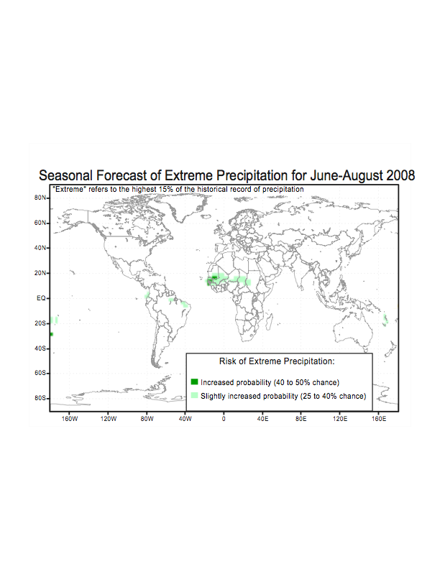
Year 3: What if we were to experience some “Global conditions”? Show the slide with the forecast and show or explain that there is an increased probability – a 40-50% chance of extreme precipitation in parts of West Africa (show dark green areas): This year imagine you are all west Africans living in this area. I will give you 2 minutes to confer and decide, but this time we will flip a frisbee (‘heads’ = flood, ‘tails’ = no flood) to better represent the higher probability of flood this year!

Year 4: Now we have some “Unusual conditions”. Explain ENSO: so we will flip the frisbee again (‘heads’ means flood, ‘tails’ means no flood)

Year 5: But have you heard, the climate is changing? So the dice really do not represent reality any more. “Climate Change” means that unprecedented, exceptional conditions are brewing. (Show slide for last 50 yrs of New England rainfall intensification) Explain: this is better represented by this ‘cone of uncertainty’ (show cone but do not toss) It gives us better depiction of the actual probability of flooding right now. I will again give you 2 minutes to confer and decide, but first let me explain - it can fall 3 ways: Explain and show 3 ways cone can land WITHOUT ACTUALLY TOSSING IT!

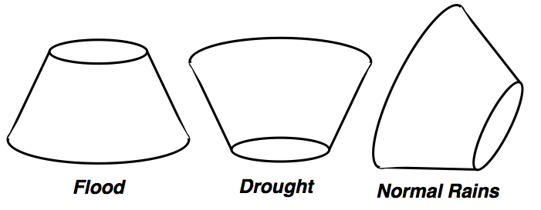

At the same time that flood risk is rising due to more frequent and more intense rains, drought is also becoming more frequent and more intense, so now if we are not prepared for either disaster – if it lands as drought, none of us are prepared so we might ALL have to sit down! Facilitate countdown, toss cone and facilitate flood consequences. If it lands on drought, end game.

Years 6 & 7: Continue with “Climate Change” cone. End the game & if any teams still have anyone standing, determine the winning row/team, give the prize.

Debrief discussion: solicit rapid responses from several players for each question.
What emotions did you experience?
How did your thinking change when the game moved to West Africa with heightened flood risk?
What did you think when it was an El Nino year?
How hard was it to interpret the cone of uncertainty?
What insights can you draw from this that relate to your own work/community? Elicit 4-5 different responses by asking “what else?”
Optional knowledge-sharing exercise:
Please form affinity groups by joining the person whose insight most resonates with you and I will give you a few minutes to exchange views on why it is relevant to your work or your community.
Now you are all ambassadors from your groups. Half the people in each group now leave and join a new group. I’ll give you a few minutes to confer as to how each of the different insights may complement each other (or not).
It is not necessary to ‘report back’ to the entire group: the aim is for everyone to have the chance to discuss in small groups.

Designed by: Pablo Suarez and Janot Mendler de Suarez, Red Cross / Red Crescent Climate Centre.

Acknowledgements
This game was developed with support from the American Red Cross (International Services Team).

