WFP/Turkish Red Crescent E-Voucher Food Card Program
Programming Manual

Contents
Page
- What is the E-voucher food card?........................................................... ...3
- UN World Food Program: Regulations for
Food Distribution………………………………………………………....4
- Building Infrastructure…………………………………………………... 6
  - Field Personnel…………………………………………………………………......6
  - Visual Materials…………………………………………………………………....7
  - Data Collection…………………………………………………………………….7
  - Electricity Supply………………………………………………………………….7
  - Building of Markets and Recruiting Personnel………………………………....... 8
  - Distribution of Kitchen Sets and Cooking Devices.................................................10
- Training..................................................................................................... 11
4.1 Education of Beneficiaries........................................................................................11
4.2 Education of Shop-owners and Cashiers................................................................. 12
4.3 Dissemination of Information among Locals...........................................................13
5. Implementation and Distribution............................................................... 15
5.1 How the e-voucher programme actually works....................................................... 15
5.2 How does the bank upload the money?................................................................... 15
6. Implementing a Framework for Monitoring and
Evaluation.................................................................................................. 18
6.1 Sphere Standards as a Basic Framework................................................................. 18
6.2 Surveys Conducted by Camp Management and Field Staff.................................... 22
6.3 Control of Markets....................................................................................................24
6.4 Control of Risks........................................................................................................25
6.5 Reports......................................................................................................................25
7. Useful Guidelines and Tools....................................................................... 27
7.1 Sample Beneficiary Satisfaction Survey................................................................... 27
7.2 Sample Market Check List........................................................................................ 29
- What is the E-voucher Food Card?

On 13 October 2012, the Turkish Red Crescent Society partnered with the United Nations World Food Programme (WFP) to launch the e-voucher food card programme to assist thousands of Syrians who were under international protection in Turkey. The e-voucher Food Card works like a credit card, and is pre-loaded with a specific amount of money per family member twice a month. This value must be sufficient to support a well-balanced diet of adequate calories (at least 2,100 kilocalories per person per day for emergency situation). These cards can be used in shops that are contracted by the Turkish Red Crescent, and available in/or nearby to camps. These cards are designed to support beneficiaries living in camps and enable them to purchase a sufficient amount of nutritious food items to meet household needs.
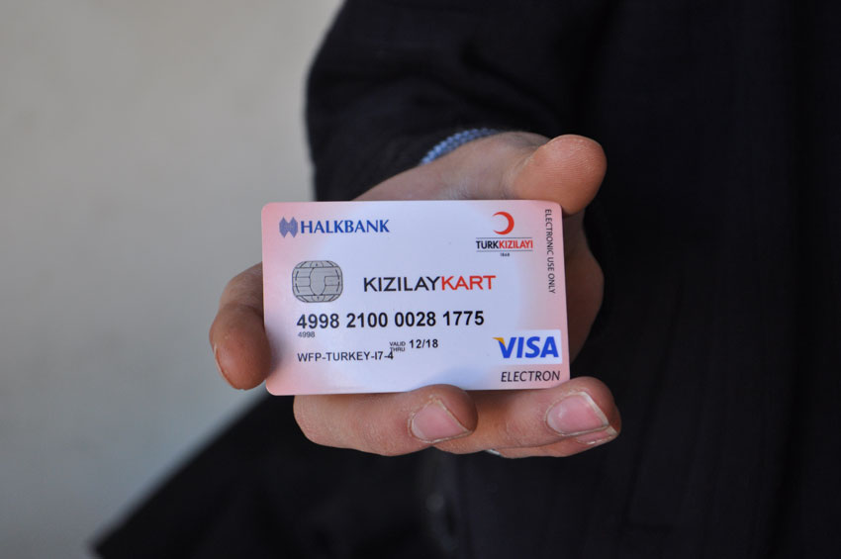
Source: http://www.un.org/News/dh/photos/large/2013/January/wfp-ertharin-syria-refs-turkey4.jpg
The e-voucher Food Card system is a cost-effective and efficient way of providing food assistance. In addition, it helps support the local economy. Most importantly, it allows beneficiaries to shop and cook for themselves based on their own tastes and preferences. This is also more cost-effective than distributing hot meals, as the Turkish Red Crescent and WFP saved up to 70% of its funds after implementing the program.

- UN World Food Programme: Regulations for Food
Distribution

In emergencies or refugee situations, people may be entirely dependent on food provided by humanitarian organizations. In this case, the key components of the food basket as recommended by WFP are: a staple such as wheat, flour or rice; lentils, chickpeas, or other pulses; vegetable oil (fortified with Vitamin A and D); sugar, and iodized salt, micronutrients such as vitamin A, iron, iodine and zinc. Often these are complemented with special blended foods (such as Corn Soya Blend) that have been fortified with important micronutrients. The total amount of food consumed by each individual in a single day is as follows:
- 400g of cereal: flour/rice/bulgur
- 60g of pulses
- 25g of oil (Vitamin A and D fortified)
- 50g of fortified blended foods (Corn Soya blend)
- 15g of sugar
- 15g of iodized salt
The total nutritional value of the above-mentioned components of an individual’s diet as an example during a day is approximately 2100 Kcal (Protein: 58g, Fat: 43g)

[Source: http://www.wfp.org/nutrition/WFP-foodbasket]

Individual energy requirements are estimated for different population groups according to age, gender, weight and physical activity level. The mean per capita energy requirement for a population has been calculated by taking the weighted-average requirements for each age-sex group. The mean per capita energy requirement is not specific to any age or sex group and should therefore not be considered as the requirement of a particular individual. The estimate of 2,100 kcal per person per day was also designed to include the needs of pregnant and lactating women within the population.
In a refugee camp, the crude mortality rate (CMR) dramatically increases (from five to tenfold) above a baseline death rate of 0.7/10,000 persons per day. The prevalence of malnutrition among under-5-year-olds is 24 percent (<-2 z-score weight-for-height). Further epidemic outbreaks are a threat as a result of the overcrowding and extremely poor sanitation conditions in the camps. The provision of at least an additional 100 kcal per day above the initial planning figure for the whole population in combination with other measures is appropriate (i.e. at least 2,200 kcal).

[Source: http://www.who.int/nutrition/publications/en/nut_needs_emergencies_text.pdf]


Source: http://www.wfp.org/sites/default/files/imagecache/600x400/photos/6-4Food_Basket_200811_WFP-Rein_Skullerud_7838.jpg

- Building Infrastructure

Before the e-voucher food card programme is implemented, building the necessary infrastructure is of utmost importance. The provision of relief food aid must be coordinated with the relief assistance provided by other humanitarian organizations. For example, even though the Turkish Red Crescent primarily partnered with WFP to launch the e-voucher food e-card program, during implementation, other partners such as the local governorates and the district AFAD (Republic of Turkey Prime Ministry Disaster & Emergency Management Presidency) camp management had to be included. In order to ensure the smooth functioning of this system, certain prerequisites must be fulfilled.

  - Field Personnel

Depending on the number and size of the beneficiary camps, the total number of field personnel and field WFP/Turkish Red Crescent e-voucher food card personnel per camp is determined by Turkish Red Crescent main office in Ankara. Field staff members of all organizations directly involved in the implementation of the programme must undergo sufficient training about the programme procedure, technology, time frame, and equipments. Moreover, the field personnel must be provided with sufficient office space within or near the camp sites, so as to enable them to access the camp sites with considerable ease. Equipments would include the availability of logs or computers to keep records of the number of registered beneficiaries in each camp, and of the amount of money allotted to each card that is being distributed in the camps.
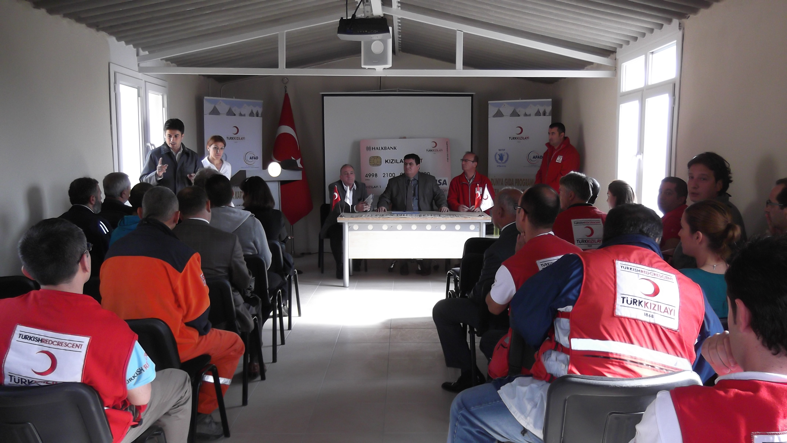

  - Visual Materials

Visual materials are a necessary part of any training programme that involves knowledge acquisition and retention. Visual materials such as PowerPoint presentations, charts, graphs, workbooks, and multimedia may be used to fulfil the learning objectives, and to provide the field personnel with a clear idea of what to expect at these beneficiary camps, and how to carry out the programme effectively. Furthermore, brochures may be provided to such personnel, in order to enable them to refer to the key aspects of the programme, whenever they might need to refresh their memory.

  - Data Collection

The camp management must work on collecting and updating data primarily about the camp demographics. This would include the total number of beneficiaries residing in the camp, the ratio of men to women, the total number of households, the number of people residing in each tent/container, and the number of people arriving at or leaving the camps. Upon registration, a photo identity card bearing the vital details of the beneficiary and a unique registration code must be issued to each beneficiary.
The number of beneficiaries in the camp is determined by the camp management according to household number living in tent/container. A list based on numbering of the tent/container is formed by Turkish Red Crescent Food E-Voucher Program Field Office. The lists are then sent to the bank for the purpose of the printing cards. Further information is required about the existence or need for markets in and around the camps, as well as the prevailing market prices of the various items to be sold at these on-site shops.

  - Electricity Supply

Electric supply lines must be drawn or generators installed in the camp site to ensure the consistent supply of electricity within the camp sites, as in the field staff offices, and markets. Apart from light sources, every container/tent/cabin must have multiple power outlets to enable the use of electronic cooking devices such as hot plates or induction cookers. Markets should have electricity for light, as well as for the running of refrigerators (required for preserving certain food products) and for the use of computers and Points of Sale (POS). There should be sufficient supply of electricity in the field staff offices as well, in terms of lights, fans, power outlets for the use of computers and other electronics.

  - Building of Markets and Recruiting Personnel

Governorate/District governorate initiates a tender than legal agreement between market owner and governorate has been signed. If there is a designated area in the camps, the shops and markets are built inside the camps by the district governorates and/or by the market owners. If there is no designated area, like in Hatay district, the shops and market can be in the nearby provinces, which are already providing services to locals. There should be sufficient storage place for both food and non-food items. The number of markets within a camp site depends on the total number of beneficiaries in that particular camp. For example, if there are more than 10,000 beneficiaries, there should be more than two shops either inside or outside the camp.
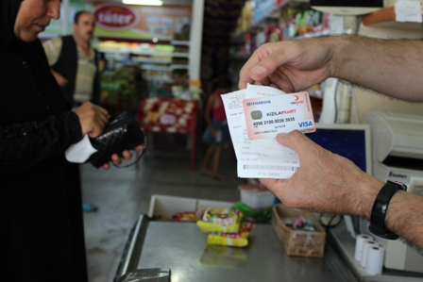
Source: http://www.wfp.org/stories/wfp-assists-syrians-turkey-food-e-vouchers

The shop-owners and cashiers can be recruited from the locals, thus opening up a new source of employment for some of them. In Turkey, the shop-owners and cashiers were recruited either from nearby towns or cities, or directly from Ankara. They must undergo sufficient training in order to fully grasp the usage of the e-voucher food card, and a legal protocol agreement should be signed between the shop-owners and Turkish Red Crescent (who implemented the e-voucher food card programme), stating clearly the duties and responsibilities of the shop-owners, and the protocol that they are required to follow. Some such terms of agreement are as follows:

- Using Turkish Red Crescent’s logo and brand name without permission is prohibited.
- They need to pay strict attention to product quality/variety, expiry date and shelf life of the product, as well as hygiene.
- There should be no price difference between purchases by cash or Turkish Red Crescent E-voucher food card.
- There should no commission charge taken from the purchases done by Turkish Red Crescent E-voucher food card.
- There should be no money converted into cash from the Turkish Red Crescent E-voucher food card.
- There should be no sale of forbidden products with Turkish Red Crescent E-voucher food card.
- Cross checking of the AFAD identity card and Turkish Red Crescent E-voucher food card should be done by the market cashier and there should be no sales to beneficiaries under the age of 18.
- The calibration of weight and measurement tools should be appropriate.
- There should be no price difference between the price tags and the cash register, also price labels of the products should be clear and understandable.
- Turkish Red Crescent, WFP, AFAD and Governorate/District Governorate can audit the market at any time.
- Market owner should keep all the data and reports up to 3 years and they should be able to present those documents upon request.
- Market employees should have proper attitude towards beneficiaries.
- Clearly stated upon this agreement under any circumstances like plundering and/or material damage, Turkish Red Crescent cannot be held responsible.
- The market should be capable of rapid stock turnover and measure against the possible density.
- Turkish Red Crescent authorities can audit and/or monitor; stock turnover, product price, hygiene, product range, and quality at any time. Upon this audit if the conditions are not appropriate they can give verbal notification. If there is no improvement they can give written notification.
- If market fails to fulfill above mentioned regulations after written notification Turkish Red Crescent has right to terminate the agreement.

  - Distribution of Kitchen Sets and Cooking Devices

Before implementing the e-voucher food card programme the camp receives all the kitchen gadgets from Turkish Red Crescent. Those materials distributed either by Camp Management or Turkish Red Crescent field personnel to the beneficiaries.
Every household should be provided with a kitchen set containing the following items:
- Cooking utensils
- Cutlery
- Plates, Glasses, Bowls
- Containers
In addition, each tent/container/cabin must be provided with cooking devices such as gas, hot plates, or even induction cookers.


Source: http://www.vibrandorange.com/slm.in/images/stainless-steel-big.jpg

- Training

Before starting this programme Turkish Red Crescent organizes training sessions to implement successfully each component starting from the camp management, field staff and actual beneficiaries, in order to ensure that they fully understand the process and how the e-voucher food card is used. Those training sessions are conducted and designed by Turkish Red Crescent. The training sessions are designed in a way that will convey all the necessary information to the concerned parties with clarity and simplicity.

4.1 Education of Beneficiaries

Since the e-voucher food card programme will be used by the beneficiaries, it is essential that they have a clear understanding of how to use the card. Their training must comprise adequate information about
- How the card is to be used?
- Where it is to be used?
- How much money is allotted to each member each month?
- What they can buy with the card, and what they cannot?
- What happens if there is money left on the card at the end of the month?
- Whom to report to, in case of lost cards, or other issues with the card?
.
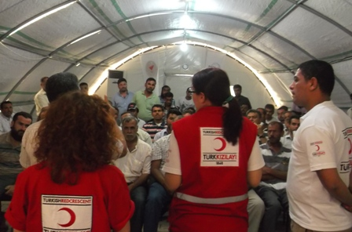
Brochures have already been printed in the native language of the beneficiaries as well as in the native language of the country in which they have resettled. Because some beneficiaries are unable to read Turkish Red Crescent uses visual components along with the text. Furthermore, Turkish Red Crescent field team holds meetings with the heads of families and camp committees in order to explain the use of the e-voucher to them, so that they may in turn convey the information to all the households.

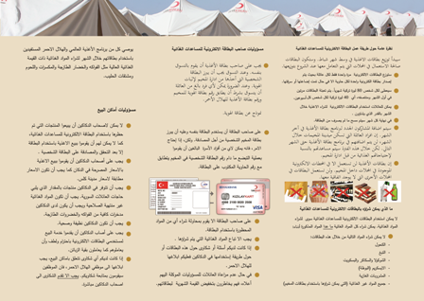

4.2 Education of Shop-owners and Cashiers

Once the shops or markets have been set up, Turkish Red Crescent field team organizes training sessions for the shop-owners and cashiers in regards to how the e-voucher food card works. Clear instructions are to be given about which items are allowed to be purchased with the card, and which are not. In the event of a shopkeeper selling a prohibited item through the e-voucher food card, his shop may be pushed off the programme altogether. Strict adherence to the storage and hygiene conditions is required, as well as other terms of the agreement. The local governorates also issue regular tenders for the shop-owners. Such training sessions and notices must be held from time to time in order to ensure the smooth functioning of the programme.

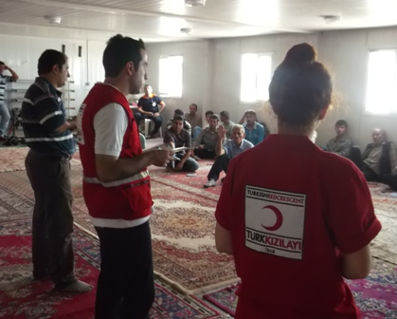

4.3 Dissemination of Information among Locals

Informing the local town or city-dwellers in also just as important, in order to preempt any misunderstanding or animosity between the locals and the beneficiaries. Adequate information about the need for this programme must be disseminated through local newspapers, radio, and through the use of posters, flyers, and other forms of media. The locals must be able to understand their role as a host, and be assured that the food and other items made available to the beneficiaries are neither at a lower, nor at a higher price than the prevailing market rates. They must also be made aware that such a programme is not only providing additional employment, but also boosting the local economy.

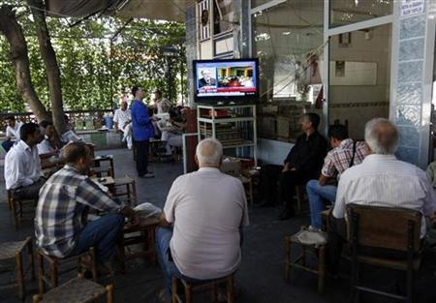
Source: http://s4.reutersmedia.net/resources/r/?m=02&d=20100111&t=2&i=44142376&w=460&fh=&fw=&ll=&pl=&r=2010-01-11T225053Z_01_BTRE60A1RGX00_RTROPTP_0_TURKEY

5. Implementation and Distribution

Once the necessary infrastructure is in place and the required training sessions carried out, the e-voucher is ready for implementation. Following, is a step by step description of how the e-voucher food card programme works:

5.1 How the e-voucher programme actually works

- Once the beneficiaries have learnt how to use the cards, the first step in the implementation process is the distribution of the cards. Turkish Red Crescent Food Project Team distributes the E-Voucher food cards accordingly to container numbers. The beneficiaries who receive the e-voucher food card must be over 18 years of age and need to sign the beneficiary distribution list. These distribution lists are maintained for the sake of transparency, as well as for archival purposes.
- At the end of every month camp managements will submit updated list with a cover letter to Turkish Red Crescent project team and project team will share these lists with a cover letter with the International Programs Directorate of TRCS for the cards to be uploaded.
- The whole project budget will be covered by WFP funds.
- The finance department of the Turkish Red Crescent works in collaboration with bank while the cards are uploaded.
- The bank then deposits money into the respective accounts opened for each household listed in the database provided to the bank. Consequently, the money deposited into the accounts gets uploaded to each card provided to the beneficiaries within that particular camp.

5.2 How does the bank upload the money?

80 TL per person (40TL in the beginning and in the middle of the month) will be uploaded to each card according to the number of household members living in that container/tent/cabin. This amount has been determined based on one person’s daily nutritional need in terms of amount of calories per month determined by WFP
For instance, if there are 5 persons in each tent, on the first day of the month the bank uploads the total amount of money allotted to five people for half a month. In Turkey, 200 TL was uploaded for 5 people for 15 days (40 TL per person/15 days). Then, in the middle of the month, the second half of the total amount is uploaded to each card (another 200 TL for 5 persons in Turkey).
If the family does not spend all the money by the end of the month, the balance remaining in the cards is taken back by the bank. Again on the first day, of the month, the original amount is deposited.

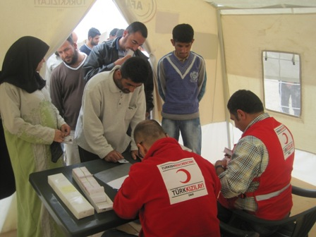
Source: http://www.wfp.org/node/378710

- Beneficiaries can use the card only to purchase staple foods such as rice, bread, water, etc. The items stated below cannot be purchased with the e-voucher food card :
- Chocolates
- Alcohol
- Cigarettes
- Soda
- Non-food items
- The supermarkets are stocked with fresh vegetables, meat and a wide variety of staple food products and basic necessities. All the items that cannot be purchased with the food card may be purchased directly with money.
- After collecting the items that they require, the beneficiaries go to the cashier, who then politely asks for the beneficiary’s registration card along with his/her food card. The tent/container/cabin number on the identity card is the same as the code on the e-voucher food card.
- If the numbers match, the beneficiary’s food card is swiped, and he/she may leave with the items. If the numbers do not match, however, the shopkeeper is not permitted to sell any items to the concerned beneficiary. All cashiers are provided with Points of Sale to swipe the e-voucher food cards.
- These food cards can either be used by the parents in the household, or by the children who are above the age of 18.
- All technical issues are resolved by trained field personnel present. If any issue cannot be resolved, then an appropriate list for the problems should be filed and sent to the Turkish Red Crescent Food Card Team to be solved.

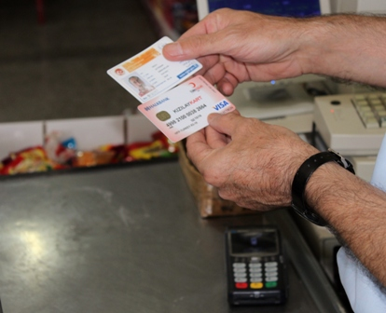

- Implementing a Framework for Monitoring and Evaluation

6.1 Sphere Standards as a Basic Framework

Cash and Vouchers are considered as ways to address basic needs and to protect and re-establish livelihoods.

Key actions:
- Consult and involve beneficiaries, community representatives and other key stakeholders in assessment design, implementation, monitoring and evaluation.
- Assess and analyze if people could buy what they need at local markets and prices that are cost efficient compared with alternative transfers, and analyze the market chain.
- Choose cash or vouchers or a combination of these based on the most appropriate delivery mechanism, and the likely benefits to the disaster-affected population and the local economy.
- Implement measures to reduce risks of illegal diversion, insecurity, inflation, harmful use and negative impacts in disadvantaged groups. Particular care is needed for targeting systems.
- Monitor to assess if cash and/or vouchers remain the most appropriate transfer and if adjustments are needed.

Key indicators:
- All targeted populations meet some or all of their basic food needs and other livelihood needs (e.g. productive assets, health, education, transportation, shelter, transport) through purchase from the local markets.
- Cash and/or vouchers are the preferred form of transfer for all targeted populations, particularly for the women and other vulnerable people.
- The transfer does not result in anti-social expenditures.
- The transfer does not generate insecurity.
- The local economy is supported to recover from the disaster.

Guidance Notes

- Cash and food vouchers are a tool: Cash and food vouchers are mechanisms to achieve desired goals, not interventions in themselves. A careful comparative assessment should indicate whether cash and/or vouchers are appropriate or not, and whether they should be used on their own or with combined responses such as in-kind support. Cash and voucher transfers can be used at different stages in the disaster. The response should be determined not only with the expected efficiency and effectiveness in meeting beneficiaries’ basic needs or re-establishing livelihoods, but also by an expected lower level of associated risks. Cash and vouchers can offer greater choice and flexibility than in-kind responses and this gives recipients a sense of greater dignity. Cash and vouchers may also create positive multiplier effects in local economies, which should be considered during assessments. Cash and vouchers can be used as follows:
- Cash grants: conditional or unconditional transfer of cash in either one or several instalments to meet a range of needs.
- Commodity or value-based voucher: transfer of paper or electronic vouchers to be exchanged for specific goods or a range of goods according to the value of the voucher.
- Cash for work: transfer of cash as income earned by participating in specific activities (usually activities requiring physical labour).
Planning, implementation and monitoring should involve local stakeholders such as governments, local authorities, community structures and representatives, cooperatives, associations, local groups, and beneficiaries. This will help ensure relevance and sustainability. An exit strategy should be planned with key stakeholders from design onwards

- Impact on local economies and market systems: Market assessment should analyze the situation before and after the disaster, and the competitiveness and integration of the market to respond to current needs. Analysis should also show the roles of the different market actors, availability and price of commodities (livelihoods assets, shelter materials, foods, and others depending on objectives), seasonality and physical, social and economic access by different groups of vulnerable people. Cash and vouchers can be appropriate when markets and functioning and accessible, and when food and other basic items are available in the required amounts and at reasonable prices. Such transfers may stimulate the local economy to a quicker and more sustainable recovery. Market responses can promote local procurement and better use of the capabilities of existing market actors.
Cash and vouchers used when the context is inappropriate can distort markets and may have negative effects such as inflation. Market monitoring is essential to understand the impact of cash and vouchers on local economies and people.

- Cash and voucher delivery mechanisms: Cash and vouchers can be delivered through local banks, shops, traders, local money transfer companies, remittance companies and post offices. They can be delivered physically or through technologies such as mobile banking and mobile phone networks. Banks are usually efficient and effective but may be less accessible to vulnerable people; if banks are accessible, perhaps through mobile banking, they can be a more secure option. The choice of delivery mechanism requires an assessment of options and consultation with recipients. Issues to consider are costs for recipients (bank charges, travel time and costs, time at collection points), costs for the organization (charges and set-up costs of provider, staff time to set up and administer, and transport, security, education and training of recipients), efficiency and effectiveness (reliability, resilience, accountability, transparency, monitoring, flexibility, financial control, financial security and access by vulnerable people). An approach that may appear costly may still be the most appropriate transfer mechanism.

- Considering risks: Common concerns on the risks of cash and voucher transfers include fears that cash and vouchers could contribute to price inflation (leaving disaster-affected people and others with less purchasing power), the use of cash and vouchers for anti-social purposes (e.g. alcohol and/or tobacco abuse), and differential access of women and men to cash compared with in-kind resources. Other concerns are that transporting cash may create security risks for implementing staff and for the affected population and that the attractiveness of cash may make it more difficult to target recipients and may increase the risks of corrupt diversion or seizure by armed groups. However, in-kind distributions also have risks. The risks for cash and vouchers can be minimized through good design, through risk analysis and through good management. Decision-making should be through evidence-based consultation: unfounded fears should not influence programme planning.

- Setting the value of the cash or voucher transfer: The value set for transfers is context-specific. Calculations should be in coordination with other agencies and based on the disaster-affected population’s priorities and needs, prices for key goods expected to be purchased in local markets, other assistance that has been and/or will be given, additional related costs (e.g. travel assistance for people with restricted mobility), method, size and frequency of payments and timing of payment in relation to seasonality, and objectives of the programme and transfer (e.g. covering food needs based on the food basket or providing employment based on the daily labour rate). Price fluctuations can reduce the success of cash and voucher transfers. Budget flexibility is essential to adjust the value of the transfer or add a commodity component, based on market monitoring.

- Choosing which type of cash or voucher transfer: The appropriate type of transfer depends upon the programme objectives and local context. A combination of approaches may be appropriate, including with in-kind assistance and seasonal variations. Agencies should find out what disaster-affected populations consider the most appropriate form(s) of transfer through informed consultations.

- Targeting in cash and voucher transfer programmes: The challenges can be as significant for in-kind commodities and services, but due to the attractiveness of cash and vouchers, particular attention is needed to minimize exclusion and inclusion errors. People can be reached either by direct targeting (to the disaster-affected households or population) or by indirect targeting (e.g. local traders or service providers). Insecure conditions may require an indirect targeting approach. Gender affects decisions on the household member registered to receive cash or vouchers, as with in-kind transfers. Co-ordination with stakeholders, including government welfare and social protection programmes providing cash transfers, is essential for targeting (as for in-kind transfers).

- Monitoring of Cash and Voucher Transfers: Baseline information is required, with monitoring before, during and after transfer programmes, taking into account the direct and indirect impacts of cash and vouchers in the market. Changes in the intervention should respond to the changes of the context and market situation. Monitoring should include prices of key goods, multiplier effects in local economies and price fluctuations. Key questions are: What are people buying with the cash and vouchers provided? Can people receive and spend cash safely? Are cash and vouchers being diverted? Do women influence how the cash or voucher is spent?

Please refer to The Sphere Project Handbook for further information.

[Source: http://www.spherehandbook.org/en/food-security-cash-and-voucher-transfers-standard-1-access-to-available-goods-and-services/]

  - Surveys Conducted by WFP and Turkish Red Crescent

Interviews and surveys are an important part of the monitoring and evaluation process. Constant feedback is required from the beneficiaries in order to ensure that the programme is running smoothly, and to make necessary changes for the improvement of the programme. Two important tools of the monitoring and evaluation process are:
- Beneficiary Satisfaction Survey
- Market Checklist
The Beneficiary Satisfaction Survey can be conducted on a daily basis by the Turkish Red Crescent field staff. Also the beneficiary satisfaction can be conducted on a weekly basis by WFP staff. The main objective of this survey should be to find out whether the implemented programme is helpful to the beneficiaries or not, and whether they are having any trouble using the card or not. Some of the sample questions that may be asked in the Beneficiary Satisfaction Survey are:
- Are you satisfied with the electronic food card?
- What are the disadvantages of the card?
- What are the advantages of the card?
- How often do you shop using the e-voucher?
- Are you satisfied with the 2-week intervals of reloading the card?
- Are you experiencing any difficulty in using the food card at the market?
- Can you get enough basic food products with the electronic food card?
- Have you ever received cash in return for some/all of the card value?
- Are you satisfied with the attitude of the market employees when you use the card?
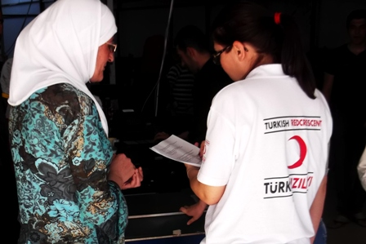

While the Beneficiary Satisfaction Survey is designed to get feedback from the beneficiaries on the effective use of the card and on any difficulties faced in the market, the market Checklist must be used to monitor market practices, as well as the quality and quantity of food available in the markets. This checklist – filled in by Turkish Red Crescent field staff – should seek to examine whether the following criteria are fulfilled appropriately or not:
- Product quality
- Product variety
- Expiry date and shelf life of the product
- Hygiene
- Price labels at departments
- Clarity of price tags
- Price consistency between shelf and cashier
- No sale of forbidden products
- No price difference between card or cash purchases
- No commission on food card purchases
- Money on food card cannot be converted into cash
- The calibration of weight and measurement tools
- Stock turnover, measure against the possible density
- Cross-checking of identity cards by cashier
- No sales under the age of 18 with food card
- Attitude of market employees towards beneficiaries
- Openness to auditing and monitoring
These market audits along with the beneficiary satisfaction surveys provide efficient monitoring and evaluation tools that help to measure the success of the electronic food card programme.
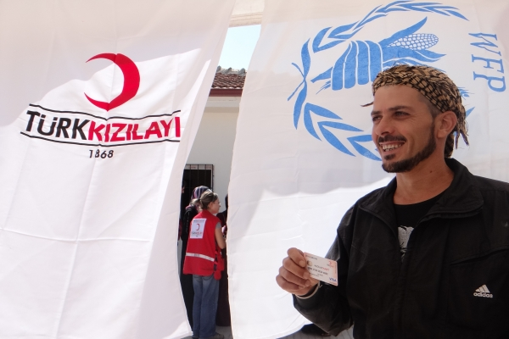

6.3 Control of Markets

The markets that are both inside and/or outside the camps regularly controlled by WFP field staff and daily by Turkish Red Crescent field staff according to the signed protocol. The market check list form filled out on each control done by Turkish Red Crescent and WFP and filled for reports.
The Turkish Red Crescent field staff needs to conduct and fill out the appropriate surveys and forms according to the protocol. Also the outcome of this daily control needs to be reported to the Turkish Red Crescent Field Project Team on weekly basis. The items tthat need to be checked are: product quality, product variety, product prices, price tags, hygiene, sale of non-food products with e-voucher food card. If a problem is recognized in the markets with regard to protocol, Turkish Red Crescent will issue a written warning to markets.
If the problem persists, Turkish Red Crescent issues a second written warning. If the problem still continues, the contract is terminated unilaterally by Turkish Red Crescent authorities.
Also other authoritative bodies like Governorate/District Governorate and AFAD are eligible to control check the markets at anytime. Compliance with existing markets with reference to the prices in the area is assessed by the Turkish Red Crescent and WFP.
WFP and Turkish Red Crescent compared prices between the markets that signed the protocol and the other markets which in city center.
Market regulation covers the terms and conditions for supplying the goods, the price allowed to be charged, and to whom the products are distributed. Another important aspect is the storage of goods and circulation.
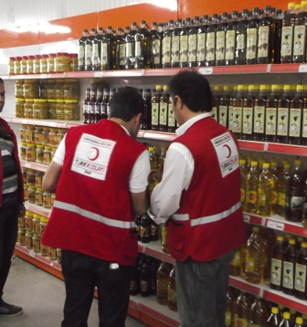

6.4 Control of Risks

This involves the identification, assessment, and prioritization of risks followed by coordinated and economical application of resources to minimize, monitor, and control the probability and/or impact of unfortunate events.
One of the biggest priorities should be protection of the products in the markets from theft or robbery, as well as protection of the beneficiaries who have access to the electronic food card. The presence of security personnel, as well as practices such as cross-checking identity card with food card are some of the things that can help in the prevention of any untoward event.
Security cameras are placed both around and inside camps. Most of the markets also have security guards and/or security cameras to prevent an untoward incident.

6.5 Reports

The weekly project report is prepared by the project team and presented to the Directorate of International Programs every Sunday afternoon.
Also Lost-Broken-Remaining card list report, abnormality reports and monthly project reports are prepared by project team at the end of every month and sent to Directorate of International Programs to be shared with the WFP.
The report spreadsheets contain the total number of cards distributed, the total amount of money uploaded, the population of the camp, as well as the gender ratio are important in order to ensure the efficient use of available funds. Moreover, it is also useful in maintaining a high degree of transparency, so that the organization can easily show what kind of work is being done, who is doing the work and for how long, with how many people, and how much money is being spent
Not only is this useful in keeping a record of the effective utilization of the e-voucher food card, but it is also necessary to make a report after conducting the surveys, in order to assess the success or failure of the programme. These reports must be prepared in an accurate and timely manner, as they are the principal source of information on the programme implementation and the extent of its success.

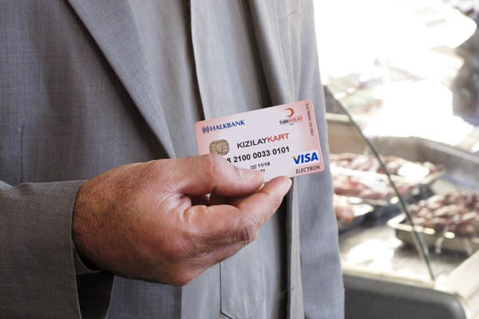

7. Useful Guidelines and Tools

7.1 Sample Beneficiary Satisfaction Survey

- Date:

- Camp:

- Interviewer:

- Gender F □ M □

- Size of family (How many under 5?)

- Who is usually doing the shopping in the family?

- Are you satisfied with the WFP/Kızılay Card?
Yes □ No □

- What are the disadvantages of the WFP/Kızılay Card? (3 items)

- What are the advantages of the WFP/Kızılay Card? (3 items)

- How often do you go shopping with the WFP/Kızılay Card during the two week period? (except bread)

- Are you satisfied with the two week intervals of reloading the card?

- Are you experiencing any difficulties while using WFP/Kızılay Card in markets?
Yes □ No □
If yes explain

- Can you get enough basic food products that you need with WFP/Kızılay Card?
Yes □ No □
- If no why not?
- Name the most frequently bought items?

- Have you ever received cash in return of some/all of the card value?
Yes □ No □

- Are you satisfied with the attitude of market employees when you use your card?

- Comments (suggestions for improvement, new proposals, etc.)

____________________

7.2 Sample Market Checklist

Date:__________________________________________
Auditor: _____________________________________
Supplier Company: _________________________________
The obligations of Supplier Company | Appropriate | Not Appropriate
Product quality
Product variety
The expiry date of the products, shelf life
Hygiene
Price labels at departments
Price tags are clear and understandable
There is no price inconsistency between the shelf and cashier
There is no sale of forbidden products
There is no price difference between WFP/Kızılay Card and cash purchases
No commission on WFP/Kızılay Card purchases
The money in WFP/Kızılay Card cannot be converted into cash
The calibration of weight and measurement tools are fine
Stock turnover, measures against the possible density
Cross-check of the identity cards by cashier
No sales under the age of 18 with WFP/Kızılay Card
The attitudes of market employees towards beneficiaries
Openness to auditing and monitoring
Miscellaneous:_________________________________________________________________________________________________________________________________________________
Explanation:______________________________________________________________________________________________________________________________________________

______________

