------------------------- Part 1: Game Overview-------------------------

Title: Upstream-Downstream
Description: This is a board game where players take on the role of upstream or downstream farmers. Each player must make planting decisions, manage land use and contend with floods and droughts to ensure the survival of their families.

Why This Game?
To understand (1) how decisions made in an upstream community can affect a downstream community and vice versa (2) how information about probability of drought or flood can affect decision-making (3) the benefits and trade offs related to risk preparedness in the context of climate variability and change.

Facilitator Skill Level
4 out of 5 stars

Number of Players
12 players

Time Needed for gameplay/discussion
1 hour and 30 minutes

Materials
Game board**
100 beans in a bowl, 3 per farmer
6 normal white dice, one per upstream farmer
1 colored six-sided die to represent regional rainfall, for facilitator
~100 green tokens in a bowl*, 6 per upstream farmer
~100 brown tokens (young trees), in a bowl*

** The game board can be drawn using 2 sheets of easel paper and red, blue, and green colored markers
*Green tokens can be substituted with alternative materials
*Brown tokens can be substituted with alternative materials

Playspace Requirements
A long table that accommodates 12 people, on which the game board fits.
Players can also place the game board on the ground and sit on the ground, if desired.

Setup
Downstream farmers begin with 3 beans and 1 mature tree.
Upstream farmers begin with 3 beans, 6 mature trees and 1 die.
Gameboard is placed in the middle of the playspace and 12 players is invited to each sit in front of one section of farm land.

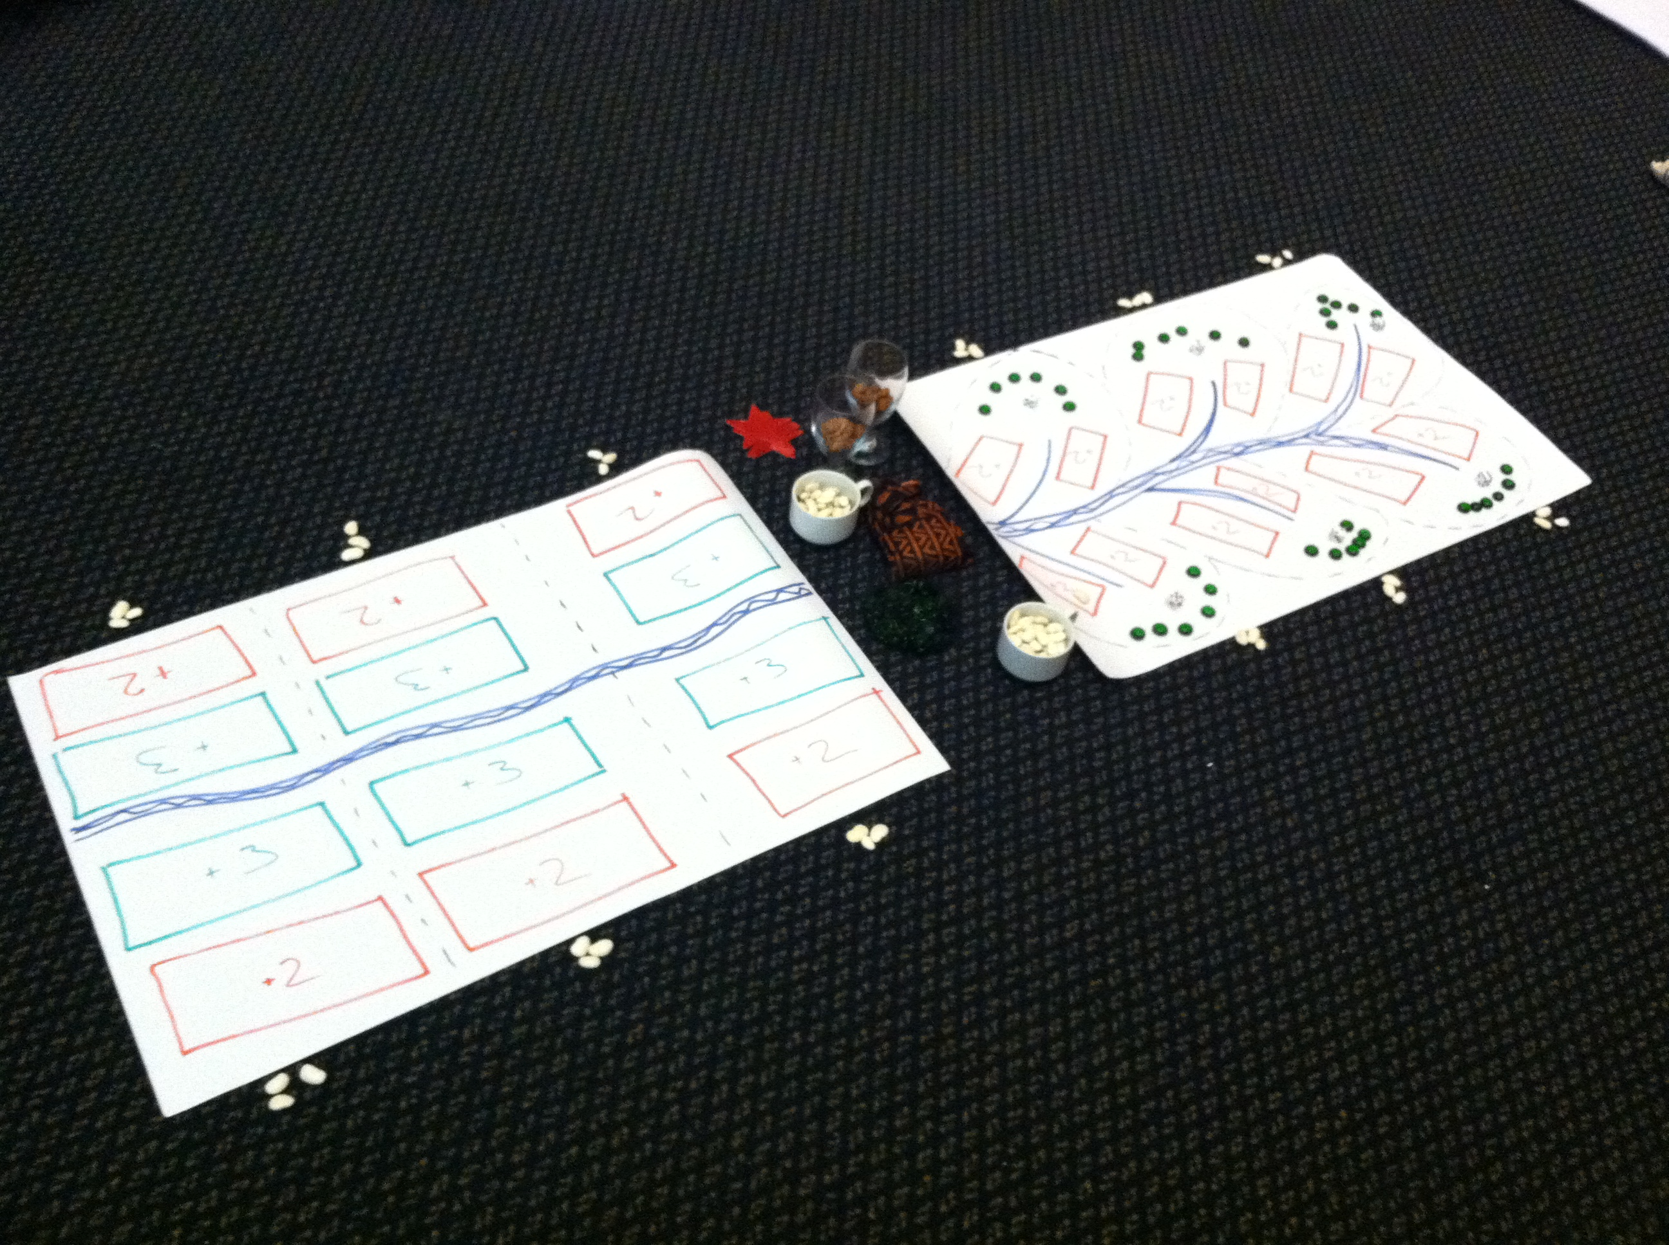

How to Win This Game
Win by having the highest number of beans and trees.

Game Play
The game consists of 10 rounds.

Part I
- Facilitator asks all downstream farmers to plant beans, and buy or sell trees and starts countdown (5,4,3,2,1…STOP!).
- Facilitator throws regional rainfall die.
- If die falls on 2-6, farmers harvest beans. If die falls on 1, downstream farmers lose beans and any young trees.
- Each player gives 2 beans to facilitator to pay to feed their families.
- If a farmer can’t pay 2, he/she must sell mature trees or emigrate to the city (leave the game).
- Players buy/sell trees. Thereafter, next round can begin.

Part II
- Facilitator asks all farmers to plant and starts countdown (5,4,3,…1).
- Facilitator throws regional rainfall die.
- If die falls on 2-6, facilitator pays out beans to farmers. If die falls on 1, facilitator collects all beans and any young trees from downstream farmers. Upstream farmers are not vulnerable to drought.
- If the dice falls on 2-6, facilitator asks each upstream farmer to throw his or her die.
- Upstream farmers that experience flood (sum of the regional and local dice is 10 or more) identify themselves.
- For upstream farmers
- Upstream farmers that experience flooding lose planted beans, and give facilitator their lost beans.
- If three upstream farmers experience flooding, there is flooding downstream. Downstream farmers give facilitator lost beans.
- Facilitator announces all farmers need to eat at the end of each round. Eating costs 2 beans for everyone. If a farmer can’t pay, it needs to sell mature trees or emigrate (leave the game).
- Finally, facilitator asks who wants to buy/sell trees. Thereafter, next round can begin.
- An upstream farmer that has less than 3 trees has deforested his/her land. Consequently, for these farmers, if the sum of his/her dice and the regional rainfall die is 9 or more, this farmer experiences flood.

Rules
Beans
- Only 1 bean can be planted on each plot
- Fertile plots harvest 2 beans; less fertile plots harvest 1 bean.
- Farmers must pay 2 beans for feeding family at the end of each round of play.

Trees
- Young trees can be bought and immediately planted for 1 bean.
- Young trees become mature trees after 3 rounds.
- Mature trees can be cut down and sold for 2 beans.
- Only mature trees can be cut down and sold.
- Farmers can buy and sell trees after paying 2 beans for their family’s food and before planting beans

Dice
- Facilitator’s die represents regional rainfall.
- If regional rainfall die is 1, this means drought for downstream farmers.
- If regional rainfall die is 2-5, this means favorable rains for downstream farmers.

- An upstream farmer’s die represents his/her local rainfall.
- Upstream farmers are not vulnerable to drought.
- If the sum of a regional rainfall die and a local rainfall die is 10 or more, that upstream farmer experiences a flood and loses all planted beans.
- If the upstream farmer has 3 or fewer mature trees on his/her land, flooding occurs when the sum of the regional and local rainfall dice is 9 or more.
- If 3 or more upstream farmers experience flooding, beans planted downstream in fertile plots are wiped out/lost.

Variations
For added complexity, assign one person the role of ‘Donor’. This person has 20 beans that he/she can choose to grant farmers as game is played. When donor’s beans run out, chances for outside assistance is over.

------------------------- Part 2: Facilitation Guide-------------------------

Preparation Time
30 minutes to draw board and set up pieces

GamePlay
The facilitator can facilitate the game in two parts.

Facilitator is responsible for:
- Keeping track of the number of rounds played
- Rolling regional rainfall die
- Collecting beans for food payments
- Distributing beans to farmers that have harvested
- Making payments for felled mature trees and collective felled mature trees
- Collecting payments for young trees and handing out young trees
- Confirming when downstream farmers experience flooding and crop loss
- Creating necessary drama when a farmer harvests, must migrate to the city, etc
- Creating necessary suspense by announcing a countdown
- Introducing climate change die at appropriate round
- Providing clarity on game rules, not on game strategy

PART I: Begin game with 6 downstream farmers
- Facilitator introduces game as simplification of reality.
- Invites 6 volunteers to the board. Explain to six players they represent farmers in the downstream community.
- Each farmer has two plots of land. Each farmer begins with three beans and one mature tree. Explain the land plots nearby the river are fertile land; plots away from river are less fertile.
- Beans are used to plant and to pay for feeding family, and for buying baby trees.
- Farmers that plant on more fertile plots will gain 2 beans when rainfall is good (+2). Farmers that plant on less fertile plots will only gain 1 bean when rainfall is good (+1).
- Mature trees can be cut down and sold for 4 beans.
- Young trees can be bought for 1 bean. Young trees mature after three rounds and can only then be cut down and sold.
- Facilitator has one dice that represents regional rainfall.
- If the die falls on number 1, this represents drought. When there is drought, all downstream farmers lose all crops and any young tree they may have bought (young trees do not survive drought). Numbers 2-6 represent good rainfall.

**Play a practice round following the Game Play order**

PART II: Continue game with upstream farmers
  - Facilitator invites 6 additional volunteers to sit around the second board. These six players represent farmers in the upstream community.
  - Each upstream farmer has three beans, one plot of land that is not fertile, six mature trees and one die. Upstream farmers can sell mature trees for 4 beans or buy young trees for 1 bean. As before, young trees mature after 3 rounds and can be cut or sold thereafter.
  - Each upstream farmer’s dice represents local rainfall patterns for their plots of land. Land upstream is not vulnerable to drought.
  - Facilitator explains that when the sum of an upstream farmer’s local rainfall die and the facilitator’s regional rainfall die is 10 or greater, this causes a flood. As a consequence of flooding, the affected upstream farmer will lose any planted beans.
  - If 3 or more farmers upstream experience floods (sum of dice is 10 or more), this causes flooding for the downstream farmers as well, and ALL beans planted downstream next to the river are lost.

**Play a practice round with downstream and upstream farmers following the Game Play order**

After the Practice Round, the facilitator should ask players if they have any questions on the rules. Provide any additional clarity on game rules.

Start the game play ‘for real’!

After round 7, facilitator should introduce new regional dice that has 8 sides. This represents increased likelihood of flood for upstream farmers and decreased likelihood of drought (1/8 vs. 1/6) for downstream farmers.

Discussion Questions
What information determined the decisions you made?
Did some players introduce tactics to help each other? (loans, etc.)
Did the introduction of the 8-sided die change your decision-making process?
How could this game be improved to better reflect reality?
How does the climate change die affect farmers’ decisions?

Designed by
Members of the PfR consortium in Nicaragua and Guatemala including the Red Cross Red Crescent Climate Centre, Netherlands Red Cross, Care Netherlands, Cordaid/Caritas and Wetlands International, working together with local NGO partners.

Acknowledgements
This game was developed with support from the American Red Cross (International Services Team), and from a research grant to the Red Cross/Red Crescent Climate Centre from the Climate and Development Knowledge Network (CDKN Action Lab Innovation Fund).
As such, this game is an output from a project funded by the UK Department for International Development (DFID) and the Netherlands Directorate-General for International Cooperation (DGIS) for the benefit of developing countries. However, the views expressed and information contained in it are not necessarily those of or endorsed by DFID, DGIS or the entities managing the delivery of the Climate and Development Knowledge Network, which can accept no responsibility or liability for such views, completeness or accuracy of the information or for any reliance placed on them.

Attribution-NonCommercial-ShareAlike CC BY-NC-SA

