COVID-19 Update, Epi-week 17-23 May 2020
Over 5.2 million cases confirmed and reported, with over 337,000 deaths reported to date (unofficially over 5.4 million cases and over 345,000 deaths, over 2.8 million active cases (increase) and over 2.2 million recovered). Countries with the highest number of cases include the USA, Brazil and Russia. Highest daily increases for cases and deaths still in US and Brazil.
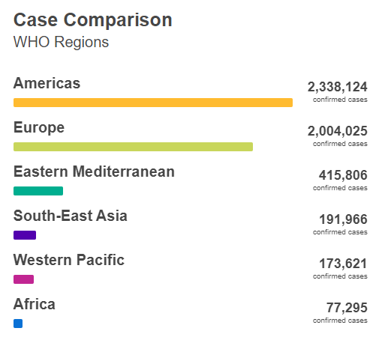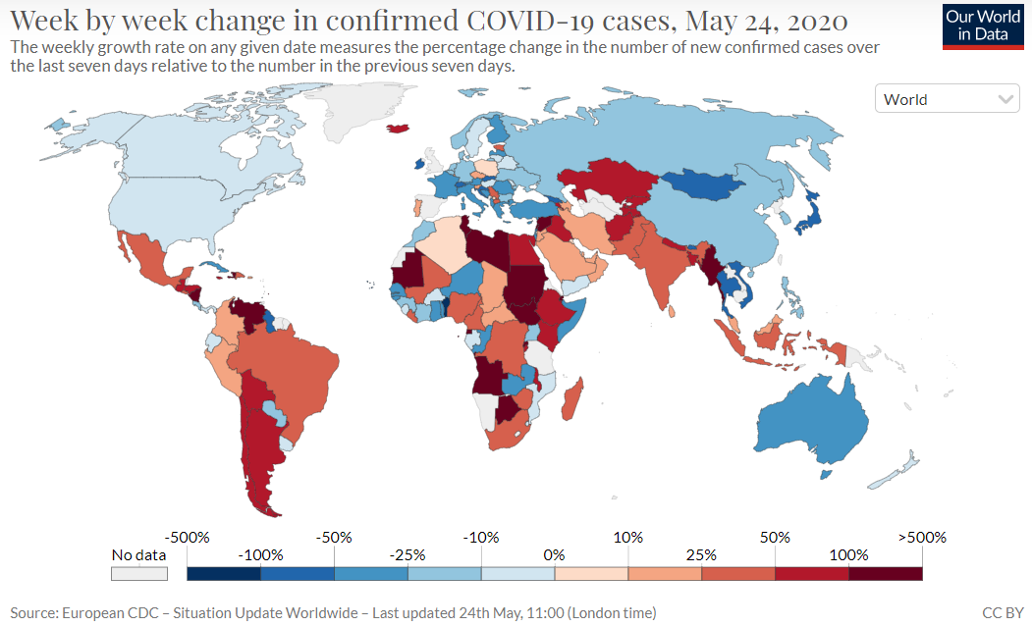

News/ Political Context
- Daily confirmed deaths increasing most rapidly in Nicaragua, Djibouti, Yemen, Guinea-Bissau, and Mauritania.
- Cases doubling rapidly in Nicaragua (2 days), Comoros (2 days), Mauritania (4 days), Haiti (7 days), South Sudan (7 days), Nepal (7 days).
- Worry about potential second wave in China as restrictions ease and case numbers rise again
- Japan has agreed to contribute to over 2.7 million USD to 9 countries in Americas to improve PH information, surveillance and control measures
- 73rd World Health Assembly opened with a focus on COVID-19 and adopted a draft resolution for COVID-19
- Johns Hopkins Released large Contact Tracing Course on Coursera last week to train US contact trainers and open to general public
- Russia’s low death rate for COVID-19 raising concern that deaths are listed under a different cause given that all-cause mortality in Moscow rose in April by 1855 compared to the same time period last year. High number of healthcare workers also being reported unofficially.
- New Case reporting card developed for suspected cases of multisystem inflammatory syndrome (MIS) in children and adolescents (WHO). Preliminary case definition can be found in the link.
  - Notably the condition has been reported less in Asian countries than in the Americas and Europe
- A $10 million contribution from the WHO Solidarity Response Fund will support UNHCR’s work on needs risk communication and community engagement around hygiene practices; provision of hygiene and medical supplies and the establishment of isolation units in countries such as Jordan, Kenya, Lebanon, South Sudan and Uganda. The funds will also support global preparedness activities.
- More than a third of infections in Afghanistan have been among doctors and other healthcare workers
- England and Wales see 20,000 excess deaths in care homes
- Some countries reporting challenges in enforcing social distancing measures during the Eid-al Fitr holiday. Important to watch in the next 2 weeks for increasing cases pockets in locations where large gatherings took place over the holiday.

Recent Research/ Evidence
- Globally males and patients in the 60+ age group represent higher proportions of cases requiring ICU admission
- Halving time remains around twice as long as the doubling time in countries who have already experienced the peak
- Risk factors for SARS-CoV-2 are associated with socioeconomic barriers including deprivation, as well as population density, ethnicity and chronic kidney disease
- Additional evidence emerging to support previous studies showing severe Kawasaki-like disease, including another Lancet article last week on reports of a higher incidence of the syndrome at the Italian epicenter of SARS-CoV-2 epidemic in an observational study.
- Recent small study of two breast-feeding mothers and infants found one of two COVID-19 positive women detected SARS-CoV-2 RNA in breast milk for 4 consecutive days and mild symptoms in the infant (who tested positive), but still limited evidence on whether infection occurred through breastmilk or other transmission modes. Current protocol is to encourage COVID-19 mothers to breastfeed, but more research is needed to better understand risk factors and transmission routes during breastfeeding. This could have major implications for global feeding practices and nutrition in neonates globally.
- Circumstantial evidence of the impact of vitamin D deficiencies and COVID-19 poorer outcomes – likely lined both to increased immune and decreased inflammatory response to viruses. Additional research ongoing into nutrition and COVID-19 outcomes.
- Call for physicians, doctors and medical organizations not to overlook known and proven supportive-care treatment for COVID-19 treatment as research is ongoing for vaccine candidates and novel treatments.
- Recent double-blind randomized study showed Remdesivir was superior to placebo in shortening the time to recovery in adults hospitalized with Covid-19 and evidence of lower respiratory tract infection.
- IHME estimates that globally 2.02 billion people lack access to handwashing with available soap and water, with more than 50% of this population in sub-Saharan Africa and Oceana having access to handwashing in 2019, showing a major need to 1. Increase access to handwashing in these countries, and 2. Develop alternative strategies for combating the spread of COVID-19 in these countries in the meantime.
- Increasing evidence that the use of cloth masks are effective in reducing the contamination of air and surfaces in public places.

Clinical Trails
- A multinational registry analysis of the use of hydroxychloroquine of chloroquine with or without a macrolide for treatment in 671 hospitals in 6 countries found that both hydroxychloroquine and chloroquine (with or without macrolide) were associated with increased mortality in the hospital after accounting for confounding variables. Mortality in control group (9.3%), hydroxychloroquine (18%), hydroxychloroquine with a macrolide (23.8%), chloroquine (16.4%), chloroquine with a macrolide (22.2%).

Modeling
- ICL modeling of the COVID-19 epidemic in the US estimates that the epidemic is not experienced evenly throughout the US with an overall 4.1% of the population having been infected to date (and in locations hardest hit less than 25% of the population has been infected – including New York with an estimated 16.6% have been infected). As of May 17th, a strong association is found between the initial reproductive number and population density and date of when 10 cumulative deaths occurred.
  - If relationship between mobility and mortality remains constant, mortality is expected to double over the next 2 months as social restrictions become more relaxed.
  - Weekly mortality trends suggest the highest R_{t} are found in Afghanistan (2.72), Chile (2.67), Bulgaria (1.77%), Kuwait (1.74%), and Bangladesh (1.65%).
- Recent modeling from ICL shows that probability of death from COVID-19 increases with poverty, with access to healthcare being the most significant driver followed by access to water and sanitation. Risk factors affiliated with disadvantaged groups compounded risk of death in the model, with the poorest quintile 32% increase in probability of death compared to the wealthiest quintile (4.5% increase).
- Using the lives saved tool (LiST) to estimate excess maternal and child deaths during COVID-19 across 118 countries, researchers from Johns Hopkins found running several scenarios that it is possible to see an excess of 9.8-44.7% children under 5 deaths each month, and 3-38.6% excess maternal deaths per month. Increased wasting prevalence alone was estimated to account for 18-23% of additional child deaths

Humanitarian Impacts
- IDMC produced an interactive map and portal examining the overlap of coronavirus risk (from INFORM index) and new displacements. High attention should be paid to locations such as Afghanistan, DRC, South Sudan, Somalia, Yemen, and smaller island countries such as Vanuatu and Fiji.
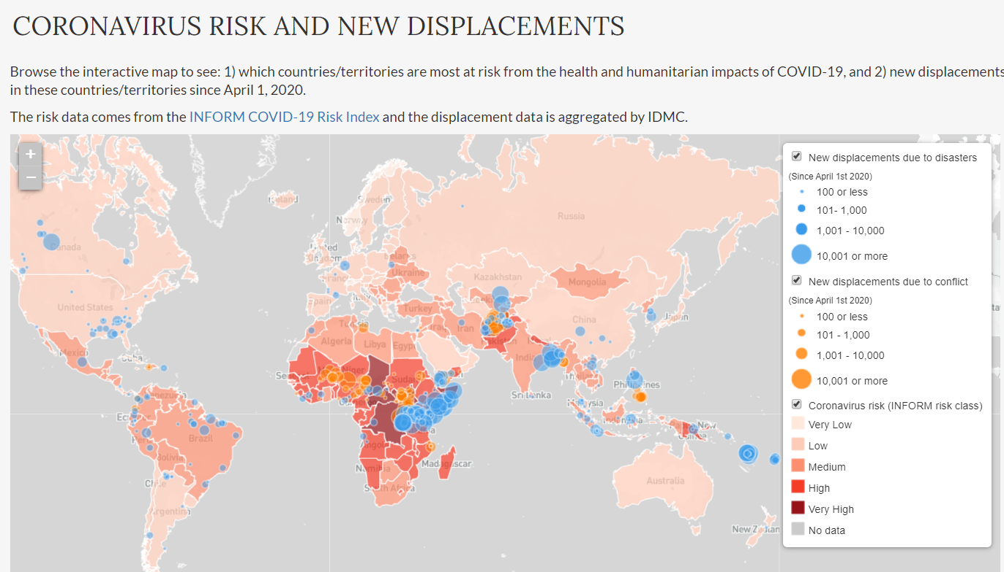
- Parallel disasters raising concerns for COVID-19 including recent flooding and worries over cholera in Somalia
- Increased risk of food insecurity in Sub Saharan Africa in COVID-19 pandemic
- Major concerns over the refugees in Cox’s Bazar – Bangladesh currently quarantined 28 Rohingya refugees on a nearby island known to be vulnerable to cyclones and flooding due to fear they had been infected
- Development of a humanitarian platform for COVID-19 by Johns Hopkins, LSHTM & Geneva Center for Education and Research in Humanitarian Action – designed for collecting evidence and lessons learned from actors on the ground.
- High daily case increases of COVID-19 in Bangladesh, with reports of significant drops in care-seeking behavior
- Shielding approach for urban settings in LIC and LMIC developed through LSHTM and available here. Includes criteria such as age, NCDs, HIV/ AIDS, TB, Measles, Pregnancy, other immune-deficiencies, and other chronic infections as recommended for shielding.
- Mapping of COVID in Humanitarian settings available here

Guidance Launched or Highlighted This week
- WHO updated surveillance strategies for human infection
- WHO Guidance on Contact Tracing for COVID-19
- UNICEF Framework for re-opening schools
- UNICEF and WHO guidance on immunization in the context of COVID-19
- Overview of social and public health measures globally
- IPC Research protocol – perceptions of healthcare workers
- Guidance on the transport and repatriation of human remains by air (WHO, CDC, IATA, ICAO)
- Monitoring and Evaluation Framework developed for preparedness and response to COVID-19 (WHO)
- Updates to Operational planning guidance to support country preparedness and response
- Interim guidance on Framework for decision-making: implementation of mass vaccination campaigns in the context of COVID-19
- WHO published interim guidance on Controlling the spread of COVID-19 at ground crossings

Weekly update (official) based on locations with highest case increases – last updated: WHO SitRep #124

Americas Region  Country | Daily change in new reported cases (decreasing shown in blue, increasing in red)
 | Sunday  17-May | Monday  18-May | Tuesday  19-May | Wednesday  20-May | Thursday  21-May | Friday  22-May | Saturday  23-May
United States | 27 090 | 22 813 | 45 251 | 13 227 | 24 417 | 23 310 | 22 787
Brazil | 15 305 | 14 919 | 7 938 | 13 140 | 17 408 | 19 951 | 18 508
Peru | 3 891 | 4 046 | 3 732 | 2 660 | 4 550 | 4 537 | 4 749
Canada | 1 164 | 1 211 | 1 102 | 1 193 | 1 003 | 1 053 | 1 210
Mexico | 2 437 | 2 112 | 2 075 | 2 414 | 2 713 | 2 248 | 2 973
Chile | 4 388 | 2 353 | 2 278 | 0 | 7 558 | 0 | 8 240
Still seeing major increases in Dominican Republic and Haiti
European Region  Country | Daily change in new reported cases (decreasing shown in blue, increasing in red)
 | Sunday  17-May | Monday  18-May | Tuesday  19-May | Wednesday  20-May | Thursday  21-May | Friday  22-May | Saturday  23-May
Russia | 9 709 | 8 926 | 9 263 | 8 764 | 8 849 | 8 894 | 9 434
UK | 3 450 | 3 534 | 2 711 | 2 412 | -525 | 2 615 | 3 287
Spain | 515 | 652 | 256 | 431 | 518 | 482 | 1 787
Italy | 875 | 675 | 451 | 813 | 665 | 642 | 652
Germany | 583 | 342 | 513 | 797 | 745 | 460 | 638
Turkey | 1 610 | 1 368 | 1 158 | 1 022 | 972 | 961 | 952

MENA Region  Country | Daily change in new reported cases (decreasing shown in blue, increasing in red)
 | Sunday  17-May | Monday  18-May | Tuesday  19-May | Wednesday  20-May | Thursday  21-May | Friday  22-May | Saturday  23-May
Iran | 1 757 | 1 806 | 2 294 | 2 111 | 2 346 | 2 392 | 2 311
Saudi Arabia | 2 840 | 2 736 | 5 102 | 2 509 | 2 691 | 2 532 | 2 642
Qatar | 1 547 | 1 632 | 3 002 | 1 637 | 1 491 | 1 554 | 1 830
UAE | 796 | 731 | 1 705 | 892 | 941 | 894 | 994
Kuwait | 942 | 1 048 | 1 914 | 1 073 | 804 | 1 041 | 955
Egypt | 491 | 510 | 535 | 720 | 745 | 774 | 783
Once again seeing increasing trends in the region, and in particular Iran
Asia Pacific Region Country | Daily change in new reported cases (decreasing shown in blue, increasing in red)
 | Sunday  17-May | Monday  18-May | Tuesday  19-May | Wednesday  20-May | Thursday  21-May | Friday  22-May | Saturday  23-May
India | 4 987 | 5 242 | 4 970 | 5 611 | 5 609 | 6 088 | 6 654
Bangladesh | 930 | 1 273 | 1 602 | 1 251 | 1 617 | 1 773 | 1 694
Pakistan | 1 352 | 1 974 | 1 841 | 1 218 | 2 907 | 2 603 | 1 743
Indonesia | 529 | 489 | 496 | 486 | 693 | 973 | 634
Singapore | 465 | 682 | 305 | 451 | 570 | 448 | 614
Philippines | 214 | 208 | 205 | 224 | 279 | 213 | 163
Afghanistan | 233 | 437 | 583 | 490 | 531 | 540 | 650
Timeline for Western Pacific available here. China NOT reporting on asymptomatic positive cases
Africa Region  Country | Daily change in new reported cases (decreasing shown in blue, increasing in red)
 | Sunday  17-May | Monday  18-May | Tuesday  19-May | Wednesday  20-May | Thursday  21-May | Friday  22-May | Saturday  23-May
South Africa | 831 | 1 160 | 918 | 767 | 803 | 1 134 | 988
Ghana | 97 | 0 | 0 | 361 | 0 | 173 | 217
Nigeria | 171 | 338 | 216 | 226 | 276 | 339 | 245
Cameroon | 0 | 0 | 482 | 0 | 204 | 555 | 112
Guinea | 127 | 69 | 69 | 67 | 64 | 140 | 47
Senegal | 119 | 51 | 64 | 73 | 97 | 101 | 94
Côte d’Ivoire | 44 | 48 | 10 | 34 | 78 | 70 | 40

Useful Sources
Some additional sources – such as specific journal articles are shared as a foot note and saved to the “Evidence” folder in Teams.
ALNAP launched COVID-19 response portal
BMJ COVID-19 resources
European Centre for Disease Prevention and Control
Health Map
Imperial College of London
ISARIC COVID-19 resources
Johns Hopkins Center for Health Security and CSSE
The Lancet
LSHTM COVID-19 mapping tool
New England Journal of Medicine
Next Strain (Phylogeny of SARS-CoV-2)
Our world in Data
ProMed
WHO
MobLabs
MobLabs Domestic and international risk of importing a case
World Meters

Official numbers and WHO visualizations available here , WHO Europe Epi Week of May 4th-10th (WHO Weekly Epi Report)
https://ourworldindata.org/coronavirus
Reference to ECDC data using https://ourworldindata.org/coronavirus
BMJ news 14 May 2020
WHO SitRep #123
Lancet 23 May 2020
Lancet 15 May 2020
Lancet 13 May 2020. An outbreak of severe Kawasaki-like disease at the Italian epicentre of the SARS-CoV-2 epidemic: an observational cohort study
Lancet 21 May 2020. Detection of SARS-CoV-2 in human breastmilk
Lancet 20 May 2020. Vit D and COVID-19
Lancet 21 May 2020
NEJM 22 May 2020. Remdesivir for the treatment of COVID-19 – preliminary report
IHME 15 May 2020. Global Access to Handwashing: Implications for COVID-19 Control in Low-Income Countries
Annals of Internal Medicine 22 May 2020
The Lancet 22 May 2020. Hydroxychloroquine or chloroquine with or without a macrolide for treatment of COVID-19: a multinational registry analysis
Atlantic 20 May 2020: America’s Patchwork Pandemic Is Fraying Even Further
ICL Report # 23
ICL Weekly short-term forecast of COVID-19 deaths
ICL Report #22
Avoiding indirect effects of COVID-19 on maternal and child health. Lancet 12 May 2020.
Early estimates of the indirect effects of the COVID-19. Lancet 12 May 2020
IDMC COVID-19 risk and new displacements
Chatham House webinar
Johns Hopkins Center for Health Security, NPR report

