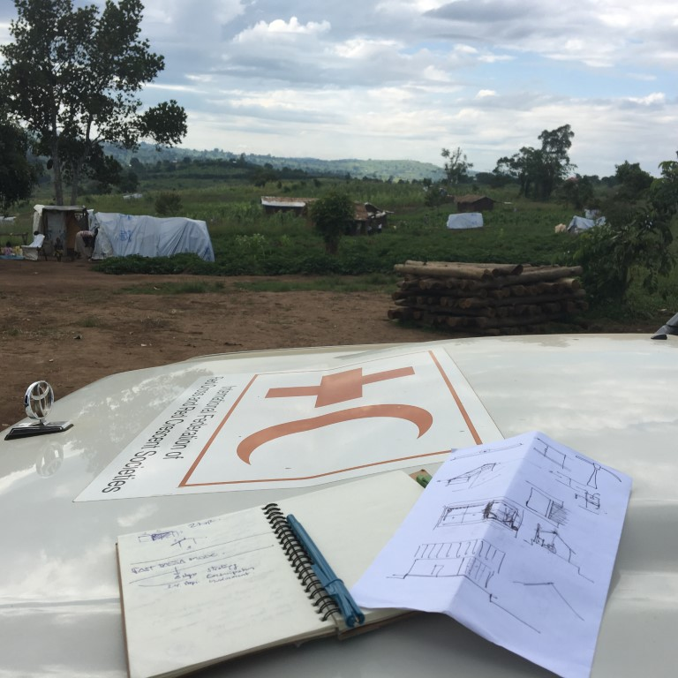

© V.Virgo, Kyaka II Congolese refugee camp, June 03rd 2018

Mission Report

UGANDA Shelter Field Assessment

DRC population movement

June 20th, 2018

Table of Contents

**1. General Information** 3

**1.1 Project/mission title:** 3

**1.2 Country:** 3

**1.3 Report date:** 3

**1.4 Type of operation:** 3

**1.5 Requesting Organization:** 3

**1.5 Editor:** 3

**2. Context** 4

**2.1 Environment context** 6

**2.2 North-Kivu and Ituri populations movement** 6

**2.3 Local housing typologies** 7

**3. Outcomes** 9

**4. Outputs** 10

**5. Activities** 11

**5.2.1 a** Shelter issues for PSN - Update of the PSN situation with faithful data through actors 11

**5.2.1 b** Shelter issues for PSN - To evaluate receptions centers / installation kit / market availabilities 12

**5.2.1 c** Shelter issues for PSN - To assess URCS shelter needs in both camps 17

**5.2.2 a** Transitional solution for PSN – To analyze and find shelter alternatives 18

**5.2.2 b** Transitional solution for PSN – To create an additional kit dedicated to transitional shelter option 19

**5.2.2 c** Transitional solution for PSN – To propose an new house model 21

**5.2.3 a** To assess URCS on shelter response capacity providing guidance 31

**6. Conclusions** 33

**7. Operational challenges** 35

**8. Recommendations** 36

**9. Annexed documents** 38

**9.1 Service agreement:** 38

**9.2 Terms of reference:** 43

**9.3 List of contacted people:** 45

**9.4 Mission itinerary:** 46

**9.5 Perez’s House** 47

**9.6 UNHCR concept with adobe blocks** 50

**9.7 Market assessment and suppliers list** 52

**9.8 Trees and types of uses table / what can be done with what?** 54

# **1. General Information**

## **1.1 Project/mission title:**

Shelter Field Assessment / DRC population movement

## **1.2 Country:**

Uganda

## **1.3 Report date:**

Mission duration: from May 29th until June 7th 2018

Reporting date: June 20th, 2018

## **1.4 Type of operation:**

Refugee camps shelter assessment for Congolese refugees’ influx / Kyangwali & Kyaka area (Albert Lake region)

## **1.5 Requesting Organization:**

Mission requested by: Luxemburg Red Cross / International Aids department

Mission facilitated by: Uganda Red Cross

International Federation of Red Cross and Red Crescent Societies

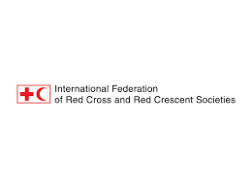

## **1.5 Editor:**

Vincent Virgo, IFRC-SRU

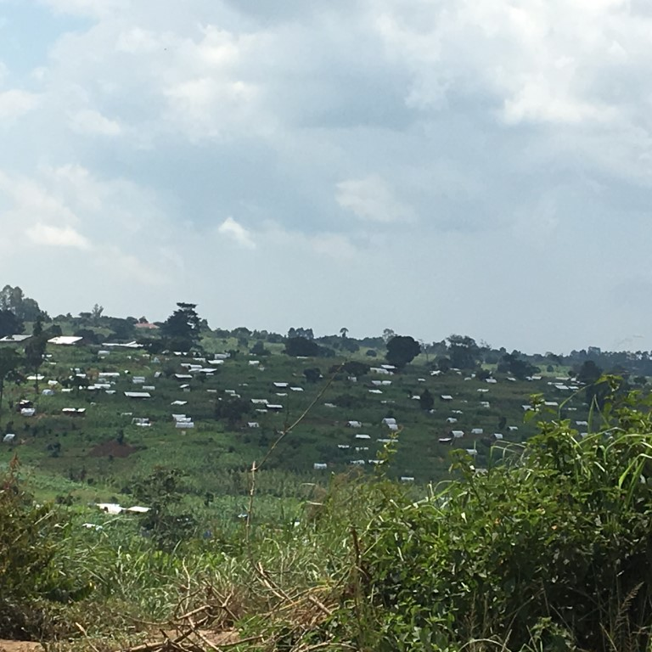 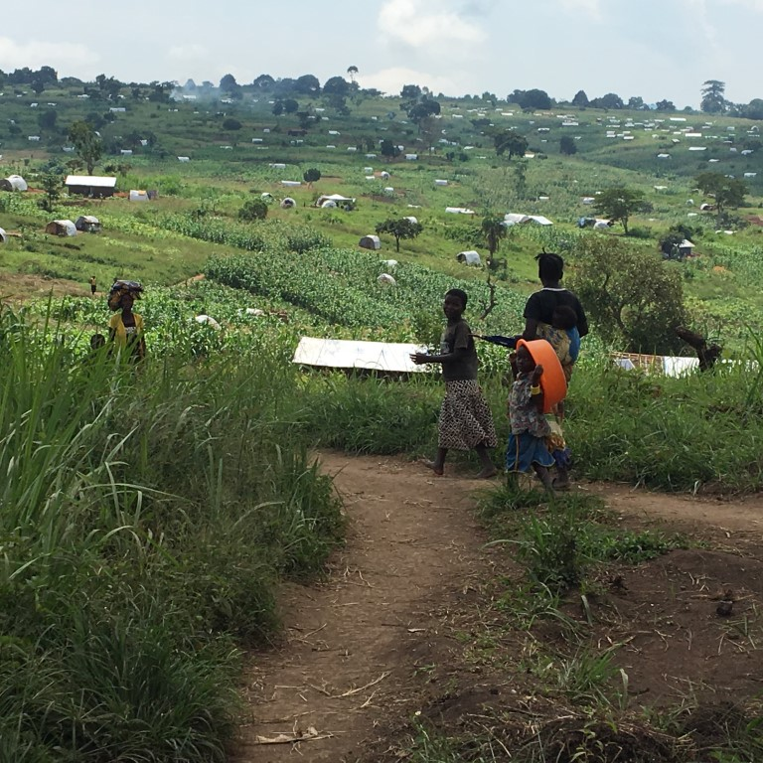

Kyangwali

Kyaka II

Kyangwali and Kyaka II are concerned by the same problematic and context. The main operational difference between the 2 sites is the funding mechanisms and support that they receive with:

* Kyangwali camp is part of the IFRC appeal

The URCS (RC implementer) is involved in almost every segment of the camp

* Kyaka II camp is supported by bilateral Red Cross agreements (and mostly by Ndl. RC).

The URCS (RC implementer) is implicated in “only” 2 neighborhoods of the camp.

# **2. Context**

The URCS[1] (with IFRC[2] assistance) needs support to help thousands of vulnerable refugees who have fled violence in DRC[3] and are now living in camps located South East Albert Lake. Ethnic violence’s have forced thousands of people to seek safety in neighboring Uganda since December 2017. The challenges are diverse and multi-sectorial, the URCS and IFRC must ensure that the new arrivals receive health services alongside water, sanitation and hygiene promotion, and that the most vulnerable people are provided for through gender, protection and inclusion activities. Definitively the shelter component has to be part of this intervention providing not only protection from the elements; but also giving sense to find back a closed and private covered space where people can feel safe again with their few belongings taken away in the hurry.

A particular attention has to be dedicated to the people with special needs (PSN) whom are part of mainly recomposed families with numerous numbers and by consequence become even more vulnerable by this situation. An assessment establishing a better understanding is ongoing for the time being and the Authorities guide this evaluation. Unfortunately, it has been impossible to obtain any trends or figures neither the criteria list on which the study is based.

The situation until early March has been extremely complex with a daily entry rate of thousands of people when at the same time the reception centers and the camps were facing a cholera outbreak.

The previsions regarding the situation don’t predict stability and are even foreseeing new troubles with new arrivals which will drastically increase the needs requiring additional resources.

In parallel, shelter in general is becoming a fundamental issue with poor living and working conditions for first the refugees themselves and second for the Red-Cross infrastructures with its volunteers.

In parallel, the report is organized by thematic to allow an easy reading offering the possibility of picking up elements or parts to be able to develop separate activities keeping a general coherence within the intervention.

Special attention has to be given to the hosting communities settled around the camps who is sharing their lands and resources when often (almost representing 70% of the population) the daily incomes is less than 1 USD to support a whole family[4].

The same philosophy and approach involving the local knowledge and skills must be applied with regard to the habits and uses to guarantee a full success of the intervention.

The underlying idea is to further strengthen community relations.

During last February, UNHCR Program Support and Management Division (Andrew Harper) reports a clear **shelter need** saying that the situation is quite dire with a lack of water, food, medical equipment and shelter. UNHCR’s main objectives are to register arrivals, relocate them to areas allocated by the Ugandan government and to build infrastructure such as shelters.

Source: <http://www.unhcr.org/afr/news/stories/2018/2/5a81779e4/refugees-flee-fresh-fighting-congo-uganda.html>

Kyangwali situation

Sebagoro

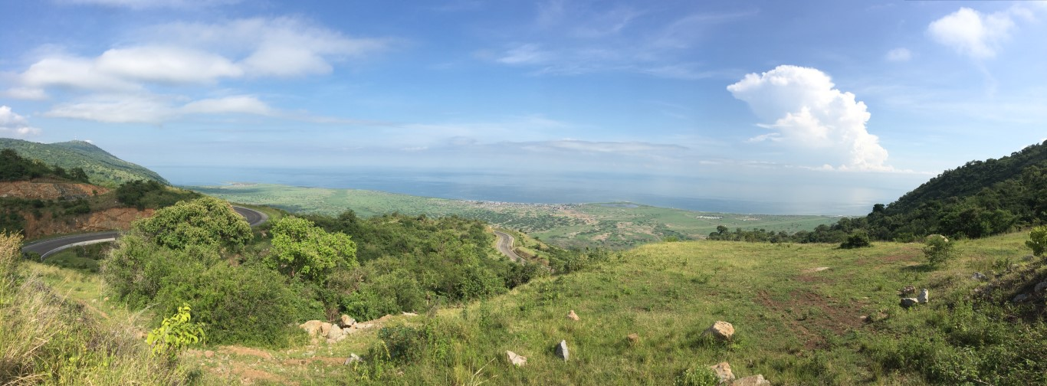

Kyangwali landing sites and arrivals proportion

**70%**

**30%**

Nsonga

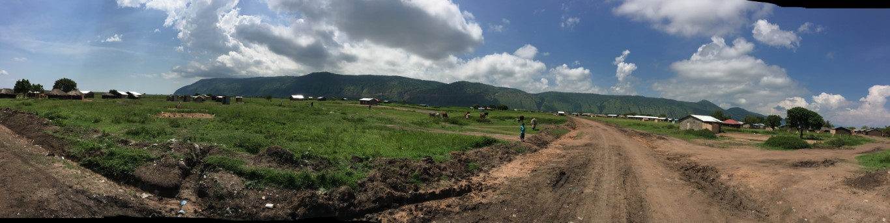

Kyangwali camp located at about 10 km

**86.000 pers.**

**Kyangwali**

Kyaka situation

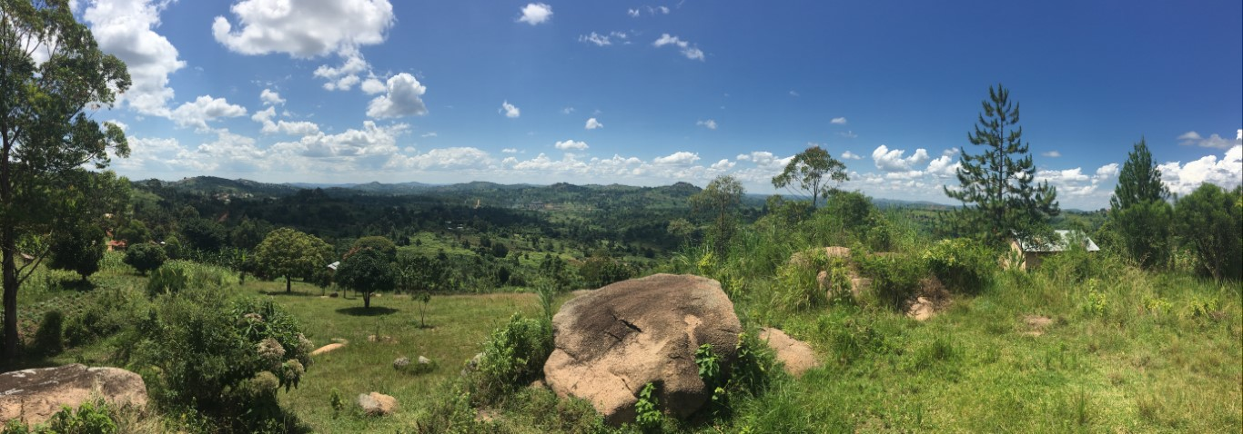

Kyaka landing sites & camp with arrivals proportion

**25%**

**75%**

**60.000 pers.**

Ntoroko

**Kyaka II**

Nyakabande

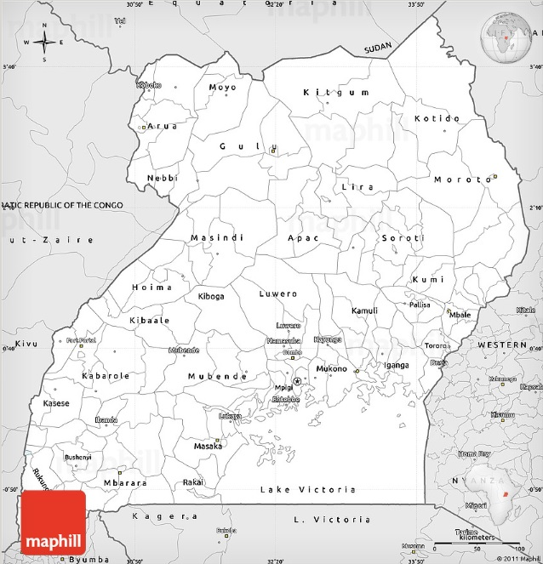

**Kampala**

**🟆**

**Kyaka**

**Kyangwali**

**🞲**

**🞲**

Source :

<http://www.maphill.com/uganda/simple-maps/silver-style-map/>

## **2.1 Environment context**

And in more particular between the Fort Portal[5] and Hoima cities where there are weather stations providing accurate measures[6].

These cities located in the highlands have a tropical wet climate with a significant rainfall in most months of the year even if there is a really short dry season with a really small effect on the overall climate. The rains can be short and intense or long and sustained. The abundant vegetation and the diversity of its species testify to this wet suitable situation where a particular wildlife has also found refuge.

The temperature here averages around 19-20 °C and the rains are providing about 1410 mm of precipitation falls annually.

The Koppen Climate Classification subtypes for these 2 cities indicate an "Aw" (Tropical Savanna Climate) and an "Am" (Tropical Monsoon Climate). The camps are located in between with intense rains and correspond therefore to a more humid reality.

It is important to point out that there is a big difference in altitude between the lake banks and the highest regions with an altitude drop of more than 600m.

This aspect affects the temperatures most particularly at the night time on the highlands where are established the camps…

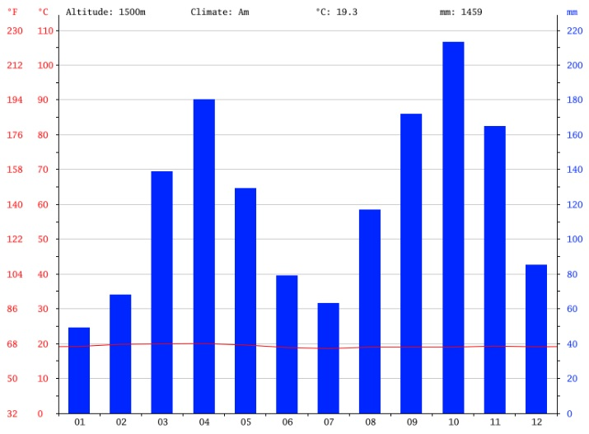 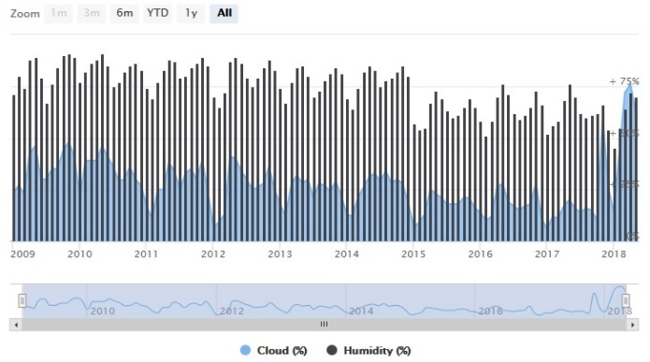

Climograph of Fort Portal Cloud and humidity of Fort Portal

Rainy all the year and constant temperature of 20°C Very overcast sky + relative humidity over 70%

(Jan. and Feb. around 35mm + rest of the year > 80mm)

## **2.2 North-Kivu and Ituri populations movement**

The Ituri province is mainly composed by a non-homogeneous population coming from different ethnic groups with for the main tribes: Alur, Hema, Lendu, Ngiti, Bira, Ndo-Okebo and the Mbuti. These groups are organized in village forms. These ones are not only localized in RDC as their territories are also part of the Uganda neighbor country[7].

The population activities are intimately linked to this extended territory in terms of varieties and by consequence to what can it be drawn from it, such as pastoral farming (cattle and agriculture) or/and also hunter-gatherers activities.

They are strong similitudes to what is ongoing in the North Kivu province with troubles since more than 20 years; where everything is controlled by the rules of the weapons with constant fights for power on lands , mines; where the population is terrorized and can only flee massively towards North or East …

One of the many well-known local armed groups, the Mai-Mai Kifuafui, is often showing off its strength[8]

## **2.3 Local housing typologies**

Discussions of architecture in this region focus chiefly on simple and poor rural dwellings and reflect the deep interaction of environmental factors such as natural resources, climate, and vegetation.

By consequence, the constructive technique uses the onsite resources next by the chosen implantation site. The favorite materials are earth (clay), wood and tree leaves.

In the less-forested areas, grasses are used as building material as well, being employed widely for thatch for roof coverings. When hardwoods in forest regions are used for building. Earth and clay are also major building resources.

In general, the house presents a rectangular blueprint of around 6x3 m; often, the walls height can be at shoulder height and be the results of closely woven frames formed from vertical poles and horizontal bracings made from stems of young bamboo plants. These wooden boxes drawn a frame of about 40x20cm and receive after a coating of earth filler (kind of basket weave packed and plastered with mud). The thickness of this walling system is about 10cm and corresponds to the irregularity of the poles or timber posts dimensions. The technic is called wattle and daub[9] and is very useful when the earth is very hard to implement because the atmosphere is really humid and the walls need additional structures.

In most of the case, 2 slopes in the length of the shelter compose the roof. The roof is commonly used as a granary or as a storage place.

It is important to report that closer we are getting close to the camps, the constructive mode evolves and changes to what has been presented here above (from 30 km around). It starts from far with on-site burnt (or cooked) bricks of 8x3x2 inches or 20x8x6 cm, after we observed some small constructions or annexes (like henhouse) with adobe blocks with a shape of around 6x12x4 inches or 15x30x10 cm to finally reached the area with almost all of the construction build with the described technique.

*Proportionally it represents in the intervention area (survey on 100 houses):

|  |  |  |  |  |  |  |  |
| --- | --- | --- | --- | --- | --- | --- | --- |
| Walls construction technic | | | Roof material used | | | Roof slope | |
|  | | |  | | |  | |
| burnt bricks | adobe blocks | wattle and daub | tarps | grasses & thatch | iron sheet | Single slope | Double slope |
| **6 %** | **2 %** | **92 %** | **10 %** | **2 %** | **88 %** | **15 %** | **85 %** |

The units are traditionally single-cell, undivided, and illuminated only from the doorway. Additional living space may be claimed from the exterior, with a semipublic space in the front and a private space, with hard-packed earthen floor, at the rear of the dwelling being used for food preparation, cooking, and other domestic occupations. Even if often the compound is surrounded by a clear delimitation or a fence, here we didn’t notice propriety limits.

# **3. Outcomes**

The aim of this shelter assessment is to support the National Society in reviewing and amending accordingly the ongoing appeal integrating this aspect.

The overall objective of this intervention would be to provide lifesaving emergency services to the most vulnerable under different operations. It would make more efficient the response in terms of quality and visibility for first beneficiaries and second for the Red Cross actors.

The main elements are:

* The People with Special Needs (PSN)
* The Protection, Gender and Inclusion (PGI) needs
* The Red Cross base camp
* The Red Cross office and storage capacity

The results that will be achieved by this assessment correspond in improving 2 main shelter situations; each of them having a direct specific need to support these activities.

These schemes can be presented as follow, with:

* People requiring specific assistance (PSN) that need an improvement of their living conditions through in particular adapted shelter solutions (including all commodities).

+ And in parallel, providing additional covered space at community level for PGI’s activities

* Improving the Red Cross base camp with better structures

+ And in addition, by improving its storage capacity allowing to plan long term activities and not work under tight flow anymore.

To cope this context, the goal is to propose tailored suitable shelter solutions corresponding to the field realities taking into account the local constraints as climatic, material resources, economical, abilities, timeframe, practices, etc.

In filigree, the ultimate goals aim to strengthen the Uganda Red Cross capacity and visibility through shelter interventions.

# **4. Outputs**

As outputs, it will be understood the questions formulated in the terms of reference describing the mission goals.

|  |  |
| --- | --- |
| 1. Identification of shelter needs for PSN[10] in Kyangwali and Kyaka II | 1. To provide an update the PSN situation with faithful data through actors 2. To proceed an assessment of   - Reception center + Refugees settlements  - Exit to the host villages: installation kit (items and quality)  - Market assessments   1. To verify shelter needs of URCS base camps in both location |
| 1. Find a semi-permanent solution including all services for 3000 people (=PSN) | 1. To analyze and to find adaptations in relation to environmental concerns (deforestation) and specific needs linked to their vulnerability and implementation capacities in relation with the provided installation kit. 2. To create an additional complementary kit to adapt it to a semi-permanent solution (including the structural needs) 3. Then generate a house model and an additional kit to go from transitional to semi-permanent housing solution (adobe and corrugated sheet) |
| 1. To assess URCS on shelter response capacity and provide guidance on possibility of strengthening. | 1. To support URCS capacity in terms of shelter programming and recommendations |

# **5. Activities**

The activities described in this section will follow the same order section 4. Outputs.

### **5.2.1 a** Shelter issues for PSN - Update of the PSN situation with faithful data through actors

**Numbers:**

* Obtain clear figures regarding the PSN situation in both camps has been impossible because the registration was still ongoing with authority agents (OPM) which were 3 in Kyangwali for a camp counting 87.000 people and quite expanded.
* The main problem is to have a clear picture on which criteria are applied to determine this particular population

+ According to the cursor position, the situation will be single to double and by consequence correspond to more or less budget. (Which is probably the main constraint)

* The situation in both camps:

*looks a bit easier in Kyaka because the RC is involved in 2 blocks and will take care of 500 PSN

*looks more difficult to foreseen for Kyangwali with a number starting from 300 going up to 1800 units depending to who is speaking to report the numbers….)

In reality it is probably closer to 2000 …

* The family situation often corresponds to an:

Unaccompanied mother with children of all ages often having fled with elderlies and/or with disabled people not necessary coming from the same families or even core. The husband stayed behind at home to take care of the few belongings or the cattle braving certainly incredible security conditions or worst has been killed or enrolled by the rebels …

The family new composition - situation often can go up to 7,8,9 pers. with small children under 5 years old.

Regarding both camps:

* For Kyaka II camp, there are more than 500 PSN households for only 2 sections of the whole camp (counting probably more than 8 entities)
* Kyangwali – probably between 1800 and 2000 households for the total camp.

*It has been impossible to obtain any confirmation.

*an assessment is ongoing and will be available soon (question of days according to UNHCR and OPM)

*the main concern is the indicator list defining the PSN situation (impossible to obtain the criteria list)

*if only 2 sectors of Kyaka camp correspond to 500 PSN households for a whole camp of 60.000 people, it is very likely that the final number of requirements for Kyangwali is even greater without being able to report any number (again depending on indicators)

→ Contact with North Kivu Red Cross Branch – Joseph Kosongo:

* The situation will not evolve to something better in the forthcoming months, probably even worst with coming elections
* This factual situation remains unpredictable at all times
* The readings are really difficult to obtain because no contact or lake of communication or no focal point
* Huge needs regarding Sanitation concerns with still Cholera
* insecurity situation with rebels and highwaymen (road cutters)
* If new displacements better to predict more PSN because young men and husbands remain behind trying to save the family goods … It means that more single weak women with children and elderlies will reach the camps …
* is willing to keep contact with URCS to provide regular updates as accurate is possible …

**Actors list:** for Kyangwali camp

|  |  |  |  |  |  |  |  |  |  |  |  |  |  |  |  |  |  |
| --- | --- | --- | --- | --- | --- | --- | --- | --- | --- | --- | --- | --- | --- | --- | --- | --- | --- |
| agencies | UNHCR | WFP | AAH | AIRD | Sam  Purse | IOM | NRC | MSF | ICRC | Save  Childr | LWF | HIJRA | URCS | IAS | ACF | CIDI | Wind Trust |
| Shelter | 100 | / | / | / | / | / | 100 | / | / | / | 200 | 100 | 300 | / | / | / | / |

→ Balance: if the number of 1800 (PSN households) is confirmed = 1800 – 800 = **1000 = GAP**

|  |  |  |  |  |  |  |  |  |  |  |  |  |  |  |  |  |  |
| --- | --- | --- | --- | --- | --- | --- | --- | --- | --- | --- | --- | --- | --- | --- | --- | --- | --- |
| agencies | UNHCR | WFP | AAH | AIRD | Sam  Purse | IOM | NRC | MSF | ICRC | Save  Childr | LWF | HIJRA | URCS | IAS | ACF | CIDI | Wind Trust |
| Latrines | / | / | / | / | / | 350 | 100 | / | / | / | 200 | / | 180 | / | ? | ? | / |

→ Balance: communal latrines 2000 programmed = 2000 – 850 ≈ around **1000 = GAP**

Statement:

* Many agencies report or claim to intervene but at field level nothing happen ….
* Need of more WATHAB builders to improve the general living conditions

### **5.2.1 b** Shelter issues for PSN - To evaluate receptions centers / installation kit / market availabilities

**Reception Center:**

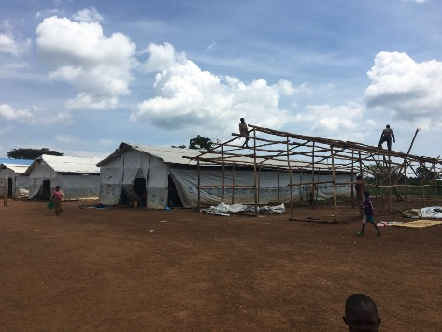 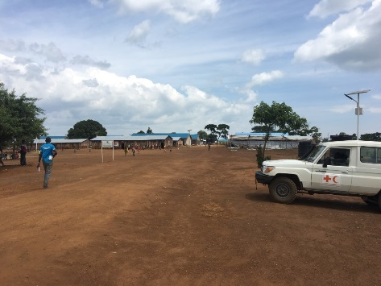 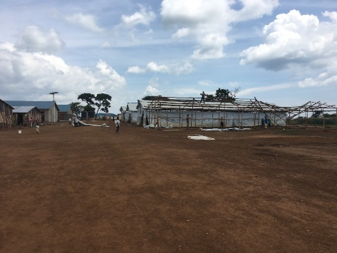

Pictures of Kyangwali context

* The collective centers in Kyangwali are managed by other organizations including IOM. People normally are supposed to spend no more than 24h but in reality can stay up to 3weeks.
* During the peak … a semi-permanent structure of around 7x25m or 175m2 (see pictures) was supposed to received 600 people when it went up to 18.000people

→ RATIO of 600/175= 3,43m2/pers. when it comes to 600/18000= 0,03m2/pers.

* Under dismantling because no need of new buildings as another NGO built new semi opened big halls just behind the 2 existing reception centers, this project includes latrines and showers and follows the watsan rules with correct number of latrines and showers
* By consequence no need to investigate this area.

*On top probably better to focus on where we can improve the ongoing RC actions / where there is not much actors

*also, RC was and will be more and more implicated in wash, watsan, hygiene promotion, PGI and now shelter …

Rem: we didn’t have time to visit the Kyaka II reception centers which are driven anyway by other agencies.

For the same reason, the same comment can be done for the Kyaka landing sites which are even further with more distance.

Additional need:

Following the PGI’s IFRC report and recommendations

* 2 multifunctional structures should be planned for Kyangwali and 1 for Kyaka

**PSN Households:** Exit to the host villages: installation kit (items and quality)

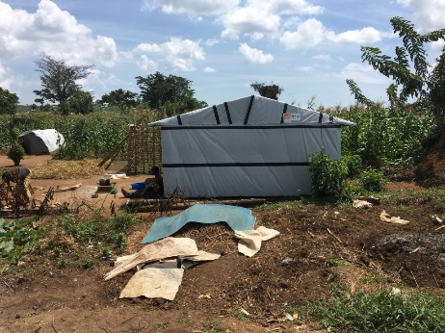 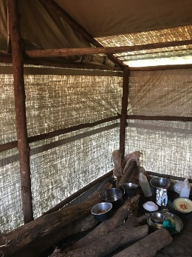 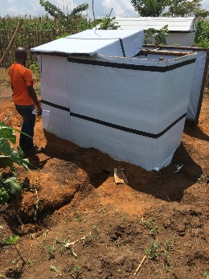 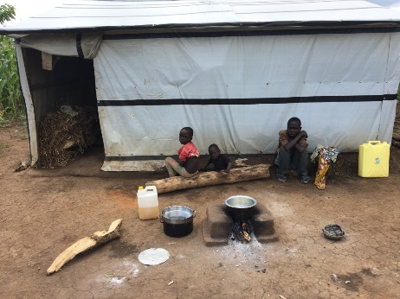

NRC proposal in Kyangwali

* Unfortunately it has been impossible to meet the organization to deepen the reasoning

What can be reported?

* Kyangwali: After registration the OPM is giving a plot of 30x50m – before it was (50x100)

Observation = densification

* PSN is not yet officially identified by consequence for the time being is under the agency responsibility whom apply his own criteria … here in this situation is a NRC transitional solution with eucalyptus poles and tarp.
* Size 4x6m with 2 rooms / 1 opening without door and no windows for ventilation
* Double structure for pit latrine and opened bath shelter dim 3x3m / open unprotected fireplace for cooking with 3 stones to hold the pan.
* Shelter inside temperature were hot during day time by greenhouse effect and cold at night time because of tarpaulin use.
* Double slope with small roof overflow / no trenches around for drainage and rainy water but buried wall material cladding
* Use of strict min wood structure

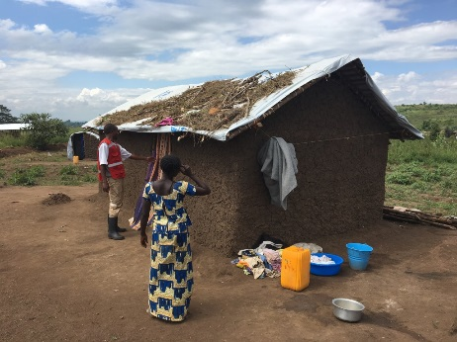 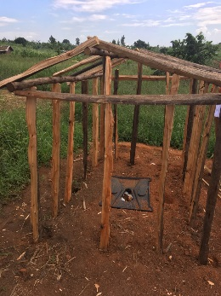 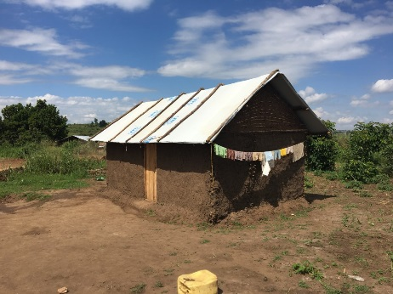 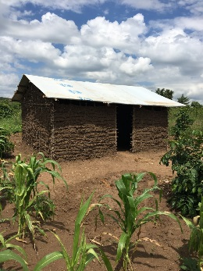

Refugee solution in Kyaka II

* Kyaka II: after registration the OPM is giving a plot of 30x30
* PSN is not yet officially registered but project ongoing for the most vulnerable with URCS support with material and shelter drawings
* Pit latrine of (150x300) wall height= 180cm and Pit of (1x2)x 2,4m / open shower with Tarp and poles
* Shelter = between transitional and semi-permanent with tarp roof and mud walls
* Shelter dimension: 3,5x6 for 9 pers. / in some cases we saw separations up to 4 tiny rooms …
* Sometimes grass on the roof to reduce sun effects during day time or/and used as attic to avoid rodents
* Wall Technic = wattle and daub / fast + easy + well known + durable + sustainable + easy repairs
* Rem: it was difficult to understand if the construction was made without windows for cold temperature at night time or for lack of budget or by cultural aspect?

**PSN Households strategy:** Exit to the host villages: installation kit (items and quality)

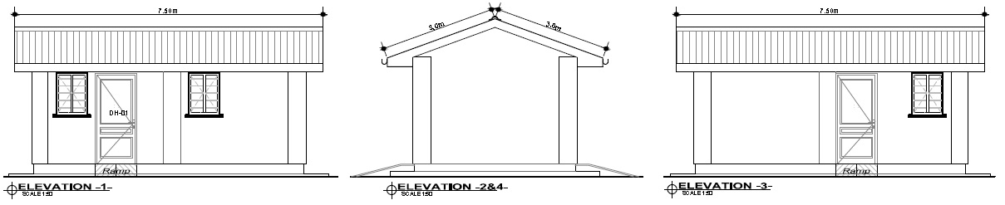Project still at drawing level even if a mock up is under construction

Quick analyze of the UNHCR concept.

*The following statements should be put in relation with Appendix 2 at the end of the report

A project using this building technic is under construction and UNHCR has bided it to another organization (unknown). It will be probably good to have a look to this prototype and observe with them their analyze or recommendations?

For the time being, only the following readings can be proposed as we couldn’t go to the worksite

*Regarding house:

* Gutters and vertical evacuation are not mentioned
* Tools are not included
* There is no concrete slab for the floor. The cement will be used only to constitute the wall basement depth of almost 80cm (see drawings)
* The cement bags weight 50kg each and the BoQ mentions 7 units … for a total of 350kg

Which corresponds to 1m3 as a foundation concrete need to be C350. In this situation, the total concrete represents 8,5m3 by deduction the mix will give a weak poor C40.

* There is no armatures in the strip ground beam.
* There is no membrane to avoid moisture rise.

*Regarding latrine:

* No armatures for the concrete slab?
* Concrete quantity see house remark as same comments
* If the idea is to dislodge the latrine there is no manhole for access / also a general survey should be conducted in the camp to consider its potentiality because high probability of misunderstandings

UNHCR quick proposal analyze:

* Apparently, this solution will be imposed to all UNHCR implementing partners or phrased with other words to whom want to work/receive support with/of UNHCR … In this situation, the BoQ is coming from AIRD
* House too small regarding family composition … it is only 20,65 m2 with inside dim of 5,9x3,5, we saw during the assessment big family with 9people / here is proposed only 1 bedroom with only 1 single bed in the layout / bedroom dimensions are 2,75x3,5 = 9,6m2 …
* Minimum surface during emergency phase should be 3,5m2 and here we are in a semi-permanent shelter solution phase … it means that the dimensions should be more comfortable or generous offering more room for the inhabitants
* We saw through the climate summary that the rains are regular (almost daily) and can be abundant offering a tiny window for building mainly with adobe bricks that need also 3 or 4 weeks of drying in normal atmosphere.

Here as a reminder, the atmosphere is almost saturated in relative humidity with more than 75%, something that will not help to dry the blocks … even if lying down with a tarp and covered over with another one it will just accelerate the condensation and accumulate even more humidity which will generate proliferation of fungi etc, …

* I guess it’s a matter of drawing but important to mention that there is no vertical water evacuation after the gutters and no drainage with a soakaway pit …
* The latrine plan is presenting a concrete slab with a dimension of 150x160 to allow a wheelchair to enter inside (+ grab bars and ramp) / pit dimension of (80x100) x370 which correspond to a volume of 2,5m3 – if we applied the formula to estimate its duration of use, it corresponds to:

Vol = ((nbre of users x Infiltrat. rate x duration) / 1000) + (0,5 x pit base Surf)) with a duration of around 2 years according to the soil type … by consequence the strategy will be to empty it for people that they never did it.

* A correct latrine solution is a solution which contain the excreta + accessible for all + limited insects attraction + no pollutant for the water + guarantee privacy + and respect the habits Which is not the case here because people are not used (direct observation in the field)
* And more over with a quite high cost …
* 2 blocks dimension with for the house wall thickness of 20cm and for the latrine 15cm
* Reminder: the best block proportion is (15x35) x22 by consequence this model could be used in both directions and answer to this aspect ….
* Need to complement the latrine plan with a handwashing system …
* About the labour / it would have been an added value to have an idea about how the companies or the workers will be hired
* How does it work with the tools and the material supply? In terms of follow up etc,…
* The estimated labour has normally a value of almost 1/3 of the total material cost … here we are always lower … better to foresee an additional security contingency to secure the budget…
* Some material are missing and need to be added which means that we have to take into account an contingency to secure the amount …. According to the presented situation probably 10 to 15% would represent the reality to stay on the safe side …
* Budget:

|  |  |  |
| --- | --- | --- |
|  | UGX | euros |
| House | 2970000 | 665 |
| Latrine | 884000 | 200 |
| Shower | 520000 | 120 |
|  | 4374000 | 985 |
| +20% contingency | 874800 | 197 |
| PSN total cost - Final budget for 1 plot | 5248800 | **1182** |

Remarks:

* It has been observed during the assessment that people were not using correctly the latrines …

It would be interesting to make some additional investigations on the pit holes trying to open them and observe how people are using the latrines?

* A pit dimension is approximatively 1m wide and 2m long by 2,4m deep. To cover the hole on top and place the plastic slab, the kit offers 4 treated logs which are when laid, making a span of around 40cm. this gap is too big and scared the beneficiaries. I even heard that mothers are concerned because they think that the small kids could fall in the pit between this intervals.
* It can be reported as well that to reduce the span sometimes people are splitting longitudinally the log in 2 parts. The consequences are the logs are 2 times weaker and are not treated anymore.

**Market assessment:**

→ See all suppliers met during the survey and the materials + tools lists at the end of the report in the appendix

Remarks:

* The prices are not necessarily more expensive in Kampala.

It depends mainly on which items we are looking for example logs and wood better to purchase it in the region.

+ Easier discounts in the capital even more for bigger amount but after need to add the transport …

* In general, the quality of the tools looks better in the capital
* All contacts can be made in the capital because of centralization of all the people from the region coming to sale their products in Kampala (wood for example).
* Often the price of tools doesn’t include the handles which are available separately and present different quality as well
* Definitively, it will be mandatory to define a strategy regarding material purchase / transport / delivery on site (inside the camps) / control and storage conditions
* Valid also for tools control according to the selected working system

Hiring externals / using volunteers / mode of payment per day or project

### **5.2.1 c** Shelter issues for PSN - To assess URCS shelter needs in both camps

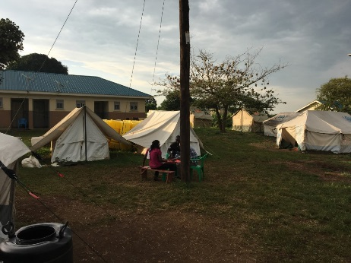 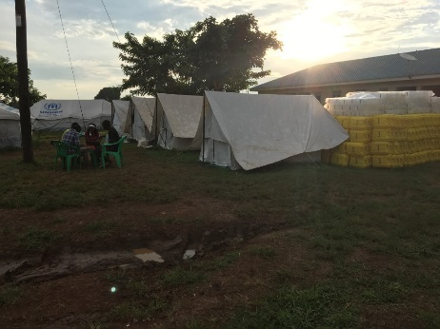 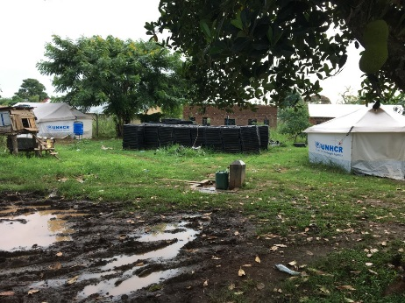

Kyangwali RC base camp

* Red Cross does not dispose its own plot and needs to share the space with other agencies renting other structures.
* The accessibility is quite difficult because hidden behind UNHCR base camp and dirt road
* No clear delimitation and by consequence can bring some confusion.
* No mast with Red Cross flag
* Only 1 toilet and 1 shower for the all team
* Use of polycotton family tents with UNHCR logo for Red Cross staff as for almost all of other agencies.
* This model is not self-standing and is assembled on the ground without preparation and no gravels to drain rainy water by consequence a lot of backwater points … conducive for mosquito larvae!
* No meeting room for the team or visitors and not either resting room for the RC staff
* Only a kitchen since the cholera outbreak but still under a small tent without real food storage (no fridge, no sinks, no storage, …)
* Electricity provided by UN compound
* Located close to the water pipes and water tower

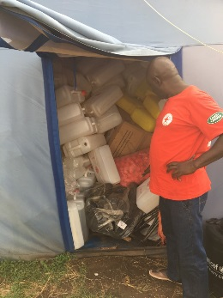 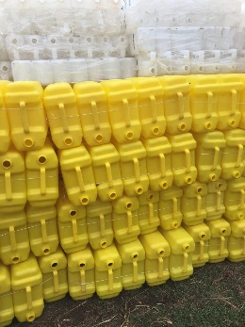 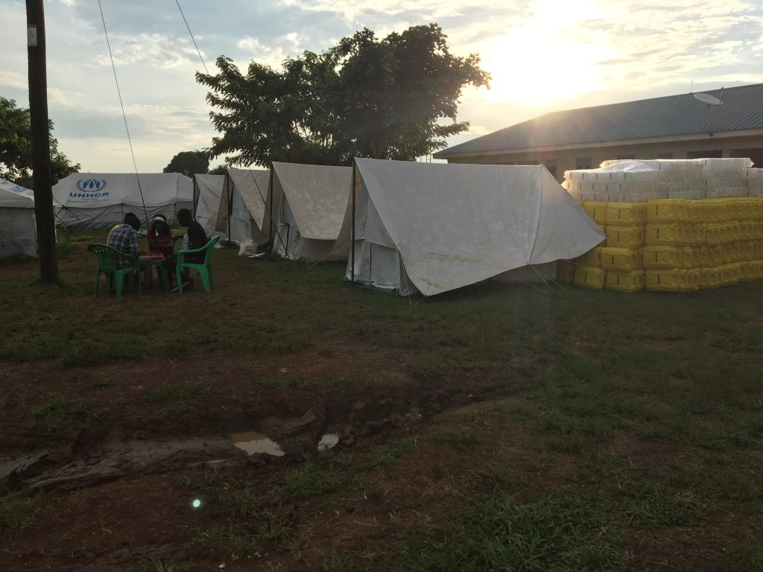

Kyangwali store

* No disposal of real store to prepare distributions / need of a real warehouse because depending on the UNHCR goodwill for potential available space.
* The store is a small Chinese tent of 12m2 which impose no stock and to work in a tight flow.
* No protection and security around the tent.

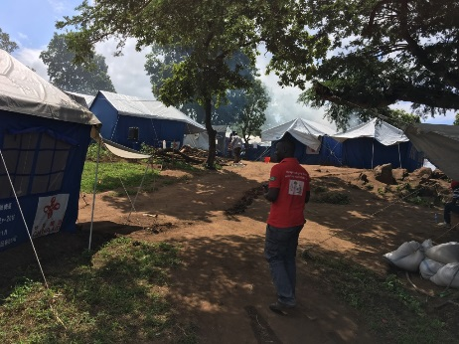 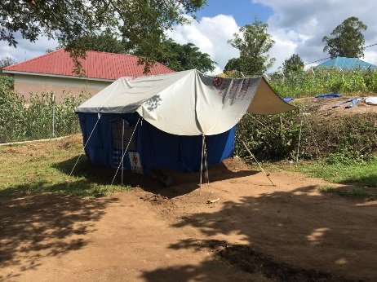 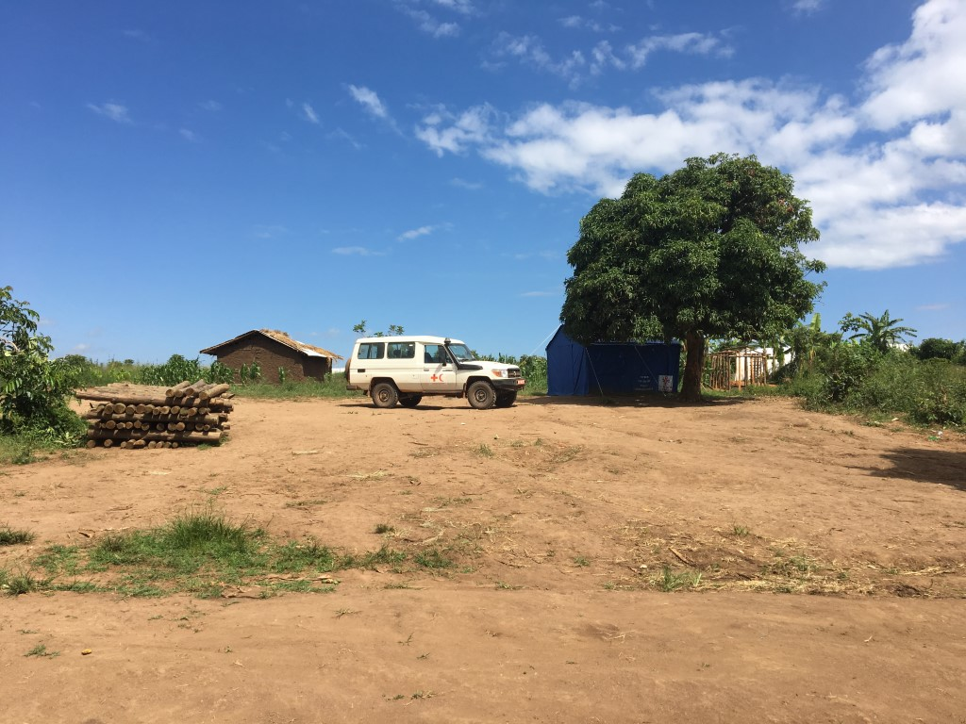

Kyaka situation

* Same situation for the base camp which probably is a bit better of Kyangwali because on top of the slope avoiding running water and located under the trees for shading
* No stock but will receive the area and UNICEF tent which will be removed close to the UNHCR logistic base outside of the camp
* Same situation regarding sharing space / identification / kitchen etc,…

### **5.2.2 a** Transitional solution for PSN – To analyze and find shelter alternatives

It is crucial to work closely with Ministry of Environment and the Forest department because more and more Uganda is facing wood traffic with big business of log dealers exporting the local resources without organizing any good management and new plantation. In this case, it is about tree exploitation with the most valuable essence.

Our situation would most probably use Eucalyptus or/and Bamboo. Their control should be facilitated with specific plantations even if it’s mandatory to propose a coherent and controlled plan including replantation of trees types.

2 main ideas:

* We could imagine to integrate this dimension in the shelter proposal as it’s quite difficult to measure the plots delimitation … Why not ask to the beneficiaries to plant trees around there living space and mark well/ delimitate their plots promoting plantation
* By reducing the wood consumption with a better energy efficiency and an improved woodstove.

This proposal is also including a huge risks reduction avoiding accidents with children and severe burns.

We could also reinforce the relation with Environment State Service because by planting specific plant essence we could recreate a kind of new Bio-Ecosystem / which could be part as well of an educational plan for schools and children …

The beneficiaries should be sensitized through a calculation method determining the total wood volume used during the construction process. It would highlight the total amount implemented and in how long it would take to give back to the nature this quantity? The concept behind being a way to make an acceptable ecological balance.

See in the appendix 4 the table showing which essence can be used for what?

At this level, it can be reported that this chart presents several aspects that can contribute to the delay life of a community with for example abilities to correspond to different needs as:

Ornamental, fuel wood, timber, shade, charcoal, soil conservation, poles for construction, flooring, dye, tools handles, medicine, food, farm tools, boats building, spice, food for animals, music instruments confection, hygiene and soap, illuminant, etc…

This list is not exhaustive and highlight the huge opportunity to interact between sector defining common interests through this complementarity …

This table shows:

* Almost all trees types can enter in the construction process and becoming logs or poles or timbers
* It is extremely important to develop a strategy with wood and sensitize the population (both hosted and hosting)
* Each type is offering at least 4 different functions with more than 60% useful for construction

### **5.2.2 b** Transitional solution for PSN – To create an additional kit dedicated to transitional shelter option

During the interviews, it appears that the UNHCR partners were using the UN kit strategy without knowing exactly what was included in the composition list because:

* Not able to enumerate what was included
* Implementers hired to work under UNHCR mode
* apparently nobody suggested to create a working group organizing revisions
* People are mixing the different kit all together and lose the thread of what they are doing
* Uniformity between camps because apparently different composition list according to different locations or operations

**UNHCR Kit composition:**

To facilitate the reading of the following charts, the different kits will be splitted into 5 themes and potential amendments/revisions will directly follow the content lists.

1. **NFI Kit / distribution at Transitional center level / individual scale**

|  |  |  |  |  |  |
| --- | --- | --- | --- | --- | --- |
| items | Family size | | | | |
| 1-2p | 3-5p | 6-8p | 9-11p | 12-14p |
| Blanket | 2 | 5 | 8 | 11 | 14 |
| Sleeping mat | 2 | 5 | 8 | 11 | 14 |
| Kitchen set | 1 | 1 | 2 | 2 | 3 |
| Soap | 1 | 1 | 1 | 1 | 1 |

*Revision:

No remarks because should be part of a specific study and not come under a shelter review …

1. **NFI Kit / distribution at settlement level after registration / family scale / one time!**

|  |  |  |  |  |  |
| --- | --- | --- | --- | --- | --- |
| items | Family size | | | | |
| 1-2p | 3-5p | 6-8p | 9-11p | 12-14p |
| Plastic basin | 1 | 2 | 2 | 3 | 3 |
| Jerry can 20 litr. | 2 | 2 | 3 | 3 | 4 |
| Solar lantern | 1 | 1 | 2 | 2 | 2 |
| Mosquito net | 1 | 2 | 2 | 4 | 4 |

*Revision:

- The solar devise should allow charging cellphone (even if few seen in the field but need confirmation)

- The number of mosquito net is not sufficient and should be 1 / 1pers.

- Probably the capacity of harvesting or storing water is not enough

1. **SHELTER Kit / distribution at plot level / family scale/ one time!**

|  |  |  |  |  |  |
| --- | --- | --- | --- | --- | --- |
| items | Family size | | | | |
| 1-2p | 3-5p | 6-8p | 9-11p | 12-14p |
| Machete Panga | 1 | 1 | 1 | 1 | 1 |
| Poles (Eucal) | 5 | 5 | 10 | 10 | 15 |
| Rope | 1 | 1 | 2 | 2 | 3 |
| Plastic tarp | 1 | 1 | 2 | 2 | 3 |
| Sickle | 1 | 1 | 2 | 2 | 2 |
| Hoe | 1 | 1 | 2 | 2 | 2 |

*Revision:

- Why nails are not included

- Need of check the products quality because some people complains about fast deteriorations …

- The number of poles have to be reviewed (see proposal after)

- Need to define an adequate tool kit list (see market assessment) according to the selected strategy

Ex: mud construction requires to work with sieves / preparation plot with racks / level / etc,…

- The amount of plastic sheeting is not enough to ensure privacy and good protection

1. **LATRINE and SHOWER Kit / distribution at plot level / family scale/ one time!**

|  |  |  |  |  |  |
| --- | --- | --- | --- | --- | --- |
| items | Family size (because 1 latrine / family or 20pers.) | | | | |
| 1-2p | 3-5p | 6-8p | 9-11p | 12-14p |
| Plastic slab | 1 | | | | |
| Poles (Eucal) | 4 | | | | |
| Plastic tarp | 2 (dim ?) | | | | |
| Treated Logs | 4pcs (2m long / Ø10cm) | | | | |

*Revision:

- More poles for structure because people are going to cut in the forest anyway where it is not controlled …by consequence better to provide the correct amount avoiding anarchical cuts and supporting environment concerns by distributions and correct amount …

- More plastic sheeting to guarantee the “waterproofness” of the holes pit top with a wider protection

- Probably additional sensitization have to be reinforced to well explain the use and the risks …

1. **DIGGING Tools Kit / distribution at plot level / communal scale (for few families) / one time!**

|  |  |
| --- | --- |
| items | For 6 Households or 21 pers. |
| Spade | 1 |
| Pick axle | 1 |
| Axe | 1 |
| Wheelbarrow | 1 |
| Rope | 1 (?m) |
| Metallic bucket | 1 |

*Revision:

- The pit hole can go up to 2,4m deep which means that without shoring system somebody could stay enclosed in case of landslides / moreover often it is a task that children are doing (and are smaller in size)

- Not really sure of the wheelbarrow use … probably better to transfer this amount of money for other purposes

It can be highlighted that:

* A kit review should be organized according to the construction practices selected
* Need to work and to develop a regional kit at family and community level

### **5.2.2 c** Transitional solution for PSN – To propose an new house model

**House concept proposition and general shelter approach:**

Shelter is more than a roof providing a simple rain or sun protection. It represents a fundamental cross sector approach with the idea of offering and including additional elements reinforcing the intervention:

* An appropriate and simple latrine and;
* an easy shower for each house or for each family where there are disabled people
* Hygiene promotion with a soap dispositive ( tip taps[11]) to remind and to encourage people to wash their hands after use
* A kitchen with minimum protection avoiding risks of injuries (mainly for children). It is also a matter of improving efficiency to reduce wood consumption and by consequence limit unsteadiness environmental impacts
* Separate rooms providing privacy and gender equilibrium
* Bedroom including a mosquito net to reduce sickness vector and also a raised bed for ease of use for elderlies & avoiding contact with the ground
* A good raised platform for the house to avoid floods to damage goods
* A solar light to improve night living conditions and security + a cellphone charger dock station
* A lockable door and window to secure belongings and goods and ensure good ventilation
* A secure water harvesting system to avoid long and painful walks until the river for washing clothes
* A clothesline under protect area to dry the clothes (e.g. roof overflows)
* An easy fire protection system
* An activity (agriculture, livestock, etc.) generating incomes or at least ensuring the people livelihood with e.g. seeds to make and grow a vegetable garden (Rift Valley)
* It’s also a matter of heritage promotion with the local vernacular architecture ensuring a fast erection and good maintenance understanding with an old well-known technic guaranteeing a long lifespan for the buildings.
* A new opportunity to better interact with the more affected people.
* Link relation with the hosting communities
* Probably possible to group few people with special needs in the same area to facilitate the follow up and the next interactions (with attention to not create a ghetto). It could follow the registration cycle.
* Last but not least:

Reducing environment impact with special hoven promotion using less wood than the open non protected fire place.

Marker points:

→ Rough calculation and fast comparison:

*Wall construction, house of 6x4m with wattle and daub technic = approximatively need of 50poles

*An opened fireplace to boil 1 meal a day for a big family is using at least 3 poles for every cycle

As we are speaking about a situation where people will stay, we can consider 1 year of wood use because charcoal is not affordable for the refugees …

365 days x 3 poles = around 1100 poles when for a house is only 50poles or corresponding to 2 weeks or 5% of a 1 year cooking wood consumption

Now if we use an improved woodstove the saving can represent almost 2/3 (around 60%) which represents a huge spare of wood and by consequence represents really more in terms of environmental approach …

Note: the calculation has been made on 1 year use …. What about 3 or 5 years later ….

* **Termite proofing**[12] approach to avoid termites’ aggressions increasing building lifespan.

So as a precaution: an additional layer in the floor or/and as additive in the mud mix preparation of Charcoal + Quarry Dust can be used. In fact Quarry dust particles are sharp and get interlocked with each forming a compact base

* Additional idea:

The reuse of pet bottle could be proposed with for example their insertion into the walls so that the inhabitants can benefit from natural light.

* A SWOT or SVOR analyze for the 2 constructive modes (UNHCR vs IFRCSRU) can quickly provide a clear picture of the challenges

|  |  |  |  |  |
| --- | --- | --- | --- | --- |
| UNHCR model  (adobe mud blocks) | | **vs**  **><** | IFRCSRU model  (wattle and daub) | |
| **Strengths**  *can be tested for normal household | **Weakness/Vulnerability**  *”unknown” technic or when used corresponds to secondary buildings  *acceptancy  *need time with block drying needs  *seasonal works  *high price  *construction time  *participatory approach looks more challenging | **Strengths**  *local practice  *easy acceptance  *fast execution  *excellent for quick needs with PSN  *possible at any time even during rainy season  *low cost  *low tech  *the roof is quickly in place and people are covered when it’s time to fill the walls | **Weakness/Vulnerability**  *use of wood |
| **opportunities**  *new approach  *wood reduction | **Treats/Risks**  *implementation misunderstanding  *acceptance  *maintenance  *block quality  *sustainability lifespan | **Opportunities**  *interact with environment  *complete vision  *include locals and beneficiaries  *easy to train people | **Treats/Risks**  *control wood quantity |

* At refugee level, a mixed approach using both technics could constitute a suitable shelter solution with:
* Wattle and daub for PSN and communal structures, when it’s more urgent
* Adobe mud blocks for beneficiaries without special needs, when a shelter project can be delayed or take longer time with additional preparations as bricks confection. It is also more sensitive to climatic constraints …
* It appears that the situation requires not only a shelter project for the refugees themselves but a need of a wider answer including additional structures improving the URCS capacity.

To facilitate the lecture, this can be summarized as follow through 4 themes:

|  |  |  |  |
| --- | --- | --- | --- |
| NEEDS: | | **Kyangwali** | **Kyaka** |
| **1** | **PSN strategy** | * Need of a suitable solution corresponding to the huge need | * To be deepened with the team because a project is ongoing |
| **2** | **PGI structure** | * Need of at least 2 multifunctional structures | * The need is there but must be confirmed by a PGI expertise as it’s really context based |
| **3** | **RC Base camp** | * Huge need * OPM is offering an equipped land | * Need some improvements and as to be part of a coherent approach |
| **4** | **RC warehouse** | * Need of storage capacity * UN is giving their warehouse location   (land emptied but fenced and equipped) | * Will be improved by a UNICEF donation as they are living their site / giving land and equipment (Rubhall included) |

To realize these different components, a strict work mode has to be define

For example for PSN shelter construction, LWF will constitute teams as follow:

* Hiring a local foreman from the hosting community
* He will hire refugees to constitute his brigade and will train them
* The daily fee for the refugees will be part of the contract to avoid abuse
* A same foreman will only be able to take a certain amount of worksites with limitation in number and distance.

**URCS & IFRC-SRU Shelter concept / joint proposal:**

1. 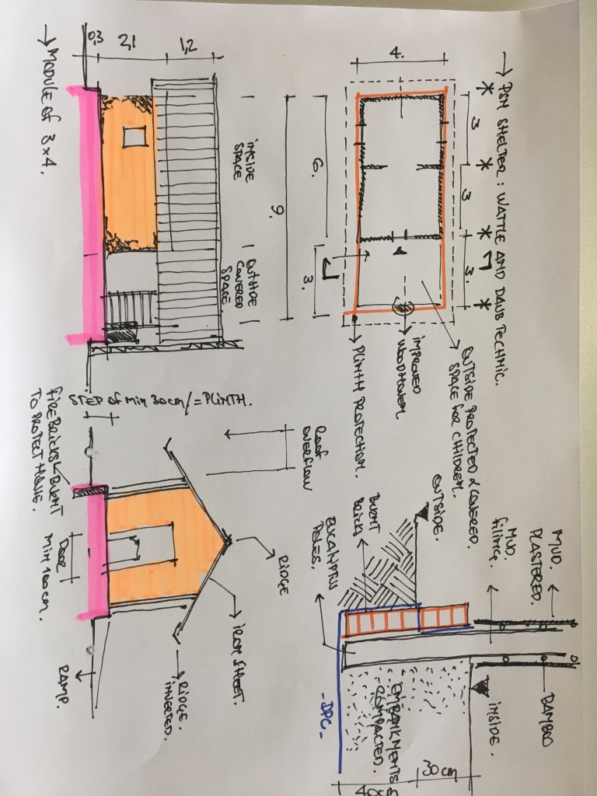**PSN strategy**

A deep review of the NFI items is advised to better support PSN people with for example:

* Additional wood and rope to rise up the bed for avoiding to lie down on the ground and facilitate elderlies to first sit on the bed and after lie
* Foam mattress to better sleep mainly for elderlies
* Solar panel because often we didn’t see it even if included in the list
* Water tank to harvest water and reduce the long difficult walk up to the river for washing clothes
* A net to cover the tank to reduce vector control risks
* A mosquito net for everybody
* To foresee internal slaked lime paintings inside the shelter to provide better atmosphere with a lighter effect and better hygiene.
* To advise the use a an additional external cover space for cooking / children space / drying clothes
* To recommend the use of an improved stove reducing wood consumption

Quotation:  


1. 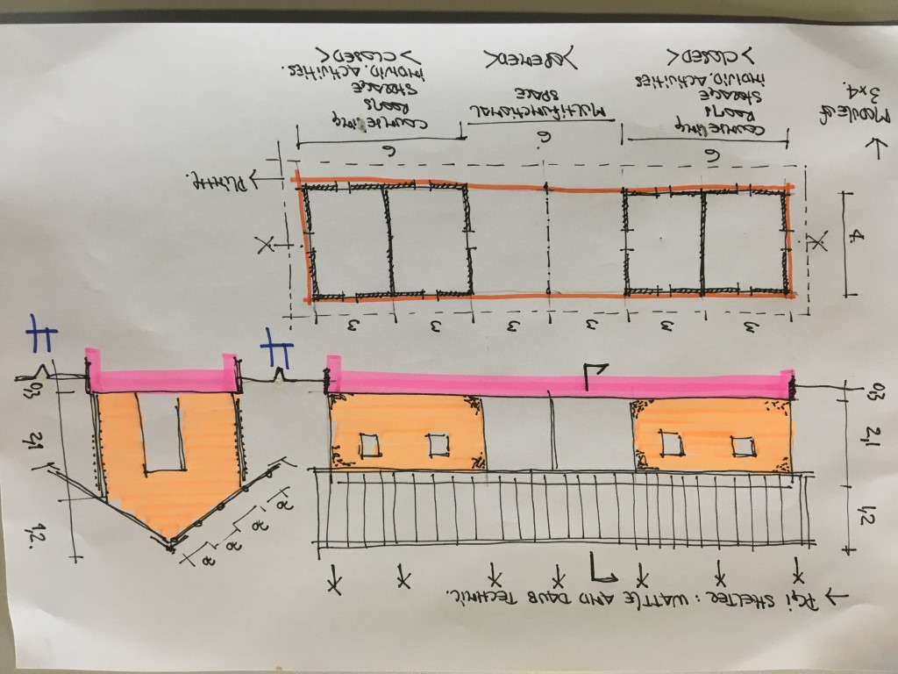**PGI Structures**

Quotation:



Note:

Probably a fence surrounding the building has to be added (see plot size and Market assessment)

1. **Red Cross Base Camp**

* Need to at least to provide the same type of structure than the ones proposed to the beneficiaries which will be definitively better than a tent (actual situation) …
* Needs:

*Dormitory / latrines / showers / ext. covered space / laundry zone / drying lines / kitchen / eating room or space / food store

*connection with electricity and water

*the compound has to be fenced + need shaded areas

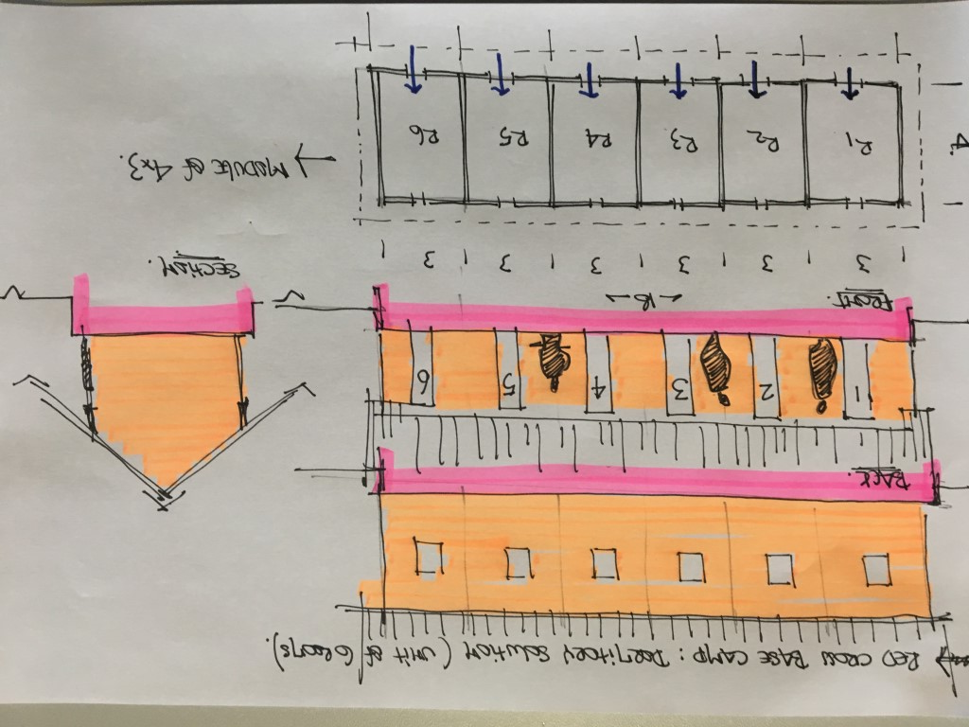

Probably the most simple solution would be to at least to provide a double roof for the tents with a slab on the ground (already gravels would change the situation)

Need = wood structure + iron sheet + gravels based on the same outline

* This light structure has to be multiplied by the number of people as here it’s for 6 people
* This set has to be completed by other services (kitchen & store with eating room + laundry + recreational) to make it easy I suggest that for this services we use the office building (see after)

*Option 1: ultra-light structure

Idem valid for 6 tents and need to be duplicated accordingly to the total number of RC staff



Rem: with light structure over tents, there is still the need of tents purchase ….

For indication, a tent is minimum 500euros by unit (ex-factory price)

*Option 2: homogeneity with the PSN intervention and same building typology



Note:

* Probably a fence surrounding the base camp has to be added (see plot size and Market assessment)

*Option 3: prefabricate structure as planned for the West Nile operation

See details in the alternative solutions here after – need to ask a quotation to the company

*Option 4: prefabricate structure or last trip container / need to be deepened at Kampala level

See details in the alternative solutions here after – need to ask a quotation to the company

1. **Red Cross Warehouse**

* Need to at least to provide the same type of structure than the ones proposed to the beneficiaries which will be definitively better than a tent …
* Same technic of the PSN house / which is economically good
* Needs:

*Office / meeting room /latrines / ext. covered space

*connection with electricity and water

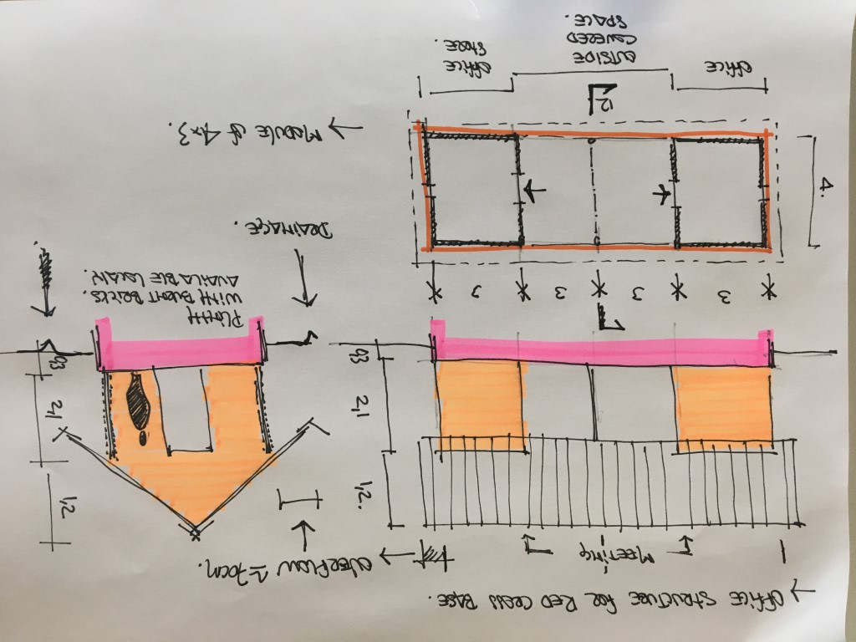

Quotation:



Just for info:

A warehouse tent model that could be proposed and moreover that could be reused for new forthcoming operations is a middle size Rubbhall offering more flexibility / a unit can be considered at 10-12.000euros without transportation

Rem:

Better to plan 3 smaller tents than 2 big ones

Ex: REX HALL model[13] (6,5x8m)

Alternative regarding RC base camp and RC warehouse:

**Prefabricated structure:**

|  |  |
| --- | --- |
|  | ALAM group  <https://www.alam-group.com/>  circular / oval / pyramidal series |

**Modular structure with containers:** (recommended by MSF Kampala)

|  |  |
| --- | --- |
|  | [www.almarcontainergroup.com/kenya/](http://www.almarcontainergroup.com/kenya/)  **Almar Uganda Contact Details:** Almar Container Conversions Uganda Uganda Manufacturers' Association PLOT 26, Coronation Avenue, Lugogo Show Grounds, Kampala, Uganda **Email:** [sales.ke@almar.co.ke](mailto:sales.ke@almar.co.ke)  **Tel:** +256 704 675 272 |

**Modular structure with containers:**

|  |  |
| --- | --- |
|  | <https://www.kroftman.com/de_DE/containeruberdachungen?gclid=EAIaIQobChMIstuZz-Kb3AIVRRsYCh1yQwGkEAEYASAAEgLtv_D_BwE>  P.O. Box 158 6900 AD Zevenaar The Netherlands +44 1223 790 107 +31 26 20 22 097 [salesuk@kroftman.com](mailto:salesuk@kroftman.com) |

### **5.2.3 a** To assess URCS on shelter response capacity providing guidance

|  |  |  |
| --- | --- | --- |
| The Red Cross teams in both camps: | Staff | Volunteers |
| Kyangwali | 4 | 37 |
| Kyaka | 2 | 31 |

Definitively, if a shelter project was confirmed it is mandatory to reinforce the teams with shelter experts assistant with a specific capacity in semi-permanent structures but also able to deal with livelihood aspects.

Even if URCS did already a shelter project in the North (West Nile project) with round huts and improved stove reducing wood consumption.

It also appears that the Ugandan Red Cross is well organized and structured with a strong Disaster Management and Response Department:

|  |  |
| --- | --- |
| DM & R Head of office | (Bob) Robert Akankwasa |
| DM & R Deputy | Paul Okot |
| Shelter focal point: | Brian Kanaahe |

Also and as mentioned during a meeting with HR Department (Ms. Orwin Tumuhirwe), it is crucial to directly hire specific people for specific tasks:

* Administration and Human Resource
* Accountancy - Finance
* Logistics, Purchase and store keeper (need of office and store)
* Foreman’s and workers (according to the type of work organization and the Ugandan laws and construction regulations)
* Watchman?
* Driver (polyvalent car & lorry)

In parallel, the HQ office will also need to be well connected with the field and some Job of Description will need to be adapted regarding this new potential aspect.

It would be extremely good to be able to break down the different works … so why not? Organizing in situ training sessions and confirming skills and capacities.

This pragmatic approach would guarantee or at least come closer to the expected results.

# **6. Conclusions**

* It appears clearly 2 readings, the first is directly related to people needs with lack of suitable shelters for both beneficiaries and RC staff, when the second corresponds to cover/protect goods and communal activities with need of multifunctional structures.
* Regarding construction activities and needs =

*The best periods of the year look to be from December to late February and from June to August.

*Need of generous roof overflows (better with 2 slopes) and drainage according to heavy rainfalls

*Need of protections at the feet of the walls to limit rising humidity

*Need of closed shelter with regard to night temperatures

*Integration of good ventilation in relation to moisture issues

* better to promote traditional and well-known technics

*Simple and accessible solution easy to implement by all even the more vulnerable

*Possibility of scaling up or scaling down with same method

*Need of mud walls proposal as locally executed because possibility to improve the interaction with the hosting community

*Need to define a better shelter kit

* Huge opportunity for the Red Cross movement to showcase what we are able to propose …

With a more sustainable and realistic approach than what UNHCR is advising to do and with closer adequacy to the real situation and closer to the resources and skills …

* PSN shelter options recap:

Recapitulative of the shelter options

|  |  |  |  |  |  |  |  |
| --- | --- | --- | --- | --- | --- | --- | --- |
|  | m2 | Cost  (euros) | House Price/m2 | Time (days) | labors | technic | difficulty |
| Perez  (partial solution) | 18 | 230 | **13**  230/18 | 4 | 4 unskilled people  1 dad + 3 sons | Wattle and daub | Easy |
| UNHCR  (full solution) | 20,6 | 1187 | **32**  665/20,6 | 40 | All services included | Adobe Mud blocks | High  (concrete works) |
| SRU  (full solution) | 24+6 | 700 | **15**  570/36 | 15 | All services included | Wattle and daub | Medium |

SRU shelter proposal:

*is almost 60% times bigger in m2 with a price extremely close to the local house

*defines a building process time of only 1/3 of the Adobe mud bricks system

*At big scale, this model will offer many improvements and would allow to achieve faster results

*the involvement of the beneficiaries will be easier

Rem: need to follow up the ongoing UNHCR project to measure its impacts and constraints to verify our proposal

* About environmental aspect: the beneficiaries will themselves become the guarantors/ambassadors of the biodiversity by replanting the forest of the region / they will support its good control and its good management – need sensitization

* Need of improving the capacity of warehousing goods. It reduces drastically the efficiency of potential operations. This aspect could completely change the approach.
* With a good shelter project (even if circumscribed) we, as Red Cross, can improve the quality of the provided assistance and by consequence gain also in terms of visibility

# **7. Operational challenges**

* Hinge time and shifting from emergency to transition mode impose a different shelter approach without tarpaulin (short lifespan and easy damageable)

* The building costs represent an important amount which is quite far from what the locals are able to propose to their own family …. High risks of destabilization …
* Implementing a shelter project is not only speaking about construction skills

Need of additional people with specific background (accountant, logistic, purchaser, admin, translator, … )

→ Strong relation and advises from HR department

→ accounting for financial advice as working with contingency

Shelter is a multidisciplinary approach and involve many components from different sectors and activities, this aspect should definitively be strengthened through shelter operation (eg. Inputs from HR department, etc)

To start a/or few construction project(s) seems simple, but in reality if this is not taken into consideration from the beginning of the operation, this project can quickly become a real nightmare …. To succeed it will need the good people at the good positions because it’s only a matter of good human resources

* Need of homogeneity for PSN identification at national level. The indicators defining the criteria must be the same with the same weight for every camps (to be verified and supported).
* Need of cross-checking with PGI report / correlations to be established to ensure consistency
* Important to integrate the uses and habits of the people to ensure success (e.g. during the visit I noticed many people not using the latrines in the camps or just hiding themselves behind it … Probably need as a recommendation to plan counselling and hygiene promotion regarding this aspect …) + latrine study
* Need to well define not only working process but also contractual arrangements + guarantees
* Using a common list of beneficiaries with other actors is definitively a big challenge
* Need of a general site planning including a common vision providing the same reply
* Special attention: if now focus on PSN what about the other people … who monitor the situation?

# **8. Recommendations**

* IFRC-SRU recommends to use the wattle and daub technic against adobe UNHCR proposal at least for PSN households. This includes environmental concerns with wood consumption reduction by using improved stove promotion.

By consequence a mixed approach could be proposed with wattle and daub for PSN shelter and adobe mud blocks for the rest of the building.

* Need of reinforcing the shelter focal point position with specific tasks as:

*market assessment follow up

*continuous investigations on potential shelter options and create a state of the art at country level (with why not a collaboration with the Kampala University – architecture dept.)

* Shelter project = a lot of material and a lot of money …. Extremely easy to cheat and make speak differently the numbers

*Create guideline and install procedures at different level

* It would be a really interesting approach to organize dedicated workshop and guidelines with the authorities to define standards for potential forthcoming operations
* Knowing that the Passa strategy is more dedicated to long term and stabilized operations (Recovery) , why not try to imagine a Fast Passa[14] mode facilitating shelter project in semi-permanent situation
* Environmental = Create a tree referential with a good understanding on what could be used for what?
* Charcoal and quarry dust can perform as natural termite repellent
* Need to create a shelter working group involving all active partners offering a common platform of exchanging information and sharing experiences … establishing also guidance and reporting to authorities using a same contact or focal point …

This coordination position should be leaded by UNHCR or IFRC and/or URCS

* Organization of shelter trainings in situ involving the direct actors / open to all implementers to guarantee a homogenous shelter reply for all beneficiaries …

*This training could be used to identify the working process (working under which mode, with how, how?) and check the capacities / skills at the same time …

*the idea would be also to use this opportunity to assemble communal structures as PGI halls or RC base camp?

* Through the work and the function of the shelter focal point, trying to better interact with UNHCR and OPM in terms of shelter programing and strategy selection (e.g. on the UNHCR drawings and on the wording of the plans appear only UNHCR and OPM logo) it is really pity to don’t have involved RC from the beginning
* Making a clear inventory of the different kits available and deepen the items specificities

+ Need to clarify the kits composition at family and community level because there are confusion in terms of items and functions

* A regional tools kit approach could be investigated it would correspond to the different households typologies
* About budget definition and quotation, need to work with a contingency plan
* Probably a good recommendation would be to make some tests before starting a big project and report constraints and foreseen actions.

# **9. Annexed documents**

## **9.1 Service agreement:**

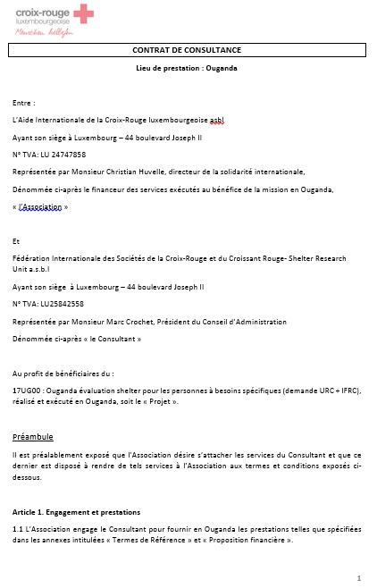

## 

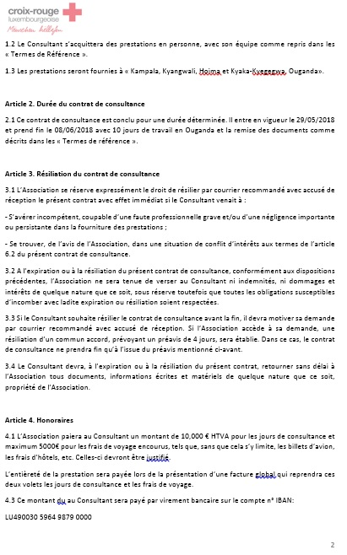

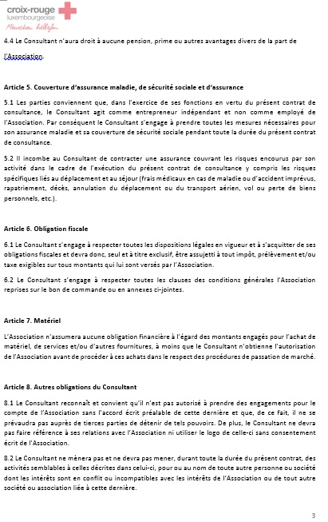

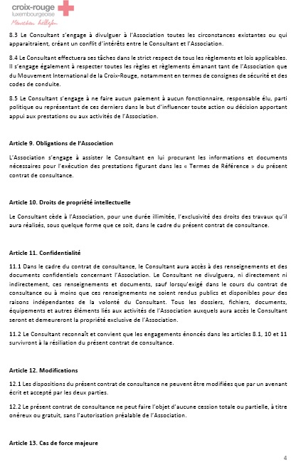

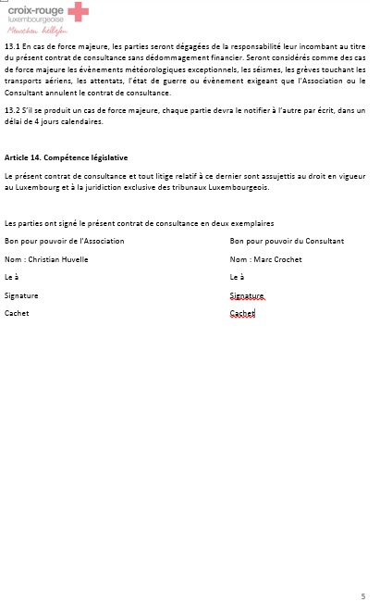

## **9.2 Terms of reference:**

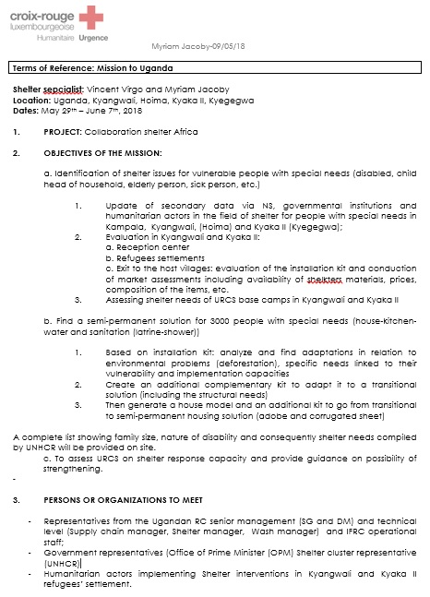

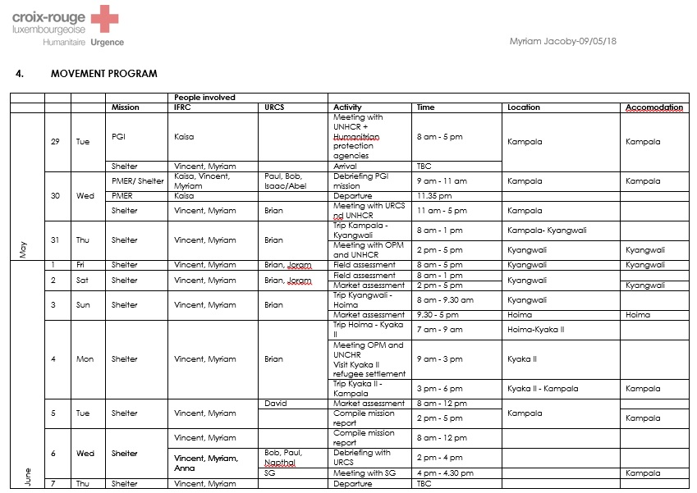

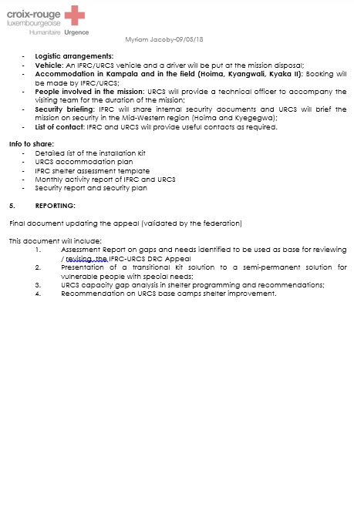

## **9.3 List of contacted people:**

The lists of contacts described below correspond to the various interviews and meetings that were conducted during the mission.

|  |  |  |  |
| --- | --- | --- | --- |
| Org. | Name & Position: | email | Tel: |
| IFRC | Kaisa Laitila / PGI officer | Kaisa.laitila@ifrc.org | +41227304222 |
| URCS | Akankwasa Robert (Bob)  / Disaster risk management Director | bakankwasa@redcrossug.org | +256(0776) 007 108/(0705) 007 108 |
| IFRC | Anna Cerutti / Country manager | anna.CERUTTI@ifrc.org | +393398160352  +256 706 568 816  +256 783 555 594 |
| UNHCR | Ali / PGI Head Officer Kyangwali |  | 0776277255 |
| LWF | Moritz Masunghe / delegate |  | 0778336997 |
| URCS | Joram Musinguri  Kyangwali Camp manager | jmusinguri@redcross.org | 0779543498 |
| URCS | Brian Kanaahe / Shelter focal point | bkanaahe@redcrossug.org | 0782926851 |
| Indiv. | Perrez | Check with Brian for contact |  |
| URCS | Frank / Kyaka II camp manager |  | 0772605226 |
| Ndl RC | Robert Mugubi / Ndl RC delegate | RMugubi@redcross.nl | +256 770 572 056 |
| Be RC | Francis Kadaplackal | Francis.kadaplackal@rodekruis.be | +256 780 603 387 |
| UNHCR | Paul Nsiela / Head office | nsiela@unhcr.org | 0776720043 |
| UNHCR | Evgenia Mavraki / Architect & Site planner | mavraki@unhcr.org | 0776505400 |
| DRC RC | Joseph Kasongo /  North Kivu branch Secretary  Ildegard PELE  / DM (Gestion Catastrophes) of North Kivu branch: | [josephkasongo7@gmail.com](mailto:josephkasongo7@gmail.com) | +243 994 014 912  +243 840 829 876.  +243 821 206 941 |
| DRC  RC | Serge /  Ituri branch Secretary |  | +243810998400. |
| URCS | Paul Okot / Emergency Preparedness & Response (EPR) Manager | [pokot@redcrossug.org](mailto:pokot@redcrossug.org) | +256(0)772407715 |
| URCS | Robert Okila / Fleet manager and transport | rokila@redcross.org | +256 772 946 877 |
| URCS | Orwin Tumuhirwe / HR Coordinator | torwin@redcross.org | +256 772 744 139 |
| URCS | Robert Kwesiga /  Secretary General | [rkwesiga@redcrossug.org](mailto:rkwesiga@redcrossug.org) | +256 772 638 890 |

## **9.4 Mission itinerary:**

Schedule: The following agenda reflects the content and the contacts of the mission

|  |  |  |
| --- | --- | --- |
| Tue. 29.05 | Departure from Brussels (day flight)  Arrival Kampala in the evening |  |
| Wed. 30.05 | At 10am Kaisa Laitila (IFRC) PGI evaluation  At 1pm Paul Okot et Bob Akankwasa (URCS)  At 4pm Brian Kanaahe (URCS shelter focal point) | Debriefing PGI mission  Briefing / context – need definition  Needs presentation + mission expectations |
| Thur. 31.05 | At 10am Brian  At 11 am Anna (IFRC country manager)  At 1pm Team Brian + Godi + Vincent | Follow up  Briefing / expectations  Trip to Kyangwali |
| Fri. 01.06 | At 8am Meeting with Joram Musinguri (URCS) | Field level / context and reality description  Camp tour and problematics |
| Sat. 02.06 | At 8am Meeting with Joram Musinguri (URCS) | Field assessment & NGO’s meeting  Market survey  Meeting with OPM + UNHCR |
| Sun. 03.06 | At 12am Meeting with Frank (URCS)  Kyaka | At 5am departure for Kyaka II  + meeting with Ndl RC delegate  Arrival at Hoima evening |
| Mon. 04.06 | At 10am meeting with UNHCR + OPM | UNHCR chief office  OPM commandant |
| Tue. 05.06 | Meetings with URCS - IFRC | Market assessment |
| Wed. 06.06 | Meeting with URCS  Meeting with BeRC  IFRC debriefing | Mission debriefing  Meeting with HR, transport /  Market assessment |
| Thur. 07.06 | Meeting with Paul et Brian  Meeting with Secretary general  Departure … | Restitution  First feedbacks and debriefing |
| Fri 08.06 | Arrival day+1 at Brussels airport by night flight | Starting report |

## 

## **9.5 Perez’s House**

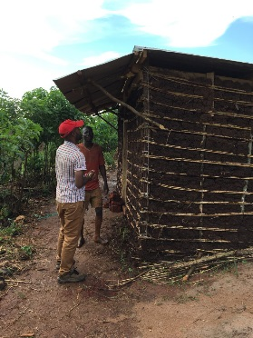 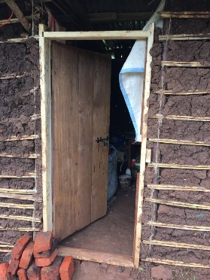 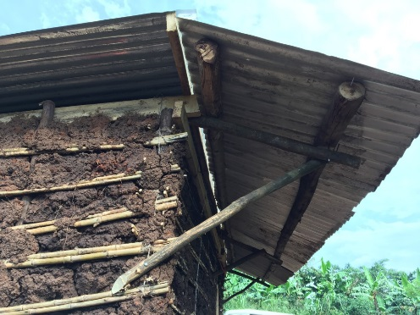 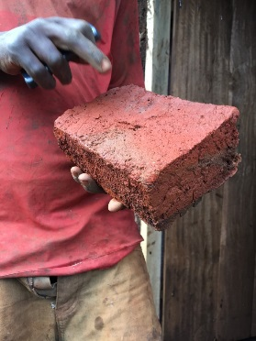

* Perez family is part of the hosting community living on the main road driving to the camp
* Perez was building his own simple house when we met. He was using a well-known ancestral construction method complemented by fishing nets to tie the wood boxes and the wood sticks all together.

He explained that he used what was massively available, as Bamboo in the bush around and which grows really fast.

* House built with the local technic = wattle and daub

Wattle and daub definition[15]:

*Wattle is generally made by weaving thin branches between upright stakes. Reeds and bamboo sticks can also be used as wattle material.

*Daub is usually created from a mixture of ingredients from three categories: binders, aggregates and reinforcement. Binders hold the mix together and can include clay, lime, chalk dust and limestone dust. Aggregates give the mix its bulk and dimensional stability through materials such as earth, sand, crushed chalk and crushed stone. Reinforcement is provided by straw, hair, hay or other fibrous materials, and helps to hold the mix together as well as to control shrinkage and provide flexibility.

*Daub may be mixed by hand. It is then applied to the wattle and allowed to dry, and often then whitewashed to increase its resistance to rain.

* His father has the same house type since more than 15years which proves its sustainability.

Every year, it needs only small maintenance and up to now no need of repairs

* House dimensions 6x3m with a single slope with a small porch roof and a single room and no windows and only a wood door with lock
* The price reported corresponds only to material need (without tools and labor). Even if indicative it’s is a valuable information with 18m2 for 230euros or less than 13euros/m2.

*see in annex1 the BoQ with price calculation

* Time for building (owner claimed) – 4 days including the most difficult part for the roof
* The construction is not including the chicken coop neither latrine and shower which come after and are part of a separate budget and are usually realized with the adobe mud block technique
* BoQ:

|  |  |  |  |
| --- | --- | --- | --- |
| Material | Unit price | Quantity | Total |
| Fresh eucalyptus poles for vertical (4m)  Spacing of 40cm | 3000 | 48 | 145000 |
| Fresh eucalyptus for roof 2 trusses + 4 rafters (4m)  Span of 1&2 m | 3000 | 10 | 30000 |
| Wood poles spare (4m) | 2000 | 2 | 5000 |
| Small sticks | ? (from the bush)  1500 | 30 | 45000 |
| Bamboo bundle (small stems = 100pces) available in the bush but can be found on the market | 7000 - 8000 | 5 | 40000 |
| String to tie the bracing bamboo boxes (in this case done with fishing net from the lake village) | 20000 | 1 or 2 | 40000 |
| Bricks burnt | 150 | 500 | 75000 |
| Adobe blocks | 100 | / | / |
| Iron sheet  Low quality 32G  (95x300)cm | 30000 | 12 | 360000 |
| Iron sheet bended to do the gutters and the ridge | 25000 | 4 | 100000 |
| Roof nails 2,5-3inches | 6000 | 5kg | 30000 |
| Nails from 3 to 4 inches | 4000 | 5kg | 20000 |
| Wood door  (80cm) | 50000 | 1 | 50000 |
| Wood double door (120cm) | 80000 | / | / |
| Wood windows  (40x40) | 40000 | / | / |
| Hinges | 10000 | 1 | 8000 |
| Bolt | 12000 | 1 | 12000 |
| Padlock | 15000 | 1 | 15000 |
| Transport  Locally small truck hired for little trip | 15000 – 20000  Further it is …  more expensive it is … | /  (corresponds to around 100 bricks) | / |
| **1.000.000 UGX = 230 euros** rate[16] | | | |

* The labour is not included because Perez did the all work with his 2 sons
* The tools are not included because no need of purchases as it was already in house …
* Single room with no window and one door / 1 slope roof with small porch … in 4days

Notes:

* The habits and practices of host and refugee populations are relatively similar in terms of contexts, resources and living conditions. They both share the same repositories which can constitute an extremely important indicator in term of not only intervention program but also acceptation.
* The materials mostly used are mud filling for the boxes walls (the most well-known technic is the wattle and daub because is adapted and fast setup) and iron sheet double slope for the roof
* We can conclude that this building system is part of the local constructive heritage and define the traditional and vernacular architecture culture (=high acceptance)
* Wattle and daub technic is quite impressive regarding execution time … Perez was speaking about 4 full days of 12h with his 2 sons.
* Adobe erection looks more used for services and annexes
* Maintenance is about once a year plaster/daub the walls again

## **9.6 UNHCR concept with adobe blocks**

→ UNHCR house approach:

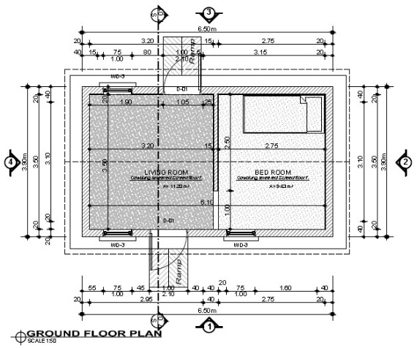 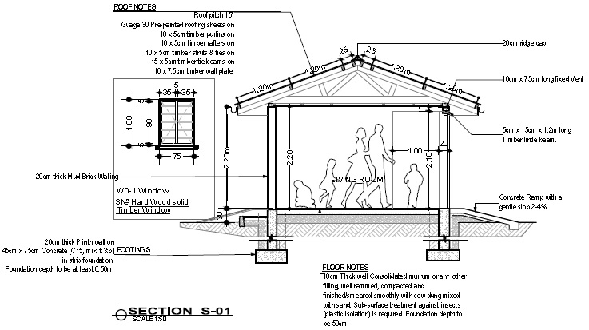



UNHCR buildings BOQ:

|  |  |  |  |  |
| --- | --- | --- | --- | --- |
| Semi-permanent house 20,6m2 (implementer = AIRD) | | | | |
| Material listing | unit | quantity | price UGX | total cost UGX |
| Adobe Mud blocks | / | 3600 | 140 | 504000 |
| Cement | Bag | 7 | 35000 | 245000 |
| Sand | T | 4 | 58000 | 232000 |
| Aggregate 1/2 " | T | 1,5 | 55000 | 82500 |
| Hook iron | Lm | 8 | 3000 | 24000 |
| Ridge caps 1.8m G30 | Pcs | 4 | 9000 | 36000 |
| Eucalyptus poles for roofing  (peeled and surface treated) | Pcs | 19 | 8500 | 161500 |
| 30 -gauge normal corrugation AZED iron sheet | Sheet | 18 | 30000 | 540000 |
| Door 750x2100mm complete with locks | / | 2 | 120000 | 240000 |
| Window 450x600mm complete with locks | / | 3 | 45000 | 135000 |
| Assorted nails | Kg | 8 | 5500 | 44000 |
| Roofing nails | Kg | 5 | 7000 | 35000 |
| TOTAL | | | | 2279000 |
| Estimated labour | | | | 700000 |
| Final Total UGX | | | | **2979000** |
| Final Total Euros[17] | | | | **665** |

→ UNHCR latrine approach:

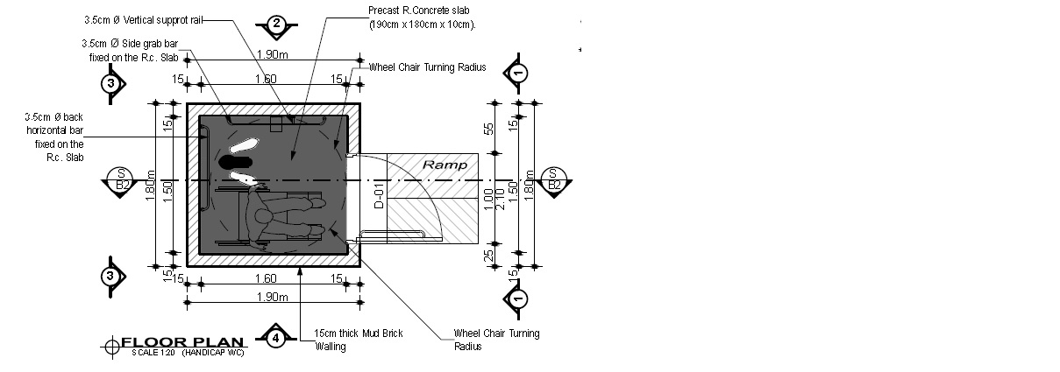 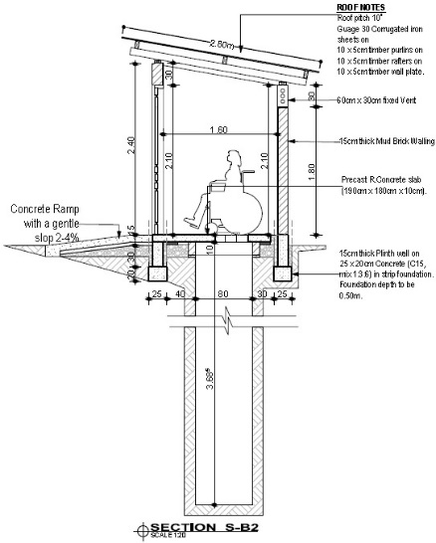

|  |  |  |  |  |
| --- | --- | --- | --- | --- |
| Latrine for disabled people 1,5x1,6 (implementer = AIRD) | | | | |
| Material listing | unit | quantity | price UGX | total cost UGX |
| Excavation | M3 | 2,9 | 15000 | 43200 |
| Adobe mud bricks | / | 700 | 140 | 98000 |
| Cement | Bags | 5 | 35000 | 175000 |
| Sand | T | 3 | 58000 | 174000 |
| Aggregate 1/2 " | T | 1,1 | 55000 | 60500 |
| Assorted nails | Kg | 3 | 5500 | 16500 |
| Roofing nails | Kg | 0,6 | 5500 | 3300 |
| Hoop iron | Lm | 6 | 3000 | 18000 |
| Eucalyptus poles for roofing | Pcs | 3 | 8500 | 25500 |
| 30 -gauge iron sheet | Sheet | 1 | 30000 | 90000 |
| Slab (in kind) | / |  |  |  |
| TOTAL | | | | 704000 |
| Estimated labour | | | | 180000 |
| Final Total UGX | | | | **884000** |
| Final Total Euros[18] | | | | **200** |

|  |  |  |  |  |
| --- | --- | --- | --- | --- |
| Bath shelter (implementer = AIRD) | | | | |
| Material listing | unit | quantity | price UGX | total cost UGX |
| Adobe mud bricks | / | 550 | 140 | 77000 |
| Cement | Bags | 4 | 35000 | 140000 |
| Sand | T | 1 | 58000 | 58000 |
| Aggregate 1/2 " | T | 1 | 55000 | 55000 |
| PVC pipe 3’’ (min75mm) | Lm | 3 | 10000 | 30000 |
| TOTAL | | | | 360000 |
| Estimated labour | | | | 160000 |
| Final Total UGX | | | | **520000** |
| Final Total Euros[19] | | | | **120** |

## **9.7 Market assessment and suppliers list**

|  |  |  |
| --- | --- | --- |
| **Materials:** | unit | Survey with price from local + Hoima + Kampala |
| Bricks burnt  Mud Bricks adobe  Cement blocks | Pce  Pce  Pce | 150 (rem often made on site)  450 (rem often made on site)  ? |
| Poles Ø 8+ cm (L13’’) | Pce | 6500 -10000 |
| Poles Ø 4-6 cm | Pce | 3500 |
| Timber roof 4x2’’ x 4m pine | Pce | 10000 – 7000 (eucal 8000) |
| Timber roof 6x2’’ x 4m pine | Pce | 13000 – 12000 (eucal 10000) |
| Timber roof 3x2’’ x4m pine | Pce | 75000 – 6000 (eucal 6500) |
| Timber roof 4x3’’ x 4m pine | Pce | 13000 |
| Treated log 7m | Pce | 10000 – 5000 |
| Wood sticks | Pce |  |
| Iron sheet G32 (85X300)  Iron Sheet G30 | Pce  Pce | 25000 – 22500 – 23000  30000 – 27500 – 28500 |
| Roof ridge 2m G32  G30 | Pce | 5000 – 6000 - 6000  7500 – 10000 |
| Nails (until 2,5inches)  Nails (> 2,5inches) | Kg  Kg | 4000 – 7000 – 6000 / by 50kg 220000  180000 / by 50kg 260000 |
| Roof nails | Kg  50kg | 8000 – 9000 / 5000  250000 |
| Rope (2mm-500m)  Big (8mm-200m) | roll | 8000 – 2000  45000 |
| Metal bending wire | M  rolls | 5000 – 5500  155000 |
| Door (w80 h200) | Pce | 80000 |
| Door double | Pce | 100000 |
| Bolt | Pce | 7500 |
| Padlock | Pce | 15000 |
| Window (70x70cm) | Pce | 50000 |
| DPC membrane | M =(2M2)  Roll (125m) | 2500 – 2500  100000 – 220000 / 100000 |
| Solar panel (light+cellcharge) | Pce | 50000 – 60000 – 75000 |
| Mosquito net | Pce | 25000 |
| Mattress single size foam | Pce | 80000 |
| Cement bag 50kg | bag | Toroso 41000 – 38000 – 35000 - 31000  Hm 31000 – 29000 - 29000  Nylit 30000 |
| Sand  Lake  Plaster | Lorry | ?  200000  140000 |
| Gravels | Lorry | ?  300000 |
| Stones | Lorry | ? |
| Iron bars Ø 12mm 12m |  | 32000 |
| Iron bars Ø 10mm 12m | Pce | 25000 – 21000 – 22000 |
| Iron bars Ø 8mm 12m | Pce | 18500 – 14000 |
| Iron bars Ø 7mm 12m | Pce | 13500 |
| Iron bars Ø 6mm 12m | Pce | 10000 |
| Iron bars Ø 5mm 12m | Pce | 6000 |
| Mesh 15x15 | Pce | 900000 |
| PVC pipe Ø 75 3’’ L6m | Pce | 23000 |
| PVC pipe Ø 90 4’’ L6m | Pce | 32000 – 32000 – 35000 |
| Fence 6’’ 18m | roll | 230000 |
| Fence 4’’ 18m | roll | 140000 |
|  |  |  |

|  |  |  |
| --- | --- | --- |
| **Tools:** | unit | Survey |
| Ladder 4m |  | 100000 |
| Meter 7,5m  Meter 5m | Pce | 8000  5000 |
| Roll meter 50m  Roll meter 30m | Pce  Pce | 70000  60000 |
| Trowel small 6’’  Trowel medium 8’’  Trowel big 9’’ | Pce | 3000 - 2500  6000 - 3000  8000 – 4000 – 8000 |
| String level  40cm  100cm | Pce | 10000 – 8000  8000  20000 / from 10000 to 15000) |
| Shuffle - spade | Pce | 15000 – 12000(metal) – 8500(wood) / 16000 |
| Hoe | Pce | 9000 – 10000 – 10000 / 10000 |
| Hand saw  50cm | Pce | 12000 – 15000 / from 15000 to 20000  35000 |
| Machete Panga | Pce | 5000 – 6000 – 20000 / 6000 |
| Hammer carpenter | Pce | 14000 – 10000 – 15000 – 10000 – 15000 |
| Shears | Pce | 30000 – 25000 / 12000 – 20000 / 25000 |
| Plastering rendering | Pce | 10000 – 15000 / 7000 – 20000 |
| Wheelbarrow | pce | 130000 / 120000 – 150000 / 11000 - 130000 |
| Water drum - tank  500lit  1000lit | Pce | 170000 - 170000  250000 - 180000 |
| Plastic sheet 4x5m  15x15’’  15x18’’  18x24’’ | Sheet | 30000 - 30000  30000  35000  75000 |
| Pic axle / Matoc | Pce | 19000 – 16500 - 19000 |
| Hand axle | Pce | 15000 – 18000 |
| Rack | Pce | 17000 |
| Arrow spade to dig hole | Pce | 15000 – 5000 |
| *every tool needs a handle |  | 1500 – 2000 |

**Supplier’s details:**

|  |  |  |
| --- | --- | --- |
| **who** | **contact** | **Comments** |
| Wood Musa Kampala  (Based in the region) | 0751.81.45.83 | Good  Can make deliveries |
| Stones – Sand – Bricks  (in kampala) | 078.213.19 02 | Probably useless as far from field |
| Jyotika Hardware Ltd.  Fort portal road - Hoima | 772 462772 / 712 462772 / 752 462772 | Looks really good  Still open to review price accordingly to quantity  Can make deliveries |
| Wood Mike Kampala  Based in the region) | 0705 225 348 / 0705 225 888 / 0782 026 921 | Good  Can make deliveries |

## **9.8 Trees and types of uses table / what can be done with what?**

|  |  |  |  |  |  |  |  |  |  |  |  |  |  |  |  |  |  |  |  |
| --- | --- | --- | --- | --- | --- | --- | --- | --- | --- | --- | --- | --- | --- | --- | --- | --- | --- | --- | --- |
| Tree  Type: | Ornamental | Fuel wood | Timber | Shade | Charcoal | Soil conservat. | Poles Construct. | flooring | Dye | Tool Handle | Medicine | Food | Farm tools | Boat building | Spice | Food for animals | Music instr. | Soap | Illuminant |
| American aborvitae | V | V |  |  |  |  |  |  |  |  |  |  |  |  |  |  |  |  |  |
| Forest natal mahogany |  | V | V | V | V |  |  |  |  |  |  |  |  |  |  |  |  |  |  |
| Uganda mahogany |  | V | V | V |  |  |  |  |  |  |  |  |  |  |  |  |  |  |  |
| River dembeya | V |  |  | V |  | V | V |  |  |  |  |  |  |  |  |  |  |  |  |
| Akee apple |  |  | V | V |  |  | V | V |  |  |  |  |  |  |  |  |  |  |  |
| Orange milk tree | V |  | V |  |  |  |  |  | V | V |  |  |  |  |  |  |  |  |  |
| Java fig | V | V | V | V |  |  |  |  |  |  |  |  |  |  |  |  |  |  |  |
| Mitzeene |  | V |  | V | V |  |  |  |  |  | V |  |  |  |  |  |  |  |  |
| African grape |  |  |  | V |  | V |  |  |  |  | V | V |  |  |  |  |  |  |  |
| Bush rubber |  | V | V | V |  |  |  |  |  |  |  |  |  |  |  |  |  |  |  |
| Areca Yellow palm | V |  |  | V |  |  |  |  |  |  | V |  |  |  |  |  |  |  |  |
| Jumping seed tree | V |  |  |  |  |  |  |  |  | V | V |  | V |  |  |  |  |  |  |
| Jack fruit |  | V | V |  |  |  |  |  |  |  | V | V |  |  |  |  |  |  |  |
| Silk tree |  |  |  |  |  |  |  |  |  | V | V |  | V | V |  |  |  |  |  |
| Hoop pine | V |  | V | V |  |  |  |  |  |  |  |  |  |  |  |  |  |  |  |
| Dwarf palmetto | V |  |  |  |  |  |  |  |  |  |  |  |  |  |  |  |  |  |  |
| Ashok tree | V |  |  | V |  |  |  |  |  |  |  |  |  |  |  |  |  |  |  |
| Coffee |  |  |  |  |  | V |  |  |  |  | V | V |  |  | V |  |  |  |  |
| African green heart |  | V | V | V |  |  |  |  |  |  |  |  |  |  |  | V |  |  |  |
| Black plum tree |  |  |  | V |  |  |  |  |  |  |  | V |  |  |  | V |  |  |  |
| African red wood |  | V |  | V |  |  |  |  |  |  |  |  |  |  |  |  |  |  |  |
| Mecodze |  |  | V |  |  |  | V |  |  |  |  |  |  |  |  |  |  |  |  |
| Drum tree |  |  |  |  |  |  |  |  |  |  |  |  |  | V |  |  | V |  |  |
| Umbrella tree |  |  | V |  | V |  |  |  |  |  |  |  |  |  |  |  |  |  |  |
| False nutmeg |  |  |  |  |  |  |  |  |  |  |  |  |  |  |  |  |  | V | V |
| Eucalyptus |  | V | V | V | V |  | V |  |  | V |  |  |  |  |  |  |  |  |  |
| Bamboo | V |  |  |  |  | V | V |  |  |  |  |  |  |  |  |  | V |  |  |

*This list is non-exhaustive and should be strengthened for environmental purpose

1. URCS = Ugandan Red Cross Society
2. IFRC = International Federation of the Red Cross and Red Crescent
3. DRC = Democratic Republic of Congo
4. <http://www.nationsencyclopedia.com/economies/Africa/Uganda-POVERTY-AND-WEALTH.html>
5. <https://www.worldweatheronline.com/fort-portal-weather-averages/kabarole/ug.aspx>
6. <https://en.climate-data.org/location/3826/>
7. <https://fr.wikipedia.org/wiki/Ituri>
8. <https://fr.wikipedia.org/wiki/Nord-Kivu>
9. <https://en.wikipedia.org/wiki/Wattle_and_daub>
10. PSN = Person with special needs
11. <https://ciirduganda.org/2017/03/24/tip-taps-and-hand-washing/>
12. <http://sacredgroves.in/?p=3912>
13. <http://www.nrsrelief.com/innovation/rexhall-mobile-storage-unit-msu-refugee-shelter-innovation/>
14. URCS - Brian’s concept
15. Adaptation from : <https://en.wikipedia.org/wiki/Wattle_and_daub>
16. <https://www.xe.com/currencyconverter/convert/?Amount=1000000&From=UGX&To=EUR>
17. <https://fr.coinmill.com/EUR_UGX.html#UGX=2979000>
18. <https://fr.coinmill.com/EUR_UGX.html#UGX=884000>
19. <https://fr.coinmill.com/EUR_UGX.html#UGX=520000>