How to conduct a contingency planning process

Introduction 2
What is the purpose of this document and how to use it 2
Response or contingency plans? 2
The process is more important than the plan itself 2
Coordination with national and Red Cross Red Crescent Movement partners is essential 3
Importance to coordinate processes and initiatives 4
Key elements of the contingency planning process 5
Prepare 6
Analyse 7
Develop 8
Implement 9
Review 10
Annex 1 – Preparation Phase tools 11
ToRs for National Society contingency planning process 11
Context and background 11
Tasks to be completed: 11
Role of the team: 11
Timing and resources 11
Data tracking table 12
Contingency planning process workplan 12
Annex 2 – Implement Phase tools 13
National Society actions to be taken for readiness 13
National Society readiness action plan 13
Inform and train human resources 14
National Society team training needs 14
Simulation and table top exercise 14
Resource mobilization 14
National Society readiness plan budget requirements 14
Budget comparison between National Society response and readiness plans 15
Annex 3 – Review Phase tools 16
Evaluating the plan 16
Sharing and reviewing 16

Introduction

What is the purpose of this document and how to use it
A review was carried out by IFRC from March to June 2020 on the contingency planning process at National Society level. To respond to the major findings of the review and on the requests from National Societies and IFRC/Partner National Societies (PNS) supporting staff, this document was developed to accompany the existing Contingency planning (CP) guide and to support a CP template document that was ready to fill in and that National Societies (headquarters and branches) could use to guide their contingency planning process. At community level the process is slightly different and should be adapted to respond to community specific needs.
The How to conduct a contingency planning process document looks at the contingency planning process, and the CP template document supports the development of written plans. However, the two documents and approaches should be considered in parallel to ensure good planning, effective arrangements and National Society preparedness. Both documents were developed using National Society existing practices, guidelines (global, regional and national) and feedback from the review process. They further explain and clarify the five phases identified in the Contingency Planning guideline (2012): 1 - Prepare, 2 - Analyse, 3 - Develop, 4 - Implement and 5 - Review.
Each phase is presented with an overview of activities to carry out, followed by tools and proposed templates to fill in. In this How to conduct a contingency planning process document, only tools for the Preparation, Implementation and Review phases are included. All the tools to be used for the Analysis and Development phases are directly included in the CP template document.
For further information, users are invited to follow the links provided directly in the text or as reference. All the tools mentioned can be found on the Global Disaster Preparedness Center website, IFRC FedNet, ICRC resource centre and Preparedness for Effective Response (PER) catalogue of resources. The two documents reflect the latest developments of the PER mechanism, the latest updates in the SPHERE handbook, the Core Humanitarian Standards and Movement Contingency Plans in the SMCC toolkit.

Response or contingency plans?
There is often some confusion between response and contingency plans. Disaster response planning is preliminary in nature and does not address specific disaster scenarios. A disaster response plan outlines risks, response strategies, actions and capacities in a multi-hazard context, while a contingency plan builds on the disaster response plan and is based on specific events or known risks at local, national, regional or even global levels (e.g. earthquakes, floods or disease outbreak). The Preparation phase and the first step of the Analysis phase of this guidance could be associated with the elaboration of a response plan. The Development and Implementation phases could be considered as feeding the contingency plan. The initial phases (Preparation and first step of Analysis) must be carried out prior to elaboration of any contingency plan (planning on a specific scenario). Therefore, it was conscientiously decided not to make any distinction between response and contingency plans and to follow the process described in the Contingency planning guide.

The process is more important than the plan itself
The focus of contingency planning should be on the planning process. A written response and/or contingency plan is not an end in itself, and a plan is much more than a document. Responding in disaster situations cannot be effective without well-functioning managerial and operational systems, structures and procedures. Planning processes and plans develop the capacities, tools, understanding and collaborations to stimulate well-coordinated and effective preparedness, early warning systems, and early action response and recovery operations.
The process and its results should be adapted to the National Society capacities and ability to respond. The How to conduct a contingency planning process document and the CP template document are replying to the competing needs of necessary theoretical and technical approaches while being “easy enough” to be handled by a National Society with limited resources and staff/volunteers. In making this process and plan theirs, each National Society has, therefore, to adapt the approach to their own needs.

Coordination with national and Red Cross Red Crescent Movement partners is essential

“We will promote and carry out pre-disaster meetings and agreements, response and readiness plans at national and regional level ensuring participation of national governments, relevant external stakeholders, intergovernmental regional disaster management systems and Movement partners. We will also support governmental authorities to assess and strengthen their disaster risk management laws, policies, strategies and plans, encouraging the authorities to assign clear roles and responsibilities to the National Society, consistent with its auxiliary role.”

IFRC Disaster Risk Management Policy – from prevention to response and recovery (December 2019)

Developing contingency plans helps National Societies to agree internally and with the partners on response roles and responsibilities as well as allocated resources.

For example, for epidemic outbreak response, will National Society staff from headquarters/branch level be expected to participate in the Ministry of Health’s initial assessment? If yes, who will be part of this and what tools and capacities must they have? Who will be carrying out social mobilization and where? Who will be in charge on WASH? Is there any role for the National Society in case management for cholera? And for Ebola? These are some of the questions to which contingency plans should provide answers.
Based on risk scenarios, the National Society can develop a contingency plan outlining its role at central, branch and community level. It is important that this largely aligns with the Disaster Management and Public Health Response Plans of the government. There may be several contingency plans. In the case of epidemics, there can be a plan for a specific epidemic outbreak, transmission type or a multi-risk strategy. The types and scale of interventions the National Society is prepared for may differ depending on the causative agent. For example, a National Society may be prepared to support clinical management of cholera but does not have the technical capacity or resources to undertake clinical management of Ebola or Marburg. It is important to outline these limitations and identify thresholds to request regional or international assistance.

As mentioned above, planning processes develop the capacities, tools, understanding and collaborations to stimulate effective preparedness and well-coordinated response operations. This is even more relevant if Movement partners are already present in the country of a given National Society. Recent events demonstrate that preparing as a Movement (i.e. Movement Contingency Plan – MCP) not only allows to respond using the whole range of services and support available within the Movement, but it also contributes to increase credibility, effectiveness and impact for all Movement components. Joint preparedness means jointly discussing and addressing in advance difficult questions and challenges, e.g. about logistics coordination, mobilization of resources, and roles and responsibilities. In case multiple Movement partners are present in country, it is therefore recommended that National Societies envisage a collective response and encourage a collective planning process. Guiding principles about Movement Contingency Plans can be found in the SMCC toolkit.

Importance to coordinate processes and initiatives

National Societies and IFRC, as key first responders, need to be actively engaged in national emergency risk management processes. The Inter-Agency Standing Committee (IASC) Emergency Response and Preparedness (ERP) approach, which guides UN/humanitarian country teams is currently being reviewed.

The below illustration indicates how contingency planning relates to the disaster management continuum and the IFRC PER mechanism.

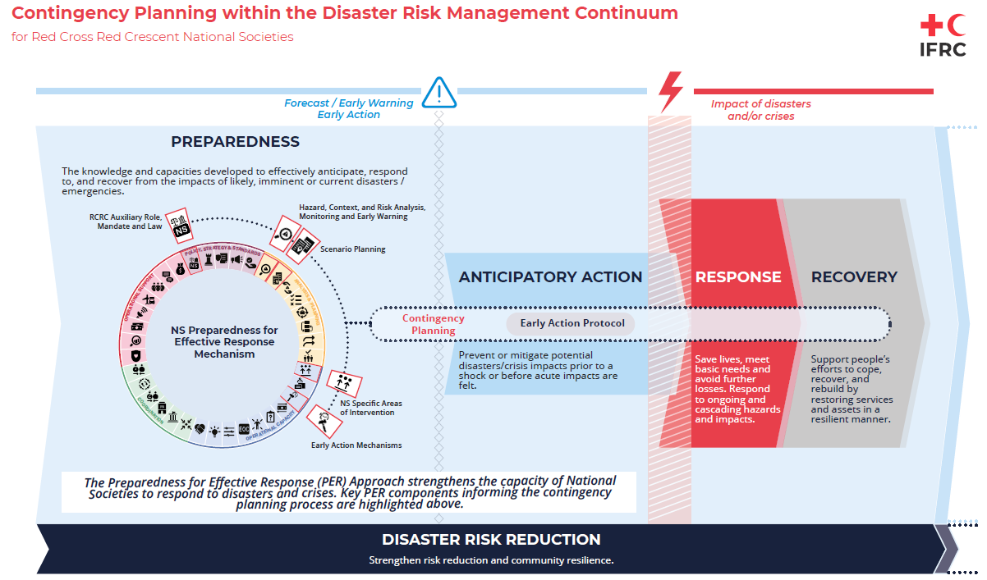

If your National Society has undergone a PER assessment, the findings will be particularly helpful for the contingency planning process. If the PER process is in progress, it can still provide a summary of which components are working well and which need improvement, highlighting some specific strengths and gaps. PER process is wider than contingency planning one (as focused on specific hazards or combination), some activities are similar. CP process could feed PER one. The PER Response Analysis Guidance document provides links to all 37 components and related benchmarks. Links to the National Society Preparedness for Effective Response (PER) mechanism are indicated, to allow National Societies already engaged in strengthening their PER process to refer to information they might already have collected.

For those National Societies that are also working on Forecast based Financing (FbF) connections between the contingency planning process and FbF are mentioned throughout the document and additional guidance on the two planning tools can be found in the document about connections between National Society Preparedness for Effective Response and FbF. Emergency Action Protocol (EAP) and CP focused on different timeframes in the disaster risk management continuum. EAP focused on the period of time between a forecast and the shock, while contingency planning focuses on the response. Meanwhile EAP may only include weather related hazards while the contingency plan should be broader and also include other hazards such as biotechnological hazards and epidemics However, some action overlap for example, evacuations, dissemination of early warning messages and actions that are done before an imminent disaster to make sure staff is ready to response immediate after the shock. These actions could be included in both the EAP and the CP, therefore the need for very close coordination in the design and implementation of both plans.
Other National Society Planning documents (operational, strategic, programmes’ plans) could help in elaborating contingency plan, as CP are generally developed in a rapid perspective to prepare for an imminent threat. If National Society has undertaken business continuity planning process, to ensure they could continue to operate in time of disaster, some process activities are similar or could complement each other, as example the analysis phase and more specifically the definition of the risk. More information could be found in the Explanatory note, Business Continuity Plan, Contingency Plan an Emergency Plan of Action link.

Key elements of the contingency planning process
The illustration hereunder summarizes the five identified phases of the contingency planning process for National Societies’ institutional preparedness. Each step of the different phases has been reviewed to be further simplified and clarified having been compiled from IFRC CP guideline, regional CP guidelines (Americas, Caribbean and Philippines), CP training package and National Societies’ most common practices.

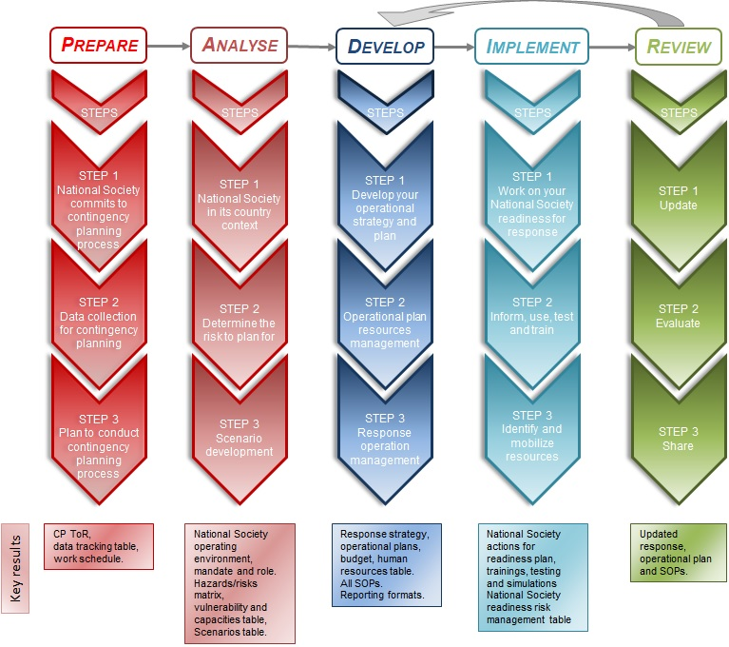

If the phases have to be carried out one after the other (as they feed from each other), they might slightly overlap or be complementary. Once a plan is finalized, steps 1 to 3 for the Review phase may be in a different order depending on the National Society’s situation.

Prepare
In this phase, the National Society plans actions to initiate the contingency planning process. This will depend on where the National Society is and where it wants to go to in its institutional preparedness process. The option of a Movement Contingency Plan is also considered and adopted when relevant (no specific template required but SMCC toolkit guiding principles can be used).
The quality of work done under this phase will ensure the success of the contingency planning process and will partly be used to fill up the introductory section of the plan (p.3 of the ready to fill template).
A template and guidance for Terms of Reference (ToR) with roles and responsibilities of the stakeholders involved in the planning process, a data tracking table and a work schedule can be found in Annex 1. They are preparatory results and do not need to be in the National Society contingency plan final document (as part of the CP template document). In this phase, it is also important to keep in mind the National Society’s position in country and how important it is to link any actions with government entities and key partners in the countries of intervention. For those national societies developing EAPs, BCP, under PER process or with pro-forma EPoA, or specific disaster situations with EPoA in development, coordination at this stage is essential to avoid duplication of efforts and optimize the time, resources for the development of all processes (contingency planning, BCP, PER process, EPoA and EAP).

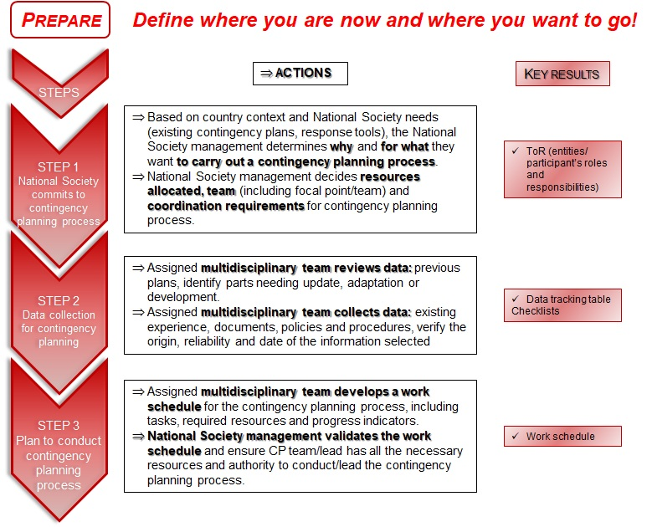

Analyse
The analysis phase is key. It will ascertain the value of your planning work. This phase needs enough time to think things through. The different steps and actions should allow your National Society to move forward. It is important to mobilize the right expertise, connect with national partners and look for existent relevant information prior to developing any further data.
It is understood that National Societies will start the analysis in Steps 1 and 2 and will adapt the approach to one where they feel the most comfortable. Based on National Society experience and in order to lighten the National Society Contingency plan template document, it is proposed to undertake the deep analysis of vulnerabilities and capacities in Step 3, when precise combination of hazards (priority risks) has been identified. If a National Society has gone through a FbF, BCP and/or PER process information on the risk analysis, historical impact, prioritized risks, exposure, vulnerability analysis, impact curves and triggers will be already available, it is suggested to review this information and use it to simplify steps 2 and 3.
Further tools are given in the Contingency plan template document, with links to take you to relevant guides and templates.

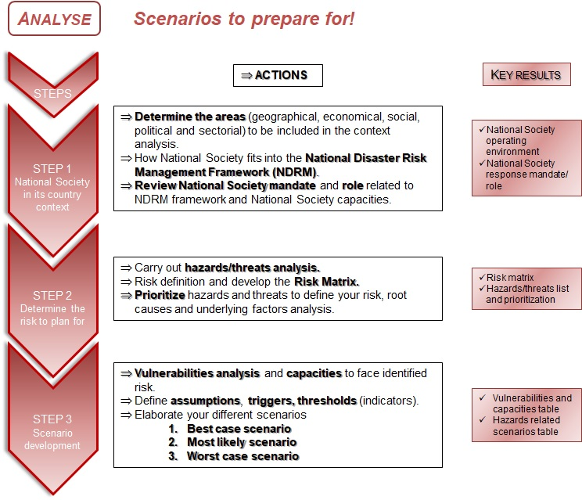

Develop
In the development phase the National Society defines its overall response to the different scenarios identified. Often the National Society operational response plans are developed for the most likely and worst case scenarios which will require scaling up resources to reach increased targets (based on humanitarian needs).
After defining your operational strategy and plan, determining your operating modalities (in step 2) requires you to look at your existing Standard Operating Procedures (SOPs), and how they are used/applied. Setting SOPs is crucial for a well implemented early action and response. Format and type of SOPs are listed in the annexes of the Contingency plan template document to further guide you. Ensure SOPs are simple, straightforward and reflect your team knowledge and capacities. Share procedures with National Society/PNS/Movement partners. Aligning SOPs set for FbF early action with CP SOPs can enhance the effectiveness of response operations, including early actions not covered by EAPs.
Here reference is made to the plan for National Society to respond to a specific crisis, all information and actions related to continuity of National Society usual activities are part of the Business Continuity planning process and should be reflected in this business continuity plan.
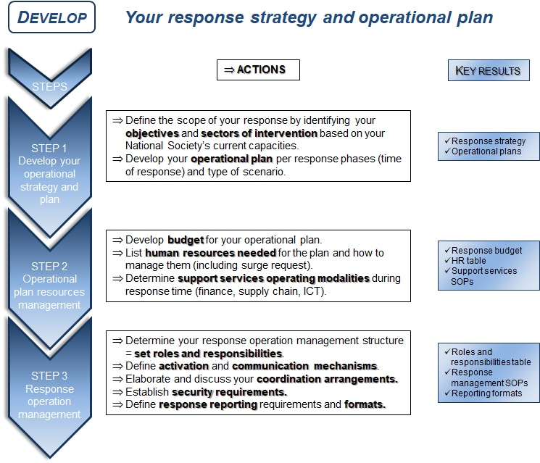

Implement
In the implementation phase the National Society uses the tools developed to make the operational plans actionable (based on specific scenarios).
Following the specifc actions to be taken for each step, detailed guidance is given to develop the National Society readiness action plan ) including appropriate trainings and testings as well as mobilizing resources to implement this readiness plan. These specific preparedness actions as well as the more generic preparedness actions based on overall risk could contribute to the PER mechanism. As they could be simiar, these “readiness” activities can be funded by the Forecast based Action by the DREF for the lifespan of the EAP (5 years). This example shows the importance to ensure alignment across different planning process, phases and preparedness/readiness actions to optimise resources mobilisation.
The tools in Annex 2 will guide you through the different implementation phase steps.
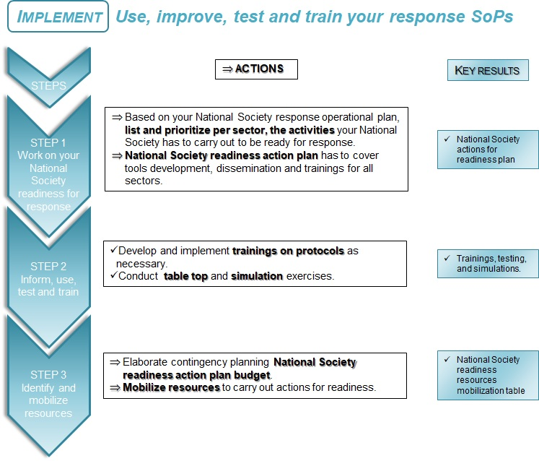

Review
The contingency plan process is a continuous process which needs to be regularly updated and adapted. This is the Review phase of the CP process. A National Society contingency plan is a living document. Regular review and updates are needed to ensure the plan remains relevant.
Further tools for CP evaluation/review and sharing process are given in Annex 3, with links to take you to useful guides and templates.

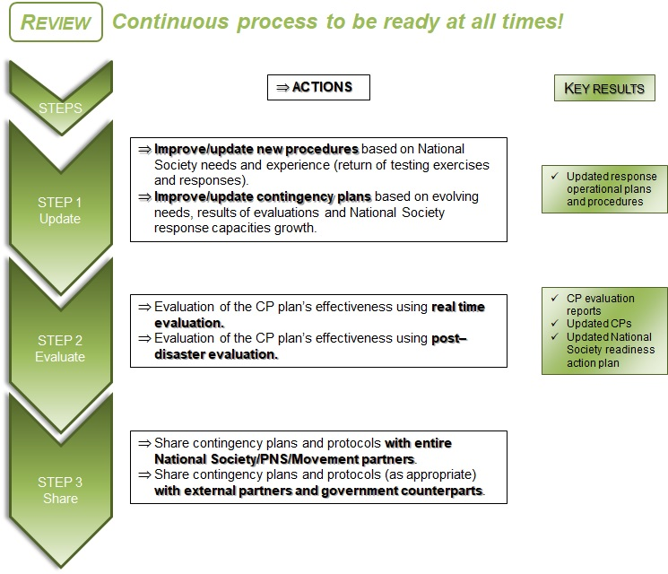
Step 1 has to be done after testing the plan (simulation or table top exercise), after a response (using result from the evaluation) and on a regular basis. The order of Steps 1 and 2 will depend on a situation of crisis or not. In normal time (non-crisis), Step 3 has to be a constant process (as part of the PER approach) while Step 2 is happening during or after the crisis.

Annex 1 – Preparation Phase tools

ToRs for National Society contingency planning process
[The text under each section is to guide the National Society and should be removed and/or replaced by National Society specific information.]

Context and background
What this contingency planning process is about
Based on your National Society core business and work in disaster time, what is your National Society mandate in the face of an imminent crisis or during response time?
National Society mandate => This requires mapping the country’s disaster risk management (DRM) context and the role of the National Society as a first-line responder, based on agreements with the government, the Red Cross Red Crescent Movement and National Society policies and strategic plans.
Based on country context and National Society capacity, what type of contingency plans need to be developed? If a PER assessment has been carried out, information collected through this process can be of great support to develop contingency plans. Are there already Early Action Protocols in place for specific hazards – or planned or under development? How will the EAP fit with the contingency planning process and the resulting operational plans?
Should the plan consider a single hazard/risk, several risks, or even a combination of several hazards (e.g. floods, locusts, natural hazard triggering technological disaster [Natech] events and COVID-19?). What period should be covered? How will the plan be tested? When will it be reviewed (e.g. for seasonal risks)? What indicators will trigger different type of actions?

Tasks to be completed:
List of tasks to be completed under this process
Looking at each phase and actions of the contingency planning process (Prepare, Analyse, Develop, Implement, Review) identify how you want to conduct the activities.
For each phase, try to set a methodological approach, quantifying the amount of work, who should lead the process and what are the resources needed. This will help you to define the length of the CP process.
This will also help you to determine if you need external assistance and how/where to get it.

Role of the team:
- Lead: It is important to assign this role to a person who has enough authority to mobilize the team, but also enough time to lead the process. i.e.
- Is responsible for the overall methodology and monitoring of the overall process
- Coordinates the information collection, teamwork and overall writing of the plan
- Has the required authority to ensure other team members/units are cooperating in a timely manner
- Has a coordination role with other disaster risk reduction activities including NS teams working in, PER, BCP and EAP developments

- Supporting team: Define the role and responsibilities of the support team (finance, logistics, ICT…)

- Other team members: Depending on the National Society’s potential intervention sectors, it is important to involve the related experts to contribute to the risk analysis, coordinate with disaster management/health authorities, and make sure that contingency plans reflect the National Society’s capacity to respond.

- Possible external support: This depends on the National Society’s capacities to lead the contingency planning process. Sometimes, National Societies need external facilitation or technical support for specific tasks. For example, the country context analysis could be supported by an external partner such as an Academic institution/university. Defining thresholds/triggers could be supported by meteorological agencies.

Timing and resources
Timeframe to achieve tasks – or core results with resources allocated to reach the results
For each phase and related actions identify the time required and the resources to be allocated. Determine key indicators for each action and/or phase. A project management table might help visualize the process.
Develop any additional documents (external consultant ToRs, budget…) required to support the National Society CP process.

Data tracking table
Listing data helps to track what is available and what should still be collected. Refer to a number of annexes that support the contingency plan. Data can be organized following the five areas of the PER mechanism.
 | Document title | Date | Where to find it | Key elements | Need to update /modify
Analysis and planning
Coordination
Operational capacity
Policy, strategy and standards
Operation support

Contingency planning process workplan
The table below is a suggested format. However, you can use any type of project management table to monitor the actions you have to take, define indicators of progress and timing. It is not necessary to develop too many indicators. Just make sure they are measurable and achievable with your National Society resources. To go further, identify needed resources and potential support.
 | Step | Actions | Resources allocated | Responsible | Indicators of achievement | Timing
Prepare | 1 | 1  2  3
 | 2…
Analyse
Develop
Implement
Review

It is important to define the resources allocated and whether the National Society has the capacities (funding, personal and skills) to lead this contingency planning process. An additional column could be added if there is a need of external support.

Annex 2 – Implement Phase tools

National Society actions to be taken for readiness

National Society readiness action plan
This component of the process is a mix of short-term planning items that can be included in the plan itself, and some much longer-term actions that are carried out as a recommendation of the plan. In other words: what should be done, when and by whom, to allow your National Society to anticipate and respond as per the agreed operational plan?
For example, in the development phase of your contingency planning process, you might have listed SOPs which need to be developed/revised. Ensure this is part of your readiness action plan. Your CP actions for readiness table (see template below) should prioritize the most urgent actions to articulate a minimum response for the identified scenarios.
Group each preparedness activity according to the main headings below and/or sectors (based on what works best in your context). These National Society preparedness activities should support identified early action and response activities. Include specific activities related to simulations, table top exercises to test the plan, as well as training required per sector, all of which inform the plan (this could also be taken back into the human resources section below).
National Society Actions for readiness | Indicators of achievement | Lead responsible | Timeframe | Budget required | Remarks
Response operational support – early warning/early action
Activity 1 – Main activity
Activity 2 - ….
This section can include preparedness actions
Technical sectors - early warning - early actions as per expected intervention
Activity 1 - Activity 2…
List specific early warning/early actions taken per sector. Refer to: Forecast Based Actions
Structure and management
Operational planning and support (including sub-headings for each technical sector and support unit)
Information and reporting
Resources mobilization
Surge capacity (national, regional and global, depending on the need)
Include staff /volunteers capacity development required (trainings)
Movement coordination and humanitarian diplomacy
Testing and evaluating the plan

Inform and train human resources

National Society team training needs
In this section you need to answer these questions:
- How many staff and volunteers will be needed to implement the operational plans elaborated in your CP?
- Which skill sets are required?
- How many staff/volunteers does the National Society already have?
- How many have the necessary skills and competencies?
- Conclusion: how many new volunteers should be recruited? Which training should be provided, and to whom?

Staff/volunteer recruitment and training should be included in your National Society readiness action plan. You can also use the Preparedness for Effective Response benchmarks to define your preparedness actions and as indicators of achievement.
National Society human resource training requirements and needs could be summarized in a table.

Simulation and table top exercise
Testing the operational plan is the best way to ensure your National Society team is up-to-date with the plans and knows how to act before and during an emergency. This might also be considered as part of your plan validation process.
Testing the plan could be done by simulating situations as close as possible to the predicted scenarios identified in the plans. This could be done by field testing, but also as a table top exercise which requires fewer resources and less time.
For more information on simulation, you can refer to ECB Simulations Project, ToT, 2007, Practical guide for simulation, CREPD, 2009, IASC Government Emergency Simulation, 2012 and Testing and learning PER benchmarks.
Simulation specific tools can be found in Guidebook, Template, Visual Explorer tool, Simex (Master Template / Scenario- Drought, Earthquake, Epidemic, Flood, Tsunami) and Training of Trainers (3Day Training/4Day Training).

Resource mobilization

National Society readiness plan budget requirements
Explain how the National Society plans to acquire the necessary resources to implement this readiness action plan. As mentioned before for weather related hazards that can be forecasted, the National Society may have already a developed Early Action Protocol. EAPs have three types of costs included, readiness, pre-positioning and the implementation of the early action. Once the EAP has been approved by the Forecast based Action (FbA) by the Disaster Relief Emergency Fund (DREF), funding will be made available to the National Society annually to complete those readiness activities that are deemed essential for the NS to be able to implement the pre-agreed early actions. This is an opportunity to make sure those readiness activities in the EAP are contributing to the overall National Society readiness plan. The whole FbF process is outlined in the FbF manual.
Based on the defined targets in your response operational and budget plan tables (in the “ready to fill template” document), detail all needs to be covered into your preparedness plan. See what could be included in your National Society routine activities and budget.

National Society Actions for readiness | Existing Resources | Targeted Resources | Gap | Budget (local currency) | Budget (chf / eur / usd)
Structure and management
Activity 1
Activity 2…
Operational planning and support (including sub-headings for each technical sector and support unit)
Information and reporting
Resources mobilization
Surge capacity (national, regional and global, depending on the need)
Movement coordination and humanitarian diplomacy
Testing and evaluating the operational plans

Budget comparison between National Society response and readiness plans
In the table below you should give the totals only, just to summarize the two resources tables and give an overview of the total budget needed. This will help you to determine if your National Society response and readiness action plans are realistic and interlinked? But it is also a basic analysis of your resource mobilization needs. This might help your National Society in fundraising.

 | Budget (local currency) | Budget (chf / eur / usd)
Preparedness activities
Response activities
Total

Annex 3 – Review Phase tools

Evaluating the plan
Define how your National Society wants to evaluate the plan:
- Activated and implemented in real response situation
- Tested in a simulation

Evaluations should be frequently made with real data using different methodologies, such as the following:
- Evaluation during the response
- Evaluation post-disaster

To define your evaluation methodology and questions you can refer to the following framework and guidance: IFRC framework for evaluation, IFRC Evaluation guideline - 2011, DREF lessons learned.
Regardless of the type of evaluation to be developed, the most important things to determine are the conclusions, lessons learnt and recommendations to improve existing and future response and contingency plans.

Sharing and reviewing
The National Society should agree on how frequently the contingency plan is reviewed, tested and updated. Write a narrative that details the agreement on review and updating. It is also important to define the approval mechanism and how to share your plan internally and externally.
To ensure the periodical updating of plans, there must be clear and appropriate procedures for the National Society. Updating procedures can be very simple but should include at least the following elements:

Sections to update | Frequency | Methodology | Responsible | Required Resources
A detailed list of the parts of the plan that must be updated, with a recommended timeframe, wherein the most important contents are well defined, as not all are updated with the same frequency or in the same way. | Clearly define how often each part should be updated. This will be organized by importance of the information and the frequency that the information is susceptible to change. For example, everything referring to resources will change more often than data related to the general context. Contingency plans should be updated much more frequently than response plans. | For each part, choose the most appropriate methodology. Some elements can be updated easily by consulting Web pages or institutional and strategic documents, while others require consultative processes or processes of evaluation, simulation or training exercises. | Resources existing in the institution should be optimized and responsibilities should be divided for updating different parts. Normally, the capability part is updated through human resources, while the response scenarios and strategies are done by programme directors or technicians. It is always recommended that one person is responsible for ensuring the complete fulfilment of the process. | If during the updating process there are additional or missing resources, this situation should be clearly identified so that it can be reflected in the National Society’s budgets.

Disaster Response and Contingency Plans: A Guide for Caribbean Red Cross National Societies, 2014 – P19. Adapted
Here “Readiness plans” are understood as preparedness for response plan. This is the definition used in these tools.
Over 40 contingency plans from Asia, Americas, Africa, Europe and Pacific regions were collected and consulted.
Emergency Plan of Action
Refer to National Society operational response plan section into the CP template document.
Here readiness action plan refer to preparedness actions to be ready for specific scenarios.
Include here Emergency Needs Assessment Planning (ENAP) if possible. If not, this has to be included under the operational heading in the following period.
If your National Society can find useful elements in this process; it will be easier to be accompanied by partners and/or IFRC.

