Session 2: Environment and Emergencies: an introduction
Desktop exercise 1: Hurricane Robson in Estar, Central America

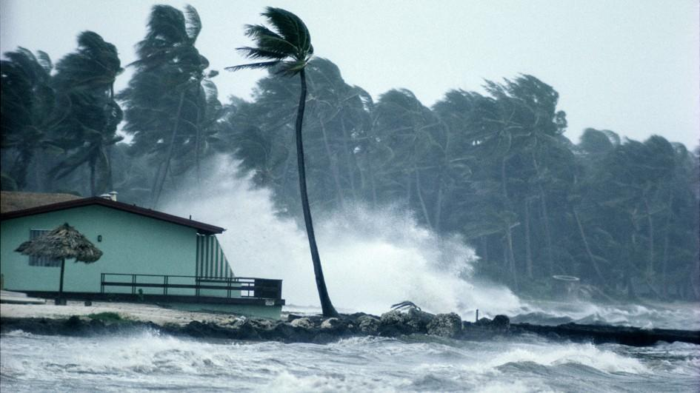

HURRICANE ROBSON
Country Profile
The state of Estar is located in Central America. It is home to over 17 million people and covers an area of 100,000 km.² It consists primarily of Spanish speakers, although several indigenous languages still feature prominently in many areas of the state. Estar has experienced a prolonged conflict for over twenty years, as local insurgents have attempted to fight against the state.
One of the sources of tension is the historical underrepresentation of Estar’s indigenous communities in the government. The Esta people have occupied the area for thousands of years and nowadays are more than 40% of the total population. They still continue to preserve their rich cultural traditions and places of worship.
Estar’s rural areas are marked by beautiful landscapes, but are also home to some of the worst poverty in all Central America - the rate of people in extreme poverty is over 20 percent. Nevertheless, Estar’s economy is prospering. Its GDP and its income rose significantly in the past decade. The main GDP sources come from tourism and from the exploitation of natural resources, particularly fishing and mining.
Livestock and extensive farming are major sources of income in the southern Estar. Most part of the agricultural facilities contain pesticides and various other chemicals used for food production.
They impose a threat to human health and to the water resources, which is also being affected by the country’s rapid and unplanned urbanization. The same occurs to the sanitation facilities, making a significant part of the population prone to contract fecal-oral diseases. The situation is aggravated with a poor waste management system, especially in the big cities.
The government has an ambitious environmental strategy, focused on conservation and pollution. However, the implementation of the programs has been plagued by budget constraints and a lack of governance. Enforcement of environmental regulations are essentially non-existent. The coast makes the exception. Aiming the attraction of tourists, the government has implemented strategies to preserve the coral reefs, sandy beaches and neighbouring forests.

Scenario
Short brief – Hurricane Robson
In August 2017, hurricane Robson hit Estar and was followed by heavy rainfall, causing intense damage to the country’s population and structure. At least 25 people have been confirmed dead and hundreds are still missing. Part of the villages and cities were damaged by the strong winds and the floods caused by the uninterrupted rains, forcing the displacement of around 10,000 people and the improvisation of temporary shelters.
The impacts on the environment are still being felt. Southern Estar, home to many of the Indigenous Esta people, has experienced the worst effects of the hurricane, and at least 50% of its agricultural areas were damaged. The intense amount of rain also caused mudslides and mudflows along the rivers. The coastal areas, on the other hand, are suffering more from the floodings. Considering the general situation throughout the country, a state of emergency has been declared by the Estar Disaster Coordination Authority.

Extended Brief – Hurricane Robson
Estimates of the death toll by Hurricane Robson in Estar have by now surpassed 500 and hundreds of people are still missing. The projections made by local news sources indicate that over 50 percent of the national territory has been affected. Thousands of people have fled their homes to get away from the increasingly flooded area.
The inhabitants of the Southern Estar are the most harmed ones. Due to the housing destructions and energy restrictions, around 10,000 people were forced to leave their homes and are temporarily allocated in schools and governmental buildings. Their access to food is restricted, since the winds, heavy rains and especially the flooding, damaged around 35% of the crops and the livestock. Water contamination also restricted their access.
What makes the current humanitarian crisis especially difficult to handle is the geography of southern Estar. The southern region is predominately mountainous, with steep cliffs and limited access to remote communities due to flooded roads.
Some roads were also closed in the coastal areas because of the flooding and mudslides. For instance, there have been unconfirmed reports of mudslides in the province of Girodo, the biggest of the Pacific Coast. There is no official information available and proper data is difficult to obtain.
Heavy rains also have produced runoff into the coastal zone, with suspension and particles affecting the tourist destinations and coral reefs. Domestic waste can be seen on the shoreline and urban areas. Moreover, a massive former landfill in Girodo, with poor design and maintenance, has been affected. The waste management in Estar was precarious before the hurricane, and now it has worsened.
Humanitarian agencies have already pledged their support to alleviate the suffering of those communities hit by the storm. In the meantime, the Estar’s defence force has been supporting the evacuation of citizens and the provision of immediate relief. Civil protection teams from nearby Central American countries are also inbound. In addition to humanitarian assistance, the government has requested support in determining the impacts of this hurricane and how to respond.

