Session 2: Environment and emergencies: an introduction
Desktop exercise 2: Tailings dam collapse

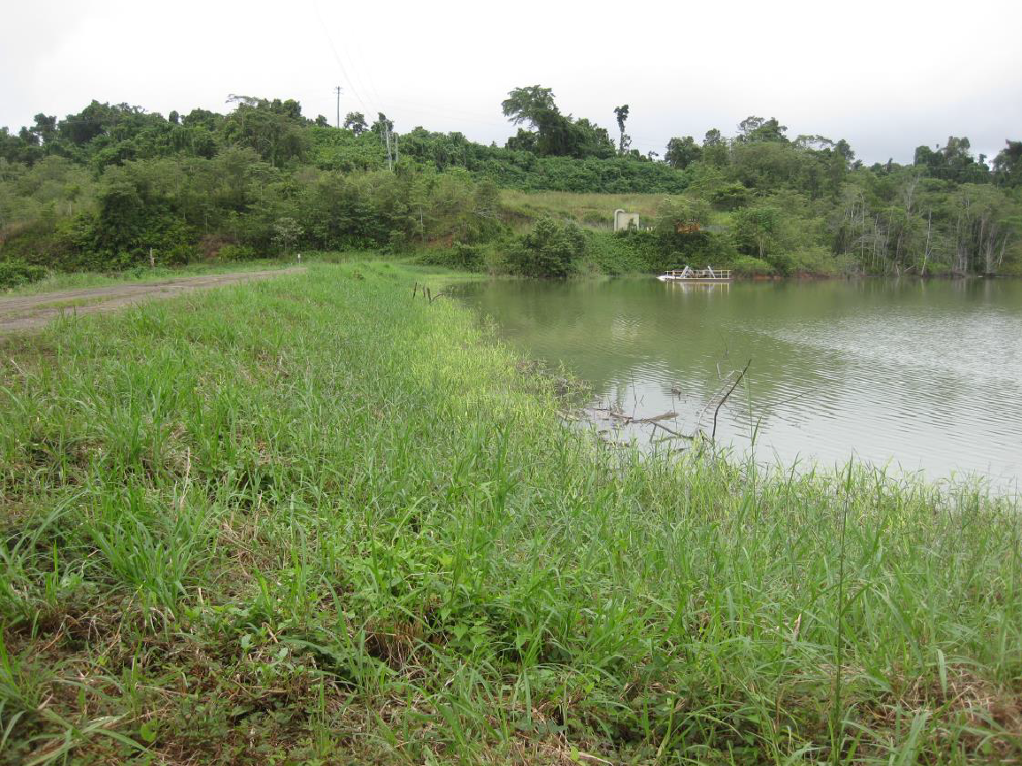

TAILINGS DAM COLLAPSE
Country Profile
The country of Garland, located in the South Pacific, consists of a series of six major islands, as well as several smaller islands. The terrain is mountainous and heavily forested. It has a tropical monsoon climate with extremely humid temperatures throughout the year.
The entire country has a combined area of 32,586 km² and a population of about 650,000. The largest island, Roberto Island, is also the most populous one – and home to the capital city, Osuna.
Garland is one of the least developed countries in the region. It achieved self-government over forty years ago, but armed conflict and civil unrest has hampered its development. Reconstruction efforts have progressed in recent years, but the rural villages, where the majority of the population lives, are still undeveloped.
Most rural households depend on agriculture, marked mostly by intensive farming, and livestock. The agricultural sector employs around 35% of Garland’s workforce. The negative side is the increased pollution due to the use of agrochemicals. The country’s GDP relies primarily on the exportation of fruits, rice and fish. There is no significant industry and the service sector has slightly increased in the last year.
Mining is another important component of Garland’s economy, since the country has many mineral resources. Most of them are extracted by foreign companies and impose environmental problems as erosion and contamination of soil, groundwater and water from the chemicals utilized. The national authorities have tried to introduce and enforce legislation, but they have not been very successful so far.
The country has rampant political corruption, which prevents effective environmental policy, and has been recovering from the violent civil war in the past.

Scenario
Short brief – Tailings dam collapse
Garland was recently hit by heavy rains causing flash flooding. The floods have caused damage to the capital city, Osuna, and also in the areas of the Morales province, placed in the second biggest island of the country.
In addition, the floods have hit a tailings storage facility used for gold mining, situated about 100 km from the capital, Osuna. This tailings storage facility is used to store the by-products of the materials mined by the Garland Goldmine. The Garland Goldmine is owned by the multinational corporation Red River Corp. There are concerns that the tailings dam used to house the materials will burst, causing further harm to the Garland population.

Extended Brief – Tailings dam collapse
For the past 72 hours, Garland has been hit with over 400 mm of rainfall. The rains affected the capital city Osuna, provoking the death of 23 people and the missing of hundreds. The immediate response to the emergency has begun. The Garland Red Cross Society (GARRCS) and the IFRC have begun to address the immediate needs of communities affected.
As the floods have slowed down, attention has turned to the situation at the Garland Goldmine. The water levels in the mine’s tailings dam has increased significantly. The mining facilities have been evacuated by the operator, and operations have been suspended. The Red River Corp., which has been plagued by recent environmental scandals, has dispatched their own emergency response team with several dam experts and crisis managers. Their proposal is an emergency dewatering of the dam, which would release sludge into the Baylor River, located below the tailings facility.
A number of small settlements are located on the shores of Baylor river. At least 3,000 people live directly downstream of the tailings facility, and rely on the river water for washing, fishing and irrigation. Furthermore, the more of 10,000 inhabitants of the city of Palco, that is 10 km downstream of the tailings facility, also depend on the river.
The communities are not in favour of a dewatering, since they are concerned with the potential hazardous substances contained in the sludge. Around five years ago, the mine released tailings water into the river by accident, which led to fish deaths.
Beyond subsistence, fishing is one of the main income sources for the community. Another one is agriculture, which would also be affected considering that the water for irrigation comes from the river and the chemicals can also have a direct impact on the soil. Beyond the economic side, there is an eminent threat for the population’s health, that would be consuming unsafe substances directly and indirectly. In the worst case scenario, they might be forced to evacuate the area.
While aid is being provided for the communities affected by the flood, the Government of Garland is overwhelmed by the situation and has requested help in determining the disaster’s impacts on the tailings storage facility and downstream communities.

