Session 2: Environment and Emergencies: an introduction
Desktop exercise 3: Drought in Dryland
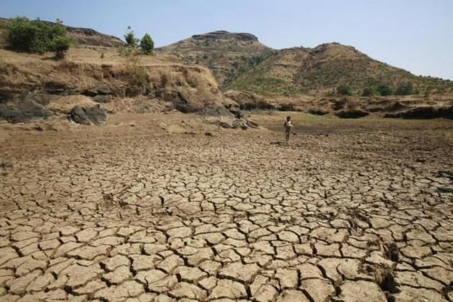

DROUGHT
Country Profile
Dryland is one of the least developed countries in the world, with a history of prolonged political instability and conflict attributed to ethnic tensions. The political situation has improved in recent times, although it remains fragile to external stresses.
The low scores in development indicators are aggravated by numerous other factors such as economic decline, environmental degradation, poor governance, poverty, social and economic inequality, among others. An interim government, backed by the international community, is currently in place. Elections are due to be held in the coming months, and international observers are already present.
The economy of Dryland is predominantly dependent on agriculture and remittances. Urban infrastructure is almost non-existent. However, the capital, Drylandia City, which is near the southern borders of the country, has seen some recent economic development, including the emergence of new industrial facilities on the urban outskirts.
Located in Northeast Africa, Dryland has a total area of 286,320 km². The majority of the country has a semi-arid climate with low amounts of arable land. The average daily temperature ranges from 25°C to 35°C. Rural and nomadic inhabitants make up the majority of Dryland’s population of 10 million people.
Due to the prolonged instability and conflict, environmental management has not been a priority for political and humanitarian actors. The conflict has had devastating impacts on the environment. Numerous oil wells have been set on fire as a form of protest, and large amounts of conflict-related disaster waste remain unmanaged.
Investment in environmental-related infrastructure and services, for example in solid waste management, has been non-existent. Furthermore, the recent industrial expansion near Drylandia City has been largely unregulated by the interim government.

Scenario
Short Brief – Drought in Dryland
Dryland has experienced two consecutive years of poor rainfall and the outlook for the upcoming season is bleak. The lack of local and transboundary water resource management has made it worse. Although the country is not unfamiliar to droughts – they are a recurrent hazard – this is reported to be one of the most intense in recent history.
This current drought has had a devastating effect on Dryland’s predominately rural communities. Food security and restricted access to water are alarming, and over 3 million people are estimated to be in need of humanitarian assistance.
In the rural areas, there is a lack of basic food due to failed harvests, which is causing a displacement into the outskirts of cities, especially into the capital. As the access for food is insufficient, some people are starting informal farming.
Despite the presence of international organizations in the country, humanitarian access is challenging, especially in the Northern Dryland, due to the conflictuous situation.

Extended Brief – Drought in Dryland

The current drought in Dryland has had a devastating effect, which is exacerbated by the recent El Niño phenomenon. Experts are concerned that the upcoming year will also see below average rainfall, despite the positive forecast.
The drought is most severe in the northern regions. The centre and south have also been affected, but to a lesser extent. Approximately 50,000 people in total are in need of humanitarian assistance. There is almost total crop failure and large levels of livestock deaths in the north. The last harvest was 60% below average. Malnutrition and drought-related diseases are on the rise. Humanitarian actors are warning of potential famine, that could affect up to half of the country’s population.
It is estimated that 500,000 people were displaced, especially from northern to southern Dryland and to neighbouring countries. The majority is concentrated in the urban periphery of Drylandia City and lives in unmanaged informal settlements, with little or inexistent infrastructure. Informal farming is arising to supply the demand.
Many industrial facilities, owned by international corporations, near Drylandia City have shut down due to the drought. In lieu of other livelihood alternatives, these facilities have been looted, with parts and machinery sold as scrap metal.
The migration has led to increased competition for resources and tensions between communities. International experts are concerned about the risk of conflict reigniting due to deteriorating political stability caused by the secondary effects of the drought.
The cluster system has been active in Dryland for many years due to the conflict and has remained to support the recovery and transition. UN agencies and INGOs have a well-established presence in the country, and work closely with the interim government. A recent humanitarian appeal for drought response has been successful and a large surge of humanitarian assistance is expected in the coming months. Food security, nutrition, WASH and health are the main sectors funded.

