Session 2: Environment and Emergencies: an introduction
Desktop exercise 4: Wildfire in the Fogo islands
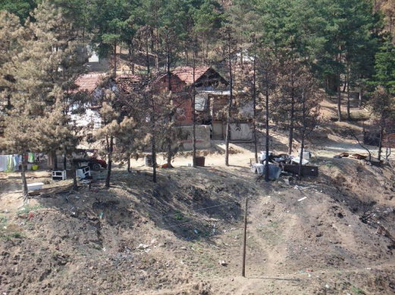

WILDFIRE
Country Profile
Fogo Islands are a group of small islands of volcanic origin located in the Atlantic Ocean. The country’s surface area is of approximately 750,000 ha and around 200,000 people live there. Most part is in the Gander Island, which represents approximately 40% of the total area, and where the capital, Gander City, is located.
The country is recognized as a Small Island Developing State (SIDS) and, as such, faces many development challenges due to its remoteness, limited resources, dependence on foreign trade and fragile ecosystems. Nonetheless, the Fogo Islands has made significant progress in economic growth. Even the poorer communities are at least almost self-sufficient. The country’s economy is reliant heavily on agriculture and fisheries, and there is also a growing tourism industry.
The country’s main infrastructure and services are centralized in the capital. The other islands, from which many are uninhabited, are predominantly untouched. The access between them is made only by boat, which hinders the entrance and exit of any material. Waste management, for instance, is challenging. There are just a few waste treatment facilities - and none for hazardous waste - and the spaces for disposal and storage are limited. Open waste burning is a common practice.
Fogo Islands have a rich biodiversity, with species endemic to the region. A good portion of its islands are designated as ecological reserves. Furthermore, the diverse forests permit the use of medicinal plants, a tradition among the native inhabitants. Most part of the practices are informal, but there is a formal sector arising.
The rich nature of the country is also part of one of the most natural disaster prone regions on earth, making it particularly susceptible to natural hazards including droughts, tropical cyclones, floods, earthquakes, volcanic eruptions and wildfires. The national government, as well as international partners, have recently recognized this, and are beginning to invest heavily in disaster risk reduction.
The government is also investing in new infrastructure and services to reduce environmental impacts within areas such as solid waste management, sanitation and water.

Scenario
Short Brief – Wildfire in the Fogo Islands
In the past few months, the Fogo Islands have experienced drought-like conditions. A heat wave, combined with windy weather in the past week has resulted in many wildfires scattered throughout the islands. Whilst wildfires are prevalent during the summer, the intensity and extent of the fires faced this year are uncommon.
Wildfires are ongoing. Authorities have managed to contain the fires on Gander Island, though due to logistical difficulties and limited resources, many of the fires on the smaller islands remain unchecked and out of control. By the moment, there are no official reports available, but it is estimated that around 20,000 ha of land has been burnt, a number expected to increase.
At least 7 people died due to the wildfire, and many are injured. Around 500 people were forced to move from the smaller islands to Gander City, where the situation is more under control. Authorities have declared a state of emergency and requested international assistance.

Extended Brief – Wildfire in the Fogo Islands
Recent summers in the Fogo Islands have been characterized by extreme heat and dryness. The fire danger levels have been at extreme for weeks and a fire plan has been in place. However, enforcement has been poor and many remote communities have continued with traditional practices of open waste burning and outdoor cooking, unintentionally starting wildfires. Another cause are lightning strikes.
The National Civil Protection Agency, responsible for overseeing emergencies, estimates that approximately 30,000 ha of land has been burnt, but this number can be higher. The smaller outlying islands are the most affected. Now it is known that at least 10 people died and approximately 500 people have been displaced or evacuated to temporary shelters in Gander City and surroundings. The numbers can be higher, since communication with these islands is difficult, and consists mostly of word of mouth and remote monitoring.
High-value forests, such as natural (state owned) or planted pine (privately owned) were majorly affected. The intensity of the fire has impacted heavily the soil cover and the forest floor, from where nearly all burnable material has been consumed. In one of the smaller Islands, a medicinal plant factory nearby one of the natural forests was also stricken. Other small informal settlements are reported to have been destroyed, although the extent of damages is still under assessment.
On Gander Islands, no property or industrial damage has been reported. Some electricity transmission lines and communication towers have been damaged, leaving numerous communities without electricity. A few smaller secondary roads have also been damaged, isolating some remote communities. In the whole country, only a limited amount of agriculture or cultivated lands has been affected.
Emergency funds have been released and state authorities and local NGOs are providing support to displaced persons. Appeals for international monetary humanitarian assistance has been requested, though no new organizations – apart from those with pre-existing activities on the Fogo Islands – are expected to respond. Emergency shelters are rapidly being renovated to ensure the provision of basic services. Significant amounts of NFIs and in-kind donations have been provided by the local population to those affected. Moreover, international firefighting support has recently arrived.

