Session 2: Environment and Emergencies: an introduction
Desktop exercice 5: Pipeline accident in Norborne

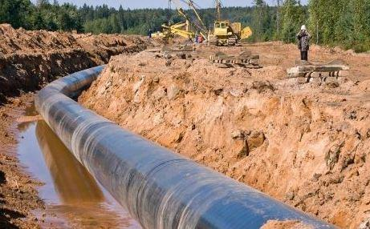

PIPELINE ACCIDENT
Country Profile
Norborne, located in Central Asia, has a population of approximately 80 million people in 512,130 km² of extension divided in 30 provinces. Its climate is classified as continental, with very hot summers and severe winters.
It is a is a higher-middle income country that has experienced impressive rates of economic growth in the recent years. Hidden behind Norborne’s development, however, are some troubling figures.
Its inequality grows steadily, and there is political tension between its major political parties. Furthermore, most part of the country’s GDP comes from the exploration of natural resources, including oil, gas and minerals, generating negative environmental impact. Each year, Norborne emits over 3,000 million metric tons of greenhouse gas emissions, placing it among the top polluters in all the world.
Norborne is also home to several oil pipelines, including the Windermere Pipeline in LaSalle, it’s biggest province. The infrastructure that carries fossil fuels throughout the country is aging and becoming more vulnerable, as the 190 significant pipeline spills that happened in the last year show. Since 2005, the costs of the leaks has amounted to $6.7 billion.
Since the 1970s, despite frequent legislative gridlock, there have been significant achievements in environmental regulation, including increases in air and water quality and, to a lesser degree, control of hazardous waste. Due to increasing scientific consensus on global warming and political pressure from environmental groups, modifications to the Norborne energy policy and limits on greenhouse gas have been suggested.

Scenario
Short Brief – Pipeline accident in LaSalle
Yesterday afternoon, the Windermere Pipeline in LaSalle, which is 15 km from the capital of the province, the city of Oakbank, burst. The accident happened when two employees were working on fixing a flaw in the oil pipeline. Three people were killed, including the two men, and twelve others were rushed to the nearest hospital in Oakbank.
The Oakbank Fire Department (OFD) is still on the scene, but even when the fire is extinguished, local experts fear for the aftermath of the situation. Based on the size of the installation, it is estimated that more than 200,000 liters of gasoline have leaked.
There is a concern about the possible impacts in the capital and, even more, in the area of the recently closed industry of Wilkes Coal Mine, that still houses various mining-related materials. The LaSalle Emergency Response Team (LSERT) is considering the evacuation of some surrounding areas, where approximately 15,000 people live. The Silas Gas has not release any announcements yet.

Extended Brief – Pipeline accident in LaSalle
The Windermere pipeline explosion has shocked LaSalle. The fire is likely to be extinguished soon, although the effects of the accident are likely to continue. All in all, experts estimate that between 200,000 and 400,000 liters of gasoline will be spilled as a result of this accident.
Authorities have limited the access to the area of the spill, and it is believed that they are going to welcome international responders to the country to assist with the response, assessment and recovery, since they have not enough resources. Silas Gas, the company responsible for the Windermere pipeline, has not released its strategies or guidelines for the accident recovery.
Evacuations begun to happen, fearing the effects of the spills, commanded by LSERT. Both in the areas of the Wilkes Coals Mine, within a 3 km radius of the explosion, and in the south of the capital, closer to the area of accident. More than 2,500 people, described as part of the “working class”, are forbidden to be back to their houses until the end of the assessment. They are mostly workers at a fertilizer plant, several farms, summer homes, and a large steel mill of the region.
The risk of contamination caused by the explosion and the leak of gasoline are also threatening to the water systems of the region. About 5 km away from the explosion, in the way to LaSalle, the Mala river is located.
Built over fifty years ago, the Windermere pipeline has been a valuable source of fuel and income for LaSalle, but it has not been without opposition. Protestors demonstrated against the extension of the pipeline two years ago, to no avail. Furthermore, experts have expressed concern about the fact that the pipeline runs quite close to urban centres, especially Oakbank.

