Session 5: Flash Environmental Assessment Tool (FEAT)
Simulation Exercise: EARTHQUAKE IN SUNDARA
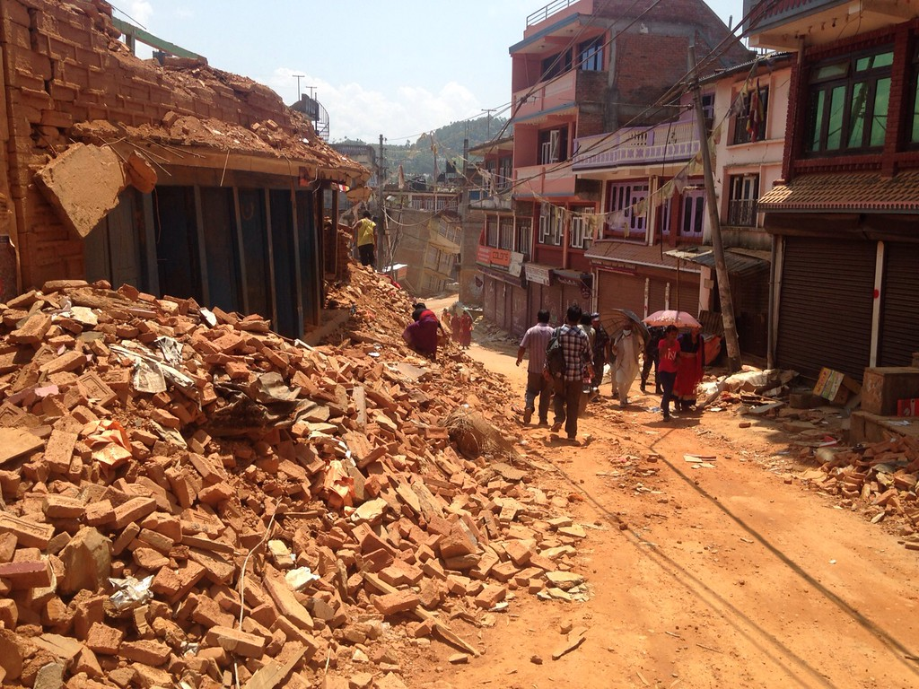

General note on the simulation exercise

The scenario for this simulation exercise introduces some of the challenges and dilemmas common to a large-scale, natural disaster emergency. The geography, climate, economy, and political structure mirror that of Nepal. No organisation or person, national and international, portrayed in the simulation is real, or based upon an actor involved in any actual operation.
This simulation exercise encourages the participants to share actions, tips and tools to address the challenges and dilemmas an Environmental Expert would face throughout the mission cycle. Participants do not have all the information that would be available in a real situation. When in doubt, they should be encouraged to make reasonable assumptions, based on knowledge of similar situations and move on. They may consult with the team’s mentor and the training facilitators regarding any questions. The participants are expected to make use of the Environmental Emergencies Guidelines and FEAT 2.0 Pocket Guide.

Country Profile

Country: Sundara

Capital: Atma
Population: 28,825,709 (2017 estimate)
Area total: 147,181 km²
Water (%): 2.8
Economic status: Sundara’s Gross domestic product (GDP) for 2012 was estimated at over $17.921 billion. In 2010, agriculture accounted for 36.1%, services comprised 48.5%, and industry 15.4% of Sundara's GDP. Agriculture employs 76% of the workforce, and produce mostly tea, rice, corn, wheat, sugarcane, root crops, milk, and water buffalo meat. Industry mainly involves the processing of agricultural produce including jute, sugarcane, tobacco, and grain. Sundara's exports of mainly carpets, clothing, leather goods, jute goods and grain total $822 million. The European Union has emerged the largest buyer of Sundari ready-made garments, with exports accounted for 46% of the country's total garment exports. Sundara is one of the least-developed economies in the world, with a GDP per capita of 730 USD, which is the lowest in Asia.
Geography and Climate: Sundara is a landlocked central Himalayan country in South Asia. It is a highly disaster prone country, and is the eleventh most earthquake-prone country in the world. The terrain in Sundara ranges from low-lying plains in the south, to hilly and mountainous in the north. Accessibility is challenging in the hilly and mountainous regions, with access often only by foot. Numerous rivers run throughout the valleys in the hilly and mountainous regions. A large majority (81% as of 2016) of Sundara’s population is rural. Most of the industry and economic development is concentrated in Atma. Infrastructure is lacking outside of the capital and most rural Sundari families are dependent on arable land and local natural resources for their livelihoods. Sundara is characterised by harsh winters and hot summers, as well as a monsoonal season from the months of June to September. Floods and landslides are a common occurrence during the monsoon.

The Earthquake
SUNDARA
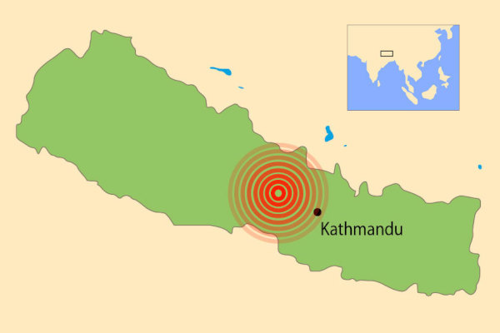
Atma (capital)
Sundara earthquake (7.8M)

On 14 September 2017, a 7.8 magnitude earthquake struck Sundara, 81 km northwest of the capital town Atma. This was followed by strong aftershocks, including one of 7.3 magnitude with an epicentre 18 km southeast of the town of Desalar on 16 September 2017.
The earthquake and its aftershocks left nearly 8,857 people dead and over 21,000 injured. The earthquake destroyed over half a million houses and damaged over 200,000 more. A large number of people were displaced and living in temporary camps in Atma and near district headquarters.
Factsheet on earthquake in Sundara
Date: 14 September 2015
Magnitude: 7.8 (Mw)
Epicenter: 28.147°N 84.708°E
Coordinates: 28.147°N 84.708°E
Type: Thrust
Total damage: $10 billion (about 50% of Sundara's nominal GDP)
Max. intensity: IX (Violent)
Aftershocks: 7.3 Mw on 12 May at 12:50
Casualties:
- 8,857 dead
- 21,952 injured
- 3.5 million homeless

The earthquake had a significant impact on water and sanitation, energy, infrastructure, transport, social services (education and health), forests, agriculture, and the private sector. Preliminary reconstruction costs are estimated at US$ 6.7 million. The most severely affected districts are in the mid-hills and mountains of western and central regions. A large scale relief effort was launched by national authorities supported by international emergency response providers. It is estimated US$ 422 million will be required to reach 2.8 million people in need of humanitarian assistance.

Impacts

- An estimated 2.2 percent forest cover was lost in six earthquake affected districts.
- The earthquake triggered over 2,500 landslides, generating a large amount of debris which will increase the sediment load and risk of flooding along several rivers.
- Hydrologic changes were recorded in several districts as water flow in some springs decreased while at other water sources there were reported increases in water flow.
- Vital sources of income for many rural communities are the 800,000 tourists visiting Sundara each year, of which a majority enter national parks. As a result, loss of natural resources and damage to ecosystems will threaten the livelihoods, food security, and health of many vulnerable communities.

In the aftermath of the catastrophe…

Water: Following the earthquake, water supplies were severely affected increasing public health risks including the spread of WASH related disease. It was estimated that about 1.1 million people lost access to protected water supplies and toilets. The monsoon rains have caused floods which further damaged water systems.
Health: Health care infrastructure was severely damaged in 14 districts depriving access to regular health care to thousands of affected people, and putting them at risk of contaminated drinking water and soil due to improper management of medical waste. The majority of healthcare facilities, including hospitals, do not have incineration and sterilisation facilities to treat waste. Medical waste may be sorted but is then often burned and/or buried in open pits near facilities or even mixed with municipal waste management operations.
Emergency Shelter and Non Food Items: Approximately 500,000 private homes were destroyed and over 250,000 damaged by the earthquake. In addition to houses, approximately 6,200 government buildings, over 1,200 health facilities, and 8,300 school buildings were destroyed or damaged.
Early Recovery - Debris waste management: An estimated 4.0 million tons of debris were generated due to the earthquake which added a significant challenge to district authorities and municipalities which were not well equipped to manage prequake solid waste management issues.
Energy sector: There was severe damage to the electrical grid and off grid power generation facilities that will take months in some cases to repair and restore, especially in rural areas. Renewable energy in rural areas was damaged or destroyed on a significant scale setting back development gains in biogas, improved cook stoves and household solar lighting systems. All of which helped reduce demand for firewood, save time and work of women and children, and reduce negative health impacts of indoor air pollution.
Logistics and Communications: Access to many communities has traditionally been difficult due to the challenging terrain. Widespread damage to many roads and bridges has been reported. Continued aftershocks have triggered many landslides, blocking additional access routes in the areas worst affected by the earthquake. Many of the remote communities can only be accessed by foot, some several days walk away from the nearest road, or by helicopter. Mobile phone reception has been disrupted in many areas, and remains particularly unreliable outside of Atma.

Local Emergency Management Agency (LEMA) & Disaster Response Actors

The Government response for large scale disasters is managed through the Central Natural Disaster Relief Committee (CNDRC).
National level: The Ministry of Home Affairs (MoHA) developed the National Disaster Response Framework (NDRF) 2013 to provide a clear, concise, and comprehensive framework for the country to deliver a more effective and coordinated national response in the event of a large scale disaster. The NDRF provides the coordination structure for disasters, Cluster support, and key coordination features for the National and International disaster assistance.
The National Emergency Operations Centre (NEOC) sits within the Ministry of Home Affairs and serves as the governmental focal point for disaster response and management at the national level. The UN country team works in close collaboration with NEOC and MoHA during disasters to ensure a coordinated response.
Regional level: The Regional Disaster Relief Committees (REOC) and the District Disaster Relief Committees (DDRCs) report to the CNDRC, and manage the ground-level response activities in coordination with OCHA field offices.
Military forces: To support military to military and civil-military coordination, the Government of Sundara established a Multinational Military Operations and Coordination Center (MNMCC). The UN-CMCoord team was invited by the Sundara Army to have a permanent liaison function within the MNMCC to facilitate information sharing and coordination as well as joint situational awareness. The UN-CMCoord team developed a civil-military coordination strategy for Sundara that included the establishment of a Humanitarian-Military Operations Coordination Centre (HuMOCC).

The International Humanitarian actors’ presence & UNCT

The cluster system was immediately activated after the first earthquake and Sundara’s government officially requested international assistance. Sundara hosts a large presence of UN agencies and NGOs due to ongoing international development programming. Considerable effort in disaster risk reduction and contingency planning has already been undertaken. Following the request for international assistance, numerous international actors responded:
- an UNDAC team was deployed within 24 hours
- foreign medical teams (FMTs)
- urban search and rescue (USAR) teams have also arrived in country to support the emergency response.
- Donors have also reacted accordingly, and humanitarian operations are rapidly scaling up.
You have been deployed as an environmental expert within the UNDAC team to assess secondary environmental impacts caused by the earthquake and to support on-going relief operations.

