SESSION 5 – FLASH ENVIRONMENTAL ASSESSMENT TOOL
SCENARIO 4 – FISH KILL

You have been regularly monitoring the daily social media updates provided by UNDAC’s secondary data analysis team and you notice an interesting Twitter post.

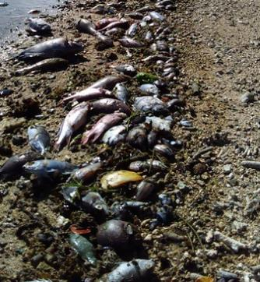
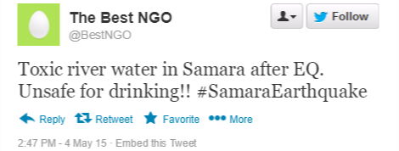
You know that the primary effects of the earthquake should not cause something like this and therefore suspect that there may be another issue at hand. You quickly contact the local representative of the District Disaster Relief Committee (DDRC) about the developing situation and ask her to check if there are any reports of damaged industrial facilities upstream of the photographed location. She reverts back shortly, advising you that records show that there is an industrial complex some 5km upstream of where the photograph was taken. The industrial complex contains agriculture and food production facilities including a sugar manufacturing factory, a vegetable oil processing plant and a poultry farm facility. Whilst none of these facilities were reported damaged by the earthquake, the facilities are not currently manned or in operation due to a lack of staffing as well as concerns about the risks associated with the continued aftershocks.

Checking the map, you notice that there is a small village, Narib, near where the Twitter photo was reportedly taken and go there to investigate. You are relieved to hear that the villagers do not drink the surface waters of the river as an NGO constructed a shallow borehole within Narib a few years ago. However, quantity of water from the borehole is insufficient to meet all water needs and the villagers continue to use the river water for bathing and agriculture needs. You also notice that whilst Narib is the closest village to the industrial complex, there are several more villages downstream of Narib, each a couple of kilometers away from each other.

- Who do you provide your report to?
- What do you include in your report?
- Who do you coordinate with? How?
- What are your findings and recommendations?

