SESSION 7: COMMUNICATING EFFECTIVELY
Practical exercise

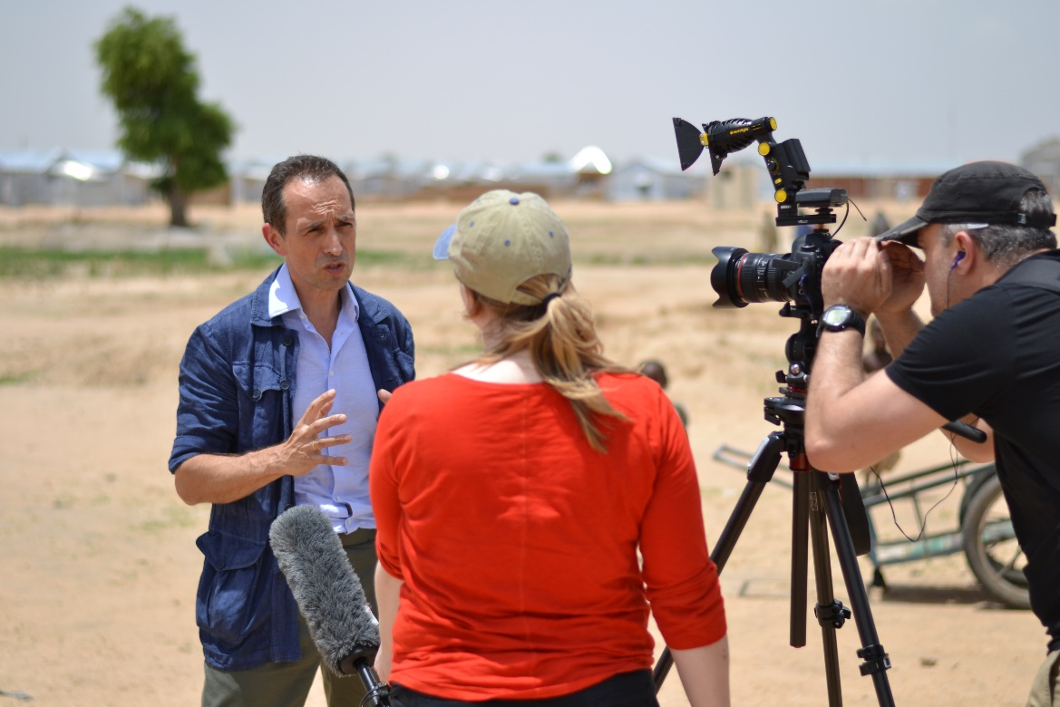

CASE 1: The First Family’s Uranium Mine

Background
A community in south-west Embia is suffering from increased cases of respiratory diseases. This increase is suspected to be due to the dust from a nearby tailings dam of the Vishnu Uranium Mine. The Embian president’s son, Senay Haile, owns a controlling stake in mine. The parent company of the mine has recently released a statement asserting that all elements of the Vishnu Uranium Mine, including the tailings dam, complies with the respective governmental standards and poses not risk to nearby communities; the statement also emphasizes that independent inspectors have corroborated this claim.
Community monitors are maintaining that the tailings dam’s dust is linked to the health issues in the community. The monitors claim that an independent and transparent environmental impact assessment was not carried out for the construction of the mine, and also that the mine operator has not taken any actions to minimize the risk to the nearby community, even after reports of respiratory issues surfaced.
In addition to the cases of respiratory diseases, the community monitors report that since the commissioning of the mine, the groundwater supply in the village has noticeably decreased. Female community members now need to travel an additional hour each day to collect sufficient water, and the local school and healthcare center is also at risk of closing down due to persistent water shortages.
Tailings dams contain contaminated water with the unwanted residues of mining. For uranium mining, the water can contain radioactive constituents, which can be dispersed as contaminated dust. An environmental field advisor has been deployed by OCHA Embia to assess the situation in the community.
Environmental Expert Findings – Case 1
The preliminary findings from your assessment are:
- The concentration of particulate matter (dust) is above WHO air quality guidelines. There are no other nearby industries which produce particulate matter. You have not yet been able to do a chemical analysis to identify the composition and source of the particulate matter.
- The groundwater level in the village is slightly lower than normal. The mining operations are likely a contributory factor, however, it is not possible to definitively claim a causal link due to the annual and seasonal variations in groundwater level.
- During your groundwater analysis, you also noted that the groundwater does not meet WHO guidelines for drinking water standards. Some of these chemical contaminants are unique to mining activities.
Media Interest – Case 1
You are interested in knowing:
- Whether the claims of the community monitors are accurate, and if so, is there a suspected source of the pollution.
- If the mining operations are having an adverse effect on the local communities, such as air pollution or water scarcity or pollution, and should the mining company be responsible for any compensation.

CASE 2: The Toxic Waste Dump

Background
Earlier in the year, a local company was observed to be dumping a large amount of sludge in sites scattered around the city of Najibad. There were reports that this waste originated from a ship owned by the multinational commodity trading company, Lafigura. Investigations by INGOs claimed that Lafigura knew that the waste was hazardous, and the company had unsuccessfully tried to dispose of the waste in multiple other countries, before contracting a local company to finally dispose of it in Najibad. National authorities have so far remained silent, but questions persist as to who permitted the dumping and who is responsible for the management and treatment of the waste.
The apparent presence of the waste was immediately noticeable with dying vegetation and a strong odour. More than 100,000 people reportedly sought medical attention for a range of symptoms, including dizziness, vomiting and breathing problems. Local medical authorities reported 15 deaths due to unexpected symptoms indicative of acute poisoning. Community tensions are high: protests have broken out in several areas against the company responsible for dumping the waste, as well as outside government offices.
Local media has reported that this waste has adverse impacts on fertility and maternal health, and local women’s group are particularly concerned about the current situation as they are unsure if they are able to continue breastfeeding.
Lafigura has so far refused to acknowledge the issue or disclose the contents of their supposed waste. The company claims that it is responsible company and abides by any respective environmental requirements. You have been deployed to assess the health and environmental impacts of the situation and Najibad.
Environmental Expert Findings – Case 2
The preliminary findings from your assessment are:
- The initial chemical composition of the waste is indicative of mining waste from a resource that is not present on the African continent.
- The chemical contaminants in the waste are known to have adverse acute and chronic health effects and require medical expertise that is not likely not available locally.
- To properly minimize the health and environmental impacts of the waste, it is necessary to know the exact source and composition of the waste, and the exact locations and quantities of the dump sites – this comprehensive information would only be available to those responsible for the waste dumping.
Media Interest – Case 2
You are interested in knowing:
- If there is further information about the source and composition of the waste.
- What the health implications of this waste are, and if there is any health advice for local residents or authorities.
- Who allowed this dumping, and who is responsible for paying for the clean-up

CASE 3: A Tank of Leaking Ammonia

Background
There have been media reports of a gas leak at the Bodolulu Ice Co. earlier this afternoon. Eyewitness accounts indicate there a strong pungent smell, indicative of ammonia, was detected around the facility. There are commercial premises in the vicinity of Bodolulu Ice Co.
Local HazMat teams responded within the hour, and were able to enter the facility and shut down all gas supply. The head of the HazMat team confirmed to local media that the substance in question was indeed ammonia, and the leak was suspected to have originated from a 6,500 lb (3,000 kg) storage container. The faulty equipment has not been repaired, however, the leak has been isolated. HazMat personal will remain onsite throughout the evening and continue to monitor the situation and concentrations of ammonia.
Twenty people reportedly sought emergency medical assistance, of which fifteen were transported to local hospitals for additional monitoring. Reported symptoms were irritated eyes, dizziness and breathing difficulties. Other businesses in the area are concerned about the potential health implications of the event.
The latest press statement by the Governor of Bodolulu indicated that he was advised by experts from the Ministry of Environment that there was no immediate danger to surrounding lives or property, and no evacuation is necessary. On the contrary, the LEMA just published an official recommendation for the evacuation of nearby businesses within a 1 km radius.
This area is economically dependent on seasonal tourism and it is currently the peak of the tourist season. An evacuation would have severe economic impacts, and would also likely dissuade future tourists from visiting due to the perceived risk.
You are an Environmental Field Advisor stationed at OCHA Bodolulu and support national authorities, including both the Governor’s Office and LEMA, in disaster risk reduction. You arrive on site to conduct your own assessments of the situation.
Environmental Expert Findings – Case 3
The preliminary findings from your assessment are:
- Based on the FEAT, the recommended exposure distance for this hazard is <0.1 km and 0.8 km for lethal and human health.
- Whilst the leak has reportedly been contained, the gas has not dispersed. Atmospheric conditions have trapped a significant amount of the gas in the vicinity of the industrial facility.
- Gaseous ammonia is highly soluble in water, and there are several natural water bodies in the vicinity of the facility. Whilst these water bodies are not used for drinking, the effects on local ecosystems are likely significant.
Media Interest – Case 3
You are interested in knowing:
- Whether the fears of locals are founded, and if they should consider evacuating given the conflicting information from local authorities.
- If there are any environmental impacts of this leak.

CASE 4: Leading the Lead Clean-up

Background
The Department of Environment in the city of Plomo announced last week that as part of their regular soil testing, they identified elevated levels of lead in the soil in certain parts of the city. Department officials suspect that a new industrial facility on the outskirts of the city, Axide Technologies, is responsible of this pollution through the deposition from lead air pollution. Axide Technologies works in heavy metal processing. Lead is a power neurotoxin that has no safe level of exposure.
Initial findings from the Department of Environment indicates that an area of 10 km² has been affected. This land is comprised of a combination of residential and agricultural properties. Preparations are underway to clean the most contaminated levels of topsoil. The Department of Environment has acknowledged that cost for cleanup is likely to be considerable, and is planning on seeking compensation from Axide Technologies.
The government has launched legal proceedings against Axide Technologies for violations of national environmental law. Axide Technologies owns many of the industrial facilities in the area, and is one of the primary providers of economic activity for local communities. Plomo is one of the most underdeveloped areas in the country, and residents have welcomed the continued support of Axide Technologies. Successful litigation against Axide Technologies would likely see the company declare bankruptcy, which would have significant implications on livelihoods in the area.
Environmental Expert Findings – Case 4
The preliminary findings from your assessment are:
- Based on additional soil testing, you suspect that the area of contamination is wider – nearly twice as large – than originally estimated by the Department of Environment.
- During your assessments, residents reported that they have been experiencing abdominal pains, headaches, and general weakness since the commissioning of the facility. These symptoms are indicative of short-term overexposure to lead and immediate specialist medical attention is required.
- Levels of lead in the air within the facility itself are higher than permissible safe levels, exposing workers to adverse health effects.
Media Interest – Case 4
You are interested in knowing:
- Whether it is safe for local residents, as well as workers in the facility, to continue with their daily lives.
- The extent of the clean-up required, and whether the company should be held financially accountable for the environmental pollution.

CASE 5: Oil spill in indigenous lands in Loma cleaned by locals

Early last week, oil began flowing down the Vesna River in the autonomous region of Loma in Grandland and has been coating the river and building up on the river banks. There is only company operating oil wells upstream of the river, OilLuk, which is a Grandland state-controlled corporation. Numerous indigenous communities, which are reliant on subsistence agriculture and fishing, inhabit the shores of the Vesna River.
Local residents have raised their concerns with local and national authorities, as well as OilLuk itself. However, there has been no official word or even acknowledgement from any of these actors. Residents stated that they observed workers from OilLuk installing containment infrastructure, but large amounts of oil continue to leak through.
Due to the inaction from authorities and OilLuk, the local indigenous people have taken the initiative to clean up the oil spill. The locals, including their children, have been venturing out into the river using their fishing boats and collecting the oil into makeshift containers. Residents are unsure of what to do with the collected oil, and have tried to sell it back to OilLuk but are also dumping it in disused agricultural land.
Comparatively, this is a small oil spill. Initial estimates are that only a few hundred barrels of oil has leaked into the river. Oil contains toxic heavy metals and direct contact can cause skin and eye irritation, as well as respiratory problems from breathing in the fumes.
You are an Environmental Field Advisor with the local OCHA field office. The political situation in the country is delicate and international organizations have a complicated relationship with local authorities.
Environmental Expert Findings – Case 5
The preliminary findings from your assessment are:
- You realize from your interviews with local residents that they will do anything to preserve the nearby environment since it is their source of livelihoods. They will likely persist, with or without governmental assistance.
- Local residents are oblivious to the serious health hazards associated with cleaning up oil spills and lack the proper personal protective equipment and training. Many are simply handling the oil with their bare hands.
- You observe fisherman continuing with their daily activities, unaware of the chemical toxicity that their catches have been exposed to. The oil spill will also cause long-term negative impacts on the aquatic ecosystems.
Media Interest – Case 5
You are interested in knowing:
- Whether it was appropriate for the local residents to take this matter into their own hands.
- What are the impacts of the oil spill on lives and livelihoods.
- Who should be responsible for the cleanup and rehabilitation

SOURCES (Real cases used for the scenario preparation):

Case 1: Gupta-owned mine accused of environmental pollution
https://www.timeslive.co.za/news/south-africa/2016-03-17-gupta-owned-mine-accused-of-environmental-pollution/

Case 2: Côte d’Ivoire: Trafigura unrepentant 10 years after toxic waste dump
https://www.amnesty.org/en/latest/news/2016/08/trafigura-unrepentant-10-years-after-toxic-waste-dump/

Case 3: Pier 38 evacuated after ammonia leak
http://www.staradvertiser.com/2017/04/24/breaking-news/pier-38-evacuated-after-ammonia-leak/

Case 4: Exide cleanup: Toxic lead removal could be California's biggest yet
http://www.latimes.com/local/lanow/la-me-ln-exide-cleanup-20150817-story.html

Case 5: Russian Indigenous communities clean up Rusvietpetro’s oil spill as company does nothing
http://www.greenpeace.org/international/en/news/Blogs/makingwaves/russian-indigenous-communities-left-to-clean-/blog/45427/

