DO’s and DONT’s for handling Asbestos

Asbestos Protection Kit should include
4x FFP3 Disposable Asbestos Masks, 2x Protective Cat3 Type 5/6 Coveralls (Asbestos Grade) , 2 Pairs Overboots, 2x Clear Asbestos Bags, 2x Red Asbestos Bags, 1x Goggles, 1x Nitrile Gloves (2 Day Kit) (FFP3 Protection) (Code APK1)

Safety Wear – PPE Kit
WHAT IS AN ‘ASBESTOS PPE KIT’ – PERSONAL PROTECTION EQUIPMENT (PPE)
WEAR all items listed in the PPE Kit whenever working with asbestos.
ALL items in a disposable PPE Kit must be disposed of as ASBESTOS WASTE after use.
Wear the PPE in the following order:
- 1. Disposable coveralls
- 2. Footwear
- 3. Shoe covers
- 4. Gloves
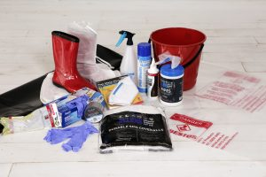
- 5. Mask
- 6. Protective eye-wear
DISPOSABLE COVERALLS
- Should be rated Type 5, Category 3
- Be labelled for asbestos use
- Be one size too big to prevent breaking or tearing when worn
- Include a hood and elasticised cuffs
- Cuffs should be pulled over the edge of gloves
- If the cuffs of coverall arms are loose, seal them with tape to prevent fibres getting in.
- After the shoe covers are fitted, ensure the coverall legs then go over the top of shoe covers.
- After the mask and eye-wear are fitted, ensure the hood goes over the mask straps and arms of eye-wear, and covers all hair.
FOOTWEAR & SHOE COVERS TO BE WORN OVER SHOES
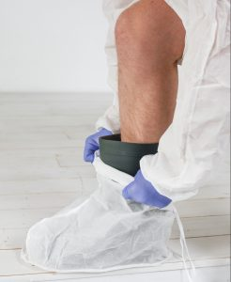
- NEVER wear boots or shoes with laces as they can’t be decontaminated.
- GUMBOOTS are the best option as they are easily wiped clean and have no laces. Once cleaned appropriately they can be re-used for non-asbestos work.
- SHOE COVERS are worn OVER shoes and should cover all of the boot/shoe and be secured above the ankle.
- WHEN shoe covers are secured, pull the cuffs of the coverall legs down to cover the top of shoe covers.
GLOVES
- Use ONLY disposable Latex, Nitrile or neoprene gloves.
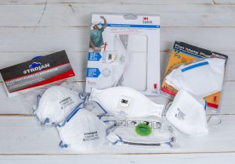
- Tuck under the cuffs of coveralls and tape the cuffs if loose.
MASK (RESPIRATORY PROTECTIVE EQUIPMENT)
- Your mask should be worn at all times when working with asbestos. Various styles of P2 disposable masks containing materials.
- Minimum P2 filter, half face disposable particulate respirator.
- Half face non-disposable particulate respirator with cartridge is preferred but it must be decontaminated after each use.
- Half face non-disposable particulate respirator with cartridge is a better option. (Silicon is better than rubber) as fits better and not as hot.
- The wearer must be clean shaven in the area of the seal.
- All respirators are different shapes and sizes so it’s important that the size is correct to properly fit to the wearer’s face.
- Ensure your mask fits perfectly by conducting a respirator fit check.
  - Close off inlet to filter with hands
  - Inhale gently
  - Hold for 10 seconds
  - Ensure the face piece remains slightly collapsed
PROTECTIVE EYE-WEAR
- ALWAYS wear protective eye-wear when working with materials that might produce dust.
- AFTER fitting your mask, fit your eye-wear and place the hood over the top of the mask straps and eye-wear arms.

Dos and DON’ts

Personal protective equipment
Wearing the right personal protective equipment is essential to protect your health when working with asbestos.

Wear an appropriate respirator

Ordinary dust masks are not effective in preventing the inhalation of asbestos fibres and dust. You should wear either a half-face filter respirator fitted with a class P1 or P2 filter cartridge, or a class P1 or P2 disposable respirator appropriate for asbestos. To ensure that the respirator is effective, users should be clean- shaven, and the respirator should have a close fit.

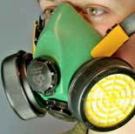

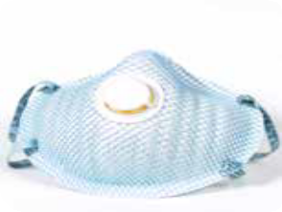
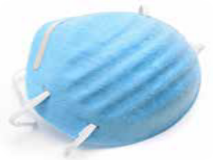
Half-face filter respirator Twin-strap disposable P2 mask Ordinary single-strap dust mask

Keep your respirator on until the work session has been completed, the cleaning is done, and your contaminated clothing has been removed, bagged and sealed.

For the removal of asbestos, a half-face disposable or cartridge-type particulate respirator class P1 or P2 is satisfactory. Respirators or masks should be worn continually by each person removing asbestos material.

Wear disposable clothing

Disposable coveralls should be used to prevent the contamination of clothing and footwear. An attached hood or disposable hat, and suitable disposable gloves should also be worn.

The coveralls should have no external pockets, and the gloves should be sufficiently robust for the work to be done. Smooth, nonslip footwear without laces or top fasteners are preferable to plastic overshoes where there is a risk of slipping.

When handling or removing asbestos cement products in general

• work in a well-ventilated area and, where possible, in the open air
DO (but not on windy days)

• thoroughly wet down the material before you start and regularly during the work by lightly spraying surfaces with water, or with low-pressure water from a garden hose (if outdoors); keep it wet until packaged for transport

• use nonpowered hand tools (e.g. a guillotine, hand saw or hand- powered drill) as these generate smaller amounts of dust and waste chips that are coarser than those generated when using power tools

• pull out any nails first to help remove sheeting with minimal breakage

• carefully lower (not drop) the sheets to the ground and stack on two layers of polythene sheeting at least 0.2 mm thick (e.g. heavy-duty builders’ plastic)

• minimise cutting or breaking of the asbestos cement products

• remove and dispose of personal protective equipment as described below

• shower and wash your hair immediately afterwards and, regardless of whether gloves were used, thoroughly clean your hands and fingernails to remove any dust and asbestos that may be on your body.

DON’T
• use high-pressure water jets to wet surfaces as this may increase the spread of loose fibres or dust

• slide one sheet over the surface of another as this may abrade the surface of the materials, and increase the likelihood of the release of fibres and dust

• use power tools, abrasive cutting or sanding discs, or compressed air on asbestos cement, as these will contribute to airborne dust and debris

• dry sand, wire brush or scrape surfaces to be painted

When working indoors

• isolate the area you are working on from the rest of the building by
DO closing and sealing internal doors

• leave external doors and windows open to maximise ventilation

• cover the floor with heavy-duty plastic sheeting to catch dust, debris
and offcuts

• keep household members, visitors and pets away from the area until
the work is completed.

DON’T
• spread asbestos dust through areas of the building that are not protected by plastic sheeting (e.g. by walking through unprotected areas without removing shoes).

When working outdoors

• inform your neighbours of the proposed work, and advise them
DO to close doors and windows while the work is being undertaken

• close all windows and doors of your home, and cover air vents to
prevent asbestos fibres from entering the building

• avoid contaminating the soil by covering the ground and vegetation
with heavy-duty plastic sheeting to catch dust, debris and offcuts

• remove play equipment, personal belongings and vehicles from the
work area

• keep household members, visitors and pets away until the work
is completed (use barricades and signs if necessary).

DON’T
• wet down roofing sheets if this creates a high risk of slipping off a roof

• work with asbestos on a windy day.

Cleaning up

• thoroughly clean the work area, tools and equipment as soon as
DO possible after finishing the job

• clean up any asbestos cement residues in the work area, and on the tools and equipment used by using wet rags and a wet mop,
• double bag, seal and dispose of any materials used during the decontamination, such as rags and mops, along with other asbestos products at a disposal facility
• keep dust, debris and offcuts damp with water

• keep your respirator on.

DON’T
• remove any materials from the work area until cleaned up as
described above

• clean the work area by dry sweeping cleaner

• store or reuse asbestos cement sheeting

• leave asbestos cement products around where they may be broken or crushed.

Packaging and disposal of asbestos

• keep the material wet until it is packaged
DO • carefully package the material, including any offcuts, in two layers
of 0.2 mm thick polythene sheeting

• keep the packages of a manageable size and completely seal them
with adhesive tape

• place smaller sized asbestos waste such as tiles, offcuts and dust in two 0.2 mm thick polythene bags (i.e. double bagged), then tie and seal for disposal with the other asbestos waste
• only fill bags half full (to minimise the risk of splitting) and gently
evacuate excess air in a way that does not cause the release of dust

• clearly label the packages ‘ASBESTOS WASTE’ using a permanent
marker pen

• as soon as possible, securely transport and dispose of the packages at a designated asbestos waste disposal site in your area

DON’T

Removing and disposing of personal protective equipment

• peel off coveralls, hat and gloves
DO • immediately seal all these items in two 0.2 mm thick (heavy-duty) polythene bags (i.e. double bagged) and clearly label to identify the contents as described above in ‘Packaging and disposal of asbestos’
• dispose of these bags with the other asbestos waste

• wash or wipe reusable footwear using wet rags
• leave the respirator on until the contaminated clothing is removed, bagged and sealed, then dispose of the respirator by doubling bagging it as described above.

DON’T
• keep or recycle disposable protective equipment; for example,
don’t attempt to shake the dust out of overalls or clean the items with a vacuum cleaner
• launder or clean gloves — the asbestos removal and laundering
process causes physical damage or deterioration of the gloves

