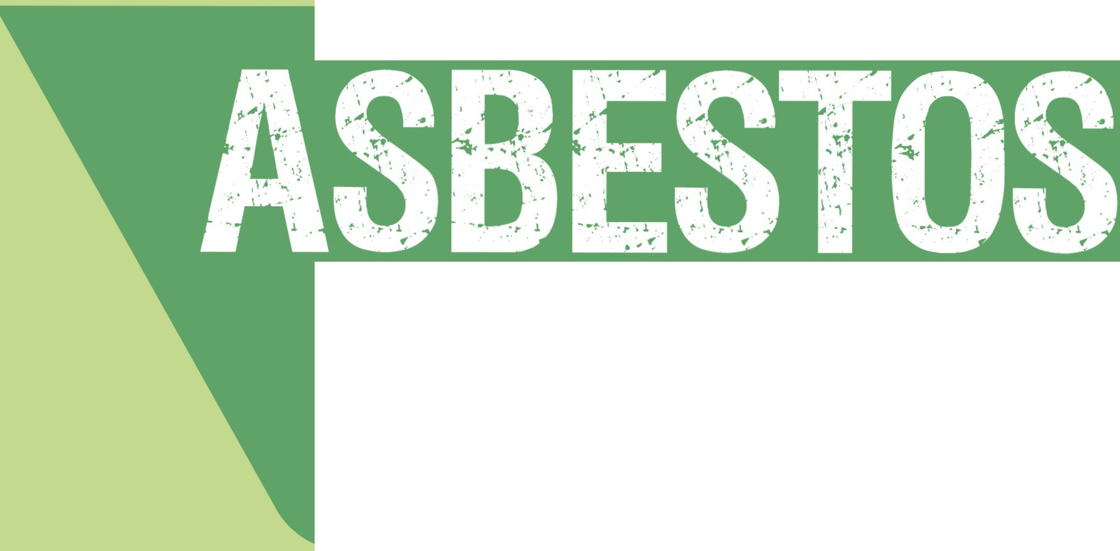

A guide for householders and the general public

February 2013

.....

I



**A guide for householders and the general public**



February 2013

This guide has been endorsed by the Australian Health Protection Principal Committee and was prepared by its Environment Health Standing Committee, enHealth



2

Asbestos: A guide for householders and the general public

ISBN: 978-1-74241-736-3

Online ISBN: 978-1-74241-737-0

Publications approval number: D0793

Copyright statements

Paper-based publications

© Commonwealth of Australia 2013

This work is copyright. You may reproduce the whole or part of this work in unaltered form for your own

personal use or, if you are part of an organisation, for internal use within your organisation, but only if you or your organisation do not use the reproduction for any commercial purpose and retain this copyright notice and all disclaimer notices as part of that reproduction. Apart from rights to use as permitted by the Copyright Act 1968

or allowed by this copyright notice, all other rights are reserved and you are not allowed to reproduce the whole or any part of this work in any way (electronic or otherwise) without first being given the specific written permission from the Commonwealth to do so. Requests and inquiries concerning reproduction and rights are to be sent to

the Online, Services and External Relations Branch, Department of Health and Ageing, GPO Box 9848, Canberra

ACT 2601, or via e-mail to [copyright@health.gov.au.](mailto:copyright@health.gov.au)

Internet sites

© Commonwealth of Australia 2013

This work is copyright. You may download, display, print and reproduce the whole or part of this work in unaltered form for your own personal use or, if you are part of an organisation, for internal use within your organisation,

but only if you or your organisation do not use the reproduction for any commercial purpose and retain this copyright notice and all disclaimer notices as part of that reproduction. Apart from rights to use as permitted by the Copyright Act 1968 or allowed by this copyright notice, all other rights are reserved and you are not allowed to reproduce the whole or any part of this work in any way (electronic or otherwise) without first being given the specific written permission from the Commonwealth to do so. Requests and inquiries concerning reproduction and rights are to be sent to the Online, Services and External Relations Branch, Department of Health and Ageing, GPO Box 9848, Canberra ACT 2601, or via e-mail to [copyright@health.gov.au.](mailto:copyright@health.gov.au)

Approved citation

Environmental Health Standing Committee (enHealth), Asbestos: A guide for householders and the general public, Australian Health Protection Principal Committee, Canberra, 2013.

Disclaimer

This document has been prepared in good faith exercising due care and attention. Users should satisfy themselves of the applicability of the document to their situation and seek expert advice where necessary. References to other websites are provided for the user’s convenience only and do not constitute endorsement of material at those

sites. The Department of Health and Ageing and the Environmental Health Standing Committee (enHealth) do not accept liability for any loss or damage caused or alleged to have been caused directly or indirectly by the use of, or reliance on, this document.

Photographs supplied by WA Department of Health and Victoria Department of Health, except dust masks page 29 © [www.istockphoto.com](http://www.istockphoto.com/)

Scientific review by the Technical Working Group, enHealth

Technical writing and editing by Janet Salisbury, Biotext, Canberra

Graphic design by Lisa Abbott, Biotext, Canberra

The Australian Government Department of Health and Ageing provided funding for the development of this guide

**FOREWORD**

I am pleased to introduce this updated guide for the general public on health risks associated with asbestos, especially during renovations.

My strong advice is that householders should engage experienced and licensed professionals to undertake home renovations where asbestos is likely to be present and/or to undertake asbestos removal.

There is no safe level of exposure to asbestos fibres.

Where householders do make the decision to undertake home renovations where asbestos

is, or may be, present, this guide provides useful information to minimise the associated risks.

I wish to thank the Environmental Health Standing Committee (enHealth) for all their work in developing and updating the guide. enHealth is made up of representatives from the state, territory and Australian governments. It is a standing committee of the Australian Health Protection Principal Committee.

The guide will be further updated following a literature review being undertaken this year.

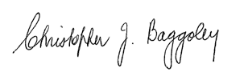

Professor Chris Baggoley

Australian Government Chief Medical Officer

Chair, Australian Health Protection Principal Committee

**ABOUT THIS GUIDE**

Asbestos – *a guide for householders and the general public* (referred to here as ‘the guide’) is a risk management document, designed to assist householders reduce the risks associated with exposure to asbestos fibres. It was developed by the Environmental Health Standing Committee (enHealth),

in consultation with technical experts and with input from other government agencies. enHealth is made up of representatives from each state and territory government environmental health unit, and the Australian Government Department of Health and Ageing (DoHA).

The guide was developed in response to the high volume of individual householders enquiries received by state and territory environmental health units in relation to asbestos identification and management. It was developed over two years including focus group testing and consultation with

a number of organisations including local governments, state and territory work cover departments, other government agencies and asbestos-related disease organisations. The scientific information in the guide is based on an earlier enHealth publication, *Management of asbestos in a non-*

*occupational environment,* published in 2005 and available on the DoHA website.

**KEY POINTS**

• Inhaling asbestos fibres may cause asbestos-related disease and death.

• Houses built before 1990 are likely to contain asbestos cement products.

• The health risk of undisturbed asbestos cement products in the home is

very low.

• Householders should engage experienced and licensed professionals to

undertake home renovations and asbestos removal.

• Householders who choose to do their own renovation or ‘DIY’ work should follow the advice provided in this guide carefully to reduce the health risk to them and their families to a very low level.

The human health effects from exposure to asbestos are well documented. In this guide, the likelihood of developing an asbestos-related disease from breathing in asbestos fibres is called the ‘risk’. The risk of developing asbestos-related disease, like lung cancer, from asbestos exposure is associated with

the level and duration of exposure, length of time since first exposure, the fibre type, and concurrent exposure to tobacco smoke and other carcinogens. Not all factors are well understood, and we do not yet know why some people develop an asbestos-related disease and others do not; however, the risk increases with the exposure to asbestos fibres.

This guide and enHealth recommend householders to engage experienced and licensed professionals to undertake home renovations, but acknowledges that some people will choose to do their own renovations. The guide therefore contains information to help householders make decisions about the risks associated with exposure to asbestos-containing materials in their home.

It also contains practical information to lower the risks of exposure; however, if in doubt, always seek assistance from a licensed professional.

4

**CONTENTS**

**FOREWORD 3**

**I NTRODUCTION 6**

**W HEN AND WHERE WAS ASBESTOS USED? 8**

**WHERE ASBESTOS MAY BE FOUND IN A TYPICAL HOME 10**

**ASBESTOS AND YOUR HEALTH 14**

Asbestos-related diseases 14

Risk factors for developing asbestos-related diseases 16

Who is at risk of developing asbestos-related diseases? 17

When are householders likely to be exposed to asbestos? 19

Six steps for reducing your risk 25

**I DENTIFYING AND DEALING WITH ASBESTOS 26**

**IN YOUR HOME**

How do I know if a material in my house contains asbestos? 26

Can I disturb asbestos materials in my home? 26

What safety precautions do I need to take? 27

**KEY ‘DOS AND DON’TS’ FOR HANDLING 29**

**ASBESTOS MATERIALS**

**F URTHER INFORMATION AND ADVICE ON ASBESTOS 35**

General advice on safe handling of asbestos 35

Occupational health and safety advice and practical fact sheets 37

Asbestos removal, transport and disposal 39

Licensed asbestos removalist and demolition information 41

Information about asbestos-related diseases 43

**INTRODUCTION**

This guide has been prepared for householders. It describes the risks to your health from being exposed to asbestos fibres. It explains who is at risk and how to reduce exposure to yourself, your family and others. It also contains basic information on

identifying and dealing with asbestos.

Asbestos is the name given to a group of naturally occurring minerals found in rock formations. Three types of asbestos were mined in Australia: white, blue and brown asbestos. Large deposits were mined in Western Australia and New South Wales, and there were smaller operations in Tasmania and South Australia. Asbestos mining was completely

stopped in Australia by 1983 but it is still mined in large quantities at many locations worldwide. Mined asbestos only represented a small proportion of the asbestos used in Australia (about 5%) and the bulk was imported. The majority of asbestos (90%) used throughout the world, including Australia, was white asbestos. Australia banned the use or import of blue and brown asbestos or asbestos products in the mid-1980s, and banned all manufacture or import of white asbestos products in December 2003.

Asbestos fibres are strong, heat resistant and have insulating properties. Clumps of mined asbestos can be broken down into loose fibres or fibre bundles, and can be mixed with

other materials, such as cement, to produce a variety of building products. Up to 90% of the asbestos produced in or imported into Australia was used for the manufacture of building

products, especially asbestos cement materials.

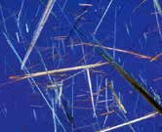

Asbestos fibres are not visible to the naked eye but, they are very light, remain airborne for a long time, and can be carried by wind and air currents over large distances.

Asbestos fibres can be found in the air from the breakdown of natural asbestos deposits and manufactured asbestos products. Once airborne, small fibres may remain suspended in the air for some time and can be carried long distances by wind before settling down. Larger fibres and particles tend to settle more quickly. Asbestos fibres do not dissolve in water or move through soil. They are generally not broken down to other compounds and remain virtually unchanged over long periods.

Asbestos-containing building products are classified as either ‘friable’ (soft, crumbly)

or ‘bonded’ (solid, rigid, non-friable).

**Friable products**

Friable asbestos products are generally quite soft and loose and can be crumbled into fine material or dust with very light pressure, such as crushing with your hand. Such products usually contain high levels of asbestos (up to 100% in some instances), which is loosely held in the product so that the asbestos fibres are easily released into the air.



Friable asbestos products are dangerous because the asbestos fibres can get into the air very easily, and may be inhaled by people living or working in the vicinity.

**Bonded products**

Bonded asbestos products are made from a bonding compound (such as cement) mixed with a small proportion (usually less than 15%) of asbestos. Bonded asbestos products

are solid, rigid and non-friable. The asbestos fibres are tightly bound in the product and are not normally released into the air. Common names for such products are ‘fibro’, ‘asbestos cement’ and ‘AC sheeting’. In this guide we refer to bonded asbestos products as ‘asbestos cement materials’ (or ‘asbestos cement sheeting’).

When in good condition, bonded asbestos products do not normally release any asbestos fibres into the air and are considered a very

low risk for people who are in contact with them, as long as

appropriate safety precautions are used when they are disturbed.

However, when bonded asbestos products are damaged or badly weathered (including

hail damage), areas may become friable.

At the end of this guide, there is a list of website addresses and other contact details to help you find information about working with asbestos safely, removing and disposing of asbestos, and asbestos licensing requirements (see pages 35–43).



**WHEN AND WHERE WAS ASBESTOS USED?**

Friable asbestos products have been commonly used in commercial and industrial settings since the late 1800s for fireproofing, soundproofing and insulation. Some friable products were also used in houses and may still be found in houses built before 1990.

In Australia, asbestos cement materials were first manufactured in the 1920s and were commonly used in the manufacture of residential building materials from the mid-1940s until the late 1980s. During the 1980s asbestos cement materials were phased out in favour of asbestos-free products. From 31 December 2003, the total ban on manufacture, use, reuse, import, transport, storage or sale of all forms of asbestos came into force.

Many houses built before 1990 therefore contain asbestos cement materials, especially

in the eaves, internal and external wall cladding, ceilings (particularly in wet areas such as bathrooms and laundries) and fences.

**AS A GENERAL RULE ...**

if your house was built:

before the mid-1980s it is highly likely that it has asbestos-containing products

between the

mid-1980s and 1990

it is likely that it has asbestos- containing products

after 1990 it is unlikely that it has asbestos-containing products.a

a Some houses built in the 1990s and early 2000s may have still used asbestos cement materials until the total ban on any activity involving asbestos products became effective from December 2003.

Asbestos-containing products used in houses

**Bonded asbestos products**

The vast majority of asbestos-containing products used in houses were bonded asbestos cement materials, including:

• roofing

• shingles and siding

(villaboard and similar)

• exterior and interior wall cladding

• eaves

• fencing

• thermal boards around fireplaces

• water or flue pipes.

**Remember:**

asbestos cement materials will become friable when they are sufficiently damaged, badly weathered or

otherwise deteriorated

**Friable asbestos products**

Some friable asbestos products may also be found in houses, including:

• asbestos-rope door gaskets in wood stoves

• loose fill roofing insulation

(not common)

• spray-on insulation or soundproofing

• low-density asbestos fibre board

• insulation on hot-water pipes, domestic heaters and stoves (e.g. lagging)

• backing material on floor tiles and vinyl flooring

• carpet underlay (not common;

see page 23)

• textured paints, decorative ceiling coatings

• heat-resistant fabrics

• brick and plaster sealants, fillers and some adhesive products

• hail or fire damaged, or badly weathered asbestos cement materials.

The diagram on pages 10–11 shows the many places that asbestos can be found around the home; pages12–13 show photos of typical asbestos products.

------

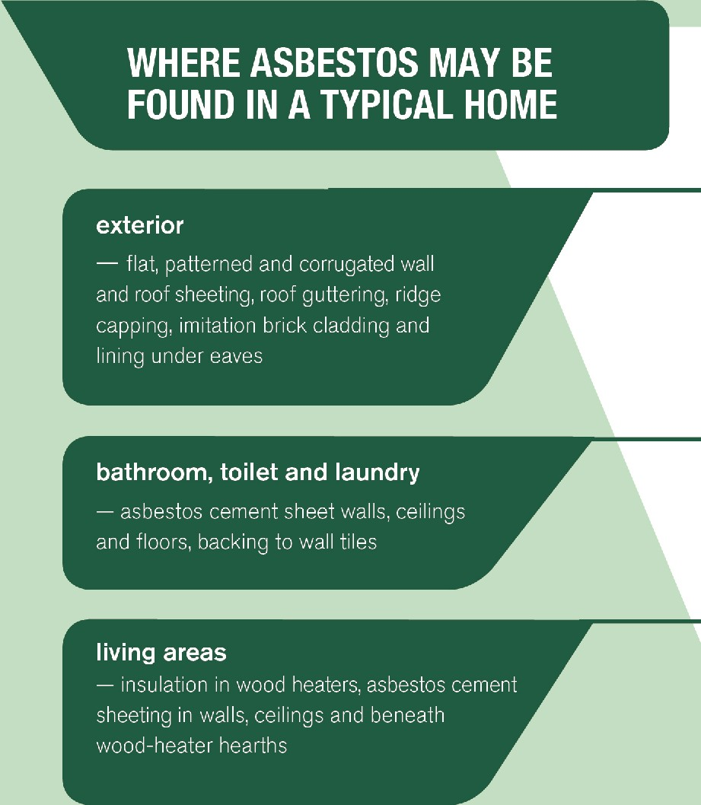

*v*I I T

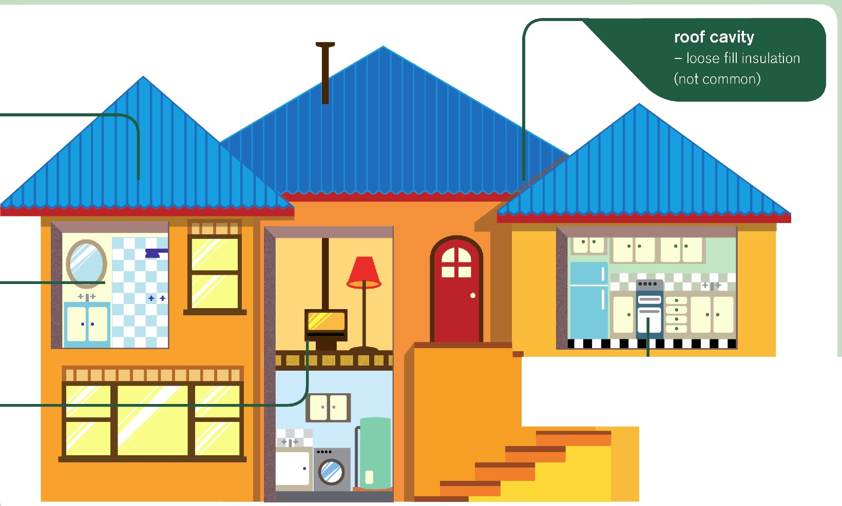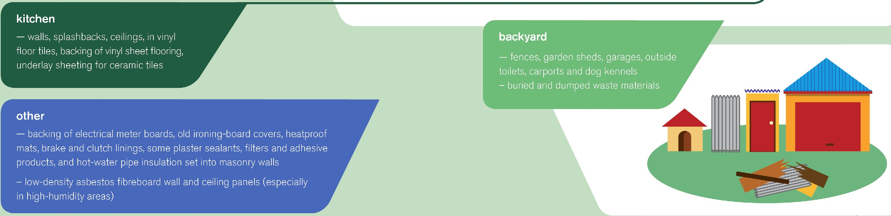

•···········································································

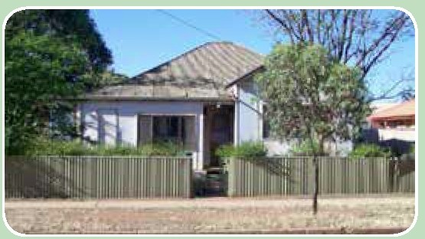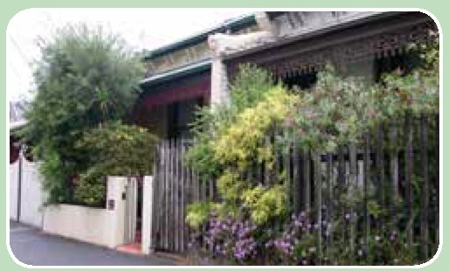

•···········································································

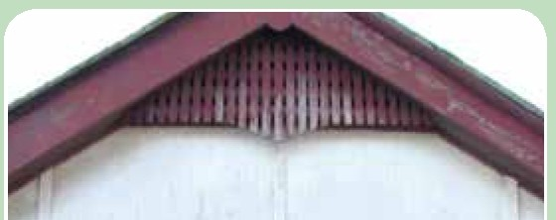

-· ---,

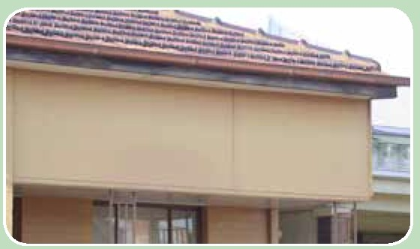

.-.-...._-·-- .

Asbestos cement sheeting in eaves

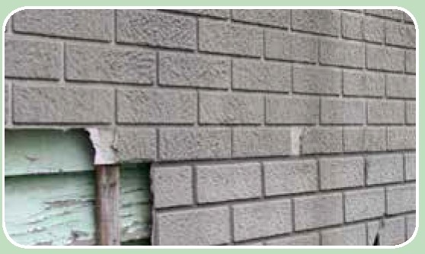

Asbestos cement 'brick' cladding

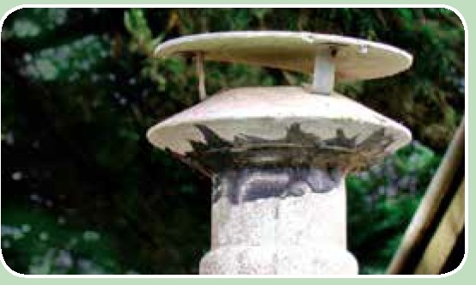

Asbestos cement flue and cowl

**-1 f•f 1•1 I J** I I I I **It**

... and in the gable end of a garage

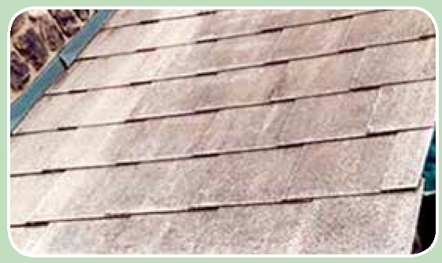

Asbestos cement shingles

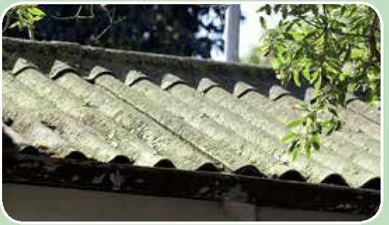

Asbestos cement corrugated roofing

Typical older style Australian houses that are likely to contain asbestos. Many older terraced houses, townhouses and units have very close neighbours who might be

affected when asbestos is disturbed.

Friable asbestos lagging on pipes Typical old vinyl floor tiles that might have asbestos in the backing material

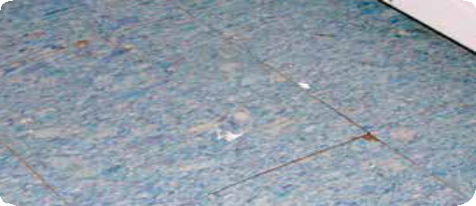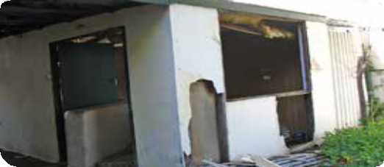

Broken asbestos cement materials from a demolition

... and in a disused outbuilding

13

If you are not sure if a product in your house contains

asbestos, play it safe and assume that it does. Alternatively, you can get advice from an asbestos consultant or have the product tested at a laboratory (see page 26).

**ASBESTOS AND YOUR HEALTH**

Asbestos only poses a risk to health when asbestos fibres are breathed in.

Undisturbed asbestos cement materials in

good condition do not pose a health risk because the asbestos fibres are bound together in solid cement.



However, if the material is damaged or crumbling (that is, has become friable), or is disturbed by breaking, cutting, drilling or sanding, fibres are released into the air.

Friable asbestos products (such as spray-on insulation or asbestos-rope gaskets in wood stoves and heaters) also produce airborne fibres during normal use or ageing. Crumbling bonded materials, and all friable products, must be carefully managed to prevent the release of fibres into the air.

Asbestos-related diseases

When asbestos fibres are breathed in, they may remain deep within the lungs. They can lodge in lung tissue and cause inflammation, scarring and some more serious asbestos- related diseases, which usually take many years, if not decades, to develop.

The four major asbestos-related diseases are shown opposite in increasing order of severity. A person may show signs of more than one of these diseases.

Pleural plaques

• areas of white, smooth, raised scar tissue on the outer

lining of the lung, internal chest wall and diaphragm

• often the earliest sign of exposure to asbestos

• not everyone who has been exposed to asbestos develops plaques, possibly because of differences in their immune response to asbestos fibres

• people with pleural plaques as their only asbestos- related symptom usually have very little impairment of lung function

Asbestosis

• a chronic condition caused by inflammation or

scarring in the lungs

• causes shortness of breath, coughing and permanent

lung damage

• caused by heavy, prolonged exposure to asbestos

Lung cancer

• cancerous tumours that mainly occur in the lining of the tubes leading into the lungs, the smaller airways or the middle of the lungs

• risk of developing lung cancer is increased in people

who also smoke or have a pre-existing lung disease

Mesothelioma

• a rare form of cancer of the tissue that lines the body

cavities, particularly the chest and abdominal cavities

• in Australia, about 90% of all mesothelioma patients have a confirmed history of significant asbestos exposure.

Risk factors for developing asbestos-related diseases

**Total number of fibres breathed in**

The risk of developing an asbestos-related disease increases in proportion to the number

of asbestos fibres a person breathes in during their life. This, in turn, depends on how many fibres are breathed in and how often.

Number of fibres breathed in during each exposure (the dose)

The risk of developing an asbestos-related disease increases when a larger number of fibres is breathed in.

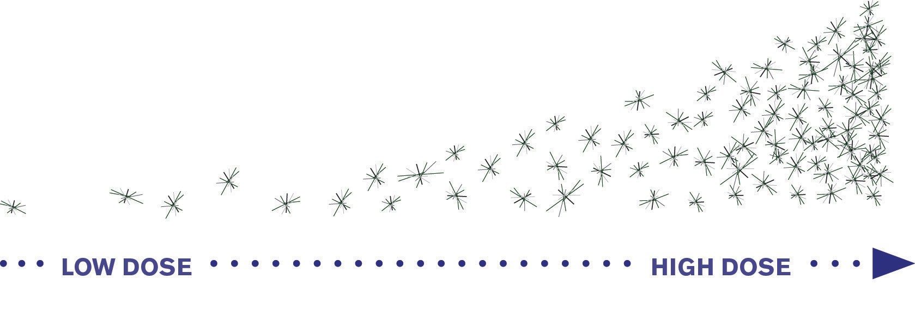

The number of times a person is exposed over time (‘cumulative dose’ or ‘lifetime exposure’ )

Very occasional exposure to a larger number of asbestos fibres (e.g. unsafe home renovation or demolition next door) poses a risk to your health …

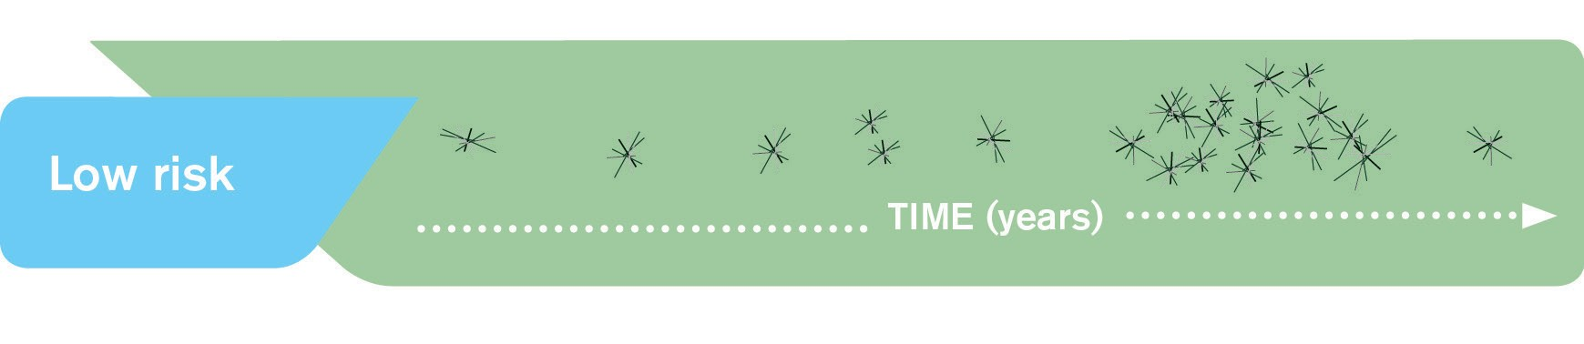

But frequent exposure to a larger number of asbestos fibres (e.g. builder or tradesperson using unsafe techniques) is much more likely to pose a risk to your health.

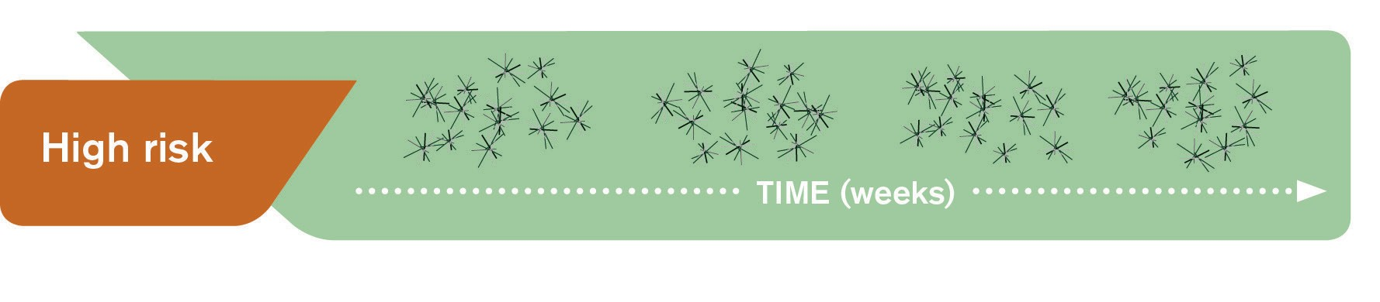

For practical purposes all types of asbestos (white, brown and blue) should be treated as equally hazardous

Who is at risk of developing asbestos-related diseases?

We are all exposed to low levels of asbestos in the air we breathe every day. Ambient or background air usually contains between 10 and 200 asbestos fibres in every 1000 litres (or cubic metre) of air (equivalent to 0.01 to 0.20 fibres per litre of air). However, most people do not become ill from this exposure, because the levels of asbestos present in the environment are very low. Most people are also exposed to higher levels of asbestos at some time in their lives; for example, in their workplace, community or home. However, for most people, this kind of infrequent exposure is also unlikely to result in any ill effects.

Most people who develop asbestos-related diseases have worked on jobs where they frequently breathed in large amounts of asbestos fibres. For example, in the past, construction workers using unsafe practices may have frequently encountered asbestos fibre levels well above background levels. The current regulated workplace limit (over an eight-hour period) is

100 fibres per litre of air (which is between 500 and 10 000 times background levels). In the past, workers in asbestos milling or mining often encountered fibre concentrations a million times higher than background levels.

Family members of exposed workers or those who lived close to active asbestos mines (Australia now has none) are also at risk. An exposed worker or home renovator can carry asbestos fibres on their clothing, boots, skin, hair and tools. Householders should be alert to ensure family members are not exposed to these fibres.

Although there is no absolutely safe level of exposure to asbestos fibres, occasional exposure to low levels of fibres poses only a low risk to your health.

A very small number of asbestos-related disease cases occur each year in people who have not worked with asbestos products. The low number of cases makes it difficult to determine the exact cause of the disease or the likely exposure event, but unsafe handling of asbestos materials in the home may have contributed to some of these cases.

The safety precautions for handling asbestos products

described in this guide are designed to reduce your risk to a very low level (see page 18).

When are householders likely to be exposed to asbestos?

Householders may be exposed to asbestos fibres during accidental damage to asbestos materials in the home, or as a result of unsafe handling of asbestos material by tradespeople or by the householders themselves. Some typical scenarios are described below.

**During normal wear and tear**

In normal circumstances, the risk to householders from asbestos is very low. If the house contains bonded asbestos products that are in good condition, it is best to leave them alone but check them from time to time for any signs of damage or deterioration.

The natural ageing and weathering of asbestos cement roofs releases asbestos fibres over time. However, this is unlikely to pose a risk to health because the fibres are dispersed, diluted by the wind and washed away in rainwater runoff systems. Air testing near buildings with asbestos cement roofs has found very little increase in fibre levels.

**During minor household maintenance or accidental disturbance** Accidental exposure may be a result of someone pushing their foot through a ceiling sheet, putting up a new towel rail, or even cleaning up garden debris.

If accidental exposure occurs, take prompt steps to manage it by reducing personal exposure and preventing further occurrences. For example, you could remove broken pieces, wipe

down surfaces with a wet cloth, close doors and windows or even temporarily relocate while the work is being carried out.

Particular tasks, such as using power tools for cutting, drilling, grinding, sanding or sawing, can release significant numbers of fibres. The use of high-pressure water blasters for cleaning can also release fibres.

You should never use power tools or high-pressure, water jet cleaning equipment on asbestos products as they may cause damage that releases asbestos fibres. In some states, these activities are illegal.

Old vinyl and linoleum floor coverings and tiles might also contain asbestos backing in a form that can easily become airborne when disturbed.

See pages 29–34 for further information on how to protect yourself and your family, including young children, and dispose of any broken pieces of asbestos cement materials or other products.

If in doubt, engage a licensed asbestos removalist (see page 27).

General public Exposure **VERY LOW RISK**

All air has a low level Number of fibres: Background

of asbestos fibres

Frequency:

Constant

Householder Exposure **LOW RISK**

Incident such as Number of fibres:

unsafe renovation or 10s-100s x Background

demolition next door Frequency: Occasional

Home renovator Exposure **MEDIUM RISK**

Unsafe removal Number of fibres:

of asbestos in 100s-1000s x Background

home renovation Frequency: Occasional

Builder/tradesperson Exposure **HIGH RISK**

Frequent exposure to high Number of fibres:

levels of asbestos by builders, Remove it! Pty Ltd 100s-1000s x Background

etc if using unsafe practices Frequency: Frequent

Asbestos mine worker Exposure **EXTREME RISK**

(Note: All asbestos Number of fibres:

mining in Australia millions x Background

stopped by 1983) Frequency: Daily

19

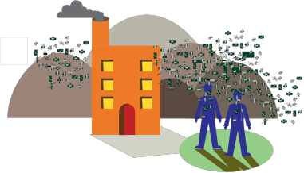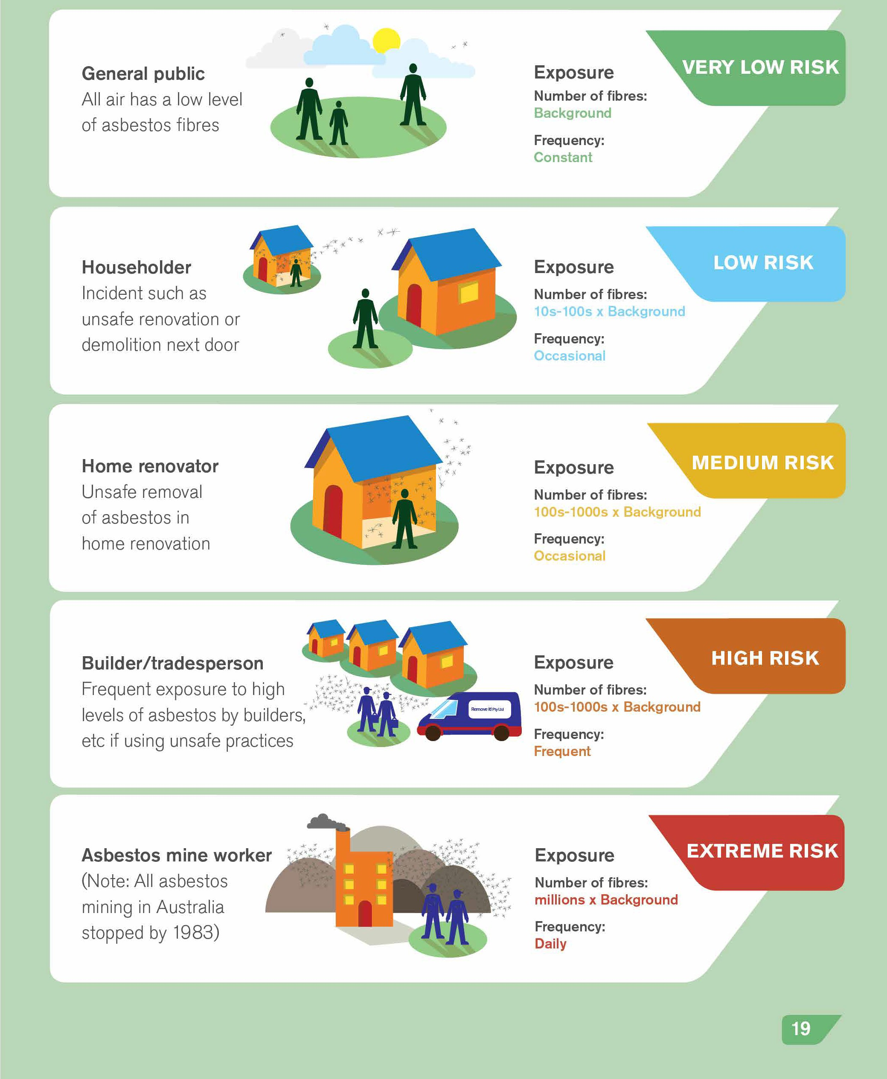

**ASBESTOS-RELATED RISK OF DISEASE**

Risk of disease increases with increased exposure (measured as number of fibres and frequency of exposure)

If you suspect that a neighbour or other person is not observing safe work practices (such

as by using power tools while cutting asbestos or by using a high-pressure spray), report the issue to your local government environmental health officer.

Note that when you engage a tradesperson, your home becomes their workplace. It is therefore important to alert any tradespeople who come to your house that it contains (or might contain) asbestos and to cooperate with all measures to ensure they are not exposed to asbestos fibres. If you are concerned about a tradesperson’s work practices you could contact your state or territory health and safety authority, who will advise on occupational health and safety issues for the tradesperson.

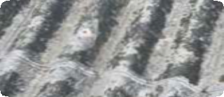

**CASE STUDY**

BOB’S CORRUGATED FIBRO ROOF

Bob is concerned about his roof. He thinks it might be over 30 years old, judging by the age of the house. The roof itself looks old, it is dirty and a mouldy dark colour from lichen. It is definitely not tiles or galvanised iron, but is made from a corrugated material which he suspects may contain asbestos.

He has noticed that a number of his neighbours in the street have recently had their roofs renovated. Bob has also noticed the increased number of storms and hail damage in the news reports for the area, and is worried about the fibro roof being damaged and then having to deal with the clean-up problems if it does contain asbestos.

He realises it might cost him money but he decides to get advice. He contacts his local occupational health and safety authority and also takes a small sample of the roofing material to a testing laboratory to be analysed (after asking for advice on how to take a sample safely). The roofing material is subsequently confirmed as being an asbestos-containing roofing material known as ‘Super 6’, and is in poor condition.

Bob then acts on the advice he has received and approaches a number of licensed asbestos removalists to get quotes for the removal and replacement of the roof, as resealing and painting is not a safe option. He decides to put money aside to get the roof replaced as soon as he can afford it.

**CASE STUDY**

JOAN’S EAVES

Recently, Joan had a new porch built on her house. The builder correctly advised her that the eaves of the old porch might be made of an asbestos cement product (fibro). They had a piece tested and the results showed

that it did contain asbestos. Joan’s builder arranged for a licensed asbestos removalist to come and remove the asbestos products before the rest of the old porch was demolished and the new porch built.

Joan is now worried that the rest of the eaves of her house might also be fibro, so she contacts the asbestos removalist about having them removed and replaced. The asbestos removalist comes back to the house and inspects the eaves for Joan. He shows her that they are all in very good condition

and pose a very low risk so Joan does not need to have them replaced. However, he tells her to contact him if she notices that they are cracking or deteriorating, or if she is having any other renovation work done that disturbs the eaves.

By following these simple steps, Joan has minimised the risk to herself and her neighbours.

**During renovations and demolition work**

During renovations or demolition of affected houses, asbestos fibres may be released into the air. While the overall health risk in these circumstances may be very low, extra precautions should be taken to reduce the chance of asbestos fibres becoming airborne and subsequently being inhaled.

The workers’ exposure can be reduced by wearing personal protective equipment such as masks and appropriate clothing. Other precautions include dampening down surfaces, not using power tools or high-pressure cleaning equipment, and vacating the home during the renovation (see pages 29–34 for further details). In some cases, the level of protective equipment used by tradespeople will be higher than that recommended for householders. This is because tradespeople, particularly asbestos removalists, often come into contact with large quantities of asbestos material during the normal course of their work. They therefore have a higher risk of developing an asbestos-related disease and so need to use more protective equipment than householders.

The removal of asbestos during major renovations or demolitions of buildings and structures needs to be supervised by qualified and licensed asbestos removalists in order to prevent the release of asbestos fibres into the surrounding neighbourhood.

If you are concerned about demolition work being carried

out close to your home, remain indoors and contact your local government environmental health officer and/or your state or

territory health and safety authority.

**CASE STUDY**

DENNIS AND MAUREEN’S BACK GARDEN

Dennis and Maureen have just moved into a run-down old house in the

inner city. While landscaping the back garden, they find a pile of old building materials behind the shed, half buried under thick weeds. Dennis thinks some of the pieces are broken fibro but is not sure.

Most of the pieces are quite big and don’t look at all flaky, but when Dennis and Maureen look around the area they find several smaller fragments. Dennis is worried that they might get crushed in the lawnmower. Maureen starts to gather up the pieces and put them in the skip they have ordered for other garden rubbish but Dennis thinks this might not be a good idea.

Dennis looks up asbestos on his state government websitea and finds information about how to dispose of broken asbestos sheeting from gardens. They are still not sure if the materials actually contain asbestos but decide

to assume that they do because getting them tested takes a few days and they want to get on with the garden. They decide to follow the instructions in the fact sheet to dispose of the material they found in their garden. Wearing gloves and masks they collect up all the pieces, including from

the underlying soil, wrap them carefully in several layers of thick plastic and tape up the parcel. They label the parcel ‘ASBESTOS’ and take it to the designated disposal site listed on the website.

By following these simple steps, Dennis and Maureen have minimised the risk to themselves and their neighbours.

See pages 35–43 for telephone and website details of where to get advice about asbestos.

a

**Other disturbances**

Carpet underlay

Some carpet underlay manufactured and installed before the early 1970s used material produced from hessian bags that had previously been used to transport raw asbestos. The Western Australian Department of Health has tested samples from over 20 homes

and only found asbestos fibres in underlay from one home. This underlay had been installed in the early 1950s. If you suspect that your carpet underlay might contain asbestos, you

can arrange to have a sample tested (see page 26 for how to contact an asbestos-testing laboratory).

Underlay containing asbestos will not pose a significant risk while it remains underneath the carpet. If the carpet is badly worn or damaged, consider replacing both the carpet and the underlay. Replacement of the carpet at any time would also provide an ideal opportunity for safe disposal and replacement of the underlay. When an old carpet is taken up, standard precautions should be taken (see pages 29–34). These precautions will provide adequate protection against dust and other allergens, as well as asbestos in the unlikely event it is

present. The Western Australian and Queensland health departments have information about carpet underlay on their asbestos information webpages (see pages 35–36).

Fire damage

During a building fire or bushfire, the amount of asbestos fibres released into the air is relatively low. Air monitoring during and after fires has confirmed this. However, pieces of asbestos material and some fibres may remain in the ash and may present a risk if they are disturbed while cleaning up after a fire. For this reason, when cleaning up after a fire,

you should wet down the debris to avoid dust and wear personal protective equipment (see page 30). If asbestos-containing materials have been burnt on your property, the best option is to engage a licensed asbestos removalist to do the clean-up work.

Hail and storm damage

Hailstorms pose a risk to roofing, particularly old asbestos roofs. If your asbestos roofing is punctured or cracked, it is best have your house re-roofed. Be very careful when checking your roof, particularly if it contains asbestos or other brittle material, because there is a high risk of falling off or through the roof. Do not attempt to repair broken asbestos cement roofs. As soon as possible after a storm, or if you suspect damage, have the roof properly assessed by a licensed professional.

Re-roofing should also be done by a licensed professional and you and your family may need to move out of the house while the work is being done.

**CASE STUDY**

JULIE AND JEFF’S HOUSE

Julie and Jeff’s house was one of a large number destroyed by a recent bushfire. They had safely evacuated before the fire, but were keen to return to their house to search for valuables and start cleaning up.

Asbestos sheeting was known to have exploded due to the intense heat of the fires and, in the aftermath, there was considerable concern about the potential for exposure to asbestos fibres in all fire-affected areas. Subsequent testing detected small numbers of asbestos fibres in the burnt remains of several buildings, but no asbestos fibres in public places.

Julie had also heard concern expressed by the health department that entering fire-affected properties and disturbing debris might be dangerous for a number of reasons. Potential hazards included exposure to airborne debris from lead-based paints and burnt treated timbers, live wires, damaged gas tanks, damaged septic tanks and chemicals in damaged containers, as well as significant amounts of dust and ash.

The department advised people not to search their properties without taking adequate precautions, and provided kits for residents to use when searching through debris on their properties. The kits included masks, gloves and coveralls that were appropriate for asbestos exposure, as well as information on possible hazards and instructions for the use of personal protective equipment.

The government also organised and paid for property clean-up, and people affected by fires were advised to use this service rather than trying to clean up their properties themselves.

By using the residents’ kit and organising the government-funded clean-up service for their property, Julie and Jeff minimised the risk to themselves and their family.

Six steps for reducing your risk

Know where asbestos-containing products could be in your home. If in doubt, get products tested, or for safety’s sake, assume it is asbestos. See page 26 for details of how to contact an asbestos-testing laboratory.

Maintain asbestos-containing products in good condition, such as through use of paint or other surface finishes, enclosures and capping.

Replace asbestos cement materials if they are damaged

or are being temporarily dismantled for any reason. Ensure all friable asbestos is removed only by a licensed asbestos removalist.

Plan ahead to prevent disturbing and releasing asbestos fibres, particularly when renovating or demolishing a structure

that might contain asbestos (such as a house, garage or shed).

Get advice from your local government environmental health officer, or state or territory government, on safe handling and disposal of asbestos-containing products,

and on the use of appropriate protective equipment.

Engage a licensed asbestos removalist when undertaking major home renovations or demolitions where asbestos may be present. Consider checking their procedures and quality of clean-up. In some states, homeowners also require a licence for removal of asbestos-containing materials.

**IDENTIFYING AND DEALING WITH ASBESTOS IN YOUR HOME**

If you are unsure whether your house contains asbestos materials, it is better to treat any suspect material as though it does contain asbestos. This section contains advice on identifying and dealing safely with asbestos-containing materials.

How do I know if a material in my house contains asbestos?

It is not possible to find out whether a material contains asbestos simply by looking at it. Careful, close examination of a sample using specialised microscopic procedures is the only way to tell whether a material contains asbestos. It is best for this to be done at an accredited laboratory.

If you know the suspect material was installed before 1990, it is safest to assume it does contain asbestos. If in doubt, get it tested.

How to find an accredited testing laboratory

The National Association of Testing Authorities (NATA) can provide details of an accredited laboratory in your area where asbestos can be identified accurately. Alternatively, contact a licensed asbestos removalist to arrange testing of suspect material by an accredited laboratory.

1800 621 666 [www.nata.asn.au](http://www.nata.asn.au/)

There is a modest cost for testing, which varies between laboratories.

Can I disturb asbestos materials in my home?

Householders may carry out minor repairs on asbestos cement materials, as long as the recommended safety precautions for these activities are followed (see pages 29–34).

In some states and territories there are restrictions on how much asbestos cement sheeting homeowners can remove themselves without a licence; check the regulations in your state or territory for details. In all cases, the recommended precautions for minimising release of asbestos fibres, cleaning up and disposing of waste should be carefully followed to reduce the risk to yourself, your family and your neighbours (see ‘Peter’s bathroom’ on page 28).

However, some jobs are best left to the experts. If you are considering a renovation that involves disturbing large amounts of asbestos cement materials, removing friable asbestos products, or demolition of all or part of your property, don’t do this work yourself. Engage a licensed asbestos removalist who knows how to manage this work safely, and without risk to you or your neighbours.

Friable asbestos material should be removed only by a licensed asbestos removalist.

How to find a licensed asbestos removalist

For information regarding licenced asbestos removalists, refer to pages 41 and 42, or the Yellow Pages under ‘Asbestos removalists’.

You can also contact your relevant health and safety authority to confirm that the business’s licence is valid and correct.

What safety precautions do I need to take?

If you are carrying out maintenance such as painting or sealing on asbestos cement surfaces without sanding, wire brushing or scraping (i.e. you are not releasing any asbestos fibres into the air), you only need to take the usual precautions for these activities (such as working in a ventilated area).

However, if you plan to disturb materials in your home that might contain asbestos (such

as by sanding, cutting or drilling), it is important to take the proper precautions for handling asbestos to avoid risking your health or the health of your family.

You should refer to your state’s or territory’s entries under ‘Further information and advice on asbestos’ at the end of this guide (see pages 35–43).

The most important points to remember when handling asbestos products are also described below (see ‘Key

“dos and don’ts” for handling asbestos materials’).

**CASE STUDY**

PETER’S BATHROOM

Peter was planning to renovate the bathroom of his 1950s house.

His friend, who is a builder, tells him that there might be asbestos cement sheeting in the walls and that he should get advice about asbestos removal.

Peter thinks that sounds expensive and he wants to do the renovation himself. He starts the renovation, which involves some structural rearrangement of the walls and removal of all the existing cladding, which he piles in a skip in his driveway.

Margaret, who lives next door to Peter, sees the rubbish in the driveway and hears the noise of the renovation. She has read about asbestos and is concerned that asbestos dust might be blowing over to her house. She is particularly worried about her four children, aged from 2 to 10 years. She keeps the children indoors and phones her local government environmental health officer (EHO), who comes straight out to inspect the work next door.

The EHO tells Peter to stop work immediately. After some questions to Peter, the EHO concludes that the house is old enough to contain asbestos cement sheeting and explains that unless Peter can show that the sheeting is not asbestos (by having it tested), he must treat it as asbestos-containing material. The EHO’s assessment of the site also shows that the total amount of sheeting that Peter needs to remove is less than 10 square metres. This means that Peter is allowed to continue work but is given a formal notice

that he must take all reasonable precautions to remove and dispose of the material safely (according to the requirements of his local authority), including double-bagging, labelling of all the materials, measures to reduce dust and airborne fibres and disposal at a designated asbestos waste disposal site.

The EHO also advises Peter about wearing personal protective equipment

(respirator, gloves and overalls) while he is doing the work.a

The EHO also reassures Margaret and explains the procedures that Peter will now be using. He tells her to contact him again if she has any further concerns.

See pages 29–34 for further information on personal protective equipment, and handling, packaging

a

and disposal of asbestos waste.

**KEY ‘DOS AND DON’TS’ FOR HANDLING ASBESTOS MATERIALS**



Before starting any work involving asbestos materials, you should assess the size and nature of the job, and your ability to complete the task. If the job appears to be complex, or beyond your ability, employ a qualified tradesperson. If you decide to go ahead yourself,

assess the number of sessions that will be necessary to complete the work. You should then obtain enough suitable equipment to carry out the work. All the equipment described below (including personal protective equipment) should be available from most hardware and safety equipment suppliers (refer to the Yellow Pages).

**Personal protective equipment**

Wearing the right personal protective equipment is essential to protect your health when working with asbestos.

Wear an appropriate respirator

Ordinary dust masks are not effective in preventing the inhalation of asbestos fibres and dust. You should wear either a half-face filter respirator fitted with a class P1 or P2 filter cartridge, or a class P1 or P2 disposable respirator appropriate for asbestos. Respiratory protection devices should comply with Australian/New Zealand Standard 1716. This number will always be displayed on the mask. To ensure that the respirator is effective, users should be clean- shaven, and the respirator should have a close fit.

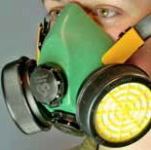

Half-face filter respirator Twin-strap disposable P2 mask Ordinary single-strap dust mask

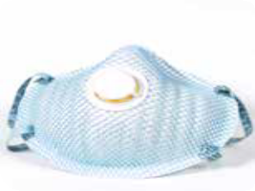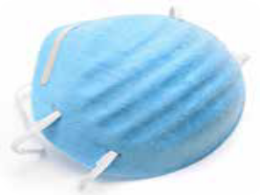

Keep your respirator on until the work session has been completed, the cleaning is done, and your contaminated clothing has been removed, bagged and sealed.

For the removal of asbestos cement material, a half-face disposable or cartridge-type particulate respirator class P1 or P2 is satisfactory. Respirators or masks should be worn continually by each person removing asbestos cement material.

Wear disposable clothing

Disposable coveralls should be used to prevent the contamination of clothing and footwear. An attached hood or disposable hat, and suitable disposable gloves should also be worn.

The coveralls should have no external pockets or velcro fastenings, and the gloves should

be sufficiently robust for the work to be done. Smooth, nonslip footwear without laces or top fasteners are preferable to plastic overshoes where there is a risk of slipping.

**When handling or removing asbestos cement products in general**

• work in a well-ventilated area and, where possible, in the open air

DO (but not on windy days)

• thoroughly wet down the material before you start and regularly during the work by lightly spraying surfaces with water or a 1:10 polyvinyl acetate (PVA): water solution, or with low-pressure water from a garden hose (if outdoors); keep it wet until packaged

for transport

• use nonpowered hand tools (e.g. a guillotine, hand saw or hand- powered drill) as these generate smaller amounts of dust and waste chips that are coarser than those generated when using power tools

• pull out any nails first to help remove sheeting with minimal breakage

• carefully lower (not drop) the sheets to the ground and stack on two layers of polythene sheeting at least 0.2 mm thick (e.g. heavy-duty builders’ plastic)

• minimise cutting or breaking of the asbestos cement products

• remove and dispose of personal protective equipment as

described below

• shower and wash your hair immediately afterwards and, regardless of whether gloves were used, thoroughly clean your hands and fingernails to remove any dust and asbestos that may be on your body.

DON’T

• use high-pressure water jets to wet surfaces as this may increase

the spread of loose fibres or dust

• slide one sheet over the surface of another as this may abrade the surface of the materials, and increase the likelihood of the release of fibres and dust

• use power tools, abrasive cutting or sanding discs, or compressed air on asbestos cement, as these will contribute to airborne dust and debris

• dry sand, wire brush or scrape surfaces to be painted

• walk on corrugated asbestos cement roofs if it can be avoided — many people have been injured by falling through weathered asbestos cement roofs while attempting to treat or repair the roof surface

• leave asbestos cement products around the garden, or where they

may be broken or crushed.

**When working indoors**

• isolate the area you are working on from the rest of the building by

DO closing and sealing internal doors

• leave external doors and windows open to maximise ventilation

• cover the floor with heavy-duty plastic sheeting to catch dust, debris

and offcuts

• keep household members, visitors and pets away from the area until

the work is completed.

DON’T

• spread asbestos dust through areas of the building that are not protected by plastic sheeting (e.g. by walking through unprotected areas without removing shoes).

**When working outdoors**

• inform your neighbours of the proposed work, and advise them

DO to close doors and windows while the work is being undertaken

• close all windows and doors of your home, and cover air vents to

prevent asbestos fibres from entering the building

• avoid contaminating the soil by covering the ground and vegetation

with heavy-duty plastic sheeting to catch dust, debris and offcuts

• remove play equipment, personal belongings and vehicles from the

work area

• keep household members, visitors and pets away until the work

is completed (use barricades and signs if necessary).

DON’T

• wet down roofing sheets if this creates a high risk of slipping off a roof

• work with asbestos on a windy day.

**Cleaning up**

• thoroughly clean the work area, tools and equipment as soon as

DO possible after finishing the job

• clean up any asbestos cement residues in the work area, and on the tools and equipment used by using wet rags and a wet mop, or with a vacuum cleaner fitted with a high-efficiency particulate air (HEPA) filter which conforms to AS4260. Attachments with brushes should be avoided because they are difficult to decontaminate

• double bag, seal and dispose of any materials used during the decontamination, such as rags and mops, along with other asbestos products at a disposal facility licensed to take asbestos

• keep dust, debris and offcuts damp with water

• keep your respirator on.

DON’T

• remove any materials from the work area until cleaned up as

described above

• clean the work area by dry sweeping or by using a household vacuum

cleaner

• store or reuse asbestos cement sheeting

• leave asbestos cement products around the garden, or where they may be broken or crushed.

**Packaging and disposal of asbestos**

• keep the material wet until it is packaged

DO • carefully package the material, including any offcuts, in two layers

of 0.2 mm thick polythene sheeting

• keep the packages of a manageable size and completely seal them

with adhesive tape

• place smaller sized asbestos waste such as tiles, offcuts and dust in two 0.2 mm thick polythene bags (i.e. double bagged), then tie and seal for disposal with the other asbestos waste

• only fill bags half full (to minimise the risk of splitting) and gently

evacuate excess air in a way that does not cause the release of dust

• clearly label the packages ‘ASBESTOS WASTE’ using a permanent

marker pen

• as soon as possible, securely transport and dispose of the packages at a designated asbestos waste disposal site in your area (your local government or Environment Protection Authority will provide advice on where this is)

• alternatively, hire a special miniskip from a waste removal company to fill with your bagged asbestos waste and have it collected by the waste company (see Yellow Pages)

• see pages 39–40 for where to find information on asbestos removal, transport and disposal in your area.

DON’T

• dispose of asbestos waste in a domestic garbage bin or rubbish skip

• reuse or recycle asbestos waste

• dump asbestos waste illegally

• dispose of asbestos during council ‘hard rubbish’ collections.

**Removing and disposing of personal protective equipment**

• peel off coveralls, hat and gloves

DO • immediately seal all these items in two 0.2 mm thick (heavy-duty) polythene bags (i.e. double bagged) and clearly label to identify the contents as described above in ‘Packaging and disposal of asbestos’

• dispose of these bags with the other asbestos waste

• wash or wipe reusable footwear using wet rags

• leave the respirator on until the contaminated clothing is removed, bagged and sealed, then dispose of the respirator by doubling bagging it as described above.

DON’T

• keep or recycle disposable protective equipment; for example,

don’t attempt to shake the dust out of overalls or clean the items with a vacuum cleaner

• launder or clean gloves — the asbestos removal and laundering

process causes physical damage or deterioration of the gloves.

**FURTHER INFORMATION AND ADVICE ON ASBESTOS**

General advice on safe handling of asbestos

Australian Capital Territory

Asbestos Awareness

13 22 81 [www.asbestos.act.gov.au](http://www.asbestos.act.gov.au/)

New South

Wales

Asbestos Awareness

[www.asbestosawareness.com.au](http://www.asbestosawareness.com.au/)

See also

[www.nsw.gov.au/fibro](http://www.nsw.gov.au/fibro)

DIY Safe

NSW Ministry of Health [www.health.nsw.gov.au/publichealth/](http://www.health.nsw.gov.au/publichealth/environment/diy/index.asp)

[environment/diy/index.asp](http://www.health.nsw.gov.au/publichealth/environment/diy/index.asp)

Northern

Territory

Health effects:

Department of Health, Environmental Health Branch

08 8922 7152 [www.nt.gov.au/health/envirohealth](http://www.nt.gov.au/health/envirohealth)

Queensland

Queensland Government

13QGOV (137468)

[www.health.qld.gov.au/asbestos](http://www.health.qld.gov.au/asbestos)

South

Australia

SA Health

08 8226 7100 [www.health.sa.gov.au](http://www.health.sa.gov.au/)

Tasmania

Workplace Standards Tasmania

1300 366 322 (if calling from Tasmania)

03 6233 7657 (if calling from other states)

[www.wst.tas.gov.au/safety_comply/asbestos](http://www.wst.tas.gov.au/safety_comply/asbestos)

Victoria

General information:

Contact your local council’s environmental health officer

See the ‘White Pages’

Health effects:

Department of Health, Environmental Health Program

1300 761 874

[www.health.vic.gov](http://www.health.vic.gov.au/environment).au/environment/hazards-asbestos.htm

Western

Australia

General information:

Contact your local government’s environmental health officer

See the ‘White Pages’

Health effects:

Department of Health, Environmental Health Hazards Unit

08 9388 4999 [www.public.health.wa.gov.au](http://www.public.health.wa.gov.au/)

and click on ‘Environmental health — Health hazards — Asbestos’

Occupational health and safety advice and practical fact sheets

Australian Capital Territory

ACT WorkCover

02 6205 0200

See also

[www.asbestos.act.gov.au](http://www.asbestos.act.gov.au/)

New South

Wales

NSW Ministry of Health

See the ‘White Pages’ for your local number [www.health.nsw.gov.au/factsheets](http://www.health.nsw.gov.au/factsheets)

and click on ‘Environmental — Asbestos and health risks’

Asbestos Resources

Heads of Asbestos Coordination Authorities (HACA)

[www.workcover.nsw.gov.au](http://www.workcover.nsw.gov.au/)

and click on ‘Work health and safety — HACA — Asbestos resources’

Northern

Territory

NT WorkSafe

1800 019 115 [www.worksafe.nt.gov.au](http://www.worksafe.nt.gov.au/)

Queensland

Queensland Government

13QGOV (137468)

[www.health.qld.gov.au/asbestos](http://www.health.qld.gov.au/asbestos)

South

Australia

SafeWork SA

Help and Early Intervention Centre

1300 365 255 [www.safework.sa.gov.au](http://www.safework.sa.gov.au/)

See also

[www.health.sa.gov.au/pehs/topics/public-health- factsheets.htm](http://www.health.sa.gov.au/pehs/topics/public-health-factsheets.htm)

Tasmania

Workplace Standards Tasmania

1300 366 322 (if calling from Tasmania)

03 6233 7657 (if calling from other states)

[www.wst.tas.gov.au/safety_comply/asbestos](http://www.wst.tas.gov.au/safety_comply/asbestos)

Victoria

WorkSafe Victoria

1800 136 089 [www.worksafe.vic.gov.au](http://www.worksafe.vic.gov.au/)

Western

Australia

WorkSafe, WA Department of Commerce

1300 307 877 [www.worksafe.wa.gov.au](http://www.worksafe.wa.gov.au/)

Asbestos removal, transport and disposal

Australian Capital Territory

ACT NOWaste

02 6207 6030 [www.tams.act.gov.au/recycling-waste](http://www.tams.act.gov.au/recycling-waste)

New South

Wales

Workers Health Centre

02 9749 7666 [www.workershealth.com.au/Workers-Health/fact-](http://www.workershealth.com.au/Workers-Health/fact-sheets.html)

[sheets.html](http://www.workershealth.com.au/Workers-Health/fact-sheets.html)

Office of Environment & Heritage

131 555 [www.environment.nsw.gov.au/waste/asbestos](http://www.environment.nsw.gov.au/waste/asbestos)

Northern

Territory

Environment Protection Authority

08 8924 4218 [www.ntepa.nt.gov.au](http://www.ntepa.nt.gov.au/)

NT WorkSafe

1800 019 115 [www.](http://www.environment.nsw.gov.au/waste/asbestos)worksafe.nt.gov.au

Queensland

Queensland Government

13QGOV (13 7468)

[www.qld.gov.au/asbestos](http://www.qld.gov.au/asbestos)

South

Australia

Environment Protection Authority

08 8204 2004 [www.epa.sa.gov.au](http://www.epa.sa.gov.au/)

Tasmania

Workplace Standards Tasmania

1300 366 322 (if calling from Tasmania)

03 6233 7657 (if calling from other states)

[www.wst.tas.gov.au/safety_comply/asbestos](http://www.wst.tas.gov.au/safety_comply/asbestos)

Victoria

Environment Protection Authority

1300 EPA VIC (1300 372 842)

[www.epa.vic.gov.au](http://www.epa.vic.gov.au/)

WorkSafe Victoria

1800 136 089 [www.worksafe.vic.gov.au](http://www.worksafe.vic.gov.au/)

Western

Australia

Contact your local government’s environmental health officer

See the ‘White Pages’

Department of Environment and Conservation

08 6367 5000 [www.dec.wa.gov.au/pollution-prevention](http://www.dec.wa.gov.au/pollution-prevention)

and click on ‘Contaminated sites — Asbestos’

Licensed asbestos removalist and demolition information

Australian Capital Territory

ACT Planning and Land Authority, Construction Occupations Section

02 6207 6400 [www.actpla.act.gov.au/topics/hiring_licensing](http://www.actpla.act.gov.au/topics/hiring_licensing)

New South

Wales

Workcover Authority of NSW

13 10 50 [www.workcover.nsw.gov.au](http://www.workcover.nsw.gov.au/)

and click on ‘Work health and safety — Health and safety topics —

Asbestos’

Northern

Territory

NT WorkSafe

1800 019 115 [www.worksafe.nt.gov.au](http://www.worksafe.nt.gov.au/)

Queensland

Queensland Government

13QGOV (13 7468)

[www.qld.gov.au/asbestos](http://www.qld.gov.au/asbestos)

South

Australia

SafeWork SA

Help and Early Intervention Centre

1300 365 255 [www.safework.sa.gov.au](http://www.safework.sa.gov.au/)

Tasmania

Workplace Standards Tasmania

1300 366 322 (if calling from Tasmania)

03 6233 7657 (if calling from other states)

[www.wst.tas.gov.au/safety_comply/asbestos](http://www.wst.tas.gov.au/safety_comply/asbestos)

Victoria

WorkSafe Victoria

1800 136 089 [www.worksafe.vic.gov.au](http://www.worksafe.vic.gov.au/)

Western

Australia

WorkSafe (WA Department of Commerce)

1300 307 877 [www.worksafe.wa.gov.au](http://www.worksafe.wa.gov.au/)

and click on ‘Services — Licensing and registration

of plant — Asbestos’

Information about asbestos-related diseases

Australian Asbestos Network

[www.australianasbestosnetwork.org.au](http://www.australianasbestosnetwork.org.au/)

Asbestos Diseases Society of Australia

[www.asbestosdiseases.org.au](http://www.asbestosdiseases.org.au/)

Better Health Channel

[www.betterhealth.vic.gov.au](http://www.betterhealth.vic.gov.au/)

Dust Diseases Board

[www.ddb.nsw.gov.au](http://www.ddb.nsw.gov.au/)

Bernie Banton Foundation

[www.berniebanton.com.au](http://www.berniebanton.com.au/)

Asbestoswise – Information and Support

[www.](http://www.ddb.nsw.gov.au/)asbestoswise.com.au

43

This guide has been endorsed by the Australian Health Protection Principal Committee and was prepared by its Environment Health Standing Committee, enHealth. [**www.health.gov.au**](http://www.health.gov.au/)



Information correct as at February 2013