“They Do not Get a Chance”: About Young People with Housing Challenges
Research focus
- youth
- homeless
- exclusion

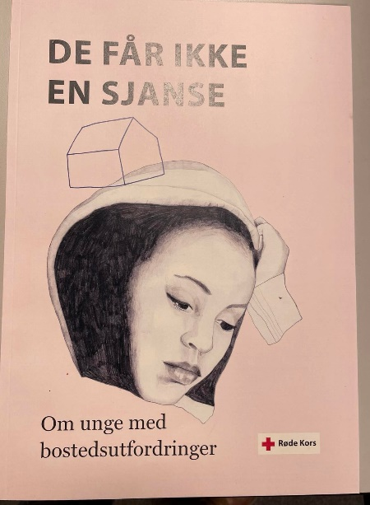
Figure 1 (Illustration: Kathrine Kristiansen Illustrasjon)
De får ikke en sjanse (rodekors.no)2020 (Norwegian)

Executive summary

Main purpose of report/analysis

There are children and youth in Norway who lack predictable, adequate, or safe housing. Some might face risks of domestic violence, struggle with substance abuse, have mental health challenges or live in poverty, the background of these young people is, however, not uniform. Many of them live outside the formal system and do not have daily activities such as school or work. This group of young people does to a varying degree spend time on the streets and is in particular apparent in Norway’s larger cities. Examples were given of youths who in the most extreme cases had to find places to sleep in underground car parks, under benches on the football field, on the night bus or in 24 hrs open gyms. The report focuses on children and youth between the ages of 15 and 23 years.
In order to gain a better insight into their problems and draw attention to this in many ways “invisible” problem, the Norwegian Red Cross compiled an advocacy report.

Main findings
- School is an important arena for capturing young people with housing challenges. The school is, therefore, also a central part of the solution.
- Housing challenges affect young people from all socio-economic strata and often have connection with challenging family situations, substance abuse, mental health challenges, or experiences with violence, abuse or exploitation.
- Many young people with housing challenges are lonely and have limited social and family networks.
- Youth are in a transition phase between children and adulthood and are in a particularly vulnerable situation as they tend to fall in the gap between support structures from the social services tailor-made for either children or for families.
- Many young people struggling with housing feel excluded from formal and informal social systems and believe that those systems only benefit some people.
- There is a lack of decent housing for young people in acute situations.
- There is a demand for safe low-threshold offers for overnight stays which young people can access without going through the social service system.
- Concern for young girls exchanging sexual favours for a place to stay the night was raised throughout the data-collection-period.

Methodology
40 interviews were conducted with 79 people in two cities: Trondheim and Oslo. Informants were mainly teachers, employees from the social services, youths who have experiences housing issues, and local stakeholders. Interviews took place one-to-one- or in group-settings. A survey was sent to alt the senior secondary schools in Norway.

Recommendations
- There is a need for increased competence and more resources in schools to take care of young people with housing challenges. School staff should have access to support systems and knowledge of how the social services is organized at city and municipal level, in order to meet students' housing challenges.
- In order to prevent housing challenges among young people, it is important to provide holistic support, through interdisciplinary cooperation. Social services must reach out as early as possible to families in difficult life situations.
- Voluntary organizations, including the Red Cross, can help complement the public assistance system by offering one-to-one activities and group activities.
- Trust must be developed so young people experience that there is equality in access to assistance from the social services and from voluntary organizations. The youth must experience that their rights are safeguarded when they are in vulnerable situations.
- Options for housing must be flexible enough to meet realities.
- The voluntary sector, in dialogue with the public sector, must rethink how to contribute to safe low-threshold services for young people with acute housing needs.
- The support system, be it public organisations or voluntary organisations, must be aware of the issue of sexual favours in exchange for housing. There should be more transparency around the topic.

