“Growing up in Norway – increasing number of children in poor households”
Research focus
- Children and youth
- Low- income-households

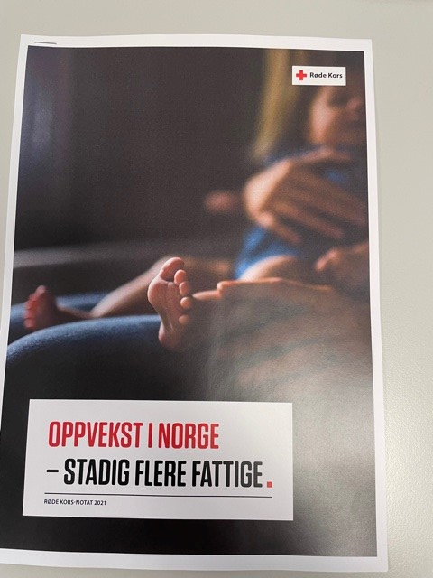
Figure 1 (coverphoto: Jenna Norman, Unsplash)
Notat 2021: Oppvekst i Norge – stadig flere fattige (rodekors.no) (2021) (Norsk)

Executive summary
Main purpose of report/analysis
This publication is a thematic note on children growing up in low-income families, and its consequences. The thematic note was used for advocacy purposes ahead of the 2021 national election.

Main findings
There has been a steady increase since 2011 in the share of children living in families with persistent low income. Statistics Norway shows that the share was 11.7 per cent in 2019.
This amounts to a total of 115,000 children and it is an increase of approximately 4,000 children compared with 2018.
Children with immigrant background constitute more than 50% of all children living in families with persistent low incomes in Norway. Children living in households with three or more children, with single parents, or in household in which few of the adults in the household are employed are particularly exposed to persistent low income. The highest share of children growing up in persistent low income is found in the most densely populated counties (where you also find the biggest cities).
There are several challenges as a result of low income, both short-term and long-term that have impact in areas such as health, local environment and school. Other potential consequences are poorer health and mental challenges.

Methodology
Desk study: literature review of available and relevant reports, research and statistics.

Recommendations
- Increase child benefit for all children from the age of 0-18 years.
- Social benefits should not be calculated as income when child benefits are estimated.
- Provide access to free leisure activities for all children and young people.
- Strengthen the team of support and supporters around children.
- Make sure children and young people are given support to close their gap in knowledge created by the covid-19 pandemic.

