Loneliness among children and youth
Research focus
- Children and youth
- lonliness

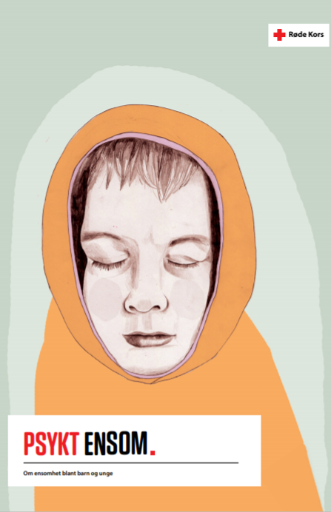
Figure 1 (Illustration: Kathrine Kristiansen Illustrasjon)
Psykt ensom (2020) Norsk

Executive summary
Main purpose of report/analysis
The aim of this report is to contribute to increased knowledge of what loneliness means to children and young people, and how we as a society can help prevent it. By putting into words what for many is still perceived as shameful, we hope to be able to help break down taboos.

Main findings
A total of 72 percent of young people say that they sometimes feel lonely nowadays (data collection period February- March 2021), out of which 24 percent say they feel lonely often, whereas 48 percent say sometimes. Girls state to a somewhat greater extent than boys that sometimes they feel lonely (82% vs. 63%). Those who live alone state this to a greatest extent, and those who live at home with their parents to a lesser extent. Those who are lonely now were also lonelier before the pandemic.
The causes of loneliness can be many and complex. In the report, young people and professionals highlight several causes of loneliness.
For some youth it is about missing friends and social relationships, for others about an inner loneliness that can stem from a feeling of not being heard, seen, understood, or belong.
Many cite stress and pressure of performance in several arenas as a cause of loneliness. Both young people and professionals highlights digital and social media as a cause of loneliness. Poverty and structural exclusion are an important cause which are related to the lack of opportunity to participate and make friends through organized leisure activities. The young people interviewed also pointed out that there is too little knowledge and openness about mental health and loneliness.

Methodology
A survey amongst 761 youth (16–19-year-olds), 10 in depth interviews (16–19-year-olds), as well as interviews with a “you tuber”, a psychologist and nurse.

Recommendations
- Ensure that there is adequate access to health nurses for students at all grade levels, and that the municipalities have enough resources for this.
- Ensure more rapid access to psychological health care for youth
- Ensure the right and earmark funds to free meeting places for youth
- Give focus to research on children and the use of social and digital media to increase knowledge about the effects this can have on friendship, communication, loneliness and mental health
- Reduce pressure in school
- Ensure increased knowledge and openness about emotions and mental health in school by introducing life skills and mental health for a separate subject
- Earmark funds for the Norwegian Red Cross’ helpline youth (Kors på halsen)

