“The welfare state put to the test” - Humanitarian consequences in the wake of the covid-19 pandemic.
Research focus
- Covid -19
- Humanitarian consequences

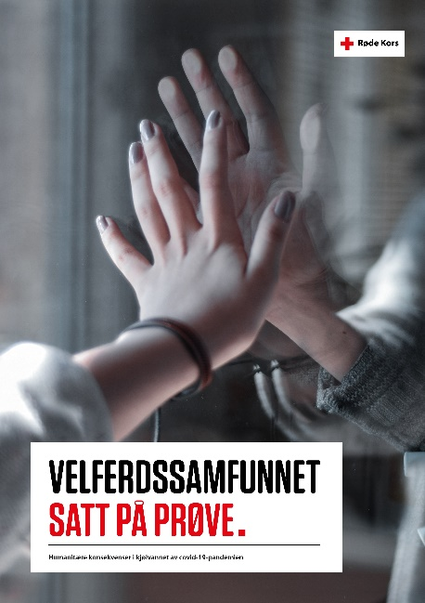
Figure 1 (Illustrasjonsfoto: Unsplash: Forside Zoë)
Velferdssamfunnet satt på prøve (rodekors.no) (2021) (Norsk)

Executive summary
Main purpose of report/analysis
The purpose of the report is to draw attention to the indirect consequences the covid-19 pandemic on the humanitarian needs in Norway. The Norwegian Red Cross wants to better understand how the covid-19 pandemic has affected and created new or changed humanitarian needs, and the long-term consequences for Norwegian society.

Main findings
The covid-19 pandemic had major economic and humanitarian consequences in Norway.
Young and old have experiences more loneliness. The most vulnerable children and youth became even more vulnerable. An example is that children and young people with disabilities were more exposed to violence and abuse in the period with shutdowns than those without disabilities. Children from low-income families experienced more difficulties during home school. Problems were related to access to equipment and facilities such as internet, computers and space in general, and they also received less help from their parents with their schoolwork.
Students experienced loneliness and poorer learning outcomes than before the pandemic.
People with low income, less education, young people and immigrants were most likely to lose their jobs (permanently or short term), particularly in the beginning of the pandemic. Immigrants experienced additional challenges related to a poorer quality introductory program. People with less education, lowest language comprehension and least digital competence was hit hard.

Methodology
Desk study: literature review of available and relevant reports and research (published during the period March 2020- March 2021).

Recommendations

Recommendations were not given in the report itself, but the findings were shared quite widely in media.

