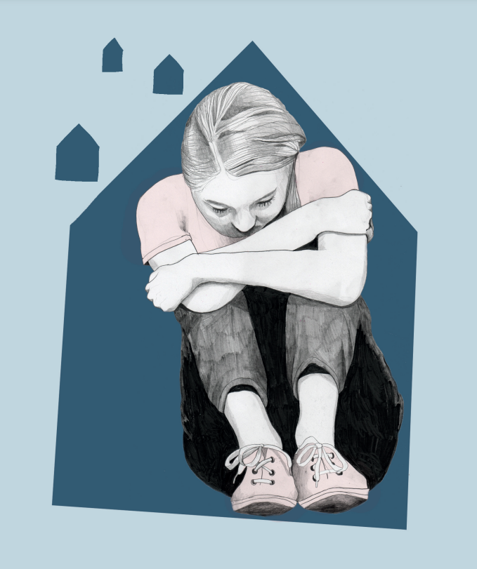
Research focus

The psychosocial consequences of the pandemic, especially for young people and the elderly.

Report cover illustration by Kathrine Kristiansen
Every day and every night seem like an eternity – The psychosocial consequences of the pandemic (2022)

Executive summary
When the report was published in March 2022, the Norwegian COVID-19 restrictions had been in place for two years in varying degrees of intensity and scope during this period. However, social distancing had remained a permanent feature among the measures recommended to the public by the health authorities. The Norwegian Red Cross (NorCross) wanted to gain insight into the psychosocial consequences of social distancing by asking the following questions:
- How had social distancing affected social life amongst the general population?
- Had more people felt lonely during the pandemic?
To answer these questions, a representative survey was carried out (N = 1 205), and a small number of interviews with NorCross volunteers were also conducted.
Almost a quarter of the respondents in the survey said that they were lonelier now (between 17th December 2021 and 7th January 2022 when the survey was conducted) than they were before the pandemic. The proportion of individuals who felt lonely now was higher than it was before the pandemic for all age groups.
Loneliness was most prevalent among the youngest and the oldest respondents. Young people were particularly affected due to reducing the amount of time spent with friends and seeing them less often than they would like. It was also high among students. Loneliness was more prevalent among women than among men, both before the pandemic and at the time of the survey.
The majority of respondents had seen less of friends and family members outside of their own households during the pandemic. The proportion that reported feeling lonely at the time of the survey was higher among those who had cut down on socializing than for those who had not. However, it is worth noting that feeling lonely was also reported to be higher at the time of completing the survey for those respondents whose contact with family members and friends had been relatively consistent throughout the pandemic. Similarly, loneliness was higher among those who did not usually see friends and family prior to the pandemic. It could be surmised that casual contact with strangers and being present in public spaces, without the presence of social distancing measures, could be more important sources of social interaction and companionship than we previously have considered.

