Social Pulse 2022 – a report on the biggest humanitarian needs in Norway
Research focus

Humanitarian needs in Norway

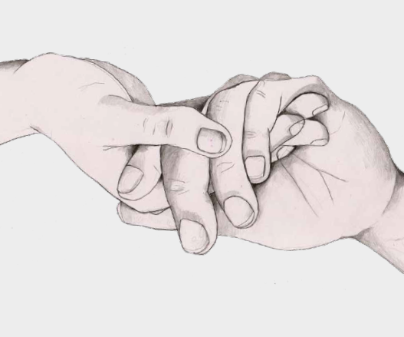
Report cover illustration by Kathrine Kristiansen
Social Pulse (2022)

Executive summary
Since the post-war years, Norway has been characterized by high economic growth and large-scale development of its welfare state. As a result, humanitarian needs have been reduced and Norway is often referred to as "the best country in the world to live in". But pockets off
need still exists and Norway is not the world's best country for all its inhabitants.

In the report “Humanitarian needs in Norway. Status 2022”, which the Norwegian Red Cross (NorCross) commissioned from Statistics Norway, Hammersland and Barstad (2022) thoroughly document how suffering and distress exists in Norway. In contrast to the suffering and distress one may encounter in low-income countries, it is more often hidden within society. Some examples include children exposed to persistent abuse or bullying, the elderly in nursing homes experiencing tremendous pain due to a lack of sufficient end of life care and individuals who are homeless and live a hard life on the streets. Whilst this group is not sizeable when measured in proportion to the Norwegian population, it is considerable in absolute terms. The form and level of humanitarian need within Norway has also been impacted by the COVID pandemic which Hammersland and Barstad’s discuss in their report.

The term “humanitarian needs” is used in the report to refer to individuals and groups of people who need help from friends, family, volunteer organisations or the welfare sector to alleviate their suffering and distress. Humanitarian needs arise when individuals or groups either experience, or are at risk of, low quality of life.

Based on a thorough review of available statistics and welfare research, Hammersland and Barstad (2022) conclude that some groups in the Norwegian society are at higher risk of having one or more humanitarian needs. They identify the ten most vulnerable groups within Norway which are as follows:
- Children who are subjected to mistreatment, violence, bullying and neglect.
- People who take narcotics intravenously or have other serious drug addictions
- Prisoners
- People with serious psychological illness
- Families with children living in poverty
- People with both health problems and low economic resources
- Social assistance and welfare receivers
- Elderly with dementia living in a care home or receiving home services
- Asylum seekers and irregular migrants
- Sexual orientation and gender identity minorities
The NorCross report “Social Pulse 2022 – a report on the biggest humanitarian needs in Norway” contains a summary of these ten vulnerable groups along with a brief explanation of how they were identified and the driving factors causing humanitarian need in Norway. The overlaps between these vulnerable groups are visualized in the report. In addition the report outlines how NorCross’ activities meet the needs of some of these vulnerable groups and finally presents recommendations to decision-makers and civil society on how these humanitarian needs can be addressed.
NorCross presents to following recommendations to decision-makers:
- Home visits for all preschool children to detect violence and neglect.
- Drug reform with treatment instead of punishment.
- Limited use of solitary confinement in prison.
- Strengthen psychological and psychiatric outreach services.
- Increase child benefit for families with children between 0 and 18 years of age.
- Increase the rates of social benefits and ensure mapping of children's needs in the assessment of social assistance.
- Ensure that all children and young people have access to free leisure and counselling services.
- Daily physical activity for the elderly at home and in institutions and establish coordinators for the elderly.
- Provide child welfare services for all children seeking asylum in Norway, especially those between 15 and 18 years of age.
- Give undocumented migrants the right and access to necessary health care and dental treatment.
NorCross recommends civil society to:
- Strengthen efforts to create inclusive free arenas.
- Ensure the participation of children and young people and other groups participating in activities.
- Actively facilitate that everyone has the opportunity to participate in organizational life, be included and find their role.

