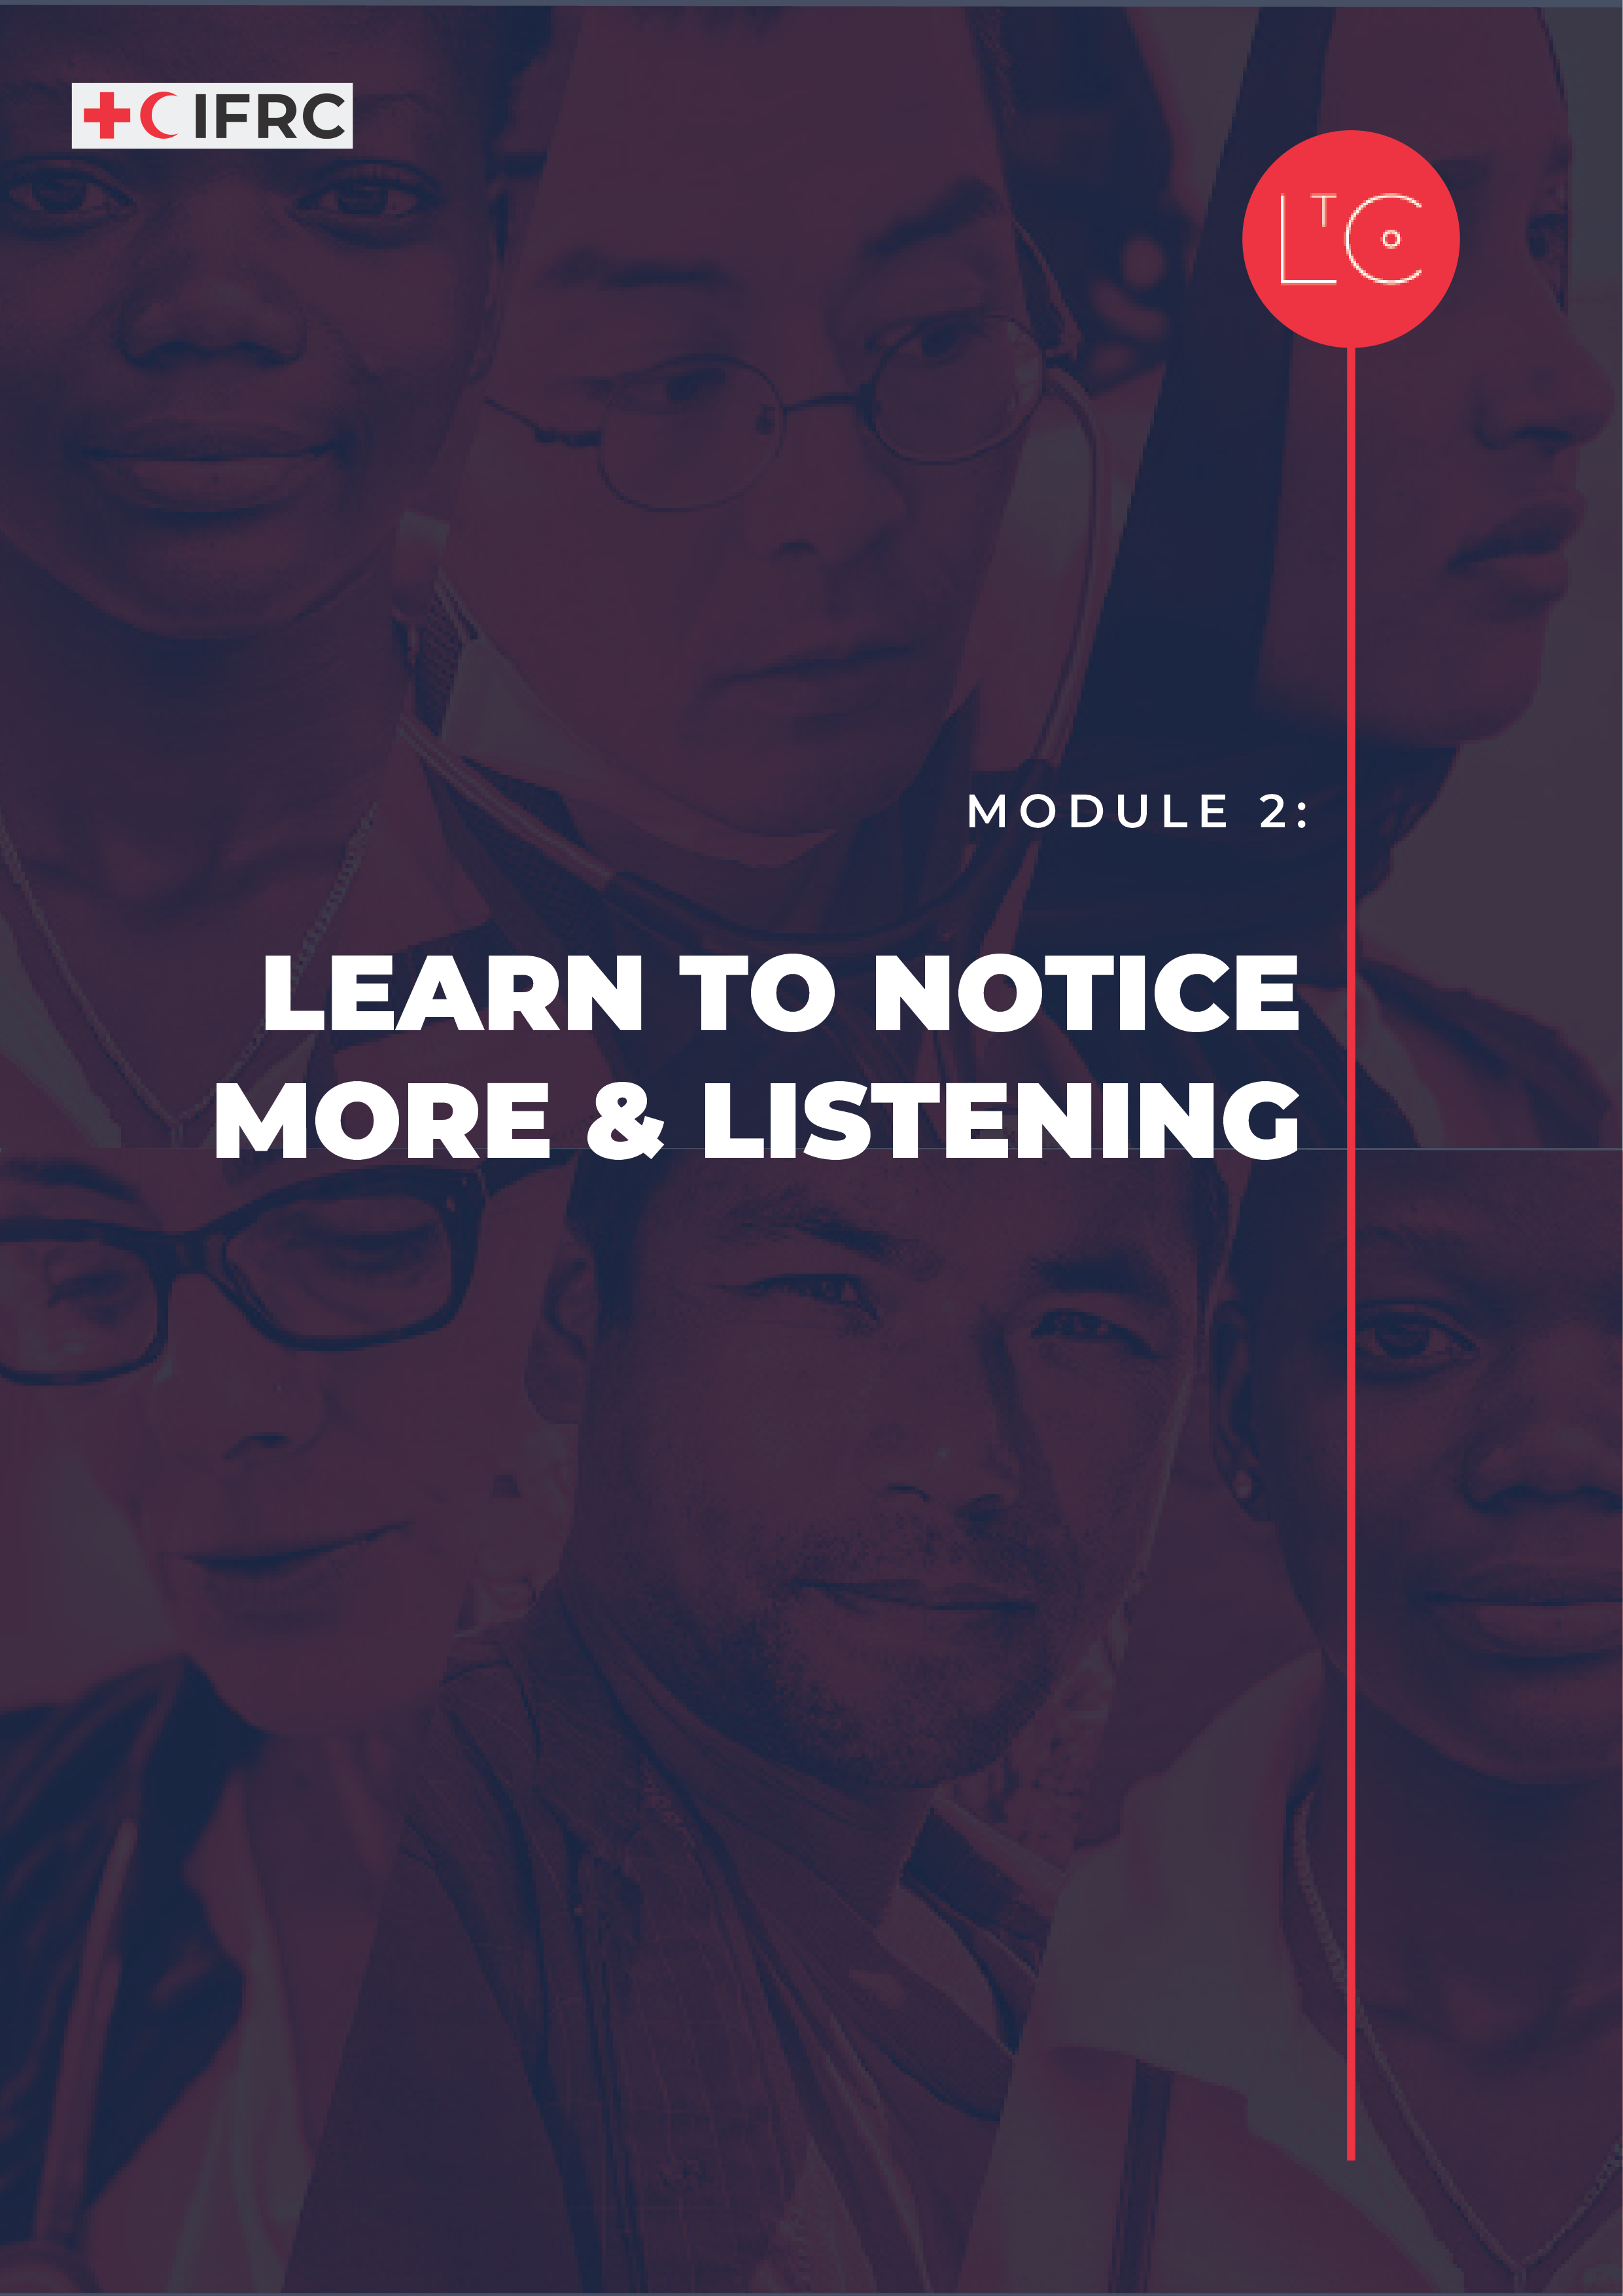
IN THIS MODULE
Before we begin to change things, we need to understand our context and environment. This session focuses on expanding our abilities to notice more about our own -and other peoples – thoughts, perspectives and experiences. This helps us to embrace diversity and question the assumptions that often hold back change.

MODULE OUTCOMES
- You will be more aware of yourself, your context, and other people.
- You will know that everyone has a different perspective and be ready to question your own and others' assumptions.
- You will be more aware of how you listen and the opportunity for generative dialogue.
- You will be more able to accept the differences between people.

PREPARATION
- Have ready the Learning Journey Image
- Have ready the tool 4 Levels of Listening
- Have ready the tool Same and Different

TIME
1.5 – 2 HOURS

HOW TO RUN THE SESSION
LAUNCH Time: 20 minutes
WELCOME AND INTRODUCTION time: 5 minutes
Welcome the group.

Remind the group that our role is to be change makers who are working to create a learning culture in RC/RC that is safe, motivating and transformative. This is so that we can best carry out our mission for the people and communities that rely on our services.

We will practice creating this culture in our sessions together. We will work to set the conditions in our learning space that reflect universal human needs: connection, safety, agency, autonomy and competence. As part of this programme and because we are adults learning together, we are all responsible for creating this culture and modelling positive, supportive behaviour.

Facilitator notes:
As the facilitator, offer psychosocial support to the participants in relation to the learning journey, to the level you can provide it.

As part of this module, we will observe our own internal environment – our thoughts, feelings and emotional reactions without judgement. Since this may raise difficult feelings or reactions, if you personally need to take time out of this session, you can leave and return at any moment without giving a reason or needing to explain yourself when you come back.

CHECK IN TO THE LEARNING SPACE time: 10 minutes
As we continue our learning journey, we take responsibility for our own learning, and build connections with other learners. Part of taking responsibility is doing our own individual work between sessions, and part of building connection is the activities we do between sessions.
In pairs or groups of three, ask the group to discuss:

- How I noticed my 2 core values being expressed in my life (personal or professional).
- How did I notice my team’s shared values of the RCRC principles present in my life?
Ask the group to share learning from their take away exercise in plenary:

- If you were able to do a team or peer group activity between sessions, how was it?
- How about any individual take away exercises?
- What did you learn or how did it feel?

INTRODUCTION TO THIS SESSION time: 5 minutes
This session is about learning to notice more, question our own assumptions, make space for the differences between people and consider other perspectives.

Display the learning journey image on a poster or slide and highlight where we are!

Developing our skills of noticing or observing without judgement, helps us to be alert to our own and other peoples’ context. This expands our options for making change happen.

TOOL LISTENING AND INCLUSION Time: 70 minutes
INTRODUCTION time: 20 minutes

Explain that during this session we will tune into how we listen to and understand each other to nurture an inclusive team space and create conditions to lead change together.

Display the 4 levels of listening image from the LtC tools.

Introduce this and give an orientation.

Facilitator notes: A way of describing the 4 levels of listening
- Level 1: You are inside your house, doors and windows closed. You are projecting your own slides on the wall. You are listening to only what you already know and think.
- Level 2: You are still inside your house, but you have opened the window and you are looking what’s going on outside. You are still in your safe place in your own thinking, but you are ready to listen to what is different from what you have thought until now. This is when you are ready to test your ideas.
- Level 3: You leave your house to see the world with the eyes of those you are listening to. You want to understand what they think and feel, and why. This is empathic listening.
- Level 4: You do not only listen to what is, but to what could be. You listen to the possibilities, seeds of things to come, etc. You also listen to your inner being: your values, dreams and potential.

DISCUSS AND EXPLORE time: 30 minutes

We will now do an exercise based on the Same and Different tool to get us to listen deeply and think about the things we have in common and our differences. Concentrate on being as present as possible and listen with empathy. Move to the third level of listening. If you are speaking, you are invited to share as openly as you feel comfortable.
In groups of 3:

- Choose one person to listen and two people to speak.

- Each speaker will take a turn speaking for 3 minutes without interruption, about:

- How I like to work and learn. What in my past has shaped my preferences.
Each speaker sets a 3-minute timer.
The listener listens quietly to each speaker, with an open heart and mind.

- When both speakers have spoken, the listener creates two columns on paper or a document. Label one column SAME and one DIFFERENT. The listener records in the columns, how the speakers were similar and how they were different
- The listener shares some of the things they noticed with the two speakers. If the speakers noticed other things, they add them to the columns.
Ask one or two listeners to share in plenary:

- How did it feel to listen to the stories?
- What did you notice? More similarities or more differences?

On a board/poster record all the ways the group can think of how people might be different or similar.

Facilitator notes: Same and Different
Examples of ways we can be different from one another include: Racialized identity, family and upbringing, skills and abilities, personality types, values, gender identity and expression, technological ability, SOGIESC (sexual orientation, gender identity, expression and sex characteristics), physical ability, neurodiversity, psychological disorders, education, and income.

Often people who fit into certain types of categories have more advantages within the systems we live and work in, for example, able bodied, educated, heterosexual, and Caucasian. However, having many different people in a group brings richness and diversity. If we encourage and embrace differences, we can be more creative and productive. This contributes to positive culture change.

Practicing third and fourth levels of listening with each other, deepening our self-awareness by reflecting both individually and as a team, are all steps toward holding a safe space for a more inclusive team and positive culture.

REFLECTION AND DEBRIEF time: 20 minutes

Ask the group to reflect individually and write in their journal:

Thinking about the categories for similarities and difference we identified,
- What advantages and disadvantages have resulted for me in the systems I work and live in?
- How might these differences affect how I behave and present myself in this learning environment?

These reflections are for you, you don’t need to share them.

Ask the group to share in plenary:

Thinking about the process we have just gone through, reflecting on how our differences and similarities connect with advantages and disadvantages,
- What surprised you?

- What questions did it raise for you?

Variation: take an extra 2 minutes to think quietly about these questions, if nobody wants to answer aloud in the group.

We acknowledge that reflecting on issues relating to power and privilege is usually uncomfortable. Please take notice of how you feel (this is a way of observing your internal environment). If you feel discomfort in the process of becoming more aware of your privilege, it is a sign that you are learning.

Facilitator Note: Privilege
“Privilege exists when one group has something of value that is denied to others simply because of the groups they belong to, rather than because of anything they’ve done or failed to do. Access to privilege doesn’t determine one’s outcomes, but it is definitely an asset that makes it more likely that whatever talent, ability, and aspirations a person with privilege has will result in something positive for them.”
(Peggy McIntosh)

LAND time: 15 minutes
REFLECT time: 5 minutes
Consider what we have discussed today and think about ways we could allow more diversity or difference to enrich teams and groups in our lives and work.
Ask the group to reflect individually or write in their journal:

- What will you do differently to allow for more diversity and difference to enrich the teams and groups you work and live with?
You will be asked to share one idea with the group at the end of this session.

TAKE-AWAY ACTIVITIES BRIEFING time: 5 minutes
Take-away activities help us to deepen and broaden our learning by applying it at work and in our lives. Everyone should set aside time to do the individual activities.
If you joined this learning journey as part of a team, follow the instructions for the team take-away.
If you joined this learning journey as an individual, you are invited to join a peer group of other individual learners. Follow the instructions for the peer groups take-away.

INDIVIDUAL
- Between now and the next session notice and record how power dynamics play out around you …or… The assumptions you are making about other people.
- Record in your journal examples of times when your perspective, experience or culture affects the way you work …or… What you are noticing now that you didn’t before.

TEAM
- Book a date and time for an action-learning meeting, in which you will do one activity to celebrate your team diversity.
- Module 2 suggested team activities:
- Revisit your working preferences tool and discuss how your similarities and differences can enrich your work together
- Choose an activity from https://teambuilding.com/blog/diversity-and-inclusion-activities
- Host an Observation Session to develop your collective powers of observation. Start with 2-3 short activities that use different senses to observe the environment, such as: Observation walk; observation bingo; 2-minute listen; Memory game; Empathy walk. Then discuss how you can apply deeper skills of observation to strengthen how supportive you are as a team.

PEER GROUPS
- Book a date and time to meet with your peer group, in which you will do one activity to extend the learning from Module 2
- Module 2 suggested peer group activities:
- Prepare by using the SAME and DIFFERENT columns to record some similarities and differences between yourself and others in your work or life. In the meeting, discuss how these similarities and differences can enrich your work as a changemaker
- Break into pairs to practice the 4 levels of listening exercise.
CHECK OUT time: 5 minutes
Share one thing that you might do differently to allow more diversity or difference into the way you work.
Ask the group to share in plenary:

- What is your ‘one thing’ to enrich your work with greater diversity and difference?
Display the responses on a board/poster:
Add your response to the shared output as a record.

MORE LtC TOOLS
LtC tools can be used in several ways: during the learning journey session as exercises, as take away tools between sessions, and/or tools to support learning habits and continuing leadership practice after the learning journey. As a facilitator, you can also choose your favourite tools to replace the suggested exercises above in the core module. The additional LtC tools associated with this module are:

- Observe the World (The World Around You Series)
- Listening and Paraphrasing Practice
- Working With Me

FURTHER RESOURCES
These resources provide more depth on the topics in this module. You may wish to review them as background reading to prepare for the session and share some or all of them with the participants.

These resources are on the topics of listening and inclusion.
https://teambuilding.com/blog/diversity-and-inclusion-activities

(Watch the video talk on Levels of Listening by the Presencing Institute’s Otto Sharmer on the 4 levels of listening – select settings and auto translate for closed captioning CC in multiple languages.)
https://www.youtube.com/watch?v=eLfXpRkVZaI

Another resource is the IFRC Protection, Gender, and Inclusion (PGI) organizational assessment. The toolkit is a guide to assessing organizational capacities to help build safer and more inclusive institutions which is essential for creating positive cultures.

https://pgi.ifrc.org/resources/pgi-organisational-assessment-toolkit-oat

