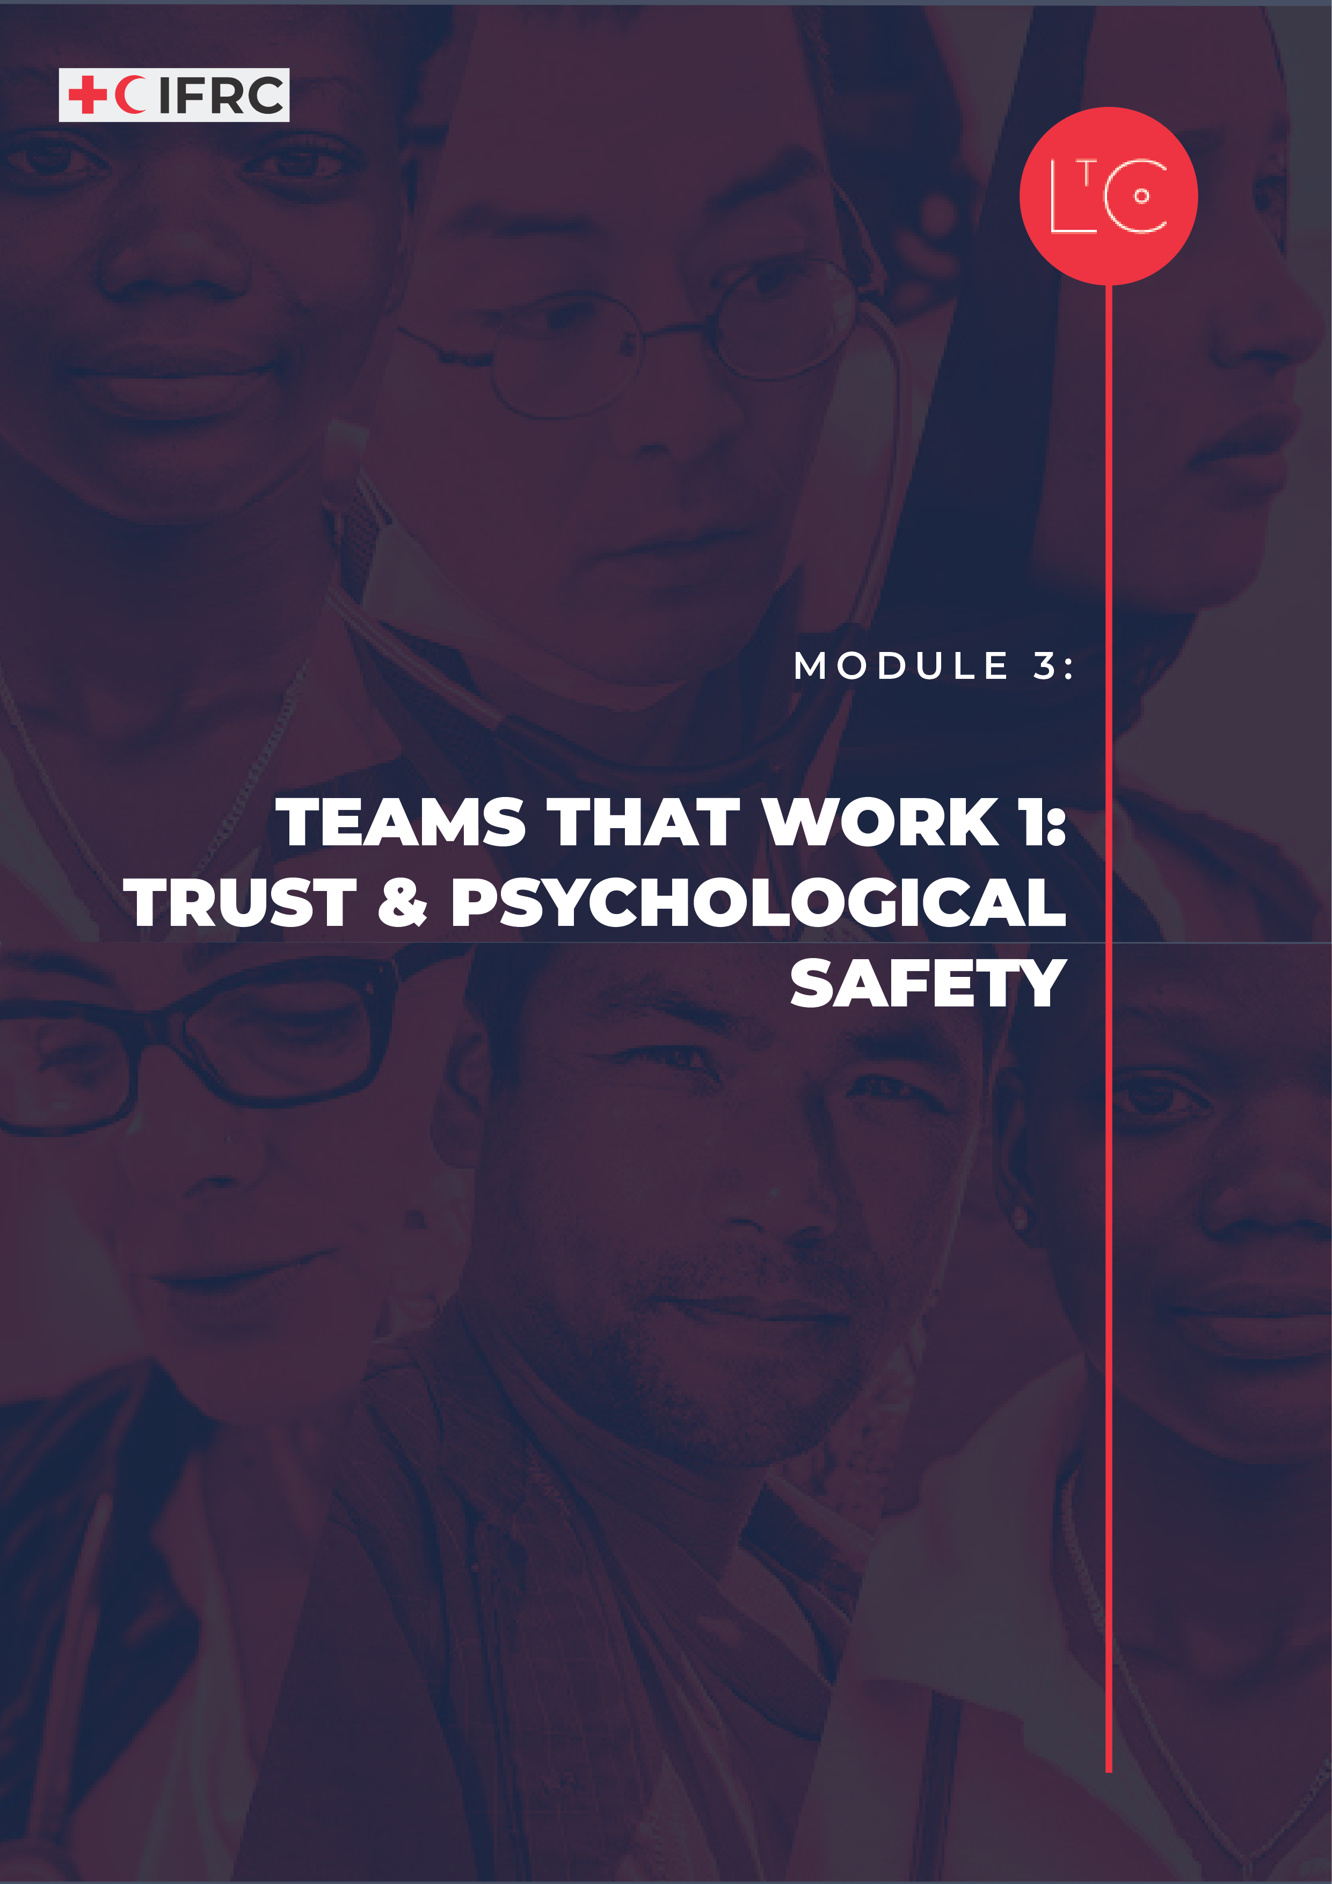
#
IN THIS MODULE
Module 3 focuses our attention on what we can each do to change culture in the groups and teams we live and work in. You will explore trust and psychological safety and come away with practical actions that you can take to bring about positive change for yourself and other people.

MODULE OUTCOMES
- You will be able to describe what makes successful and well-functioning teams, and what you contribute to them.
- You will be able to explain the features of a positive team culture.
- You will be able to ask questions to identify how you could improve a team culture.

PREPARATION
- Have ready the Learning Journey Image
- Prepare the information you want to present to introduce culture, team effectiveness and psychological safety
- Prepare instructions for the IN/Out tool to share with small groups.

TIME
1.5 – 2 HOURS

HOW TO RUN THE SESSION
LAUNCH Time: 20 minutes
WELCOME AND INTRODUCTION time: 5 minutes
Welcome the group.

Remind the group that our role is to be change makers who are working to create a learning culture in RC/RC that is safe, motivating and transformative. This is so that we can best carry out our mission for the people and communities that rely on our services.

We will practice creating this culture in our sessions together. Another way of defining culture is simply “the way things get done around here”. So, we will work to set the conditions in our learning space that reflect universal human needs: connection, safety, agency, autonomy and competence. As part of this programme and because we are adults learning together, we are all responsible for creating this culture and modelling positive, supportive behaviour.

Facilitator notes:
As the facilitator, offer psychosocial support to the participants in relation to the learning journey, to the level you can provide it.

As part of this module, we will observe our own internal environment – our thoughts, feelings and emotional reactions without judgement. Since this may raise difficult feelings or reactions, if you personally need to take time out of this session, you can leave and return at any moment without giving a reason or needing to explain yourself when you come back.

CHECK IN TO THE LEARNING SPACE time: 10 minutes
As we continue our learning journey, we take responsibility for our own learning, and build connections with other learners. Part of taking responsibility is doing our own individual work between sessions, and part of building connection is the activities we do between sessions.
In pairs or groups of three, ask the group to discuss:

- How has my perspective, culture and experience influenced how I am?
- What did I notice that I was missing before, but is clear now?
Ask the group to share in plenary their experience with the take away exercise:

- How was your team or peer group activity session? What did you learn or how did it feel?
- Did you have the chance to explore any of the tools or take away exercise on your own?

INTRODUCTION TO THIS SESSION time: 5 minutes
This session is the first of two sessions on ‘teams that work’. Together we will explore
- what makes successful and well-functioning teams and what you contribute to them
- the features of a positive team culture, and how to improve team culture.
Display the learning journey image on a poster or slide and highlight where we are!

TOOL SAFE SPACES Time: 60 minutes
INTRODUCTION time: 10 minutes
Now we will look at what makes teams productive and well-functioning. The foundation for this is creating a positive team culture. I will introduce some of the research which informs what we know about teams.

Facilitator notes: What is culture?
- To put it simply, culture is “the way things get done around here”.
- Organisational cultures are the combination of beliefs, values, assumptions, and norms that are shared in an organisation (Robbins P and Coulter M, 2005; Schein and Schein, 2017).
- In the same way that our personal high-level values (Module 1) drive our individual behaviour, organisational or team values drive the culture that is created and the behaviour that is accepted.
- Positive culture is linked with increased productivity, employee wellbeing, engagement, and performance (Grant A, 2014; Seppala E, 2016; Seppalaa and Cameron, 2015).
- Every team and organisation have its own culture. Either they emerge organically, or they are carefully created and tended intentionally.
- By understanding more about what it takes to create positive and productive team cultures, we can choose to create them in our teams and organisations.
Use these notes and other resources to present the information in plenary.

Facilitator notes: Team effectiveness
Google undertook a study code-named Project Aristotle which was given the goal of identifying what makes a team effective at Google. They studied 180 teams and found the following factors were the most important in order of importance:
- Psychological Safety: Team members feel safe to take risks and be vulnerable in front of each other
- Dependability: Team members get things done on time and meet Google’s high bar for excellence
- Structure and Clarity: Team members have clear roles, plans and goals
- Meaning: work is personally important to team members
- Impact: Team members think their work matters and creates change.

Facilitator notes: Psychological safety

“Psychological safety is a sense of confidence that the team will not embarrass, reject or punish someone for speaking up. It describes a team climate characterized by interpersonal trust and mutual respect in which people are comfortable being themselves.’’ (Amy Edmondson)

What helps teams to build psychological safety?
- Teams that promote listening, curiosity and ‘not always knowing the answer’ help build psychological safety
- People want to be seen and appreciated for their unique gifts and contributions
- As long as everyone gets a chance to talk, the team does well. If only one person or a small group speak all the time, the collective intelligence declines!
- Teams that feel connected to one another are more productive, creative and collaborative (Friedman, 2022)

Trust and psychological safety are not the same thing. Amy Edmondson explains:
“A key difference is that psychological safety is experienced at a group level… Trust on the other hand refers to interactions between two individuals or parties; trust exists in the mind of an individual and pertains to a specific target individual or organisation.”

It is essential to consider everyone in the team. If one person doesn’t feel safe, it isn’t a psychologically safe team. In Module 2 we considered others’ perspectives. We must keep asking “How might people with less power or groups who are underrepresented, experience being in our team?” and “How can we ask them what they need in a way that enables them to contribute safely to a more positive culture?”

EXPLORE AND TRY time: 15 minutes
Now we are going to consider how we can create a positive culture in our team and organisation, where people feel psychologically safe.
In plenary explain the instructions before moving into groups.
In small groups of 4-6:

- Agree a way to record your findings e.g. flipchart, shared document, whiteboard. Label one area IN and one area OUT.
- As a group identify behaviours you think build a positive team culture or psychological safety. These are behaviours that you would generally want to see, encourage and model
- record them in the area marked IN.
- Identify behaviours that you don’t think create psychological safety.
- record them in the area marked OUT.
Be sure to describe the actual behaviours:
“respect” is not a specific behaviour
“looking at your phone when talking to colleagues” is a specific behaviour that is not respectful
“listening to what others have to say without interrupting” is a specific behaviour that is respectful
- Once you have completed your lists, discuss and make notes on:
- How can we make sure that everyone does what is IN and avoids what is OUT?

PSYCHOLOGICAL SAFETY IN CONTEXT time: 20 minutes
We will now try to put all our ideas into context.
In plenary ask the group to reflect on these questions for a couple of minutes:

- What are concrete actions/behaviours that you can do to create a psychologically safe and positive culture?

- How could you hold one another accountable for implementing these actions / behaviours?
In small groups of 5 – 8, discuss and record your ideas for each question.

Facilitator notes: Psychological safety actions and behaviours
It is important that the groups identify real actions / behaviours, not concepts.
Examples could be:
- we will regularly appreciate each other’s contribution
- we will have check-ins at our meetings to build connection in the team
- we will practice inviting people to express different opinions
- we will say “yes and” instead of “yes but”
- we will have a way to ensure that everyone gets to speak and contribute their ideas in our meetings in a more equal way,
- we will practice asking for help

Please give your own examples that are appropriate to the context for participants.

Examples of actions and behaviours to hold ourselves accountable could be:
- Add healthy team rituals to our regular meeting agenda e.g. regular check ins, appreciation / recognition rounds etc.
- Meeting chairs ask each person in the meeting for their contribution
- Suggest how others could change their behaviour if they are not acting the way we have agreed
- Ask each other how we can be better allies to create a psychologically safe and positive culture

Please give your own examples that are appropriate to the context for participants.

LAND time: 15 minutes
REFLECT time: 5 minutes
Reflect on the session.

Ask the group to reflect individually and journal:

- What has surprised you about what we discussed today?
- What would you like to know more about?
- What is one thing that you are going to start doing right away or continue to do that will help to create a more psychologically safe and positive culture?
You will be asked to share what you are going to start with the group at the end of this session.

TAKE-AWAY ACTIVITIES BRIEFING time: 5 minutes
Take-away activities help us to deepen and broaden our learning by applying it at work and in our lives. Everyone should set aside time to do the individual activities.
If you joined this learning journey as part of a team, follow the instructions for the team take-away.
If you joined this learning journey as an individual, you are invited to join a peer group of other individual learners. Follow the instructions for the peer groups take-away.

INDIVIDUAL
- Between now and the next session notice and record in your journal, how you contribute to creating psychological safety and a positive culture within your team.
- What opportunities do you have to strengthen support to people that are underrepresented or have less power?
- When do you change your behaviour to make it safer for others?

TEAM
- Book a date and time for an action-learning meeting, in which you will do one activity to develop trust and psychological safety.
- Module 3 suggested team activities:
- Discuss the rituals (things you will do regularly) you will commit to doing as a team to create greater psychological safety and a more positive team culture. Use the lists you generated in the final exercise as a starting point – or just choose from them.
- Research practices you could include in your teamwork to boost trust and psychological safety:
- https://www.fearlessculture.design/blog-posts/how-to-use-team-rituals-to-boost-your-culture
- https://www.eleapsoftware.com/6-rituals-to-help-you-develop-a-culture-of-continuous-learning/
From Google Aristotle project Team effectiveness discussion guide
Check in question ideas
- https://tscheck.in/
- https://serendipitymachine.abracademy.com/?utm_medium=social&utm_source=linkedin&utm_cam
- https://checkin.daresay.io/
- https://toolbox.hyperisland.com/check-in-questions
Appreciation activities
- Try the Appreciation Sunshine LtC Tool as a team
- https://www.sessionlab.com/library/appreciation
- https://toolbox.hyperisland.com/feedback-i-appreciate
- Be ready to share the commitments with the group at the next session.
PEER GROUPS
- Book a date and time to meet with your peer group, in which you will do one activity to extend the learning from Module 3
- Module 3 suggested peer group activities:
- Preparation: choose a practice you could include in your own work with teams and groups to boost trust and psychological safety:
- https://www.fearlessculture.design/blog-posts/how-to-use-team-rituals-to-boost-your-culture
- https://www.eleapsoftware.com/6-rituals-to-help-you-develop-a-culture-of-continuous-learning/
From Google Aristotle project Team effectiveness discussion guide
Check in question ideas
- https://tscheck.in/
- https://serendipitymachine.abracademy.com/?utm_medium=social&utm_source=linkedin&utm_cam
- https://checkin.daresay.io/
- https://toolbox.hyperisland.com/check-in-questions
Appreciation activities
- Try the Appreciation Sunshine LtC Tool as a team
- https://www.sessionlab.com/library/appreciation
- https://toolbox.hyperisland.com/feedback-i-appreciate
- Try it and discuss the impact when you meet with your peer group.
- Meet with your buddy pair and discuss how you are each changing your behaviour to make it safer for others. Be ready to share some feedback about your experience with the group at the next session.

CHECK OUT time: 5 minutes
Share what you are going to start doing right away that will help to create a more psychologically safe and positive culture.
Ask the group to share in plenary:

- What are you going to do or continue doing right away?
Display the changes on a board/poster:
Add your response to the shared output as a record.

MORE LtC TOOLS
LtC tools can be used in several ways: during the learning journey session as exercises, as take away tools between sessions, and/or tools to support learning habits and continuing leadership practice after the learning journey. As a facilitator, you can also choose your favourite tools to replace the suggested exercises above in the core module. The additional LtC tools associated with this module are:

- Significant Change Storytelling
- Psychological Safety 7 Statements
- The Safety Gap
- Safety and Motivation Check-In
- Appreciation Sunshine
- Rollercoaster Check-In

FURTHER RESOURCES
These resources provide more depth on the topics in this module, specifically team trust and psychological safety. You may wish to review them as background reading to prepare for the session and share some or all of them with the participants.

Building a psychologically safe workplace Ted Talk with Amy Edmondson – Video in English with option to go to settings and select auto translate for multiple languages for closed captions (CC).
https://youtu.be/LhoLuui9gX8

Information and printable guidance from Project Aristotle Findings from Rework https://rework.withgoogle.com/print/guides/5721312655835136/

Connection and high performing teams
https://hbr.org/2022/09/high-performing-teams-dont-leave-relationships-to-chance

Reports, guidance, research on culture
https://www.workhuman.com/resources
https://www.gallup.com/workplace/327371/how-to-build-better-company-culture.aspx
https://horizonsnhs.com/wp-content/uploads/2021/06/A-practical-guide-to-the-art-of-psychological-safety-in-the-real-world-of-health-and-care-.pdf

