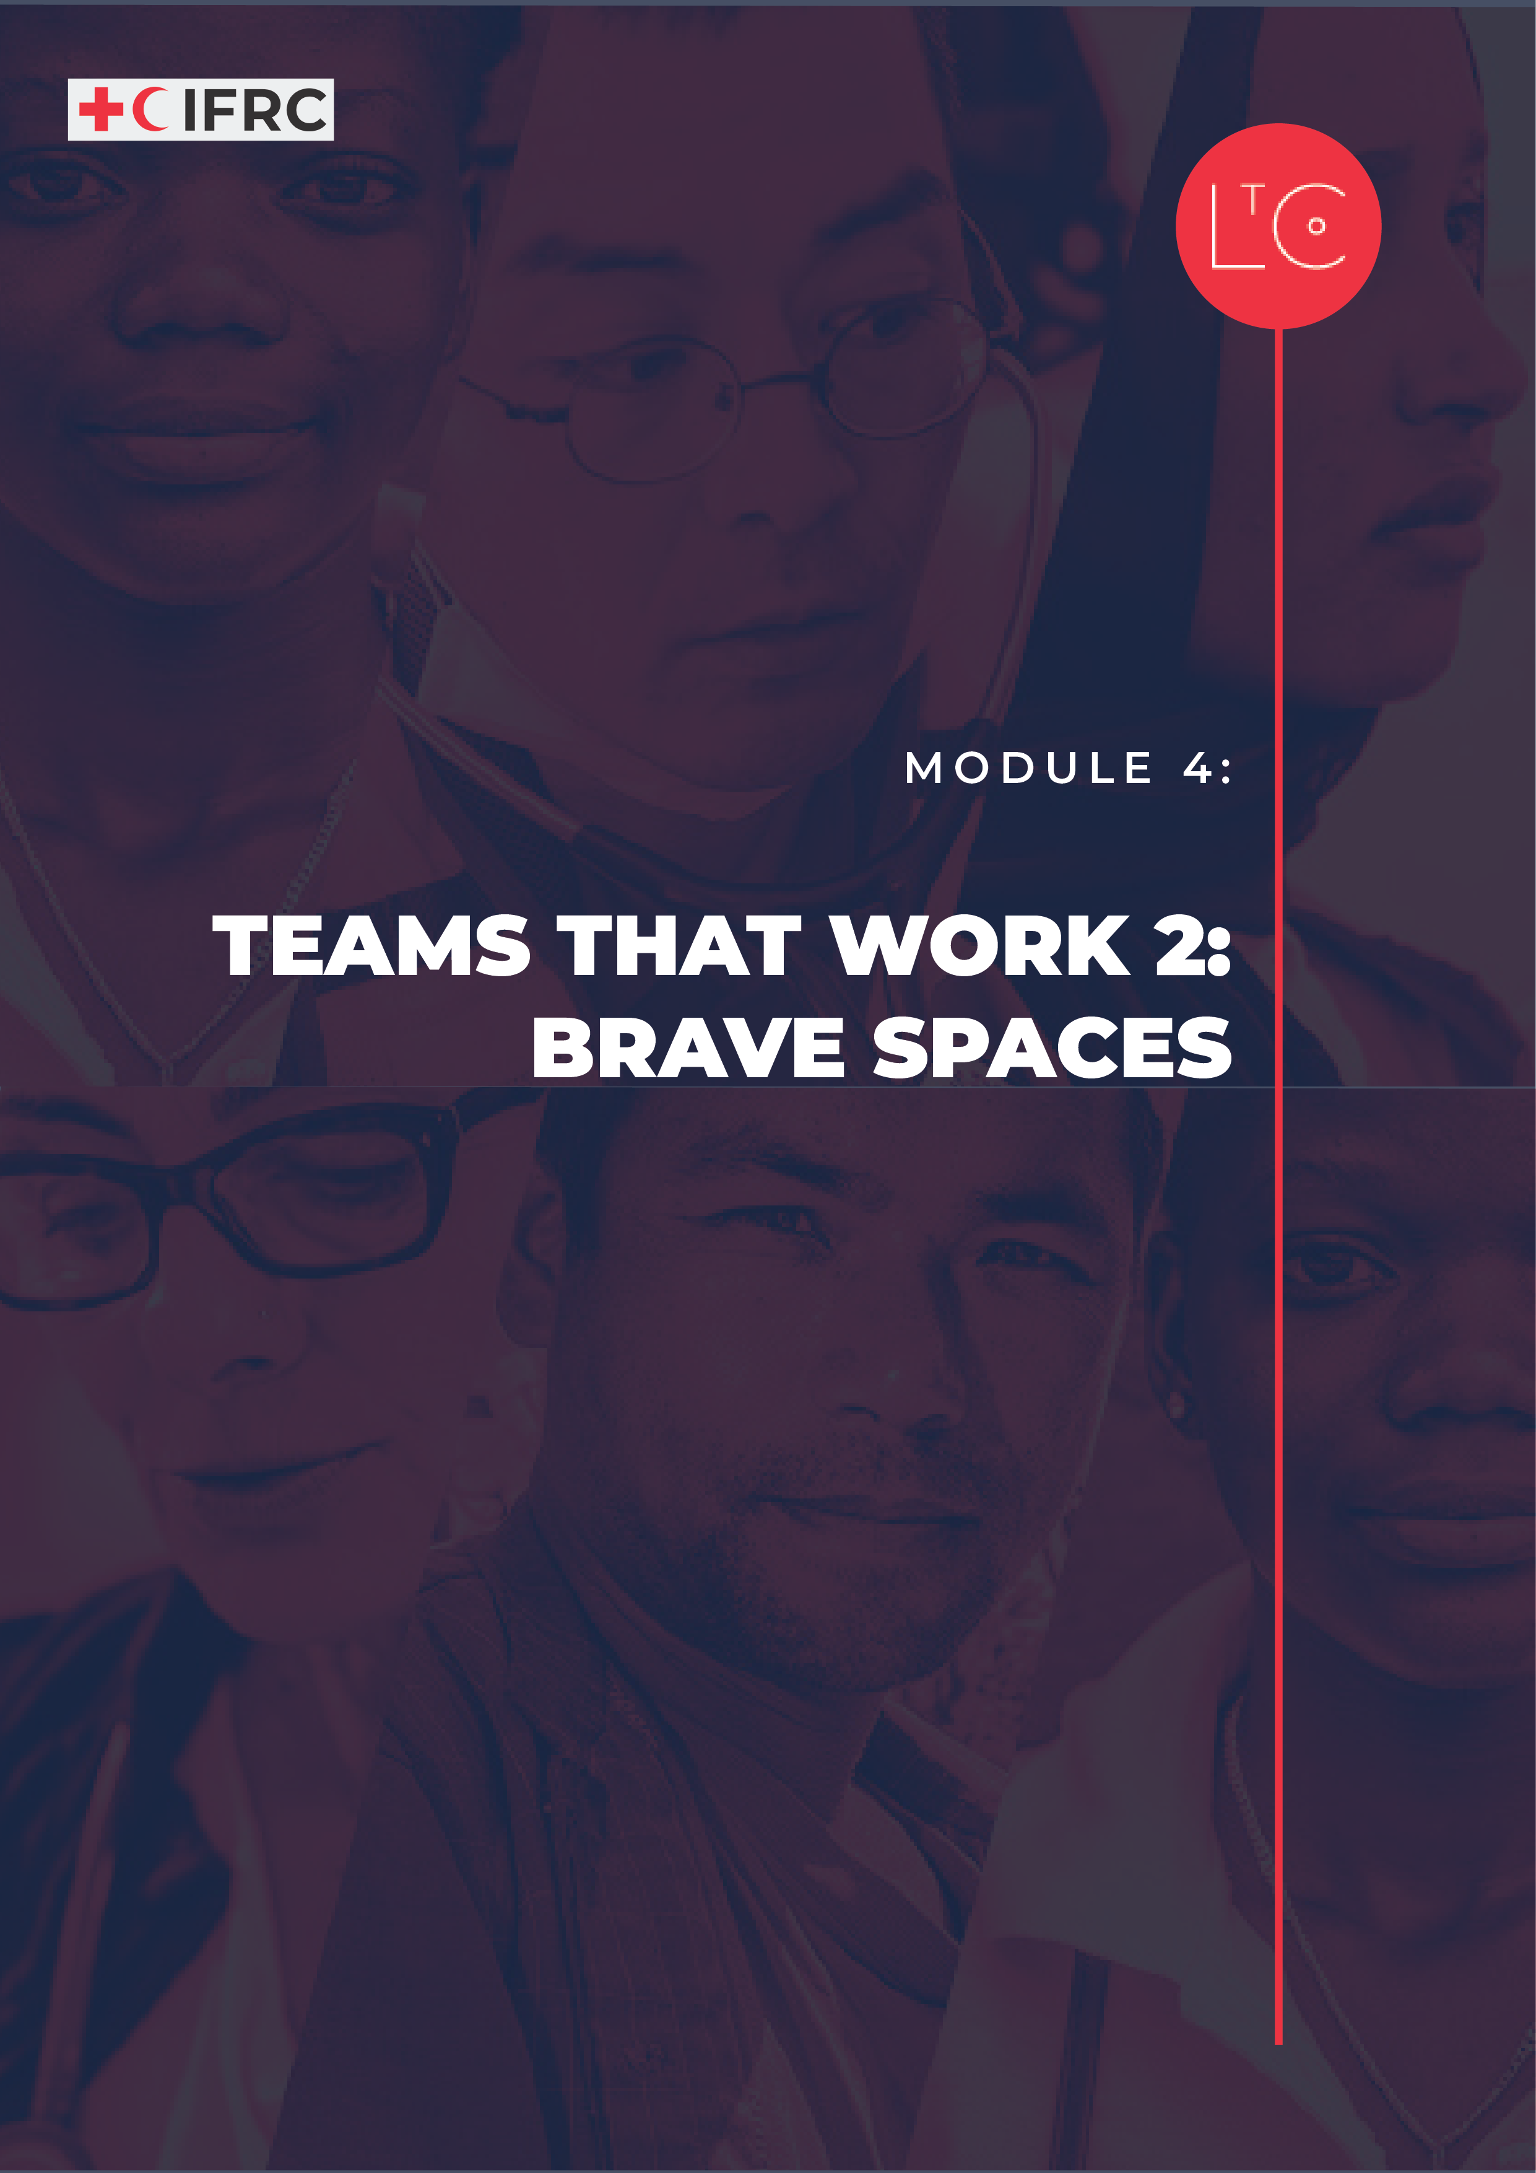

IN THIS MODULE
This session builds on Module 3. In teams that work, people can modify their own behaviour to create safety for others. In this session you’ll consider how to bravely take practical action to change culture for the better.

MODULE OUTCOMES
- You will be able to demonstrate the behaviours of a successful and well-functioning team-member.
- You will be able to identify changes to your behaviour that you can implement to strengthen your team.

PREPARATION
- Have ready the Learning Journey Image
- Have ready the Accountability in Action tool
- If ‘accountability’ is not a word in the language you are using, you may want to include a short plenary discussion so that the group can clarify a definition of the concept that everyone understands and can use in this group.

TIME
1.5 – 2 HOURS

HOW TO RUN THE SESSION
LAUNCH Time: 20 minutes
WELCOME AND INTRODUCTION time: 5 minutes
Welcome the group.

Remind the group that our role is to be change makers who are working to create a learning culture in RC/RC that is safe, motivating and transformative. This is so that we can best carry out our mission for the people and communities that rely on our services.

We will practice creating this culture in our sessions together. We will work to set the conditions in our learning space that reflect universal human needs: connection, safety, agency, autonomy and competence. As part of this programme and because we are adults learning together, we are all responsible for creating this culture and modelling positive, supportive behaviour.

We are now at the mid-point of the learning journey! In the remaining sessions you will be encouraged to think more and more about your own position as a change-maker and determine how you apply what you learn for yourself.

Facilitator notes:
As the facilitator, offer psychosocial support to the participants in relation to the learning journey, to the level you can provide it.

As part of this module, we will observe our own internal environment – our thoughts, feelings and emotional reactions without judgement. Since this may raise difficult feelings or reactions, if you personally need to take time out of this session, you can leave and return at any moment without giving a reason or needing to explain yourself when you come back.

CHECK IN TO THE LEARNING SPACE time: 10 minutes
As we continue our learning journey, we take responsibility for our own learning, and build connections with other learners. Part of taking responsibility is doing our own individual work between sessions, and part of building connection is the activities we do between sessions.
In pairs or groups of three, ask the group to reflect on their own learning journey so far. Use these questions as prompts:

- What do you find most interesting about creating psychological safety and a positive culture?
- What ideas have you had for how you can help do this in your team or national society?
- What have you already put into action because of your learning so far?
Ask the group to share in plenary:

- What changes have you noticed in your team or the groups that you work with?
- What changes do you think are due to the activities you/they are doing between modules?

INTRODUCTION TO THIS SESSION time: 5 minutes
This session is the second part of ‘Teams that work’. Together we will explore
- what makes successful and well-functioning teams and what you contribute to them
- the features of a positive team culture, and how to improve team culture.
Display the learning journey image on a poster or slide and highlight where we are!

You can also see that we are now at the midpoint of our learning journey, so we are going to take this opportunity to check in with ourselves, by reflecting on what we committed to at the start of the learning journey.

Ask the group to reflect individually and write in their journal:

Think about the change you want to make that you identified during the helicopter view journaling exercise in Module 1 and reflect on where you are with that change in this learning journey.
- How is this progressing for you?
- Does your commitment need to be expanded or changed?
Refine your commitment to change and record it in your journal.

TOOL: ACCOUNTABILITY TO EACH OTHER Time: 60 minutes
INTRODUCTION time: 10 minutes
Thinking back to our earlier sessions, we learned that values are the foundation of cultures and that values drive behaviours. So how do we ensure our behaviours truly express our values and create positive cultures? And how do we help to hold each other accountable for our actions?

In this session we are going to discuss how we can more actively hold ourselves and others accountable to create psychological safety and positive cultures. Throughout this session, it is important for us to:
- Remember our own power, rank and privilege in the group
- Be aware that our privilege and representation has an impact on the level of discomfort we may experience.
- Acknowledge the impact we have on others, regardless of our intention.

Facilitator notes: accountability
Simply put, personal accountability is taking responsibility for yourself, your intentions, words, and actions. It means entering a space with good intentions but understanding that aligning your intent with action is the true test of commitment. (Elise Ahenkorah)

(Optional) Discussion in plenary:

- How can we best describe the concept of accountability in our own words?

We understand that we are all learning. As we learn, we take responsibility for our actions and words. If you say something offensive or problematic, you are responsible even if you did not mean it. Apologize that your actions or words were offensive — not that the other person feels insulted.

DISCUSS AND EXPLORE time: 10 minutes

Facilitator notes:
The exercises for this module are based on the Accountability in Action tool.

In this exercise we will think about examples of behaviour that we want to see less of. You can select your own examples from your own experience to discuss if you prefer. Remember to describe anonymous situations and avoid naming people or places.
Display a few examples of behaviour:

- You see gender stereotypes being reinforced in a meeting when a woman is called pushy, aggressive, or emotional
- You watch a junior team member being interrupted repeatedly
- You see a person of colour have their idea be credited to another person
- You know that a member of your team is repeatedly undermined by a manager in meetings
- You see someone take credit for work done by another member of the team at a presentation to management.
In groups of 3-4, consider the examples and discuss these questions:

- Have you witnessed any of these or perhaps done some of them yourself?
- What could be done in the moment to act as an ally, without shaming or ridiculing the person doing it?
Remember that this takes courage and is difficult, particularly if you hold less power, rank, or privilege.

ACCOUNTABILITY IN CONTEXT time: 15 minutes
In plenary, acknowledge that we rarely talk about some of these important things in a healthy, open way. This is why they are particularly difficult to discuss. They are also very personal, and we can react emotionally to them as they raise deep feelings within us. This is normal for human beings!

Ask the group to spend 1 minute encouraging and congratulating each other for taking on this work. Speak to as many different people as possible.

Imagine a world where, when you realised your words or actions had negatively impacted somebody, you could say “I am sorry, I want to do better, it wasn’t my intention to harm you, but I acknowledge the words or actions I used were wrong. I am going to learn more, so I don’t do this again. Thank you for telling me.”
Ask the group to reflect individually or write in their journal:

- How might it feel to take responsibility when you have unintentionally done something that could negatively impact others?

In plenary ask people to share their reflections on how it feels to act as an ally in the face of negative behaviours or take responsibility when you may have had a negative impact.
Ask the group to share in plenary:

- How does it feel to draw attention to negative behaviours?
- How does it feel to take responsibility when you may have had a negative impact on someone?

LAND time: 15 minutes
REFLECT time: 5 minutes
Consider what we have discussed today.
Ask the group to reflect individually or write in their journal:

- What has surprised you about what we discussed?
- What are you going to do differently?
These reflections are for you, you don’t need to share them.

TAKE-AWAY ACTIVITIES BRIEFING time: 5 minutes
Take-away activities help us to deepen and broaden our learning by applying it at work and in our lives. Everyone should set aside time to do the individual activities.
If you joined this learning journey as part of a team, follow the instructions for the team take-away.
If you joined this learning journey as an individual, you are invited to join a peer group of other individual learners. Follow the instructions for the peer groups take-away.

INDIVIDUAL
- Between now and the next session notice and record where you might be able to do better in supporting others to create a safer team.
- Reflect in your journal on where your behaviour and language may have made it less psychologically safe for others in your team.

TEAM
- Book a date and time for an action-learning meeting, in which you will do one activity to develop a more psychologically safe environment.
- Module 4 suggested team activities:
- Discuss what you can do to create an environment where people feel safe to ask difficult questions and have hard conversations.
- Identify areas where there are opportunities for creating a safer and more inclusive team environment. Discuss what you could achieve together and how to do it.
- Talk about the words that you want to use as a team, to help everybody feel safe and able to be brave. Start with an IN words and OUT words activity, then discuss how you want things to be in the future.
- Discuss 3 things we have considered in this learning journey that everyone can do to create wellbeing in our teams:
- Listen
- Understand
- encourage each other
What can you do as a team to make sure you listen, understand and encourage everybody equally and authentically? Which additional routines do you want to incorporate in your team culture/practice?

PEER GROUPS
- Book a date and time to meet with your peer group, in which you will do one activity to extend the learning from Module 4
- Module 4 suggested peer group activities:
- Meet in buddy-pairs to discuss your reflections and your opportunities to create a safer team.
- Expand the discussion on how to sensitively call people to account (be an ally) in different contexts.
- Discuss 3 things we have considered in this learning journey that everyone can do to create wellbeing in our teams:
- Listen
- Understand
- Encourage each other
What can you personally do to make sure you listen, understand and encourage others fairly and authentically? Which additional routines do you want to incorporate in your practice?
CHECK OUT time: 5 minutes
Summarise your ‘big take-away’ from this session. We all have different perspectives so there may be a lot of variety!
Ask the group to share in plenary:

- What is your biggest take away from today?
Display the responses on a board/poster:
Add your response to the shared output as a record.

MORE LtC TOOLS
LtC tools can be used in several ways: during the learning journey session as exercises, as take away tools between sessions, and/or tools to support learning habits and continuing leadership practice after the learning journey. As a facilitator, you can also choose your favourite tools to replace the suggested exercises above in the core module. The additional LtC tools associated with this module are:
- 10 Steps Peer to Peer Coaching
- Feedback Guide
- Team Reflection Tips
- Rollercoaster Check In

FURTHER RESOURCES
These resources provide more depth on the topics in this module. You may wish to review them as background reading to prepare for the session and share some or all of them with the participants.

https://medium.com/@elise.k.ahen/safe-and-brave-spaces-dont-work-and-what-you-can-do-instead-f265aa339aff
https://hbr.org/2019/11/how-the-best-bosses-interrupt-bias-on-their-teams

