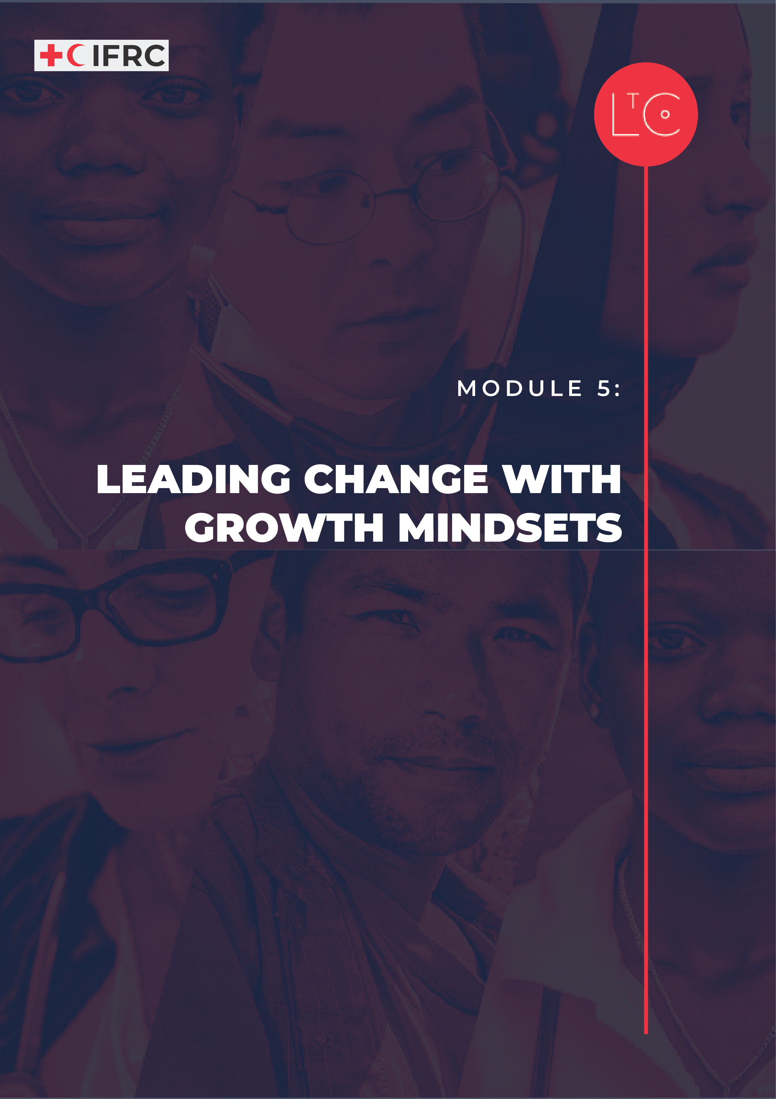

IN THIS MODULE
In this exciting module you’ll participate with a small team in a creative task that calls for a growth mindset. You will explore how developing your growth mindset can lead to agile and adaptive practices, especially when supported by inclusive teams that practice listening and reflection. You’ll have the chance to put everything you’ve learned about teams that work into action.

MODULE OUTCOMES
- You will understand the value of a growth mindset to support adaptive and agile practices.
- You will be able to take risks, make mistakes and experiment in a team.
- You will experience talking openly about failure and celebrating success.
- You will be able to identify your strengths, and your areas for improvement when working in a team.

PREPARATION
- Have ready the Learning Journey Image.
- Prepare the creative stretch task to give the groups. You can make this more relevant to their working context or connect it to the work in the learning journey. (See Facilitation notes below.)
- Prepare instructions for the celebration task to prepare for Module 6. (Optional – See Take Away Exercises below.)
- Prepare and have ready the Growth Mindset Visual and Continuum Tool.
- Have ready to display or hand out Team Reflection Tips tool.
- Prepare instructions for Hot Wash tool.

TIME
1.5 – 2 HOURS

HOW TO RUN THE SESSION
LAUNCH Time: 25 minutes
WELCOME AND INTRODUCTION time: 5 minutes
Welcome the group.

Remind the group that our role is to be change makers who are working to create a learning culture in RC/RC that is safe, motivating and transformative. This is so that we can best carry out our mission for the people and communities that rely on our services.

We will practice creating this culture in our sessions together. We will work to set the conditions in our learning space that reflect universal human needs: connection, safety, agency, autonomy and competence. As part of this programme and because we are adults learning together, we are all responsible for creating this culture and modelling positive, supportive behaviour.

Facilitator notes:
As the facilitator, offer psychosocial support to the participants in relation to the learning journey, to the level you can provide it.

As part of this module, we will observe our own internal environment – our thoughts, feelings and emotional reactions without judgement. Since this may raise difficult feelings or reactions, if you personally need to take time out of this session, you can leave and return at any moment without giving a reason or needing to explain yourself when you come back.

CHECK IN TO THE LEARNING SPACE

As we continue our learning journey, we take responsibility for our own learning, and build connections with other learners. Part of taking responsibility is doing our own individual work between sessions, and part of building connection is the activities we do between sessions.

time: 5 minutes
Ask the group to reflect individually or write in their journal:

- What have you learnt about yourself through the learning journey, that is unexpected?
- What are you open to improving, from what we have learnt through the learning journey?
- How has your team culture influenced how you percieve your ability to improve?

INTRODUCTION TO THIS SESSION time: 5 minutes
In this module we ask you to draw on all that you have learnt throughout your LtC journey. You will have a chance to create something new together. You will reflect on what you have learnt about yourselves, how you work in teams and how teams work together.
Display the learning journey image on a poster or slide and highlight where we are!

EXPLORE MINDSETS time: 10 minutes
Before we get into an activity, we will think about mindsets. We sometimes use the labels fixed mindset and growth mindset. It describes how we show up in different situations.
Display the Growth Mindset Visual and Continuum

Give an orientation.

Growth mindset is not something you have or don’t have. It is something you can continue to develop over a lifetime. Growth mindset and fixed mindset are on a continuum. Learning habits of listening and reflection will help you challenge yourself to stretch your growth mindset. An inclusive team culture can create the conditions for you to feel safe enough to show up with a growth mindset, practicing agile and adaptive behaviours. Even gaining experience practicing agile and adaptive behaviours - becoming more comfortable taking risks, talking about failure, and celebrating success - can help reinforce your ability to exercise a growth mindset.

Facilitator notes: Growth and fixed mindset
- Growth mindset describes one extreme mindset where the openness to develop capabilities exists.
- Fixed mindset describes the opposing extreme mindset where capabilities are static.
“In a fixed mindset students believe their basic abilities, their intelligence, their talents, are just fixed traits. They have a certain amount and that’s that, and then their goal becomes to look smart all the time and never look dumb. In a growth mindset students understand that their talents and abilities can be developed through effort, good teaching, and persistence. They don’t necessarily think everyone’s the same or anyone can be Einstein, but they believe everyone can get smarter if they work at it.” (Carol Dweck, Stanford University)
- Individuals don’t have one or the other kind of mindset, it depends on the situation we find ourselves in. For example, you might have found yourself frustrated and wanting to give up in one challenge but behave differently in other situations.

TOOL: CREATIVE STRETCH TASK AND AGILE BEHAVIORS Time: 40 minutes

We will challenge our own growth mindsets today to stretch us to learn from the process of a creative task with our team, practicing agile behaviours, and then later to continue the habit of team reflection, which helps strengthen our adaptive behaviours.

CREATIVE STRETCH TASK time: 40 minutes
We will now do a task together, which you will need to do as part of a small team. After 20 minutes each group will have 5 minutes to present their results to us all.

Facilitator notes: Creative stretch task
This exercise is about practicing agile behaviours by creating something together. It is a chance for teams to challenge their growth mindsets and work under pressure on a creative and somewhat difficult project. The learning is in the doing, not in what they produce (or don’t produce!). Suggestions for the task could be:

- Create an image, video or audio product that represents the things that they have most enjoyed or the single most important thing they learned from the journey.
- Design a new activity for groups in your National Society to use to create greater connection. Present it in a visual format.
- Make up a new motivational quote for the Red Cross & Red Crescent Network. You will perform to the group and present it in an interactive and engaging format using as many members of the team as possible

Use any resources you wish. For an in person learning journey, you can draw on a poster or flipchart paper with markers or crayons. For an online learning journey, you could use tools available in a whiteboard or search on the internet for icons or photos to create a google slide.

These are just some examples. Encourage your participants to be imaginative and provide them with access to as many creative resources as possible. If any of the products are audio/visual, be prepared to manage the tech support for presentations, or adapt the guidance so that the creative products are limited to artwork, visual images and dramas.

In groups of 4 to 5, complete the task and be ready to present what you have produced.
In plenary, assuming there are about four groups, allow each group 5 minutes to present the result. With a larger number of groups, you may adapt the debrief to manage time.

TOOL: TEAM REFLECTION AND ADAPTIVE BEHAVIORS Time: 30 minutes

Now, take time to reflect on what we learned from our creative stretch task experience. Team reflection exercises help develop adaptive behaviours, which are critical for leading change. LtC offers several tools that help facilitate team reflection.

Before beginning our team reflection, take a moment to recall how we learned about the levels of listening during Module 2. Can we listen to each other now with an open heart and open will to engage in reflective and generative dialogue? Challenge your growth mindset with a sense of curiosity and willingness to improve.

Display or hand out the Team Reflection Tips LtC tool and review it briefly before getting into groups.

time: 15 minutes

- Return to the same groups of 5 that were together for the creative stretch task.

Do a team reflection exercise and ask participants to reflect together on the experience of challenging their growth mindsets during the creative stretch task. Consider using the Hot Wash tool.

You can adapt the session and use any one of your favourite LtC team reflection tools instead (ex. Sailboat, Hot Air balloon, Open the Box).
time: 10 minutes
- Give participants an opportunity to respond to one or more of the below reflection questions in plenary discussion, or by writing with sticky notes (in person) or in the chat (online).

- Were there any insights that would help you improve how you handle difficult tasks in the future?
- What did it feel like to talk openly about failure and the parts of the process of working on the creative stretch task that could be improved?
- How did taking some time to celebrate how you worked together impact your experience?

LAND time: 15 minutes
REFLECT time: 5 minutes
Look back on what we have done today, and how it has called for us to choose a growth mindset.
Ask the group to write in their journal:
- How did it feel to be part of my team?
- How did my team’s process impact how fast we generated an idea and how creative it was?
- What did I find most difficult about the team activity today?
- What can I learn (about myself) from what I found difficult?

These reflections are for you, you don’t need to share them.

TAKE-AWAY ACTIVITIES BRIEFING time: 5 minutes
Take-away activities help us to deepen and broaden our learning by applying it at work and in our lives. Everyone should set aside time to do the individual activities.

INDIVIDUAL
- Between now and the next session reflect on the growth mindset.
- Record in your journal examples of times when you find it easy to adopt a growth mindset. What is significant about them? Record examples of times when it is difficult. Why do you think this is?

TEAM
- Book a date and time for an action-learning meeting, in which you will do the set task.
- Suggestions if you would also like to do other team activities:
- Practice team reflection using a tool you haven’t tried before.

PEER GROUPS
- Book a date and time to meet with your peer group, in which you will do the set task.
- Suggestions if you would also like to do other team activities:
- Practice team reflection together using a tool you haven’t tried before. Reflect on the creative stretch task (it does not matter if you were not in the same group).

CHECK OUT time: 5 minutes
Share one thing that you learned about yourself by doing the team creative stretch task.
Ask the group to share in plenary:
- What did you learn about yourself by doing the team creative stretch task?
Display the responses on a board/poster:
Add your response to the shared output as a record.

OPTIONAL EXERCISE TO PREPARE FOR MODULE 6
CELEBRATION TASK BRIEFING

Together, you will design a short event to celebrate your learning journey together! 20 minutes at the beginning of our final module will be entirely over to you, to run and facilitate your celebration. Consider how you can build appreciation, celebration and connection into the event. As part of the event you design, you are invited to create a product that can be shared and kept by all participants as a reminder of what you have learned.

The creative output you produce is up to you – for example a visual, audio / audio-visual, ceremonial act or physical object. It must be participatory and accessible to everyone in the group.

Facilitator notes: This exercise to invite participants to create a shared output that celebrates the learning journey is optional or you may adapt it. Consider how many participants there are in your learning journey and how easy it will be for them to collaborate between sessions. Is it practical for them to all work on one task together or can you help them get set up as pairs or small groups to work on tasks as smaller teams? You should feel comfortable to adapt this session so that is valuable to your learning journey and relevant to your context.

Why do we create a shared output of the learning journey?
Creating a shared record of the learning we do in community can help create a sense of shared history among participants, encouraging future peer networking and support. It can also be a tangible reminder of the experience for individual participants.

Some facilitators call this shared output an “artefact” which is a term used in learning theory. Imagine an expedition of archaeologists discovering your learning journey artefact years into the future!
You can name the shared output whatever you like. The important thing is that it is meaningful for the people who shared the learning journey.

Examples of shared outputs include:
- Sculpture, picture, artwork, collage
- Word-cloud, cartoons, poster
- Ceremonial act (ritual), dance, song, musical performance
- Video, audio recording, soundscape

Participatory means that everyone gets to join in the process of making the shared output.
Accessible means that there is nothing about the finished product, or the process of creating it, that excludes someone in the group.
Examples to consider:
- Physical ability – can everyone move safely and easily? Is everything within reach?
- Sensory capacity – can you fully include people who are deaf/hearing-impaired, blind/partially-sighted?
- Psychological safety – can everyone participate safely, with an open heart and mind?

MORE LtC TOOLS
LtC tools can be used in several ways: during the learning journey session as exercises, as take away tools between sessions, and/or tools to support learning habits and continuing leadership practice after the learning journey. As a facilitator, you can also choose your favourite tools to replace the suggested exercises above in the core module. The additional LtC tools associated with this module:

- Engage the World (The World Around You Series)
- Action Log to Challenge or Idea
- Growth Mindset Dialogue
- Growth Mindset Journaling
- Sailboat
- Open the box
- Hot Air Balloon

FURTHER RESOURCES
These resources provide more depth on the topics in this module. You may wish to review them as background reading to prepare for the session and share some or all of them with the participants.

TedTalk Carol Dweck video talk “The Power of Believing You Can Improve” – In English with auto translate multiple languages in closed caption (go to auto translate in settings option)
https://youtu.be/_X0mgOOSpLU

https://www.growthengineering.co.uk/top-10-youtube-learning-videos/

Mindset Book Summary & Review (Carol Dweck): https://youtu.be/W9DV2K4Aebw

Harvard Business Review article on “Fake-Growth” Mindset: https://hbr.org/2016/01/what-having-a-growth-mindset-actually-means

Team Reflection resources:
https://the-curve.org/wp-content/uploads/2020/07/The-Curve-Pause-Reflect.pdf
https://toolbox.hyperisland.com/team-retrospective
https://toolbox.hyperisland.com/reflection-team

