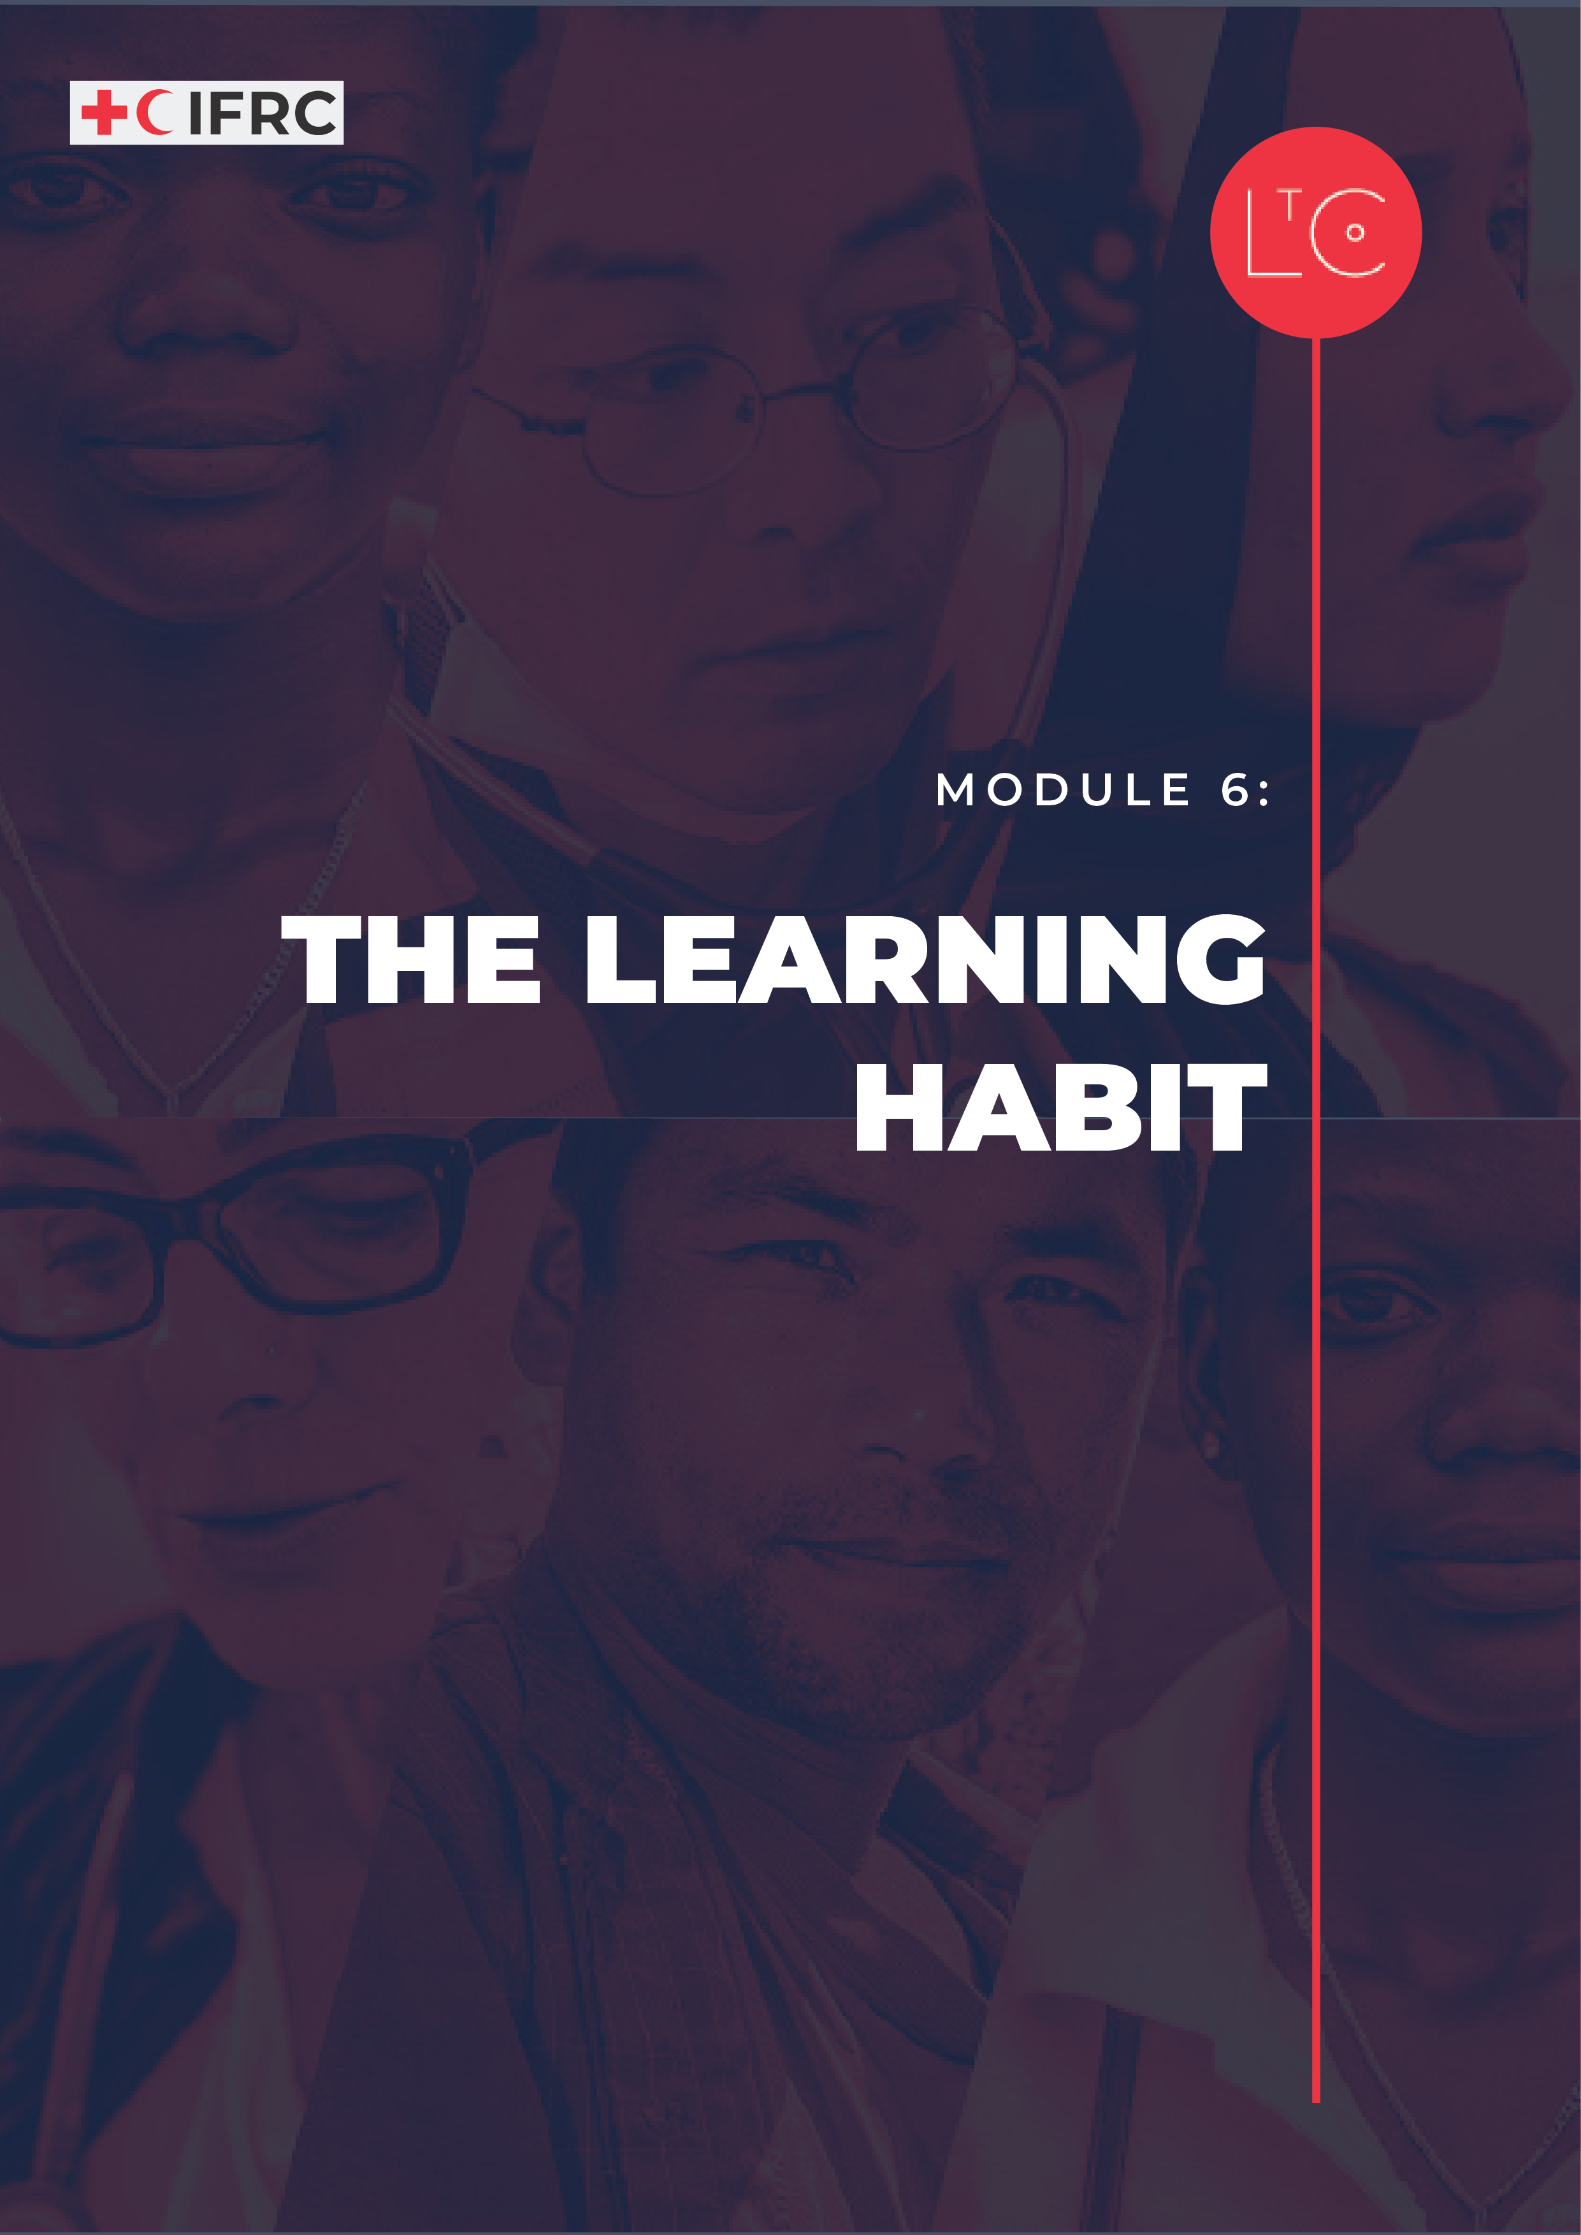

IN THIS MODULE
This is the end of this Learning Journey, but the springboard to further learning and change. You will reflect and celebrate your learning and make a commitment to your future self to continue the learning habit as part of your personal leadership practice.

LEARNING JOURNEY OUTCOMES
- You will have strong connections with colleagues you trust.
- You will know how to create the conditions for greater safety and agility in teams and groups you are part of.
- You will be bold and able to help each other to be brave.
- You will feel confident as a learning leader and proud of the learning journey you have been on.
- You will recognise the individual change that has taken place in your personal leadership and celebrate and appreciate it with others.
- You will be committed to a continuing personal leadership practice supported by the learning habits you have developed on this learning journey and reinforced by LtC tools and peers.

PREPARATION
- Pre-allocate participants to groups according to location, for the discussion at the end of the TOOL section. For example: People who work in the same team; people who are co-located in an office or work for the same National Society. If that isn’t possible, group people who work in the same technical area or region. (Preparation for one of this module’s group debriefs.)
- Have ready the Learning Journey Image
- Adapt the Hot Wash Tool (Change Liked, Lacked and Learned reflection questions to Worked Well and Do Differently)
- Have ready the Commitment card print one per participant (in person) or ready to display or share as a PowerPoint slide (online)
- For the opening activity, there are multiple tools as optional. Prepare the tools that you choose.

TIME
1.5 – 2 HOURS

HOW TO RUN THE SESSION
LAUNCH Time: 45 minutes
WELCOME AND INTRODUCTION time: 5 minutes
Welcome the group.

As we close this learning journey, we continue to take responsibility for our own learning and build connections with other learners. We also consider how we have made progress toward the change we wanted to make in this learning journey and plan how we will continue a life-long personal leadership practice and learning habit.

LANDING THE LEARNING JOURNEY Time: 40 minutes

Facilitator Notes:
Module 6 starts with your choice for an activity. The opening of the session is an opportunity to appreciate each other and reflect on personal or team transformation; to look toward the future; or to simply celebrate the learning journey. You decide. Some options for activities are:

Option A: Appreciation & Transformation
You can use Appreciation Sunshine or Significant Change Storytelling from the LtC tools to design a celebration and appreciation activity for your learners. These tools create space for learners to acknowledge each other’s contributions and the change they have experienced in their own lives or in their teams.

Option B: Imagine the Future
You can use the LtC tools Imagine a World and Letter from my Future Self to design an activity for learners to look forward. You may have time for only one of these tools or you can run both exercises at the same time and give the learners the option themselves if they wish to join a group discussion to discuss a vision for their team or for the RCRC in the future (Imagine a World tool), or if they prefer the individual work of taking the session time to write a letter to themselves (Letter from my Future Self tool).

Option C: Celebration
You can take this time at the beginning of Module 6 for participants to share the output (also called “artefact”) from the optional celebration task that was provided at the end of Module 5. If you choose this option, take time not only to presenting the artefacts, but also for discussion about how learners experienced working together to create the output. Think through how to manage time in this activity depending on how many pairs/groups are presenting.
TOOL: CONTINUING THE LEARNING HABIT Time: 50 minutes
EXPLORE STRUCTURED REVIEW time: 20 minutes
For our final tool, we are going to review the learning journey so that you can think about all the other ways in which you might want to use it in the future.
Display the learning journey image on a poster or slide and highlight how far we have come!

In groups of 5-8, ask the group to think back to the tools used during the learning journey and reflect on these questions:

- How can I use Learn to Change tools and the connections I have made with colleagues on this learning journey in the future?
- What changes would I / my team need to make, to adapt tools for use in my context?
- How can we implement more celebration and appreciation in our work, to move us forward together?

TEAM REFLECTION time: 30 minutes
We will now reflect as teams on the learning journey. How did you do with progress toward the change you want to make? How did your team do to progress to a more positive, inclusive culture?
In groups of 5-8, reflect on the learning journey using the Hot Wash tool.

Use the Hot Wash tool, but instead of Liked, Lacked and Learned, ask:
- What Went Well?
- What could you Do Differently as you continue using the tools into the future?

Keep a record of your answers to share with the whole group at the end.
Rearrange the group into small teams according to location, to discuss the questions:
- Of all the things we have learned together, what are the most important for our team [or country, region, technical discipline]?
- What will it look like when we apply our learning for good in our precise context?

LAND time: 15 minutes
REFLECT time: 5 minutes
Think back to the start of the learning journey and everything that we have learned together. This is the end of this learning journey but just the beginning of whatever comes next for each of us! So now let’s commit to the next stage.

Ask the group to reflect individually or write in their journal:

- Take 5 minutes to reflect on how you have changed during this learning journey and how you think you are going to change in the future. Review your previous journal entries to help you. Plan in your diary when you are next going to review your journal entries.
- Now complete your commitment card, which you will be asked to share with the group at the end of this session. You can fill out a paper card (in person) or record a voice note/video or write in your journal (for online).

TAKE-AWAY ACTIVITIES BRIEFING time: 5 minutes
Take-away activities help us to deepen and broaden our learning by applying it at work and in our lives. Everyone should set aside time to continue their individual activities. We encourage you to continue journaling. We also encourage you all to continue meeting in teams or as learning peers.

INDIVIDUAL
- Continue to reflect on your individual learning journey.
- Try using the questions in a debriefing tool to help you reflect.
- Write a letter to your future self, keep it safe and review it in 1 years’ time.

TEAM
- Book dates and times for a regular action-learning meeting, in which you will do something to expand your learning.
- Review the posters / shared outputs generated from each of the sessions. Use them to carry out a ‘Now What?’ debrief session on the Learning Journey, asking the questions: what have we learned? how are we different now? what about our team culture do we want to work on next?
- Choose some Learn to Change tools to try out in your work as a team and agree when to use them.
- Run the 7 statements to gauge psychological safety tool with your team.

PEER GROUPS
- Book a date and time to follow up with your peer group.
- Share your experiences of using Learn to Change tools in your work. What was the impact? What tips can you share with peers?
CHECK OUT time: 5 minutes
Share aloud the commitment you recorded (on a card / voice note).

Ask the group to take turns to share aloud in plenary:

- What is your commitment at the end of this learning journey?

Now save it in a place where you will notice it frequently e.g., wallet, phone / phone case, and put a date in your diary for 6 months’ time to review how you are getting on.

MORE LtC TOOLS
LtC tools can be used in several ways: during the learning journey session as exercises, as take away tools between sessions, and/or tools to support learning habits and continuing leadership practice after the learning journey. As a facilitator, you can also choose your favourite tools to replace the suggested exercises above in the core module. The additional LtC tools associated with this module are:

- Letter from my future self
- Imagine a World (The World Around You Series)
- Learning Log
- Appreciation Sunshine
- Significant Change Storytelling

Sharing the LtC toolkit: You may also wish to direct learners to the space where they can access both tools that you used in the learning journey and those you did not have time for by sharing with them the ALL LtC tools. This way, participants can make their own choices about which tools to integrate into their continuing leadership and learning practice following the learning journey.

LtC also offers a sample participant feedback survey that you can use and adapt. Following the learning journey, we encourage you to seek participant feedback to improve your future learning journeys.

FURTHER RESOURCES
Please share some or all the resources from the other modules with participants, especially those that focus on topics you have gone into in greater depth.

