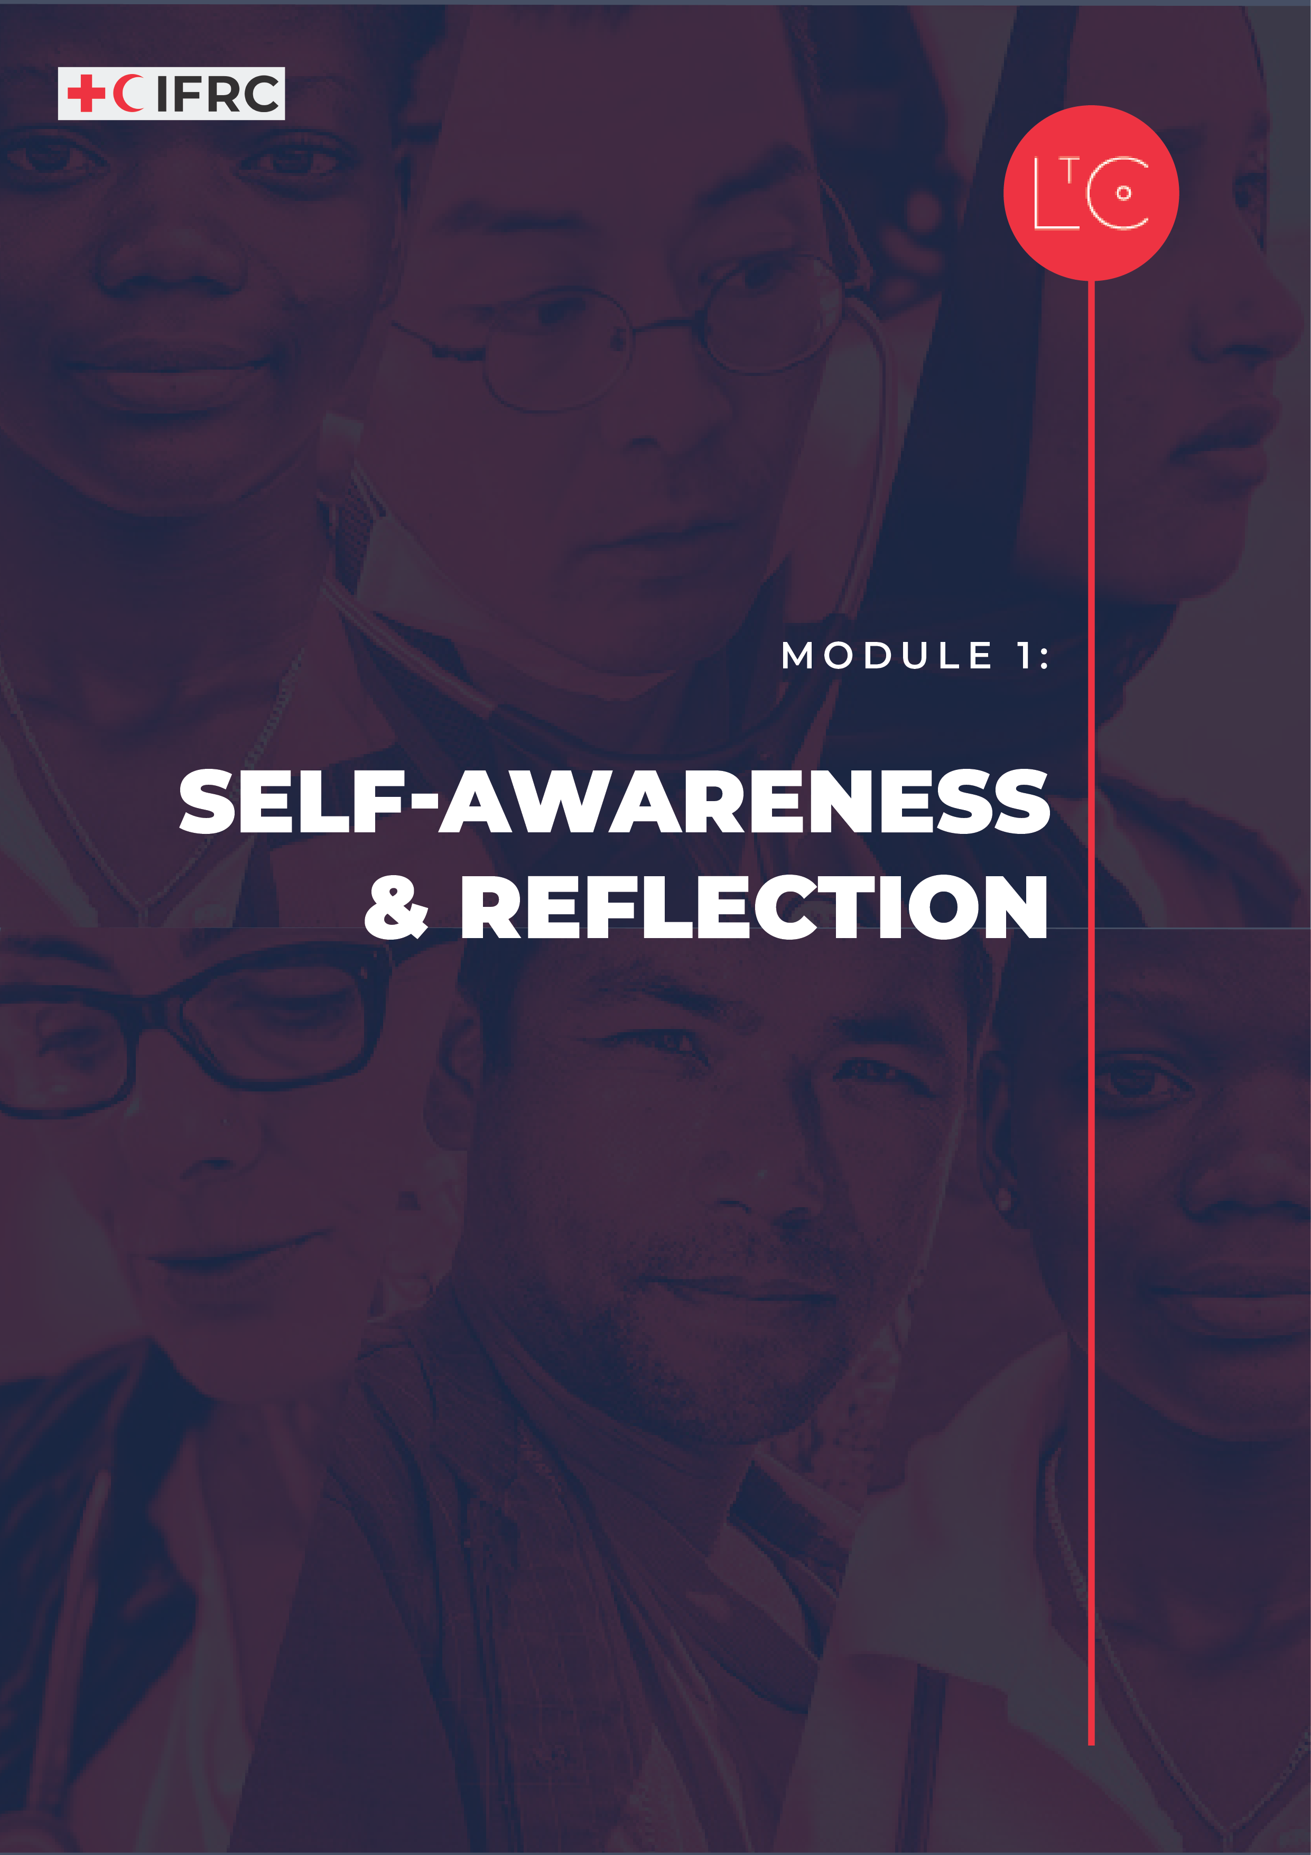

IN THIS MODULE
This is the start of the Learning Journey. Through short discussions in small groups, you will build connections with each other. Through reflecting, you will build connections with your own personal values and what is important to you. We will also explore our shared values as members of the Red Cross/Red Crescent Network, and you will reflect on what the RC/RC principles mean to you. This foundation launches the learning space and enables everyone to identify what they need to learn.

MODULE OUTCOMES

- You will consider how your personal values and our collective values of the RCRC principles drive your behaviours.
- You will begin to build a consistent personal reflection practice.
- You will build connections with others, so you feel safe enough to do the hard work on yourself.
- You will know the change you want to make on this learning journey.
- You will use tools that you can apply during the journey and in your work and life.
- You will want to begin the journey!

PREPARATION
- Have ready the Learning Journey Image
- Be prepared to display a list of examples of values (provided in the facilitation notes below or you can create your own list).
- Have ready the tool RCRC Principles
- Have ready the tool Helicopter View Journaling
- Each participant should have paper and pen for journaling. They will use it throughout the learning journey for journaling exercises in each module. For in person sessions, you may want to buy a small notebook for each participant and hand them out in the room, and for online sessions, you can give participants pre-instructions to bring their own journal or notepaper, and a pen, to the session.

TIME
1.5 - 2 HOURS

HOW TO RUN THE SESSION
LAUNCH Time: 15 minutes

WELCOME AND INTRODUCTION time: 5 minutes
Welcome the group.

Introduce this Learning Journey and use information from the “Start Here” Facilitator Guide to share the purpose of Lead to Change and explain what a learning journey is.

Display the learning journey image on a poster or slide and highlight where we are going!

Facilitator notes: What is a learning journey?
- A learning journey is a way of describing the process that takes place when people decide to learn new things, such as through a programme like Lead to Change.
- Your learning journey includes all the learning tools, experiences and practices that you will participate in. These help you to create change in yourself and in your organisation.
- For Lead Change, an overall learning journey has been created, which includes all the things we do together in these modules.
- Each of you is also on a unique learning journey which is all about you. What this is like will depend on what you decide to engage with, the goals and challenges you set yourself and the things you learn about in greatest depth.
- The design of Lead to Change Learning Journeys emphasizes experiential learning, which is ‘learning by doing’. This means that our time together will be a mixture of exploring ideas through discussion and practicing skills and behaviours. You will have time to think about how they make sense in your context, whether you are learning individually or as part of a team.
- We encourage you to keep a journal throughout this Learning Journey. This is a way of thinking about what you are learning, both during the sessions and at other times. You can think of your work and life outside these sessions as your “practice space”, where you learn by trying out what you have done in the sessions.
- To get the most from Lead to Change, make time to meet with other people between sessions and some activities that help you to apply the learning. These people could be your team, colleagues you work with or other people in your life. At the end of each session, there are suggestions for activities you could do.

CHECK IN TO THE LEARNING SPACE time: 10 minutes
As we start this learning journey, we acknowledge that we are all on our own personal life-long learning journeys that began before we came together for this shared experience and will continue long after.
In pairs or groups of three, ask the group to discuss:

- What has “learning” meant to you in your life?
- What has influenced your own personal learning journey up to this moment?
- What brought you into this learning journey and space today?

TOOL: SELF-AWARENESS Time: 40 minutes

INTRODUCTION time: 5 minutes
Now we will look at how we individually show up in the world and as members of the RCRC Network. An important part of changing culture is acknowledging that we need to continually develop our own self-awareness. First, we will examine the values that drive us as leaders and later in the session we will consider how a reflective practice can help us stay in tune with our motivations and sustain our self-awareness so we can grow as a leader.

VALUES: WHAT DRIVES OUR BEHAVIOUR?
It is important to identify and understand our values because they drive how we behave. As members of the Red Cross/Red Crescent, we hold shared values of the RCRC principles. We also come into this community with our own individual values.

Facilitator notes: What are values?
- “Values are widely shared, abstract ideas about what is good, right, and desirable” (Williams, 1970)
- Values are a key motivator of behaviour
- They provide guideposts or guard rails to help us make decisions
- Values are held by individuals and groups
- Personal values are generally formed by late adolescence, considered consistent across time and context, and are inherently desirable, though the values you prioritize may shift in different life stages.
- The higher the importance a value is to an individual, the greater likelihood it will guide behaviour. We call the values we think are most important, our core or higher-level values
- When we act out of alignment with our core values or experience others doing so (such as in our organisations) we get a feeling of discomfort or distress. This is labelled cognitive dissonance (Hinojosa, 2016).

Preparing participants for a conversation on values:
To help participants understand the concept of values and stimulate self-awareness of their own values, you may want to display a list of examples on a poster, flipchart or online whiteboard. You will have the opportunity to add to this list during a plenary brainstorm session.

Examples of values include Kindness, Creativity, Loyalty, Family, Faith, Patience, Perseverance, Risk Taking, Compassion, Wisdom, Connection, Curiosity, Integrity, Diversity, Competence, Inclusion, Community, Independence.

These examples come from Brené Brown’s Dare to Lead List of Values that you can find online. You can provide other examples from your own search as relevant to your own context.

ACTIVITY: IDENTIFYING OUR INDIVIDUAL VALUES time: 5 minutes
Display the list of example values and ask the group to brainstorm additional possible values, writing down what people say and adding to the list:

- What are examples of values you have seen in people you admire?
time: 5 minutes
Working individually:

- Review the list of examples on the poster or whiteboard and choose all the values you believe apply to you.
- Now choose the two values that best define who you are and what you are like every day. (If this is difficult, think about the values you most miss when they are not present.) Everyone should keep a record of these 2 values.

Ask the group to share in plenary: time: 10 minutes
Ask participants to think of a time when one of their 2 core values has driven their behaviour (and the type of leader they are and want to be). It could relate to how they decided to take a job, how they act in a sports team or work team they are part of, or how they behave with family or friends.

Give an example from your personal experience to help the group get started.
Share in plenary.

ACTIVITY: IDENTIFYING OUR SHARED VALUES

We come into the Red Cross/Red Crescent Network and community with our own individual values. At the same time, once we join the community, we begin to also identify with our shared values. Let’s take a moment to think about how the Red Cross/Red Crescent principles represent our shared values.

Understanding and respecting that we may hold values that are different from one another is important for how we show up as a member of a diverse and inclusive team. Recognizing that we ALSO have shared values in the RCRC principles provides us with an opportunity to build on what we have in common and grow together as a team.

Display or hand out the RCRC Principles tool from the LtC toolkit.
Working individually: time: 5 minutes

- Review the RCRC principles and reflect how they relate to your own core values.
- Reflect on how the RCRC principles influence your behaviours at work and in life.

Ask the group to share in plenary: time: 10 minutes
Ask participants to think of a time when they observed a teammate behave in a way that was aligned with the RCRC principles. It could relate to how they do their job or how they behave with family or friends.

Give an example from your personal experience to help the group get started.
Share in plenary.

TOOL: REFLECTION AND JOURNALING Time: 25 minutes

INTRODUCTION time: 5 minutes

Reflection is a critical component of developing our personal leadership capabilities. We can reflect alone or as teams.

Today, in module 1, we are creating the foundation for how we show up as teammates and leaders by developing our self-awareness and building a personal reflection practice. We have already examined our individual and shared values, as well as how they drive our behaviours. Maintaining this level of self-awareness as you live, and work requires practicing consistent and deliberate reflection.

In module 5 we will explore team reflection exercises after we have done the work in Module 2, 3, and 4 to create inclusive, safe and brave spaces that create the conditions for constructive team reflection.

First making the effort and taking the time to tune into ourselves helps us show up to our team space in a way that allows us to learn, grow, create and adapt together.

A tangible and concrete personal reflection practice is journaling. Journaling has multiple benefits. It allows us to make meaning of experiences, to identify and prioritize worries and problems, to celebrate success and practice gratitude. Journaling can help us check in with ourselves and consider if our day-to-day actions and interactions are aligning with our individual and shared values. Journaling is also helpful for our mental health. A journaling habit can reduce anxiety and depression and help us cope with stress.

Individual Journaling time: 20 minutes

Facilitator Notes: This exercise is an adapted version of the Helicopter View Journaling tool, which is inspired by a guided journaling exercise developed by the Presencing Institute. The exercise starts with silent time and then you will read journaling questions out loud in a calm voice, one question at a time, pausing for the suggested times. It is better to resist the urge to write the questions on a poster, whiteboard or powerpoint slide. That way, participants can hear the questions one at a time as they are writing instead of reading them all at once before they begin.

We will be doing a guided journaling exercise to begin to exercise our reflection muscles as well as ground ourselves in this learning journey experience. I will speak the questions out loud and give you just a few minutes to write what comes to mind for each one before moving on to the next. Write only the answers to the questions. I can share the questions afterwards. Just focus on answering the questions you hear. ​
​
What you write is for you to keep. Write in your language if easier. There is no need to share your notes. ​The way we journal is that you touch the pen to the paper and let it flow, let things emerge, suspending the needs for writing properly, structure, good form, syntax, calligraphy etc.

This is a personal time. Make sure you have a good space for it and feel comfortable. ​

Display the Minute of Silence image from the LtC tools. (Optional: The exercise can also be held with no image.)

Before we start journaling, we would like tune into ourselves, leaving behind work and worries from outside the session. One way to do this is to have a minute of silence. You can use this minute how you wish, to notice the room around you, to soften your gaze or close your eyes. You may want to notice your breathing, paying attention to the air coming in and out through your nose or mouth, or you may want to pay attention to your body and its sensations. The purpose is to pause and be present here. At the end of the silent time, you will be invited to pick up your journal and pen and answer the questions.

Facilitator notes: Options for adapting the minute of silence exercise
- Adapt the time: This exercise can be done for up to 3 minutes.
- Adapt the purpose: This exercise can also be done before a group exercise to help participants be present and ready to listen to each other, or after a group exercise to allow for personal reflection.
- Adapt the approach: If you feel comfortable, you can also use this opportunity to lead a guided meditation with a calm voice, noticing the room – sounds, colours, objects – this can help ground learners to the present.
- Adapt for online: If this is an online setting, you can suggest learners turn off their cameras if they wish for privacy.

Let’s pick up our pencil or pen and start to write what comes to mind. I will pause for a few minutes between each question and then will move you to the next question to encourage a free flow of thoughts.

Helicopter View Journaling questions:

- What in your current work (and life) are sources of energy for you? What do you love about your work? What motivates you? (1min)​
- What frustrates you most in your work at the moment? (1min)​
- (Helicopter view) What is it that you are currently trying to achieve in your work and more broadly in your life in this period? (1min)​
- Travel into the future – 5 years from now - How do you see yourself? What have you achieved? Who are you now? How have you changed? (1.5 min)​
- From that place in the future, what would you most like to see happening in your team? What is the future you would most like to be part of? (1 min)​
- What would you like to be able to say about how you contributed to achieving that future? (1min)​
- What 2-3 things would be happening as evidence of your team’s success? (1min)​
- What is the change you want to make during this learning journey that will help you achieve these things? (1min)​

LAND time: 20 minutes
REFLECT
Take time to talk through the journaling exercise with the participants who shared your experience. You do not have to share the substance of what you wrote, we set an expectation before we began journaling these were private thoughts just for you, but we do invite you to share your experience and any general learning hopes that surfaced. You are also invited to share the change you want to make during the learning journey, but only if you want to.
time: 10 minutes
In pairs or groups of three, ask participants to debrief the journaling experience:

- How was the journaling experience, what emotions did it surface for you?
- Did it surface any hopes for the learning journey that you would like to share?
- If you feel comfortable sharing, what is the change you want to make through your participation in this learning journey?
- How do you think your personal values and your RCRC values influence your goals for this learning journey?

TAKE-AWAY ACTIVITIES BRIEFING time: 5 minutes
Take-away activities help us to deepen and broaden our learning by applying it at work and in our lives. Everyone should set aside time to do the individual activities.
If you joined this learning journey as part of a team, follow the instructions for the team take-away.
If you joined this learning journey as an individual, you are invited to join a peer group of other individual learners. Follow the instructions for the peer groups take-away.

INDIVIDUAL
- Between now and the next session notice and record how the 2 core values you identified and the RCRC principles are present as values in your work and personal life.
- Record in your journal examples of times when those values influenced your behaviour. What do your values say about the kind of leader you are and want to be?

TEAM
- Book a date and time for an action-learning meeting, in which you will do one activity to help build greater connection.
- Module 1 suggested team activities:
- Personal presentations (https://toolbox.hyperisland.com/personal-presentations)
- Start a check-in habit for every team meeting (https://checkin.daresay.io/ or https://tscheck.in/)
- Review the changes you each want to make and discuss how they will show up in the work you do together.

PEER GROUPS
- Book a date and time to meet with your peer group, in which you will do one activity to extend the learning from Module 1
- Module 1 suggested peer group activities:
- Personal presentations (https://toolbox.hyperisland.com/personal-presentations)
- Review the changes you each want to make and discuss how they will show up in your life.

CHECK OUT time: 5 minutes
Share hopes for the learning journey.

Ask the group to share in plenary:

- What are your hopes for this learning journey?
Display the learning hopes on a board/poster:
Add your learning hopes to the shared output as a record.

MORE LtC TOOLS
LtC tools can be used in several ways: during the learning journey session as exercises, as take away tools between sessions, and/or tools to support learning habits and continuing leadership practice after the learning journey. As a facilitator, you can also choose your favourite tools to replace the suggested exercises above in the core module. The additional LtC tools associated with this module are:

5-minute Journaling
Individual Timeline

FURTHER RESOURCES
These resources provide more depth on the topics in this module. You may wish to review them as background reading to prepare for the session and share some or all of them with the participants.

The benefits of leading with LtC approaches.
https://hbr.org/2022/06/the-power-of-healthy-relationships-at-work

Behaviours in relation to values.
https://brenebrown.com/resources/living-into-our-values/

The power of reflection and journaling.
https://hbr.org/2022/03/dont-underestimate-the-power-of-self-reflection
https://www.u-school.org/journaling

A practice of self-compassion can help you attend to negative emotions that can surface when journaling.
https://self-compassion.org/category/exercises/
Kristin Neff’s Ted Talk on self-compassion
https://www.youtube.com/watch?v=IvtZBUSplr4 (Select settings and auto translate for closed captioning CC in multiple languages.)

