Urban heat stress in Indonesia
Executive summary
Existing research has provided evidence that Indonesia has suffered lost work hours from heat stress and will experience more heat stress in the future. This study provided an analysis across space and time, to understand trends of heat stress and population exposure from 1983 to 2016.
Heat stress was defined using international standards (wet-bulb globe temperature > 30 °C), using one of the most accurate and highest resolution datasets of urban heat stress currently available.

Key findings include:
1) Heat stress is rapidly increasing in various regions of Indonesia, with the largest increases up to 3 days/year in Riau province.
2) On average, Indonesia experiences 14 humid-hot days each year, with a higher number of hot days in recent years. The years of 1998, 2010, and 2016 contained a disproportionate number of humid-hot days, with 50, 35, and 57 days respectively.
3) Exposure is increasing by 17.5 million people-days per year across Indonesia, as a result of increases in urban warming and population growth.

A range of actions are recommended, including improving public messaging on heat risks to raise awareness, monitoring temperatures in important locations, training caregivers on heat risks, working together with local universities to co-develop studies, and more.

- Introduction

Background
Heat stress is rising globally and is posing large risks to the communities around the world [1]. The past eight years have been the hottest on record and this trend is likely to continue. Heat stress refers to conditions of high temperature and/or humidity, hazardous to human health and natural systems. Heat stress is becoming a growing concern for tropical countries like Indonesia, where the impacts can be especially severe due to high temperatures in combination with high humidity. In contrast to mid- to high-latitude countries where heat stress is restricted to summer months, heat stress in Indonesia happens year-round.

Research on heat stress and its impacts remains extremely limited across Indonesia. This lack of evidence is not an indication of a lack of heat stress or impacts, but rather resulted from the unavailability of adequate data, both weather and health data, required to conduct robust assessments. Still, recent global and regional studies have provided evidence for the current and future risks of heat stress. Supari et al. (2017) showed that Indonesia has clearly experienced significant warming over the past decades, with minimum temperatures increasing at a faster rate than maximum [2]. Future projections have shown that tropical, humid areas will be much more exposed to deadly heat stress compared to higher latitudes [3], that Indonesia will experience more frequent, longer, and more intense heat stress under multiple future scenarios [4], and become much less suitable for humans and systems to thrive [5]. Chambers et al. (2020) identified Indonesia in the top 5 countries with highest exposure of vulnerable people to days of heat stress in the past decades [6]. In a recent study, Indonesian farmers and forestry workers reported experiencing distress from heat exposure and emphasized the need for information and guidance from governmental authorities [7]. A study done in Makassar, Indonesia found dangerous heat-stress conditions, both indoors and outdoors, which were significantly underreported by weather stations [8]. This indicates that there is an urgent need to document and address heat stress across Indonesia and increase research efforts in order to understand the local characteristics and impacts.

Impacts from heat stress
Heat stress can impact nearly all sectors of society. Most importantly, heat stress poses a serious threat to human health and well-being and can be deadly [9], [10]. Heat stress exacerbates pre-existing health conditions such as cardiovascular disease and respiratory illnesses, kidney disease, causes heat strokes, cramps and exhaustion, and increases the rate of transmission of food and waterborne diseases [9], [11]–[13]. Next to impacting health, heat stress makes outdoor labor increasingly difficult and can have large economic and health consequences for a wide range of occupations as productivity decreases and work hours are lost. Indonesia has already been identified as one of the countries suffering most losses of potential labor capacity, estimated at 4-6% of the annual GDP [10]. In 2019, 71.8 work hours per person were estimated to be lost across Indonesia, translating to 15 billion work hours lost in total (ibid.). Furthermore, essential services (e.g. electricity, food, and water supplies) can be disrupted, and crops, livestock and biodiversity can greatly be affected [9], [11]. Heat also interacts with other disasters such as wildfires, droughts, and storms, which can result in cascading and compounded impacts.
Although heat can affect anyone, the impacts are often unequal and disproportionately affect vulnerable groups in urban areas. These groups for example include elderly, young children, people with pre-existing illnesses, people living in informal settlements and outdoor workers. Urban areas are especially at risk, as heat is amplified in cities which absorb and re-emit heat in the concrete building materials, also known as the urban heat island (UHI) effect [14].

Data challenges to address
Unlike cyclones or earthquakes where damages are directly visible, heat stress is a slow-onset disaster with impacts that are silent, insidious, and difficult to quantify. Impacts can be delayed and occur only after days or weeks of prolonged exposure to heat stress. Heat compounds other pre-existing health risks thereby often masking the cause of death from heat [9], [11]. On top of this, in many countries the lack of appropriate data (both weather and health data) makes it increasingly challenging to quantify impacts. For example, weather stations across Indonesia have been found to contain a high number of missing values, making it difficult to understand trends and correlate heat with health outcomes. Recent advances in earth observation technologies can fill some of these gaps and enable analysis, such as in this study. Still, strong efforts must be made to increase weather and health surveillance to enhance on-the-ground understanding of heat stress and its impacts.

Reducing risk to heat
The good news: there is robust scientific evidence for relatively simple and cost-effective adaptation strategies, that greatly reduce impacts from heat [9], [11]. In other words, heat-related impacts are largely avoidable if appropriate action is taken. Such actions are generally captured through national or city-scale Heat Action Plans (HAPs) and can range from issuing heat early warning systems and health advisories, mobilizing resources at vulnerable locations, to urban planning strategies [15].

Currently, there is insufficient awareness and preparedness to heat stress in Indonesia. This study presents a country-wide analysis on urban heat stress across Indonesia from 1983 to 2016, using a recently developed high-resolution urban heat exposure dataset (Section 2.1). It is important to note that these results present merely country- and city-level results yet heat exposure can differ greatly within cities. Additional research is needed to highlight these variations in heat stress on neighborhood-level scales, to identify hotspots within cities and target solutions effectively across space. Following this introduction, this report is structured as follows: the methods and datasets are presented in Section 2, the results and discussion in Section 3, and the conclusion in Section 4.

Main objectives of this study
The two main objectives of this research were formulated as follows:
- Understanding the spatio-temporal characteristics of heat stress and corresponding trends.
- Understanding the number of people exposed to heat stress and corresponding trends.

- Methodology & datasets

2.1 Datasets

Wet-bulb globe temperature (WBGTmax) (1983 – 2016)
The Global High Resolution Daily Extreme Urban Heat Exposure (UHE-Daily) was recently developed and contains high-resolution records of urban heat stress and population exposure for 1983 to 2016. The daily WBGTmax > 30 °C was extracted for 110 urban settlements across Indonesia. All maps were developed using ArcGIS Software (ArcMap 10.8). This dataset is openly available through https://sedac.ciesin.columbia.edu/data/set/sdei-high-res-daily-uhe-1983-2016. For details on the development of these datasets, see [16].

2.2 Heat stress definition
There is no universal definition for heat stress, as what is considered heat stress is dependent on the local climate and vulnerability of the population. In this study, heat stress is defined as wet-bulb globe temperature (WBGT) > 30 °C. WBGT is a combination of radiated heat, 2m air temperature, wind, and relative humidity. This metric was chosen as WBGT is a widely used and validated index to assess heat stress, suitable for many regions and climates. The WBGT threshold of 30 °C follows the International Standards Organization (ISO) criteria for risk of occupational heat-related risk [17], [18]. WBGT > 35 °C is the upper limit for human survival, but lower thresholds have been observed to seriously impact human health and productivity, even in young and healthy adults (e.g. in India 2015, WBGT reached 30 °C and caused over 2,500 deaths).

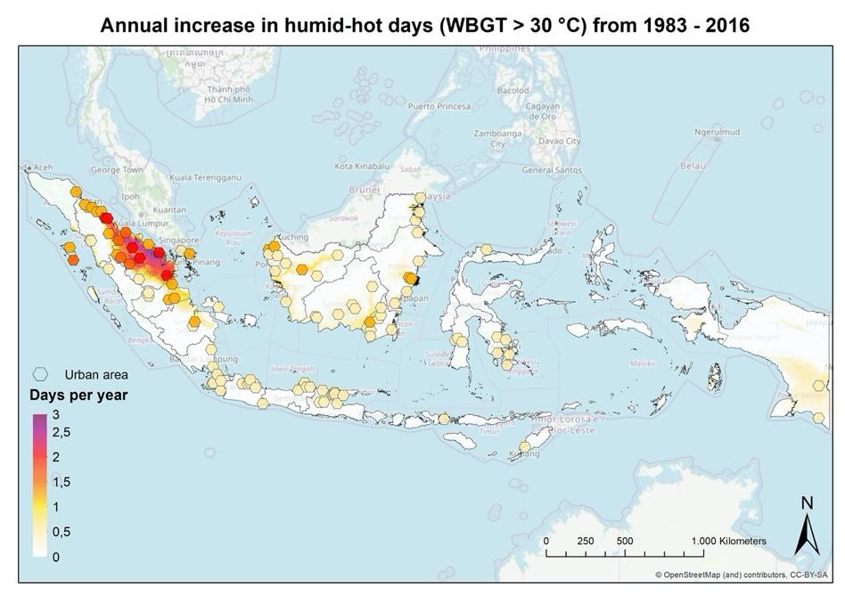
- Results and discussion

Trends
Heat stress (WBGT > 30 °C) has significantly increased over the past decades in various regions across Indonesia. The number of days with heat stress was found to be increasing 0-2.9 days per year in Indonesia, with the largest increases in Riau province. The regions with the highest increases of nearly 3 days per year have experienced 96 more days of heat stress in 2016 compared to 1983. On average, the urban areas of Indonesia are experiencing an increase in days with heat stress of 0.6 days per year.
Figure SEQ Figure \* ARABIC 1 Annual increase in days WBGT > 30 °C per year across Indonesia (1983 – 2016)

Figure 1. Annual increase in humid-hot days from 1983 - 2016

On average, cities across Indonesia experience 14 days of heat stress each year (Figure 2; black line). This average was exceeded more often in the past decade compared to the earlier decades. Between 1983 to 2000, Indonesia experienced on average 10 humid-hot days, whereas between 2000 to 2016, this average was found to be 18 days. Years which recorded exceptionally high numbers of humid-hot days were 1998 (50 days), 2010 (35 days), and 2016 (57 days). In these years, 1-2 entire months of dangerous levels of heat stress were observed throughout Indonesia. This surely has resulted in a variety of negative impacts, yet at present there is no understanding of the magnitude and extent of these.
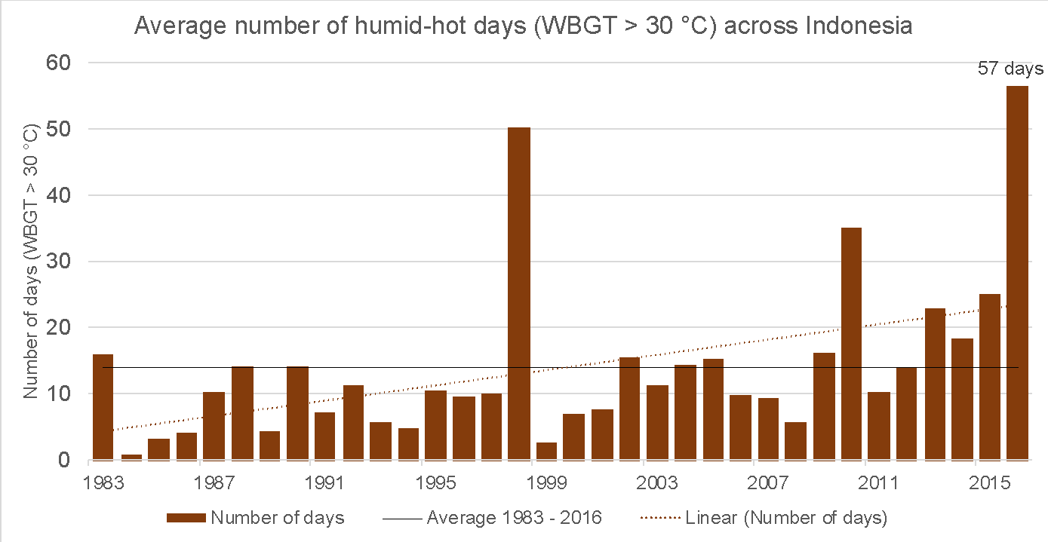
Figure 2 Annual average number of humid-hot days (WBGT > 30 °C) across Indonesia for 1983-2016.
Years with high number of hot-humid days: 1998, 2010, and 2016
The top 3 years with exceptionally high number of hot-humid days (WBGT > 30 °C), 1998, 2010, and 2016, were visualized across Indonesia (Figure 3). Spatial patterns of heat stress were found to be very similar across all years, with most hot-humid days in Riau province (of 150+ days in 1998, 2010 and 2016), followed by the provinces of Jambi and South Sumatra.

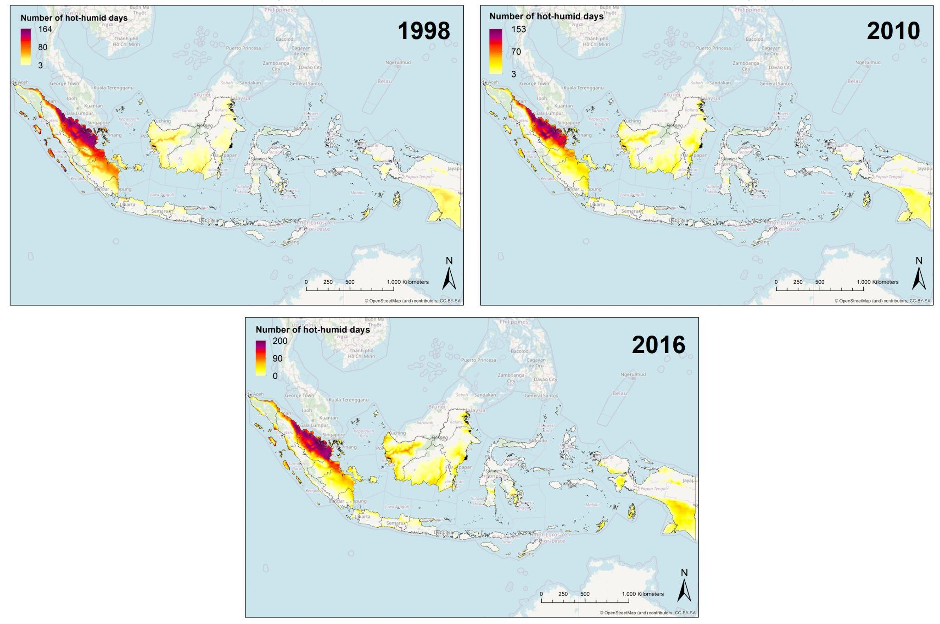
Figure 3 Number of hot-humid days across Indonesia for 1998, 2010, and 2016.

Long-lasting conditions of humid-heat
From 1983-2016, long-lasting conditions of dangerous humid-heat were observed across Indonesia, with Table 1 listing the top 10 longest episodes. The average temperature observed during these episodes of humid-heat was 30.7 °C. All top 10 of these events occurred either in 1998 or in 2016, and all started in March. This could be explained as 1997/98 was one of the most powerful El Niño years, which have also resulted in significant land and forest fires across Indonesia, releasing high carbon emissions, exacerbating air pollution, and affecting at least 20 million people’s health [19]. Another El Nino lasting from 2014 to May 2016 contributed to drought, reduced harvests, and intensified fires. Heat stress and air pollution on its own are problematic for human health, but when occurring at the same time they can result in much worse health outcomes through compounding effects. As heat stress, drought, and wildfires are coupled, it is important to understand the compound effects faced during such episodes in Indonesia.

Table 1. Top 10 longest humid-heat conditions across Indonesia
Location | Start date | Duration (Consecutive days of WBGT > 30°C) | Average temperature (°C) | Total intensity (excess heat: cumulative °C above WBGT > 30 °C)
Pulo Rungkom | 1998/03/24 | 69 | 30.8 | 56.2
Pulo Rungkom | 2016/03/03 | 65 | 30.7 | 47.1
Sono | 2016/03/04 | 58 | 30.6 | 37.0
Lhokseumawe | 1998/03/24 | 51 | 30.7 | 37.6
Pelabuhan Nelayan | 1998/03/23 | 50 | 30.7 | 36.4
Lhokseumawe | 2016/03/03 | 45 | 30.7 | 31.4
Tanjung Balai | 2016/03/23 | 45 | 31.0 | 44.0
Bireun | 2016/03/03 | 43 | 30.5 | 22.5
Sono | 1998/03/19 | 43 | 30.7 | 28.3
Pelabuhan Nelayan | 2016/03/30 | 42 | 30.7 | 29.6

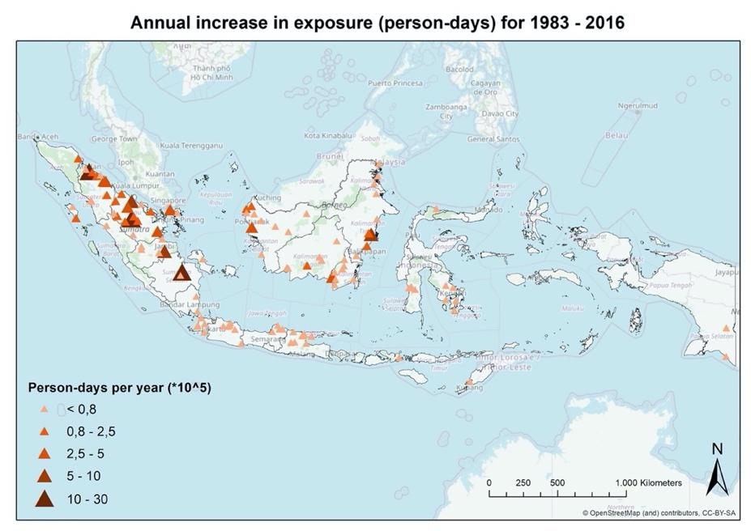
Population exposure
Exposure is measured in person-days per year, which is defined as: “the number of days per year that exceed a heat exposure threshold * the total urban population exposed”. Our results show that population exposure to heat stress has increased significantly in various urban areas across Indonesia (Figure 3). The urban areas with highest exposure include Medan, Pekan Baru, and Palembang (see Appendix, Figure 7 for city-level plots). Overall, exposure is increasing across Indonesia at a rate of 17,500,000 person-days per year, which is driven by nearly equal percentage contributions from warming (52%) and urban population growth (48%) (Figure 5).

Figure 4. Annual increase in exposure (person-days) for 1983 - 2016.

This increase in exposure has been a result of increases in warming as well as increases in population. The driving factor contributing to exposure is visualized in Figure 4 below. For example, urban areas where population growth has contributed most to increases in exposure include Bangkalan, Palembang, Bojong Gede, Nganjuk, Tuban, Singkang and Sibolga, amongst others. Urban areas where warming has contributed most to increases in exposure include Merauke, Tayu, Umbulan Bundan Udik, Telukkepik, Batam and Asike. However, in Southern Indonesia, total urban warming drove exposure, despite containing rapidly urbanizing cities.

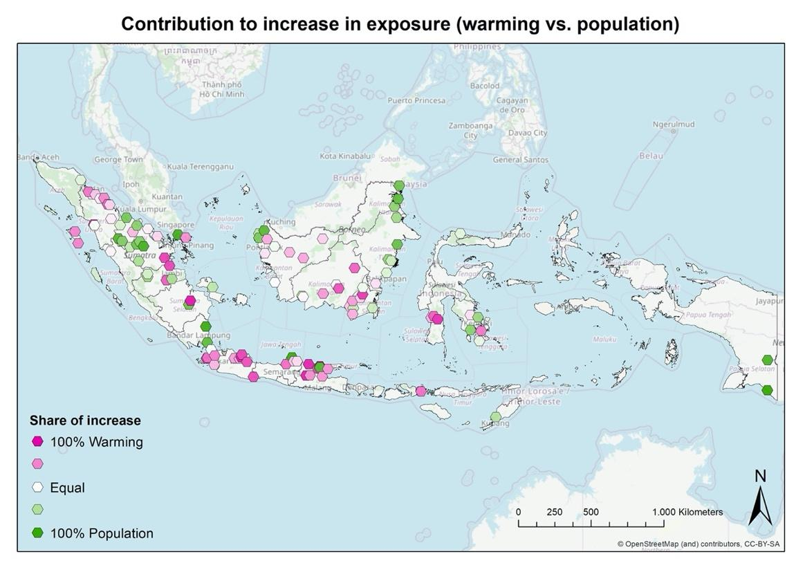

Figure 5 Contribution to increase in exposure (warming vs. population)

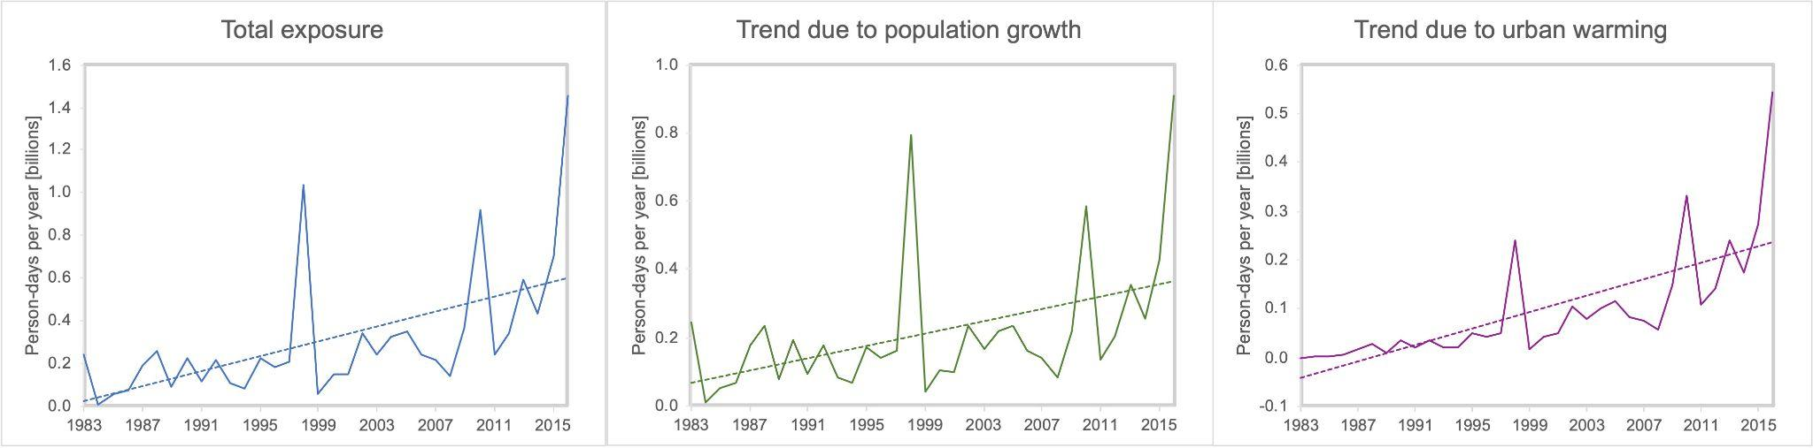
Figure 5 National-level exposure to days of heat stress (WBGT > 30 °C) in person-days x 10⁹ (billions) in Indonesia for 1983-2016, with contribution from urban population growth and total urban warming.

- Conclusion

This study has provided strong evidence for the increase in dangerous levels of humid-heat across Indonesia. On average, Indonesia experiences 14 humid-hot days each year, with a higher number of hot days in recent years. Largest increases in hot-humid days were found in Riau province, of increases up to 3 days per year. The years of 1998, 2010, and 2016 contained a disproportionate number of humid-hot days, with 50, 35, and 57 days respectively. Exposure is increasing by 17.5 million people-days per year across Indonesia, as a result of increases in both urban warming and population growth.

It is certain that heat stress will lead to far-reaching and ongoing impacts in Indonesia. Considering the rate at which heat stress is increasing, it is highly worrisome that currently, there is extremely limited understanding of the characteristics of humid-heat, as well as the risks and impacts on a local scale for Indonesia. This analysis provides a foundation for further research that is urgently needed across Indonesia, to inform and urge people to adapt and prepare for heat stress. Our findings are relevant for health practitioners, meteorological officers, urban planners, and other policy makers. Addressing heat risks will protect the health, livelihoods, and well-being of citizens, ensure resilient and sustainable communities, and contribute to growing economic development across Indonesia.

Recommendation potential actions for PMI

A list of potential short- and long-term actions have been identified for Indonesia [11]:
Long-term:
- Improving public messaging of heat risks to raise awareness
- Training caregivers in social facilities on heat risks
- Monitoring temperatures in important locations (vulnerable neighborhoods, schools, hospitals)
- Working together with local universities to co-develop studies
Short-term:
- Planning visits to important locations to raise awareness (vulnerable neighborhoods, school, hospitals)
- Providing drinking water distribution points
- Supporting community early warnings
- Opening cooling centers

References

[1] C. Raymond, T. Matthews, and R. M. Horton, “The emergence of heat and humidity too severe for human tolerance,” Sci. Adv., vol. 6, no. 19, 2020, doi: 10.1126/sciadv.aaw1838.
[2] Supari, F. Tangang, L. Juneng, and E. Aldrian, “Observed changes in extreme temperature and precipitation over Indonesia,” Int. J. Climatol., vol. 37, no. 4, pp. 1979–1997, 2017, doi: 10.1002/joc.4829.
[3] C. Mora et al., “Global risk of deadly heat,” Nat. Clim. Chang., vol. 7, no. 7, pp. 501–506, 2017, doi: 10.1038/nclimate3322.
[4] Z. Dong et al., “Heatwaves in Southeast Asia and Their Changes in a Warmer World,” Earth’s Futur., vol. 9, no. 7, pp. 1–13, 2021, doi: 10.1029/2021EF001992.
[5] C. Xu, T. A. Kohler, T. M. Lenton, J. C. Svenning, and M. Scheffer, “Future of the human climate niche,” Proc. Natl. Acad. Sci. U. S. A., vol. 117, no. 21, 2020, doi: 10.1073/pnas.1910114117.
[6] J. Chambers, “Global and cross-country analysis of exposure of vulnerable populations to heatwaves from 1980 to 2018,” Clim. Change, vol. 163, no. 1, pp. 539–558, 2020, doi: 10.1007/s10584-020-02884-2.
[7] E. Y. Yovi, “Climate Change Impacts on Occupational Health of Indonesian Farmers and Forestry Workers,” pp. 1–45, 2022.
[8] E. E. Ramsay et al., “Chronic heat stress in tropical urban informal settlements,” iScience, vol. 24, no. 11, 2021, doi: 10.1016/j.isci.2021.103248.
[9] G. R. McGregor, P. Bessemoulin, K. Ebi, and B. Menne, Heatwaves and Health: Guidance on Warning-System Development, no. 1142. 2015.
[10] N. Watts et al., “The 2020 report of The Lancet Countdown on health and climate change: responding to converging crises,” Lancet, vol. 397, no. 10269, pp. 129–170, 2021, doi: 10.1016/S0140-6736(20)32290-X.
[11] R. Singh, J. Arrighi, E. Jjemba, K. Strachan, M. Spires, and A. Kadihasanoglu, “Heatwave Guide for Cities,” Red Cross Red Crescent Clim. Cent., 2019, doi: 10.1088/1751-8113/44/8/085201.
[12] The World Bank, Turn Down the Heat: Climate Extremes, Regional Impacts, and the Case for Resilience. A Report of the World Bank by the Potsdam Institute for Climate Impact Research and Climate Analytics, vol. 31, no. 2. 2013.
[13] M. Li, S. Gu, P. Bi, J. Yang, and Q. Liu, “Heat waves and morbidity: Current knowledge and further direction-a comprehensive literature review,” Int. J. Environ. Res. Public Health, vol. 12, no. 5, pp. 5256–5283, 2015, doi: 10.3390/ijerph120505256.
[14] G. Manoli et al., “Magnitude of urban heat islands largely explained by climate and population,” Nature, vol. 573, no. 7772, pp. 55–60, 2019, doi: 10.1038/s41586-019-1512-9.
[15] R. Kotharkar and A. Ghosh, “Progress in extreme heat management and warning systems: A systematic review of heat-health action plans (1995-2020),” Sustain. Cities Soc., vol. 76, no. September 2021, p. 103487, 2021, doi: 10.1016/j.scs.2021.103487.
[16] C. Tuholske et al., “Global urban population exposure to extreme heat,” Proc. Natl. Acad. Sci. U. S. A., vol. 118, no. 41, pp. 1–9, 2021, doi: 10.1073/pnas.2024792118.
[17] K. Parsons, “Occupational health impacts of climate change: Current and future ISO standards for the assessment of heat stress,” Ind. Health, vol. 51, no. 1, pp. 86–100, 2013, doi: 10.2486/indhealth.2012-0165.
[18] T. Kjellstrom, B. Lemke, and M. Otto, “Climate conditions, workplace heat and occupational health in South-East Asia in the context of climate change,” WHO South-East Asia J. public Heal., vol. 6, no. 2, pp. 15–21, 2017, doi: 10.4103/2224-3151.213786.
[19] N. Byron and G. Shepherd, “Indonesia and the 1997-98 El Niño: fire problems and long-term solutions,” Commonw. For. Rev., vol. 77, no. 28, p. 236, 1998.

Dataset: Tuholske, C., P. Peterson, C. Funk, and K. Caylor. 2022. Annual Global High-Resolution Extreme Heat Estimates (Preliminary Release). Palisades, New York: NASA Socioeconomic Data and Applications Center (SEDAC). https://doi.org/10.7927/hff0-k565. [Accessed 08/02/2023]

Supplementary Materials

Weather stations – not included
Dataset: Weather stations (1980 – Present)
Temperature observational records were obtained from National Climatic Data Center’s (NCDC) daily summaries (GHCN-Daily) archive (www.ncei.noaa.gov/). For this part of the analysis, three weather stations were extracted, one in Medan and two in Surabaya. However, a large number of missing values were found both for maximum and minimum temperatures, limiting our understanding of temperature trends. Therefore, an additional analysis was done with the datasets described below.

Medan: number of days WBGT > 30 °C
Medan has experienced an average of 16 humid-hot days each year between 1983 and 2016, with a significant increase of 0.7 days per year observed. In other words, Medan has experienced 24 more days in 2016, compared to 1983. Years with exceptionally high number of humid-hot days include 1998, 2010, 2015 and 2016.

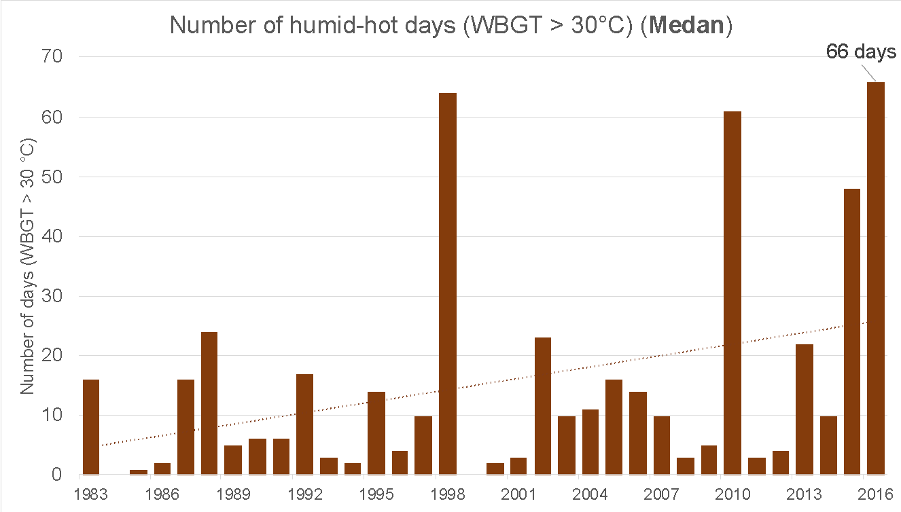
Figure 6 Annual average number of humid-hot days (WBGT > 30 °C) for Medan, Indonesia.

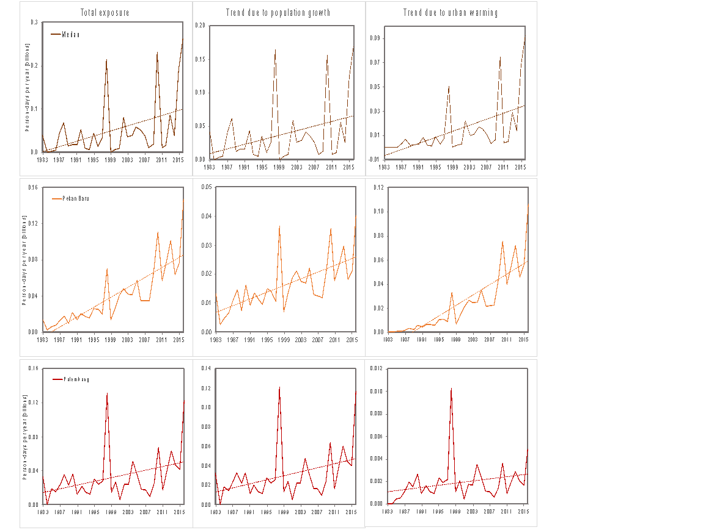
Figure 7 City-level exposure to days of heat stress (WBGT > 30 °C) in person-days x 10⁹ (billions) for 1983-2016, with contribution from urban population growth and total urban warming.

