City Heat Action Plan (HAP) – Template
August, 2023

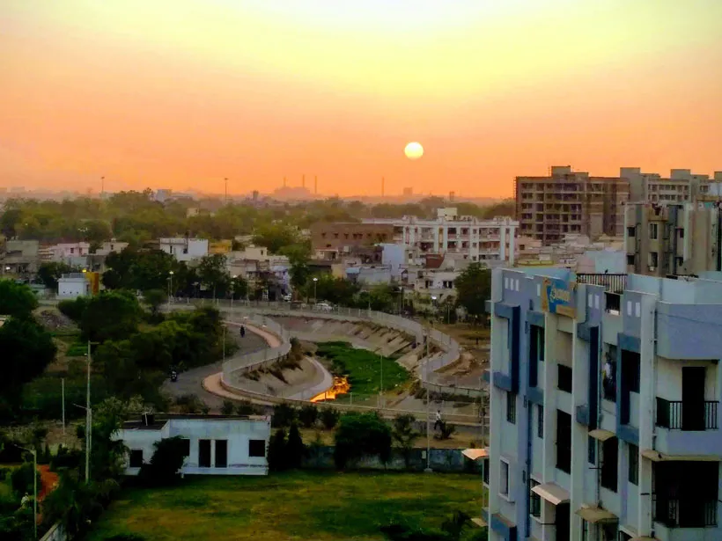

About the template
A Heat Action Plan (HAP) provides a framework for implementing, coordinating and evaluating extreme heat action across different timescales in the respective city, in order to minimize the negative impacts of extreme heat on the health and livelihood of the city’s residents. This template explains eight important components which are recommended to be part of your City Heat Action Plan.

The first component sets the stage and outlines important background details about your city. Next, the second component is focused around developing a definition of extreme heat for your city, including the development of a heat early warning system. The third component relates to determining who are the most vulnerable groups in your city. As vulnerable groups suffer most impacts from extreme heat, this plan should pay special attention to such groups. The fourth component (optional) is focused on mapping heat risk hotspots throughout your city, which can help prioritize actions across the city. Next, various types of actions to reduce risk from heat considering different timelines are outlined. The fifth component relates to heat preparedness actions, the sixth to heat risk management and response actions, and the seventh to long-term adaptation and planning measures. Lastly, it is crucial to keep evaluating and updating your City Heat Action Plan, which is outlined in the last component.

Table of Contents

Component 1: Background of the city 2
Component 2: Defining heatwaves in the city 3
Component 3: Determining the vulnerable groups 7
Component 4: Identification of heat risk hotspots (Optional) 8
Component 5: Heat preparedness actions 9
Component 6: Heat risks management and responses 11
Component 7: Long-term adaptation/planning measures 12
Component 8: Evaluation and learnings 14

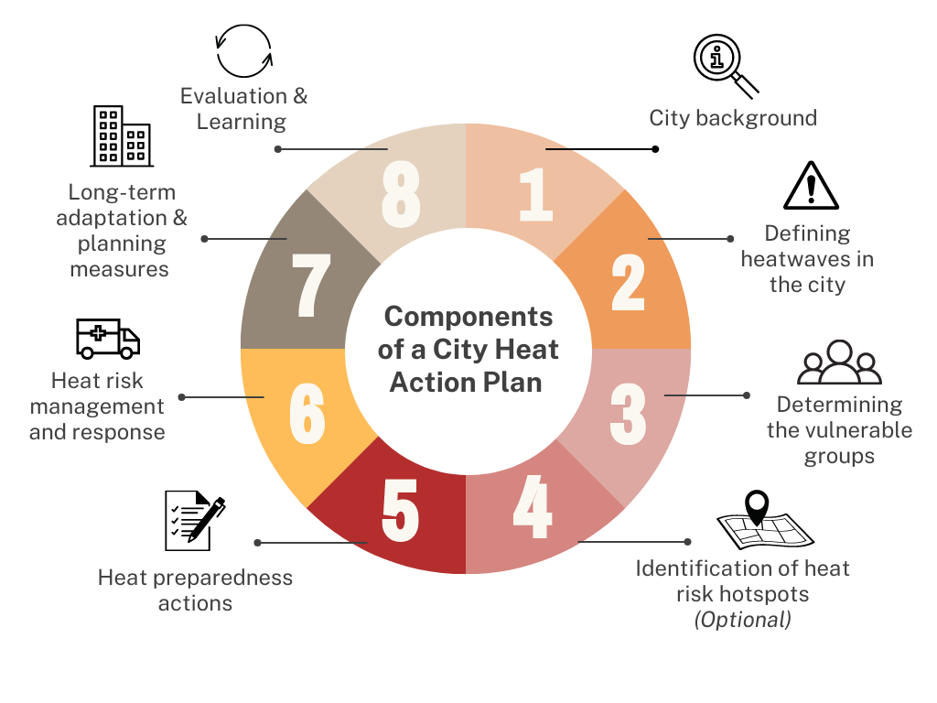
Figure 1: Components of a City Heat Action Plan

Component 1: Background of the city

Overview of the city
It is essential to provide a broad overview of the city to familiarise the reader with the local context. You may develop this section by investigating secondary data for the following characteristics of the targeted city:
- Geographical location
- Demographic overview
- Socioeconomic and physical aspects
- Climatology and hydrology
- The city map (ward wise)
- City governance system (briefly)

Heat risks and impacts in the city
This section will set the context to justify why we need heat action in the city. This analysis is also useful for the identification of heat thresholds and hotpots. You can accumulate relevant information by undertaking desk research and reviewing the following kinds of literature:
- Scientific, peer reviewed papers, published in journals
- Relevant reports, fact sheets, briefing papers, videos from the eminent institutions and organisations
- Newspaper articles, web blogs
- Secondary data on heat stress from the municipality (e.g. stress on the utilities or health or emergency services during the pick heat time)

Purpose of the HAP
Your city must have some specific goals for developing a HAP. Consult with your city authority and other key stakeholders (such as health department, utility service providers, met department etc.), specify the purpose, and list the objectives. The HAP must be framed based on the purpose and the particular goals. For example, your goals may include to minimize impacts on human health and enhance liveability in your city.

Component 2: Determining the vulnerable groups

Although extreme heat can affect anyone, vulnerable groups of people are affected by heat disproportionately and suffer most from the impacts. Therefore, it is crucial to pay special attention to the most vulnerable groups in your HAP.

Determining the vulnerable groups in your city
- Identify the vulnerable communities which are present in your city. Generally, older adults, very young children, pregnant and lactating women, and those with pre-existing medical conditions (e.g. cardiovascular and respiratory conditions, obesity, mental illness), and working outside or cooking indoors in informal settlements are most at risk of adverse health outcomes and mortality during a heatwave. You can find details about the different vulnerable groups and their risks factors in the Heatwave Guide for Cities (page 17-18)
- Determine in which areas of your city most vulnerable communities reside
- This can be done during the risk assessment process. You can also get a better sense of the vulnerable groups during the stakeholders’ workshop or/and participatory exercises such as Focused Group Discussion (FGD)

[Add visual showing building blocks of central components of HAP – EWS, seasonal preparedness, longterm actions – all is best, but its iterative and you can add as you build]

Component 2: Defining heatwaves in the city

There is no single, universal definition for a heatwave because different temperatures have varying impacts in different parts of the world. However, heatwaves are generally described as “a period when temperatures, or temperature combined with other factors such as maximum temperature, night-time temperature, and humidity, are unusually high and hazardous to human health and well-being.” Heatwaves must be defined using thresholds that correspond to local weather conditions and their impact on human health and systems. The below chart shows examples of how heatwave definitions vary in different countries.

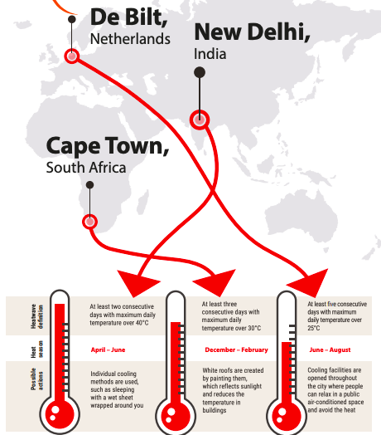
Figure 2: Different heatwave definitions across countries (Source: Heatwave Guide for Cities, 2019)

Developing a heatwave definition
- Each country determines their heatwave definition using heat thresholds corresponding to local weather conditions and their impact on human health and systems. The national metrological service is generally the nodal agency who defines the country's heat threshold and definition.
- To initiate HAP developing process for the respective city, contact the national meteorological agency to validate the heat definition of the country. If the national nodal agency did not yet determine a heatwave definition, consider encouraging your meteorological service to (collaboratively) develop a heatwave definition.
- Alternatively, you may consider the heatwave definition published by the World Meteorological Organisation (WMO), if the targeted city falls in the temperate climatic zone. The WMO defines a heatwave as: "five or more consecutive days during which the daily maximum temperature surpasses the average maximum temperature by 5°C (9°F) or more."

Setting up a heat Early Warning System:
Identification of heat threshold:
- Heat thresholds for triggering early warning and early action for heatwaves shall be response-specific and threshold values could be set at a level associated with negative impacts on human health and livelihood.
- Heat threshold for early warning and early action can be set up using the Human Discomfort Indices (HDIs) considered to be relevant for the targeted regions (based on literature review).

Threshold using HDIs:
- Not a single HDI can be considered a fit for all the regions or universally applicable^{[1]}.
- Different sets of HDIs are used for identifying the heat threshold. Some of the critical factors that shall be considered for choosing the rights HDI are human metabolic and work exposure environments (e.g., indoor and outdoor labour activities), climatic zones (such as arid, tropical, and temperate regions), and direct/indirect exposures to weather elements (e.g., sunlight, wind etc.).
- In research studies, the choice of location-specific HDI is based on statistical models employing daily mortality data. In general, for moderate to high-humid regions, HDIs such as the wetbulb temperature (Tw) that are weighted more by relative humidity in their formulation tend to perform better as an exposure variable. However, other climatic and geographic features such as distance from the coast, topography, diurnal variation and correlation between temperature and humidity also help to map the HDIs by regions.
- In the absence of daily mortality data for locations where the performance of a HDI cannot be evaluated, the alternative method is to examine the similarity in climatic and geographic features in relation to the locations that are already studied in literature.
- For the CoCHAP project cities - Medan and Surabaya (Indonesia), San Lorenzo, Nacaome and Choluteca (Honduras), Tanga (Tanzania) and Unguja (Zanzibar), Heat Index (HI) is proposed as a HDI for setting the heat threshold. You can calculate HI using an online HI calculator developed by the National Oceanic and Atmospheric Administration (NOAA). NOAA’s formula has been elaborated in the HAP process document.
- More recently, the HI has been revised^{[2]} to extend to extreme hot and humid conditions, and an online calculator based on it is also made available by ISGlobal Barcelona Institute of Global Health.

Table 1: Categories of Heat Index with threshold levels and associated heat-related risk
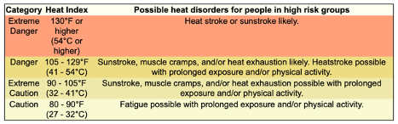
Source: https://www.weather.gov/ffc/hichart

Threshold analysing impacts data:
- The heatwave has a direct impact on health and livelihood.
- Mortality data are most regularly collected and standardized for analysing heat health impacts. However, obtaining daily ‘all cause’ or ‘non-external’ cause mortality counts (that are required for assessing the suitability of HDIs as exposure variables) can be one of the biggest challenges and often a lengthy process.
- It is recommended to collect daily all-cause or non-external cause mortality data from the Director General or Chief Medical Officer (CMO) office of the district to get a collective figure from all city hospitals.
- You should collect and analyse the daily mortality data for at least the last 3-4 years to understand the trend and get more accurate results.
- For analysing the heat impacts on livelihood - you can undertake a sample survey or Focused Group Discussion (FGD) with the outdoor workers who are highly exposed to the sun or heatwave (e.g. construction workers, street vendors etc.). This exercise will help to interpret how heat negatively impacts their livelihood and during which days of the month they felt this challenge. It would be best to carry out this exercise during the peak heat time to get more accurate feedback from the respondents.
- The healthcare and livelihood analysis can be evaluated against the extreme temperature to identify the humid heat threshold for the targeted city.
- You can validate the humid heat threshold or the threshold of the combined HDI (here the proposed use of the Heat Index) in the stakeholders' workshop.

^{[1]} https://rmets.onlinelibrary.wiley.com/doi/10.1002/joc.8160
^{[2]} https://journals.ametsoc.org/view/journals/apme/61/10/JAMC-D-22-0021.1.xml
https://doi.org/10.1175/JAMC-D-22-0021.1

Early warning mechanism and communication
- Once the heat threshold is determined, the next immediate activity will be setting up a warning mechanism. You can use the threshold maximum temperature for initiating the preparedness activities and the heat threshold based on the impact limits for the heat risks management and response related activities.
- You can coordinate with the local or nearest station of the national meteorological agency that can issue the heat forecast or early warning for the targeted city.
- The respective local authority can also take the lead in translating the forecast data from the national met agency into early warning/heat alert.
- Adopt Common Alert Protocol (CAP) mechanism for framing the early warning/ alert messages to ensure consistency and inclusivity.
- You can outline a guide on how the early warning/ alert messages will be communicated and disseminated using different tools such as WhatsApp, Facebook, Radio, TV etc.
- You can outline an internal communication mechanism. It will entail how the temperature forecast and early warning can reach the concerned departments of the local authority such as health, water supply, electricity and other stakeholders such as Red Cross Red Crescent National Society, media, and Civil Society Organisations (CSO) to enable proper preparedness and response.

Communication Plan for Ahmedabad Municipal Corporation Nodal Officer Activation of a Heat Alert :
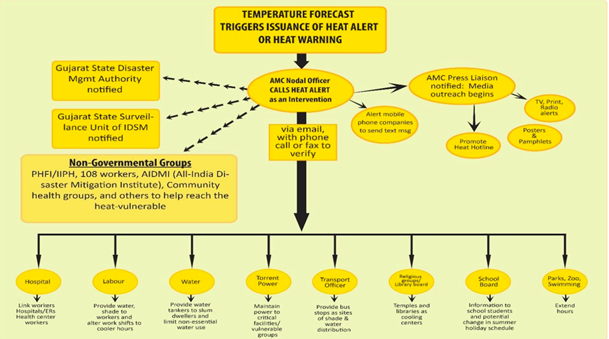
You have to set up an external or public communication mechanism via traditional and social media including TV, radio, newspapers, Twitter and Facebook, among others. You can immediately issue a press release once heat forecast data or warning data is received.

You can also use colour coded warning based on the on the likelihood of an event occurring and for an impact-based warning and accordingly release the advisory.

Three-tier heart alert system in Karachi, Pakistan
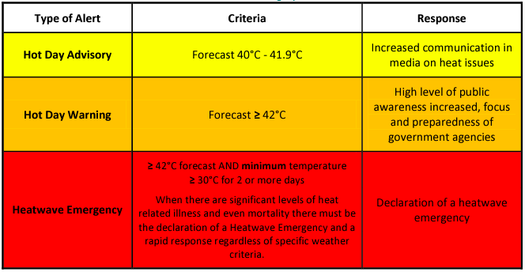

Component 4: Identification of heat risk hotspots (Optional)

Identification of heat hotspots to heatwaves helps to understand where the preparedness and response measures by the city authority and other emergency service providers needs to be considered. The entire city can be affected by the heatwave. However, the heat hotspots can facilitate the respective city authority and other emergency service providers to prioritise their actions, depending on available resources and capacity.

In order to develop a heat risk map, first a list of factors which contribute to heat risk must be established. Such factors include land surface temperature (LST), population density, built-up areas, green and blue space, socio-economic factors, house or roof type, health service facilities.

Next, data should be gathered for each factor. Lastly, a hotspot map can be derived by standardizing all values, assigning weights accordingly, and combining the factors into one single risk map.

Note:
- The indicators for the identification of heat hotspots can be adopted based on the city's local context, objectives and results from the stakeholders' consultation process.
- The weightage values can be set through local expertise and stakeholder consultation.
- The value of the parameters for the socio-economic, physical, Infrastructure/capacity vulnerability analysis should be normalized to compute normalized heat index scores and accordingly to plot on the hotspot maps.
- If you want a rapid heat hotspots identification process, then you can also use the relevant tools explained in the EVCA and City Risk Assessment guides.
- The methodology for the normalisation of values has been discussed in the process document.

Component 5: Heat preparedness actions

Heatwaves are often seasonal. Heat preparedness can take place throughout the year. However, the preparedness action should be intensified at least 1-2 months before the respective city's heat season. The actions and corresponding stakeholder(s) should be outlined clearly in your HAP. Some examples of the actions that the targeted city authorities are listed below.

Governance/Coordination:
- Identify the department that will lead the overall heat action. Generally, the disaster management or emergency department takes the lead. However, in some cities, such as Karachi in Pakistan, the city commissioner's office supervises the entire process.
- Hire a city heat officer. Alternatively, identify an official as the Nodal officer or focal point who will act as the heat officer or first point of contact for the heat action in the city.
- Form a coordination or core committee or task force that will be the responsible body for driving the heat action process in the city. The committee can consist of representatives from some of the critical departments of the city, such as disaster/climate change, energy, water supply, health etc. The Red Cross Red Crescent National Society branch representatives can also join the core committee.
- Undertake a stakeholders' mapping exercise and form a stakeholder committee for multi-dimensional information, learnings sharing and validating the heat action plans. You may follow the city coalition-building toolkit for the stakeholders' mapping and coordination.
- The respective local authority of the city and the Red Cross Red Crescent National Society could come to an understanding with the national met agency to ensure the local station provides forecast data or issue the heat alert once it touches the threshold temperature.
- Outline a stakeholders coordination plan

Communication:
- Enhance targeted training programs, capacity building efforts, and communication on the heat risks and impacts for the key stakeholders such as medical/healthcare staff and other emergency service and utility providers during the peak heat time.
- Outline an internal and external communication plan for information sharing and coordination for the heat response/action activities.
- Organise awareness generation programmes for the occupationally exposed groups, women, elderly, disabled or chronically ill, pregnant and lactating mothers, individuals residing in slums and students on heat risks, impacts and individual coping mechanisms.
- Develop capacity-building and awareness-raising toolkits such as pamphlets, posters, videos, radio messages etc.
- Check with hospitals, utility service providers mainly for water and electricity supply, and other emergency service providers if they are maintaining a systematic database management system
- Initiate dialogue with the business chambers and workers’ union to change the working hours or install cooling facilities at their workstation so that the workers are less exposed to heatwave/sun during pick heat time of the day (e.g. 12 - 3 p.m)

Infrastructures/Technologies:
- Initiate setting up cooling centres and start equipping them with the necessary materials
- Start the process of installing water ATMs and other public water facilities. If they already exist, get additional undertake a maintenance drive for all such facilities in the city.
- In the hospitals, start adding additional beds, keep heat-focused examination materials ready, get ambulances ready, update surveillance protocols and programs, including tracking daily heat-related data, establish more clinician education and ensure cooling facilities in the hospitals (e.g. fans, air cooler, air conditioning) are properly placed.
- Cover windows/doors with drapes, shades, curtains, awnings or louvers
- Develop a redundancy plan for the energy supply, especially in critical infrastructures such as hospitals and water supply, especially in the already water-stressed areas in the city.
- Organise first-aid training session on how to treat heat-related emergencies.
- Providing advisory for maintaining the AC, fans and additional drinking water storage facilities

Component 6: Heat risks management and responses

Heat risk management and response aims to help safeguard lives and livelihoods for the community. The actions related to heat risks management and response should be implemented at the individual and city levels and in close coordination with the concerned stakeholders. These actions should be activated once the temperature reaches the threshold maximum temperature and intensify further when the maximum temperature reaches the heat threshold based on the impact limits or any early warning by the concerned nodal agency. Some of the actions that the targeted city authorities may consider are listed below.

Governance/Coordination:
- Activate the heat alert when it reaches the threshold and, accordingly, activate the city-wide response
- Form a rapid response team (that can consist of Red Cross Red Crescent volunteers) and mobilise them on the field for heat response
- Maintain adequate stock of life-saving drugs/vaccines for heat wave related health problems
- Set- up an emergency help-line number and take prompt action upon receiving any request
- Reach out to vulnerable people (through tele-calling or household visits) and check if they need any relief support or other help.
- Engage with community leaders, religious leaders, or any other person that can help spread messages around heat risks and how to protect oneself.

Communication:
- Start coordinating and communicating with the different actors following the communication plan that you have developed and endorsed by the stakeholders
- Publish a press release, and contact local FM radio and TV stations for frequent messaging on the heat risks, impacts and individual coping mechanisms to reduce the risks
- Enhance the awareness campaign activities as per the communication plan. Start frequent messaging through SMS, WhatsApp and using Facebook boosting services.
- Continue to train nurses and paramedics on heat first-aid and deploy them in various clinics, cooling centres and strategic places in the city.

Infrastructures:
- Set up the water distribution points at the strategic location of the city. Ensure the Water ATM or other public water points are functional.
- Increase efforts to distribute fresh drinking water to the public through tankers, especially in the water-stress areas of the city
- Activate the heat emergency services in the hospitals/clinics and provide immediate care to patients with heat-related illnesses or symptoms
- Activate the cooling centres at the strategic location of the city
- Setting up public displays of temperature such as LED boards, put up posters, and banners at the strategic locations of the city, start miking, distributing heat awareness pamphlets

Component 7: Long-term adaptation/planning measures

The respective city authority should establish long-term adaptation measures to combat heat risks in the city. Some of such long-term strategies are listed below.

Healthcare systems:
- Training health personnel, such as volunteers, paramedics, nurses and emergency medical personnel, to help them recognize the signs and symptoms of heat-related illnesses.
- Quantifying heat-related data - all the hospitals and clinics must keep a record of heat-related illnesses.

Energy management plans:
- Regularly checking and maintaining the transmission lines reduces the risk of frequent cut-offs during heatwaves.
- Using alternative energy or renewable energy sources, such as solar panels, can help to support vulnerable communities that do not have access to electricity and also reduce the demand pressure on the grid.
- Using energy-efficient appliances (e.g. using LED/CFL lighting system) is one of the fastest and most cost-effective ways to meet growing energy demand.
- Electricity disruptions can have a cascading effect on other infrastructure and essential services that rely on a consistent supply of electricity, such as hospitals, cooling centres etc. As a result, officials must control peak electricity consumption and ensure the availability of backup energy sources for critical infrastructure.

Building construction:
- Introducing passive cooling strategies in building codes or related by-laws. For instance, the direction of a house or building, size, window design, awning or canopy, along with window blinds and orientation, can influence how hot it becomes during the summer months.
- Puffing or sandwich panels can be used for the insulation against temperature
- Spreading straw over the tops of houses with cement roofs can help to reduce heat absorption.
- Install a false ceiling using cardboard sheets or wooden board under the metal thatched roof, to reduce the indoor temperature
- Encouraging for cool roofing system in the budlings:
  - Painting the rooftop with high reflectivity paint to increase the roof surface’s solar reflectance index
  - Increase the roof surface’s Solar Reflectance Index (SRI)by using pre-fabricated materials such as membranes or sheeting to cover an existing roof
  - mosaic tiles or shingles on top of an existing roof or to a new roof
  - Greening the roofs by using vegetation, plants

Water supply system:
- Installation of deep tube wells/hand pumps at the strategic locations in the city and regular maintenance of those facilities
- Refurbish the defunct tube wells/hand pumps.
- Rainwater harvesting at the households/community level to reduce the water demand during the heat season.
- Expansion of pipe water supply in the city to meet the increased demand for drinking water during the heatwave season
- Procuring adequate number of mobile water tankers to meet the additional demand during peak heat time
- Undertake different measures to reduce water losses in the pipe water supply system

Urban Greenery:
- Planting trees along streets, walkways and between buildings
- Conserve the existing park properly and also establish new parks
- Unnecessary paving slabs, concrete tiles and asphalt surfaces can be replaced with patches of lush green vegetation along with trees and permeable pavements
- Convert abandoned piece of land and demolishing old, abandoned building into micro forest or green verge
- Conducting tree audit to gauge the tree stock and identify new planting areas
- Encourage for rooftop gardening and vertical gardening in the city

Water bodies:
- Conserving and rehabilitating the water bodies in the city
Increase the number of water bodies, ponds, water spray parks and fountains throughout strategic locations of the city
Transportation:
- Encouraging city residents and developing infrastructures for a non-motorised transportation system.
- Designate areas in the city as the car-free or/and vehicle-free zones on certain days and if not for full-day, at least for a stint

Component 8: Evaluation and learnings

After each heat season, it is important to evaluate and document learnings from the various aspects of the heat action. Evaluation of the plan is crucial to ensure that activities are having the desired effects.

- Outline a relief and recovery plan and accordingly the rolls of different stakeholders
- Conduct an after-action review of the Heat Action Plan, you can call the core team members and key stakeholders in the review meeting
- In the after-action review the following aspects of the heat action can be reviewed:
  - Alerting system
  - Stakeholders Coordination framework
  - Communication mechanism – internally and externally
  - Identifying the heat threshold
  - Identifying heat hotspots and vulnerable people
  - Preparedness and response actions
  - Long term strategies
  - Operating costs and budgeting for the next year
- The primary questions that need to be discussed and documented for learnings and updating the heat action for the following years are:
  - What was planned?
  - What actually happened?
  - What worked well and why?
  - What could be improved and how?
- You can also engage with city residents by developing community- or household-level surveys involving the most vulnerable groups, to make the learning process more holistic and inclusive.
- Based on the learnings from the after-action review, the heat nodal officer and city core team can start updating the heat action plan for the following year.

Resources
A few examples of City Heat Action Plans are:
- Ahmedabad Heat Action Plan
- Karachi Heat Action Plan
- Nepalgunj Heat Action Plan (2023)
- Odisha Heat Action Plan (2022)

