Guide for National Societies on Heat Risk Perception Research

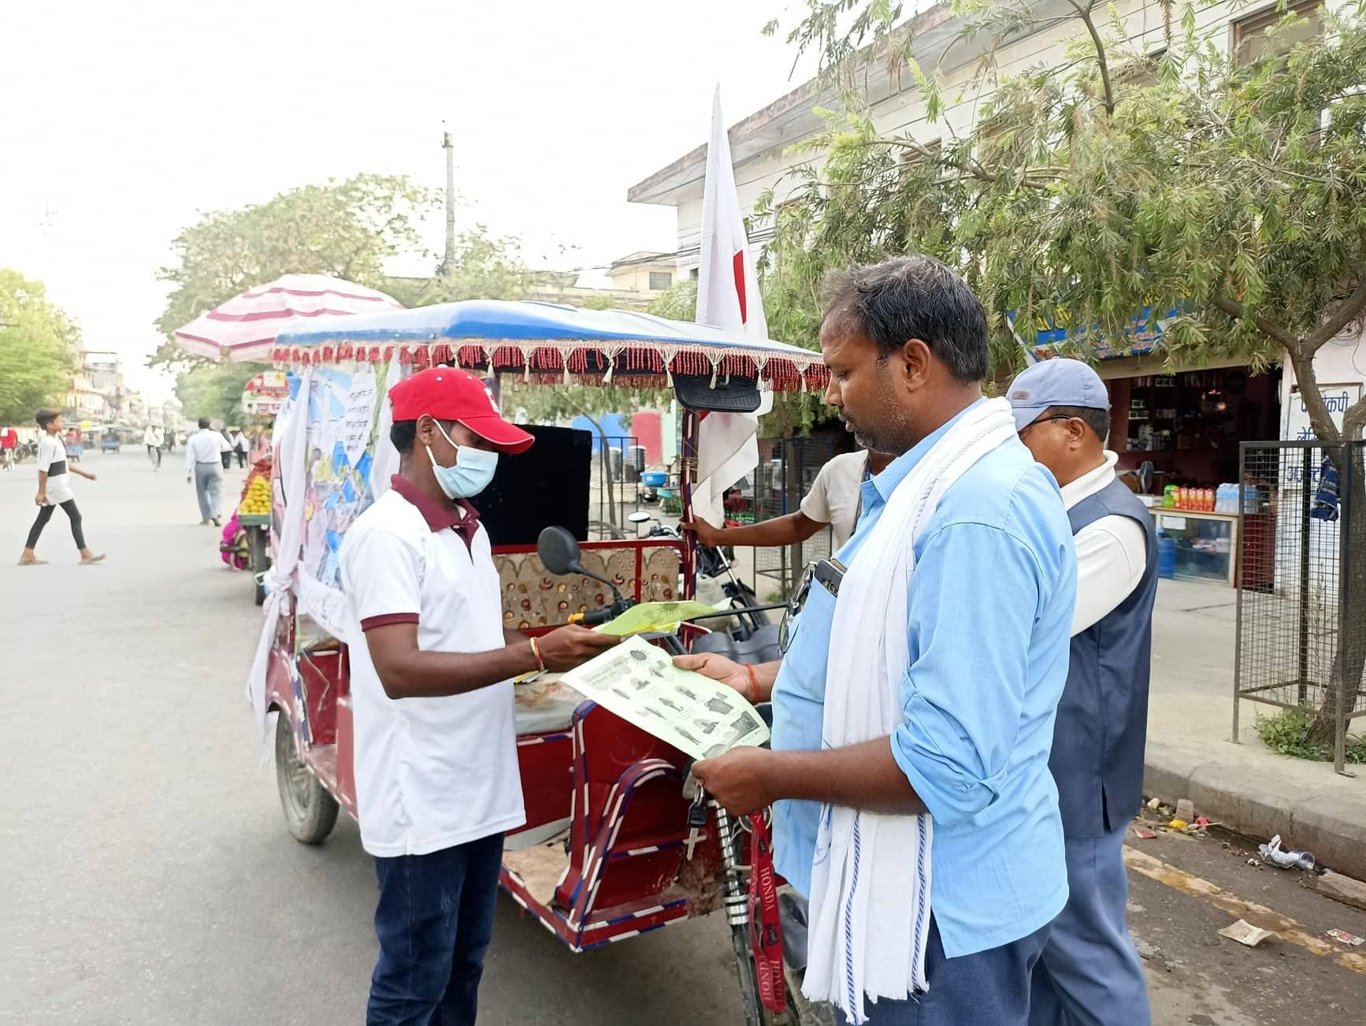

Introduction
In many countries there is a lack of public heat risk perception, which results in inadequate preparedness and response during periods of heat stress. Often, little is known around levels of perception among the public and which communication strategy is best to reach the respective target groups, particularly those most at risk. This guide is developed to inform research to be conducted on public heat risk perceptions by National Societies, including the core parts related to conducting heat risk perception research.

Project commitment:
Intervention 2.1 Increasing Individual and Household Risk Perception: The project will conduct a study on public risk perception to determine individual strengths and barriers to heat action and identify behavior change strategies to expand action. Based on those findings, the project will develop a public awareness raising campaign in collaboration with local government officials and local media partners.

The goal of this research is: to determine individual strengths and barriers to heat action and identify communication strategies to change behavior and minimize heat impacts in your city.

Step 1: Hiring a consultant/researcher and develop timeline

The first step is to open applications to hire a researcher of a local university or relevant institution (e.g. National Institution of Health) to lead the research. Next, start developing your plan and timeline together with the researcher.

Note: consider the timing of the survey in your plan. The preferred timing will be to conduct the study during or right after the heat season.

When hiring a researcher, ensure the following qualifications:
- Master degree in environmental sciences, public health, or related field. A PhD in a similar field would be advantageous.
- Theoretical knowledge of climate change, heat risk and risk perception.
- Experience with qualitative methods and survey design, e.g. designing and implementing surveys, qualitative research methods, and analyzing survey data, with proven fieldwork experience.
- Experience with community engagement and outreach and ability to collaborate with diverse stakeholders.
- Awareness of own positionality in working with vulnerable groups.
- Strong communication and organizational skills.
- Proficiency in the local language and in English.
- [any other qualifications you might want to add]

Step 2: Designing research method(s)

Together with your lead researcher, develop a detailed plan, which should include at least:
- Timeline of the study
- Type of methods (household surveys, interviews, focus groups, or a combination of these?). Note: We recommend household surveys for the risk perception survey, and focus group discussions (FGD) for testing messages (see our guidance document on FGDs)
- Target groups (inclusion and exclusion criteria)
- Selecting neighborhoods
- Training survey team/volunteers
- Data collection method
- Data storage method
- Software for data analysis
- [any other important areas to cover in the plan]

2.1 Developing survey questions

The survey should include the following requirements:
- The survey should cover questions around a few main themes which are outlined below. An example survey is in the Appendix.
- Consent of the participants should be asked before starting the survey. This can be written consent or verbal.
- Ethical approval should be obtained from the research institution or relevant ethics committee. Follow ethical principles and guidelines throughout the research process. Note: this can take a long time (1-6 months or in some cases longer), depending on the institution. Still, it is important to obtain approval in order to ensure ethical principles are followed appropriately and results can be published afterwards.
- The survey should be developed in the local language and translated to English.

Themes to cover in survey
- Background information & demographics
The survey should start with recording background information and demographic variables, such as: date of the survey, number of the survey, location, age, sex, income level, employment status, highest level of education attended, health condition, number of children in household, total household size, religion, and ethnicity.
Note: in order to adhere to ethical principles, the survey should only collect demographic and personalizable information that is absolutely required for the research.

- Knowledge of heat stress and impacts
This section should include questions around the level of knowledge of extreme heat. This includes questions around knowledge of temperature levels on hot days and nights, perception of change or increase in extreme heat over the past years, and causes or drivers of the heat.

- Adaptation strategies and barriers
This part should focus on identifying participants’ knowledge and barriers towards adapting/coping with heat. Questions can ask participants to list their top 3 most and least used methods to protect themselves from heat. This section should also make sure to identify barriers such as limited water, electricity, or any other barriers towards adaptation.

- Information & communication channels
This section should include questions around the information and communication of extreme heat from the government, other authorities, or community members. This section will be especially important for the design and dissemination of adaptation strategies.

2.2 Choosing study areas & target population

Next, it is important to identify your target population. A few things to keep in mind:
- Develop a list of inclusion and exclusion criteria. (For example, inclusion criteria could be: person aged > 18 years old. Exclusion: individuals who are temporarily staying in the identified neighborhood)
- Ensure that your sample covers multiple groups of people (e.g. different age, gender, and socio-economic groups)
- Think of how many participants per neighborhood you would like to survey in order to get a representative sample (e.g. at least ~50-100 respondents per neighborhood) and also remain feasible.
- Consider ways to recruit participants (e.g. through a trusted community leader)

In order to identify neighborhoods, the aim is to select a few neighborhoods with multiple population groups. How to select neighborhoods?
- Select at least two neighborhoods (preferably more) to conduct your survey, based on local expertise and collaboration between the lead researcher and your team.
- Optional: perform a heat risk/vulnerability analysis of your city, in addition to using your own local expertise of characteristics of different neighborhoods. A risk analysis can be done through desktop research and can be supported by the Climate Centre.

Step 3: Train volunteers, pilot testing, and conducting the survey

Recruit and training volunteers / survey team: consider how many volunteers you may need and recruit volunteers who will help in conducting the survey. It will be important to hold one or more training sessions on how to run the survey, depending on the level of experience with surveys. Note: it is important to have a trustworthy and committed team to conduct the surveys in order to obtain good results.

Pilot test the survey: test the questionnaire with a small group of participants to ensure it is effective and understandable. Consider the cultural appropriateness of the language and format. Make revisions as necessary.

Conducting the survey: conduct your surveys or interviews with your target population (in the local language). Consider methods of data collection, storage, and how you will analyze the results.

Next steps:
After analyzing and interpreting results, follow with developing messages, testing of messages (e.g. using focus groups), and planning the awareness raising campaign.
Note: It will be hugely beneficial to publish results from your heat risk perception study in the scientific literature.

Resources: list of existing studies on public heat risk perception

- Emerging climate change-related public health challenges in Africa: A case study of the heat-health vulnerability of informal settlement residents in Dar es Salaam, Tanzania. Available through: https://www.sciencedirect.com/science/article/abs/pii/S0048969720348841
- Public perceptions of the health risks of extreme heat across US states, counties, and neighborhoods. Available through: https://www.pnas.org/doi/10.1073/pnas.1813145116#:~:text=Nationally%2C%20the%20population%2Dweighted%20mean,47.9%2C%20SD%20%3D%2024.6).
- Risk perception of heat waves and its spatial variation in Nanjing, China. Available through: https://pubmed.ncbi.nlm.nih.gov/29335771/
- The driving influences of human perception to extreme heat: A scoping review. Available through: https://www.sciencedirect.com/science/article/abs/pii/S0013935121004679

PrepareCentre heat research
All studies are available through: https://preparecenter.org/site/heatresearch/

- Knowledge, Attitudes, Practice & Risk Perceptions Regarding Heatwave Among Outdoor Workers in Nepal
  - Methods: A mixed method study was conducted to assess the social vulnerabilities among the outdoor workers in selected 8 districts of Nepal. 11 focus group discussions and a total of 356 quantitative surveys were conducted.
- Heat Risk Perception and Communication Strategies for Adaptation in Kampala City, Uganda
  - Methods: Qualitative and quantitative data and information was collected through literature review from secondary data sources, and conducting 382 surveys using standard questionnaires in Kibuye I and Bwaise III parishes, as well as key informant interviews with community members, business operators, civil society organizations (CSOs), and ministries, departments and agencies (MDAs) link to climate change and urban development domains.
- Residents Perceptions of Extreme Heat in Beitbridge, Zimbabwe
  - Methods: The study was largely a fieldwork-based assignment, involving collection of primary data using both qualitative (observation, in-depth-interviews, Focus Group Discussions, Key Informant Interview) and quantitative (survey) data collection methods. Focus group discussions lasted for one-two hours and each group consisted of 8-10 participants across with a total of 41 participants comprising 26 women and 15 men. A total of 150 questionnaires were distributed to participants.
- Heat Risk Perceptions among different occupational groups in South India
  - A cross-sectional study was conducted between May and September 2022 with 418 outdoor workers from five outdoor workplaces in southern India. Using a modified and validated High Occupational Temperature Health and Productivity Suppression (HOTHAPS) questionnaire, employees' perceptions of non-traditional risk factors for CKDu were assessed.
- Extreme heat risk among informal sector workers based on perception in Nagpur, India
- Public Perception of the Health and Social Risks of Extreme Heat in Northern Ghana
  - Four (4) focus groups discussions were conducted with twelve (12) individual interviews.
- Examining relationships between extreme heat and migration/ displacement and human mobility in Zacapa, Guatemala
- Climate Change Impacts on Occupational Health of Farmers and Forestry Workers in Indonesia

Appendix: Example Survey

Introduction
- [Give background information on research]
- [Ask for consent]

Part 1: General information

- No. of the survey: _________________
- Date of the survey: ________________
- Location/neighborhood: ____________
- Age group
  - 18 - 30
  - 30 - 50
  - 50 - 65
  - > 65

- Sex
  - Female
  - Male
  - Other

- Income level/group
  - [add categories]

- Employment status
  - Unemployed
  - Formal employment (specify job)
  - Casual labor (specify job)
  - Other (specify job)

- Highest level of education attended
  - Never attended formal education
  - Primary school
  - Secondary school
  - University

- Health condition
  - No health condition
  - Existing chronic illness
  - Disability
  - Other (specify)

- Number of children in household
  - 0
  - 1 - 5
  - 5 - 10
  - > 10

- Total household size
  - < 5
  - 5 - 10
  - > 10

- Religion:
  - [Add categories]
  - Other: _______

- Ethnicity:
  - [Add categories]
  - Other: _______

Part 2: Knowledge of heat and related risks

- Have you ever experienced periods of unusually or uncomfortably hot weather in [City]?
  - Yes
  - No
  - I don’t know

- If yes, how often do you experience periods of uncomfortably hot weather?
  - Less than once a year
  - Once a year
  - Multiple times per year
  - Year-round

- During which time of the day do you mostly experience discomfort from hot weather?
  - Morning
  - Afternoon
  - At night

- Do you know the temperature levels on hot days/nights?
  - Yes
  - No
  - Sometimes

- Do you think there has been an increase in temperature in the past years in [City]?
  - Yes
  - No
  - I don’t know

- What do you think are the causes of the high temperature in [City]? List below.​ [do not provide the respondent with the options below, but select which ones best approximate the responder’s answer]
____________________________________________________________________________________________________________________________________________________
  - Climate change
  - Urbanization
  - Deforestation
  - Overcrowding
  - Other: _______

- Do you agree that extreme temperatures are a problem in [City]?
  - Yes
  - No
  - I don’t know

- How severe do you think the heat is in [City]?
  - Not severe
  - Very mild
  - Mild
  - Moderate
  - Severe

- How much are you worried about the following issues? Rank the following problems from least (1) to most (5) worried about: cyclones, droughts, poverty, heat stress, and energy blackouts.
- The least important: __________
- Slightly more important: __________
- Important: __________
- Very important: __________
- The most important: __________

- Do you consider yourself vulnerable to heat?
  - Very much
  - Somewhat
  - Not at all
  - I don’t know

- Are you concerned about heat-related risks that can affect you?
  - Yes
  - No
  - Maybe

- If yes or maybe, which areas of your life does heat affect you:
  - Health issues
  - Food availability
  - Water availability
  - Work productivity
  - Community aggression or violence
  - Social activities
  - Other: ___________________________

- Are you concerned about heat-related risks that can affect your family or your community?
  - Yes
  - No
  - Maybe

- Some people are more vulnerable to extreme heat. ​​Can you name some groups of people who you think are most vulnerable to extreme heat? [do not provide the respondent with the options below, but select which ones best approximate the responder’s answer]
____________________________________________________________________________________________________________________________________________________
  - Elderly
  - Newborns
  - Children
  - People on medication
  - Obese
  - People with disability
  - Socially isolated
  - Athletes
  - Outdoor workers
  - Tourists
  - Informal settlers
  - Homeless

- Heat can have various impacts on human health. Do you know some of the symptoms associated with heat? List below the ones you know.​ [do not provide the respondent with the options below, but select which ones best approximate the responder’s answer]
____________________________________________________________________________________________________________________________________________________
  - Dizziness
  - Sunburn
  - Headache
  - Nausea
  - Muscle cramps
  - Fatigue
  - Increased heart rate
  - Skin rash
  - Excessive sweating
  - Others: [...]
  - I don’t know

Part 3: Adaptation strategies and barriers

- There are ways to protect yourself from extreme heat. Do you know some things you could do to prevent health effects from extreme heat? [do not provide the respondent with the options below, but select which ones best approximate the responder’s answer] __________________________________________________________________
  - Increase consumption of fluids (water)
  - Using a fan or air-conditioning
  - Sleeping/resting during hottest periods of the day
  - Adjust clothing (wear loose clothes, light materials/color, wear hat)
  - Close windows (when outdoor temp is higher)
  - Visit parks / green areas
  - Avoid physical activity
  - Avoid outdoor activities
  - Eat small meals
  - Other, namely: ___________________

- Do you change your behavior during periods of hot weather?
  - Always
  - Sometimes
  - Almost never
  - Never

- Which measures do you most likely take during hot weather? List your top 3:
  - Increase consumption of fluids (water)
  - Using air-conditioning
  - Using a fan
  - Sleeping/resting during hottest periods of the day
  - Adjust clothing (wear loose clothes, light materials/color, wear hat)
  - Close windows (when outdoor temp is higher)
  - Visit parks / green areas
  - Avoid physical activity
  - Avoid outdoor activities
  - Eat small meals
  - Other, namely: __________________

- Which measures do you most likely NOT take during hot weather? List your top 3:
  - Increase consumption of fluids (water)
  - Using air-conditioning
  - Using a fan
  - Sleeping/resting during hottest periods of the day
  - Adjust clothing (wear loose clothes, light materials/color, wear hat)
  - Close windows (when outdoor temp is higher)
  - Visit parks / green areas
  - Avoid physical activity
  - Avoid outdoor activities
  - Eat small meals
  - Other, namely: __________________

- If you don’t take any measures, why not?
  - The weather was not hot enough
  - The heat doesn’t affect me / I am used to the hot weather
  - I didn’t know the heat can be dangerous
  - I don’t have the resources to change my behavior
  - Other: ____________________________

- Do you spend more money during hot seasons to cope with heat?
  - Yes. If yes, list why: ______________
  - No

- Do you have access to water during periods of high heat?
  - Always
  - Most days of the week
  - Half of the time
  - Very little

- Do you have and use mosquito nets?
  - Yes
  - No

- Do you experience blackouts?
  - Very often (more than once a week)
  - Often (once a week)
  - Sometimes (once a month)
  - Rarely (few times per year)
  - Never

- Do you look for cooler locations in the city during hot days?
  - Yes. If yes, what type of locations do you visit: _________
  - No

Part 4: Information & communication channels

- Do you check the weather forecast?
  - Yes
  - No
  - Sometimes (specify how often)

- Did you ever receive an alert or warning for heat stress?
  - Yes
  - No
  - I don’t know

- Did or would you change your behavior based on such an alert?
  - Yes. If yes, explain how:
    - ____________________
  - No

- If yes, what type of information did you receive?
  - Maximum temperature
  - Minimum temperature
  - Level of humidity
  - Duration of the event
  - Until when the heat will last
  - What actions to take to protect yourself from the heat
  - How to protect my family and friends
  - Other: _________

- If yes, How many days in advance did you receive this information?
  - A week in advance
  - A few days in advance
  - One day in advance
  - On the same day

- What other type of information would be useful for you to receive?
  - Maximum temperature
  - Minimum temperature
  - Level of humidity
  - Duration of the event
  - Until when the heat will last
  - What actions to take to protect yourself from the heat
  - How to protect my family and friends
  - Other: ________

- Where do you look for information about the weather?
  - Word of mouth (specify: community leaders, neighbors, family members, and/or friends)
  - Public displays
  - TV
  - Social media (specify platform: facebook, instagram)
  - Radio
  - Whatsapp
  - Newspaper
  - Other: ___________

- In your community, how do you think information can best be spread?
  - Word of mouth (specify: community leaders, neighbors, family members, and/or friends)
  - Public displays
  - TV
  - Social media (specify platform: facebook, instagram)
  - Radio
  - Whatsapp
  - Newspaper
  - Other: ___________

- In what language would you prefer to receive information?
  - [add languages]
  - Other: ________

- What type of information would you find useful to receive?
  - Maximum temperature
  - Minimum temperature
  - Level of humidity
  - Duration of the event
  - Until when the heat will last
  - What actions to take to protect yourself from the heat
  - Other: _________

- Do you think your community would benefit from being more prepared to deal with hot weather?
  - Yes
  - No
  - Don’t know

Part 5: Concluding questions

- Do you have any other comments that we have not addressed until now, that you feel are important for our study?
____________________________________________________________________________________________________________________________________________________

- Would you like to receive a quick guide on the impact of heatwaves and what you can do to reduce heat risk? If yes, list below your address or email (your email will not be used for any other purpose)
____________________________________________________________________________________________________________________________________________________

- In the next phase of this project, we will test specific awareness messages. Would you like to participate in a focus group on this topic? If yes, indicate your phone number or email below:
____________________________________________________________________________________________________________________________________________________

