Heat Awareness Campaign
– guidance note

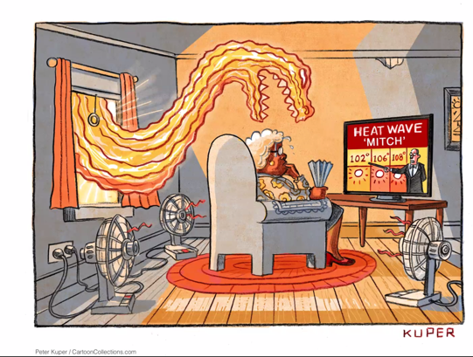

Introduction:

Extreme heat is rising globally and posing health and livelihood risks to communities worldwide. Often called the ‘silent killer,’ heatwaves have killed thousands of people in recent years. Climate change increases the frequency and intensity of heatwaves, and the global surface temperature will continue to increase. IPCC has projected that due to climate change, the global population exposed to deadly heat stress will increase from today's 30% to 48-76% by the end of the century.

In countries like Indonesia, Tanzania, and Honduras, which fall in hot, tropical and sub-tropical climatic zones, heat stress is becoming a growing concern, where the impacts can be especially severe due to high temperatures combined with high humidity. In contrast to mid to high-latitude countries where heat stress is restricted to summer months, heat stress in the countries that fall in the abovementioned climatic zones happens almost year-round. Consequently, communities often do not perceive heat stress as a risk and threat to their lives. A lack of heat risk awareness, both by the public and, in some cases, governments, results in inadequate preparedness for current and future heatwave risks. It is therefore very important to raise awareness on the risks of extreme heat and what can be one to reduce risks. Extreme heat awareness raising campaigns are considered an effective way to increase the knowledge of city residents, local government officials, students, medical and humanitarian aid practitioners, and political leaders on the impacts of extreme heat. The campaign also make them aware of the simple heat actions they can take to reduce the exposure and associated risks to people’s wellbeing.

This guidance note aims to provide a step by step guidance for the Red Cross Red Crescent National Societies and their partners including the local governments and city service providers in designing and implementing heat awareness campaigns in cities and towns. The steps described below should be carried out in consultation and coordination with key stakeholders and the city coalition members
Figure 1: Overview of the steps for designing the heat awareness campaign

Step 1: Identify the implementation timeline for the awareness raising campaign

Setting the timeline for implementing the awareness-raising campaign is the foremost step. The awareness-raising programme ideally should begin before the start of the hot season and continue until the season’s end.

The campaign can be carried out as an extended programme or can be done in several phases, depending upon the resource availability. If it is agreed to be conducted in several phases, ensure the first phase is the longest one compared to the subsequent phases.
For example, the peak hot season in the city is from April to June. In that case, it is preferable to get all the preparatory activities done by the end of February or 1st week of March and roll out the awareness campaign by mid or, at the latest, 3rd week of March.

For example, if the pick hot season in the city is from April – June and it has been decided to roll out the awareness campaign from mid-march, then it is preferable to continue the campaign till at least mid-April in Phase 1, the first two weeks of May in phase 2; and the last phase can be conducted at the beginning of June for at least a week time. As an alternative approach, the Nepal Red Cross Society and the respective municipality carried out a continuous month-long awareness-raising programme in Nepalgunj city in Nepal.

It is always recommended to assess your level of preparation and resource availability before setting the timeline for conducting the heat awareness raising campaign.

Step 2: Analyse the results of the extreme heat risk perception study

It is important to integrate the results and insights from the heat risk perception in designing the heat awareness campaign to make it evidence-based and inclusive. Some of the factors that need to be investigated from the extreme heat perception study are:
- perception and attitude towards extreme heat risk and impact by the different population groups
- how do they receive the early warnings or other alert messages
- what are the residents’ preferred channels to receive any alert messages
- if residents’ behaviour and activity change during the extreme heat days
- the kinds of heat symptoms or illnesses they experience during the extreme heat days
- lifestyle, occupations, working hours, food habits, and socialisation/recreational habits for the different population groups
- the different social media platforms that youth and women use for social awareness and getting various promotional news
- present practices/measures they take to deal with extreme heat

The analysis of these indicators will provide evidence to determine the preferred channels, language, formulating the awareness messages, timing to broadcast the heat awareness videos on the TV/radio, and boosting services in social media.

If the heat risk perception study can’t be completed before the 2024 heat awareness campaign planning process, the results and insights from the heat risk perception should be incorporated in designing the next heat awareness campaign from 2025 onwards.
Step 3: Identify the target groups

The design of the entire campaign will be shaped based on who are the target groups. It should be done in consultation with key stakeholders and the city coalition members and using the results of the heat perception studies (where available) and relevant health, demographic and socio-economic data of the city.

Extreme heat can pose a negative health impact to anyone. However, there are specific groups that are typically at higher risk. The table below showcases the different vulnerable population groups and their factors.

Table 1: Vulnerable population groups to extreme heat
VULNERABLE POPULATION | RISK FACTORS
Older adults (such as over 65) | Are less able to adapt to extreme heat, may be socially isolated, and may not perceive extreme heat as a risk. Older adults also tend not to feel thirsty in higher temperatures, which makes them more vulnerable to dehydration. They may also be taking medication that makes it harder to regulate their body heat.
Individuals with chronic medical conditions | These include heart disease, lung and kidney conditions, diabetes and mental illness. Many medications can also worsen the impact of extreme heat.
Children under five years old | Are sensitive to the effects of extreme heat and must rely on others to keep them cool and hydrated.
Women and girls | Depending on local cultural norms, women and girls may have limited access to a variety of media which limits their interaction with heatwave warnings. They may sleep in ill-ventilated rooms or lack private bathing space, especially during menstruation, which can help to keep them cool.
Pregnant and lactating women | Pregnant women are more likely to go into early labour in the week following a heatwave. This risk goes up with more consecutive days of extreme heat. Lactating women require more drinking water as breastfeeding is extremely dehydrating.
Outdoor workers (incl. traffic police, security guards, street vendors, construction workers etc.) | Are often engaged in strenuous labour while directly exposed to sunlight as well as heat and air pollution. They are more likely to become dehydrated and suffer from heat-related illness. They may need to reduce the amount of jobs they take which will also reduce their family’s income.
Indoor workers | Indoor workers can be at risk for overheating due to increased exposure to indoor heat in certain occupational settings (i.e. electricity, gas, water manufacturing), lack of ventilation, working hours, physical activity, exposure to chemicals, and protective clothing.
Athletes | Engage in intense physical activity, often outdoors, that can rapidly increase body temperature and result in water loss through sweating.
People who are isolated or living alone | May not readily receive warning information or may not be able to access help quickly.
People with limited mobility | This includes in-patients at hospitals, older population, people with dementia or Parkinson’s disease, those supported by medical equipment, and people with disabilities. People with lack of mobility or conditions that require them to stay indoors or be bed-ridden during heat waves could be at greater risk if they lack cooling mechanisms.
Individuals with disabilities | May have limited access to cool spaces and may not be able to access help quickly.
Overweight and obese individuals | May be more sensitive to extreme heat and their bodies may have difficulty regulating body heat.
People with mental health conditions | This particularly includes schizophrenia, dementia, neurotic and anxiety disorders. Mental health disorders can cause impairments in physiological and behavioural thermoregulation, exacerbate social isolation, and medication use (i.e. antidepressants) can adversely interact with high temperatures
Individuals with low socio-economic status | May have limited access to information about heatwaves and/or cooling centres as well as fewer resources. They may not be able to afford time off work to take care of family members. They may have to travel longer distances to access cool spaces and may feel unwelcome in certain neighbourhoods. In some locations they may also have limited access to clean drinking water.
Migrants and refugees | May not have access to current information about heat advisories and health risks or may experience heat conditions that are different to their place of origin. Negative legal or cultural norms toward migrants and refugees may also increase their hesitancy to contact emergency services.
People living in densely built areas | In densely built urban areas – such as slums, informal settlements, mobile-home parks and high-rise buildings – multiple families share small spaces. Densely built areas can magnify the urban heat island effect.
Homeless people | May not receive timely early warning messages, may be unaware of cooling centres and may have limited access to other cooling measures (e.g. cool showers or baths). May also feel unwelcome at cooling centres due to marginalization and stigma.
People with limited literacy and non-native language speakers | Cannot read current information about heat advisories and health risks. Non-native language speakers may not be able to understand advisories broadcast on TV and radio.
Tourists | May not be able to understand advisories in local languages. May not know how to access cooling centres, green spaces or other resources, including emergency management systems. May also be from cooler climates and less adapted to the heat.
Eventgoers | May be outdoors, exposed to the hot sun, or in close quarters with other people without access to proper ventilation, water, or cooling.
Stigmatized groups such as LGBTQ+, geographically or culturally isolated groups | Varies depending on the group, but mainly linked to stigma and marginalization. People who are marginalized may feel unwelcome at cooling centers and they may be hesitant to seek medical attention.
Animals/livestock/pets | Dependent on owner for adequate protection from the heat.

Step 4: Identify the channels and platforms for the campaign

It is a critical step to ensure that all the key messages are effectively reached to the targeted group. The type of communication channels to be used will influence the format in which heat information is shared. Information can be shared in visual, audio or text forms. A combination of formats can serve a broader population range compared to using a single format.

Here are examples of some of the formats to deliver heat awareness messages:

Print and outdoor publishing:
- Installing posters in the strategic locations of the city (such as busy streets, markets, railway station, bus stops, near play grounds/ children parks, hospitals and government offices etc.)
- Billboards or banners for greater visibility and reaching out to the mass
- Distributing pamphlets with heat awareness messages in places such as busy streets, markets, hospitals and government offices.
- Attaching pamphlets with heat awareness messages to the newspapers

Social Media:
- Posting heat awareness messages (with graphics), and videos on Facebook, Instagram, X (Twitter), WhatsApp channels.
- Making the heat awareness post viral through WhatsApp and X
- Using the boosting features (paid) on Facebook, Instagram ensure that the heat awareness-related posts and videos are shown on the top of the page at least once a day, preferably during the peak hours daily
- Producing TikTok videos on heat awareness and try to reach as many people as possible
- Engaging with selected social media influencers who produce educational or social awareness-related videos and other high-profile people such as celebrities, doctors to deliver the heat awareness messages.

TV/Radio:
- Broadcasting heat awareness messages on local radio and TV channels
- Producing podcasts and jingles on heat awareness and broadcasting them on local radio/FM channels and, if possible, in Spotify

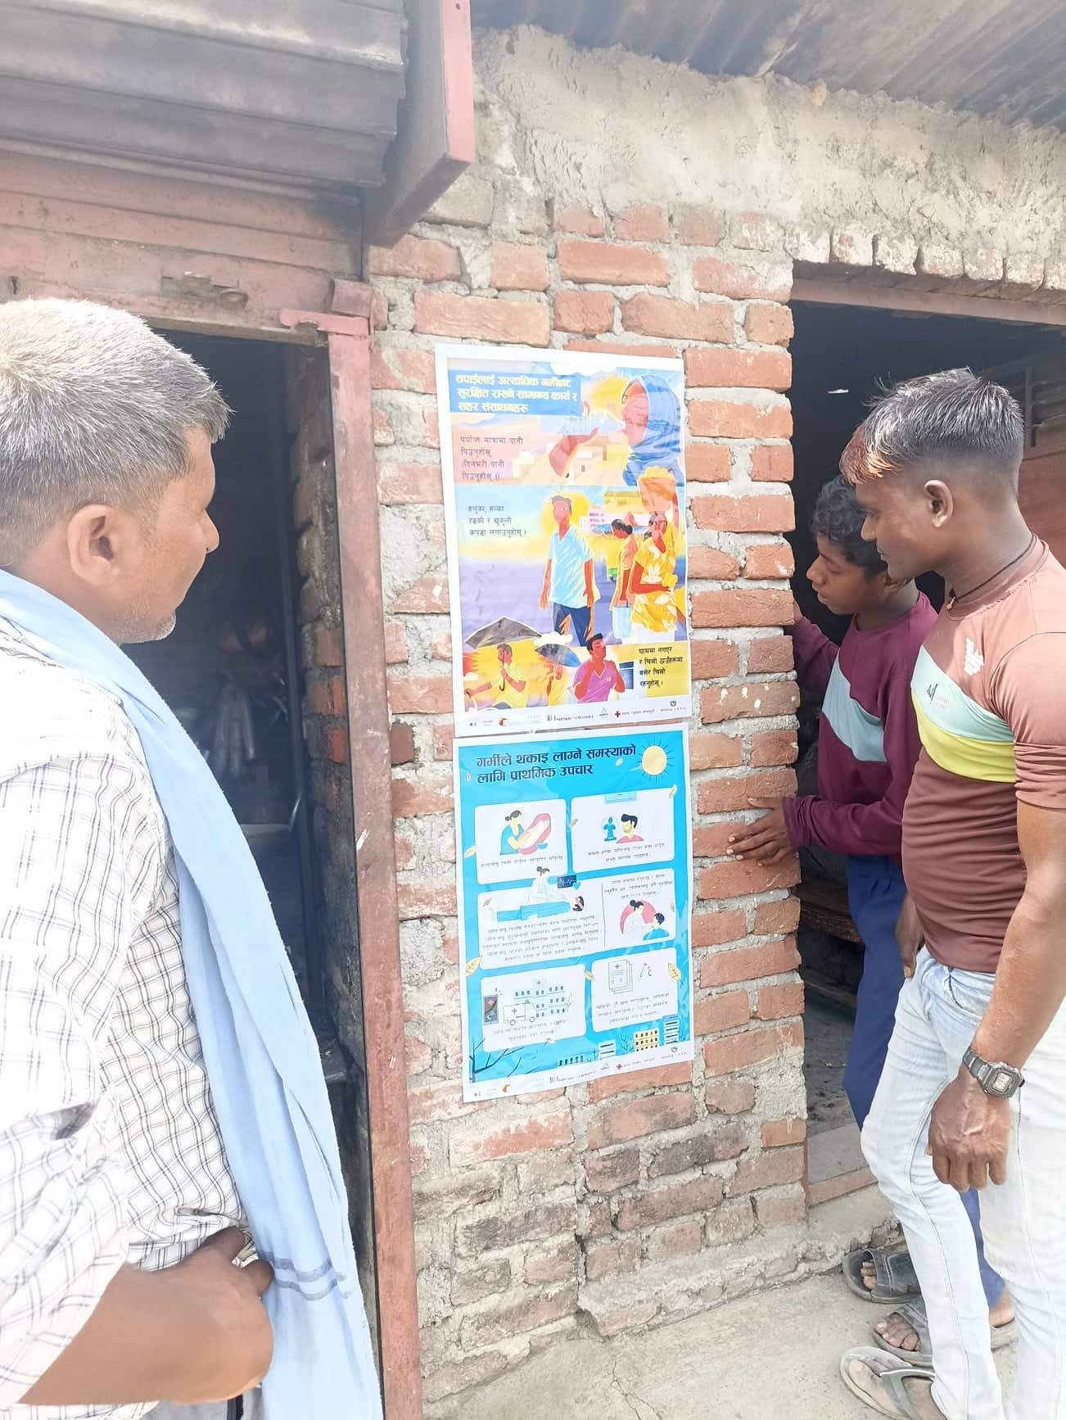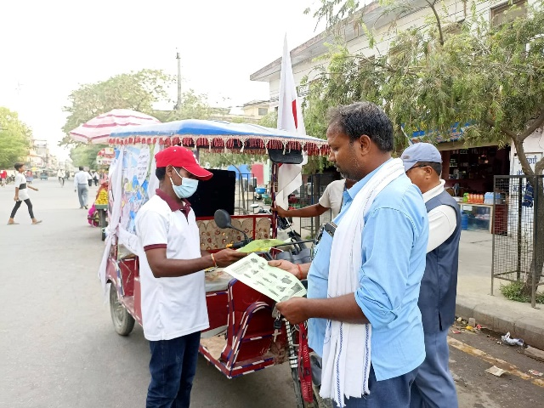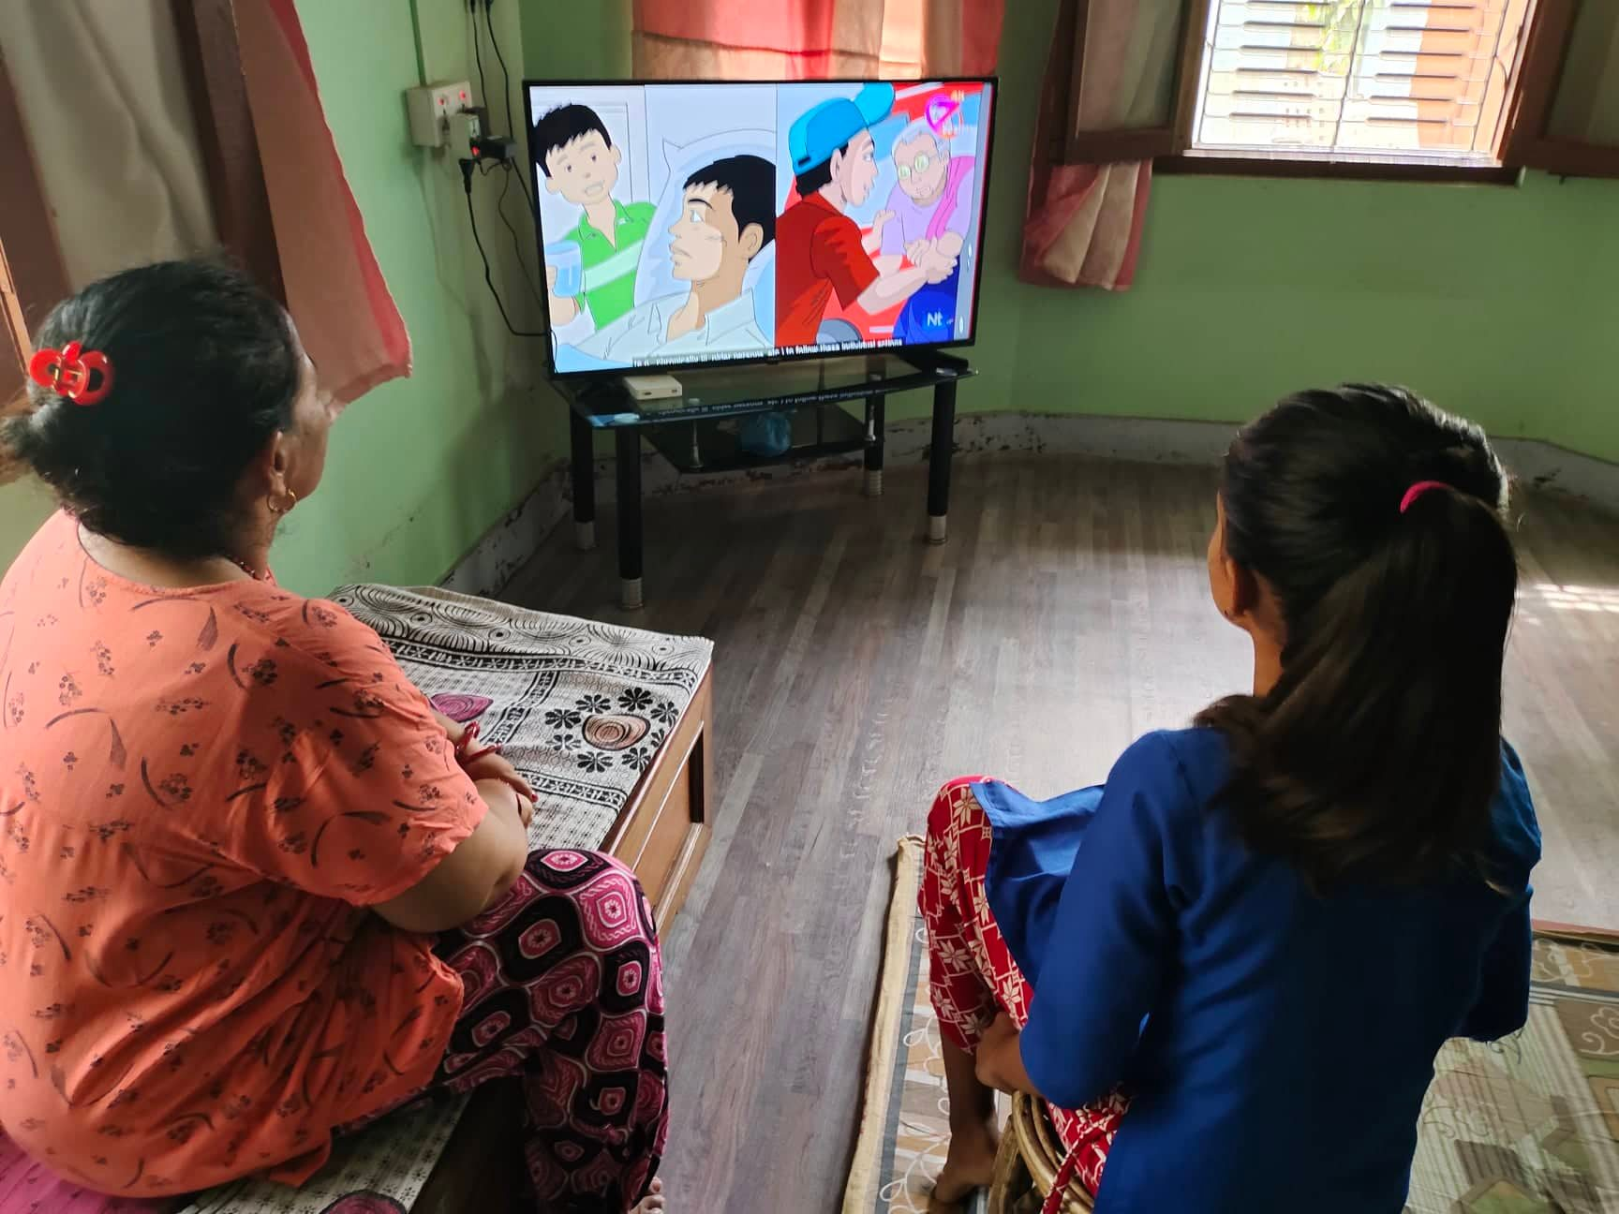

Photos 1: Heat awareness campaigning through posters, pamphlet distribution and broadcasting messages on a local TV channel (Zee Nepal) in Nepalgunj, Nepal.

In-person/face-to-face communication:
- School visits and conducting heat awareness-raising sessions with the students
- House visits to the identified target groups to deliver messages (and distributing pamphlets)
- A short speech by the priest or religious leaders during the Mosque/Church/Temple gathering, etc.
- Community meetings to deliver heat awareness messages
- Meetings with outdoor workers to deliver heat awareness messages.

Tactical urbanism technique: Tactical Urbanism (tacticalurbanismguide.com)

- Flash mobs delivering the heat awareness messages
- Graffiti/Caricature/3D painting on the walls with heat awareness messages

Others:
- Heat awareness messages announcement through mikes/speakers
- Any other local awareness raising or communication mediums that are locally familiar and acceptable
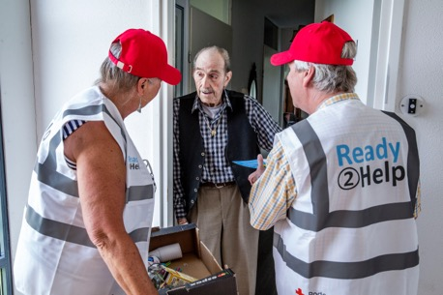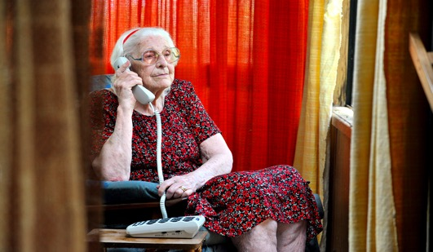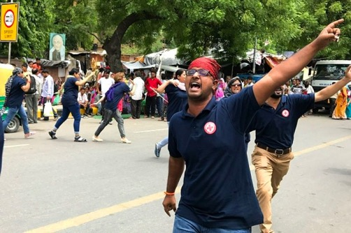

Photos 2: Heat awareness campaign by door-to-door visits (Netherlands RC), tele-calling (Australian RC), flashmob (Indian RC Society)

The channels or mediums that the target population groups prefer should be selected based on the results of the heat perception study (where available). Channel preferences differ between sub-populations due to factors such as education and literacy level, language, their level of access to and trust in a particular channel.

Please check Annex- 1 to access the already available resources you can tailor and use for the campaign.

Step 5: Formulate the communication messages that will be delivered to the targeted groups

It is advised to co-produce awareness messages and alert messages with key stakeholders or coalition members such as public health agencies, key media, community organisations, etc. The messages should be formulated based on analysis of the heat perception survey study results (where available).

It would be preferable to create long and short versions of awareness messages to be used according to the limitations of various communication channels and keep the message consistent across all channels.

Below is the list of the different critical messages for the different target groups that can be tailored to the local contexts and used for the awareness campaign:

Table 2: Key messages for the awareness campaign

Key Message/title of the message | Content of the message | Target Audiences
Extreme heat is deadly | Extreme heat kills people every year. Protect yourself from the heat. | All targeted group
Who are at risk to extreme heat? | - Older adults (such as over 65)  - Individuals with chronic medical conditions: heart disease, lung and kidney conditions, diabetes and mental illness  - Children under five years old  - Pregnant and lactating women  - Outdoor workers (incl. traffic police, security guards, street vendors, construction workers etc.)  - Individuals with disabilities  - Overweight and obese individuals  - People living in densely built areas  Homeless people, migrants and refugees | All targeted groups
You can prevent heat deaths | Be a good friend/neighbour. Reach out to your grandparents and elderly neighbours. Give them a phone call or pay them a visit. Check to see if they can access water to stay hydrated, and have a way to cool themselves when it gets very hot. If they seem disoriented or confused, encourage them to seek medical attention. These simple actions can save lives! | Younger people/School children
How to recognize the signs of heat illness | Know the Warning Signs  Heat Exhaustion:  - Faint or Dizzy  - Excessive Sweating  - Cool, pale & clammy skin  - Rapid, weak pulse  - Muscle cramps  - Headache  - Dizziness  - Nausea or vomiting  - Tiredness or weakness  Do: Get to a cooler place. Drink water if fully conscious. Take a cool shower or use cold compresses.  Heat stroke:  - Throbbing Headache  - May show signs of confusion  - High body temperature (103⁰F or higher)  - Red, hot and dry skin  - Rapid, strong pulse  - May lose consciousness  - Nausea  - Confusion  Do: Call for emergency help, and take action to cool the person until help arrives.  Heat cramps:  - Heavy sweating during intense exercise/sports  - Muscle pain or spasms  Do: Stop physical activities, move to a cool place, drink water and call for emergency help | All targeted groups (especially youths and adults)
How to protect elderly people extreme heat | Heat is dangerous – you older adults are at greater risk.  Chronic health conditions (such as heart, lungs, kidney diseases) increase your risks.  Don’t worry, you can take simple and cost-effective actions | Elderly people
How to protect construction workers from extreme heat | Water. Rest. Shades.  If you are working outside - drink water regularly (even if you’re not thirsty!), take lots of breaks to rest, and find shade.  If you can, try to work outside early in the morning or late in the evening when its cooler. Discuss with employer to modify work schedules. | Construction workers/ employers and outdoor workers (e.g vendors etc.)
Tips to keep workers safe in the heat | - Gradually decrease workloads and allow more frequent breaks, especially for outdoor workers, workers new to and those who have been away from work. Give everyone time to adapt to working in the conditions.  - Modify work schedules and arrange frequent rest periods, with water breaks in shaded or air-conditioned areas.  - Provide workers with good supply of cool water close the work areas.  - Designate a responsible person to monitor conditions and protect workers who are at risk of heat stress  - Consider protective clothing that provides cooling | Outdoor workers, workers in factory/businesses and their employers
How to protect individuals from extreme heat | - Drink lots of water.  - Wear light-weight clothing.  - Avoid working outside during the hottest time of the day (for children playing outside)  - Wear sunscreen. | All targeted groups
Simple actions & city resources to protect you from extreme heat | - Stay hydrated - drink water throughout the day. Avoid alcohol and caffeine  - Wear lightweight, light coloured, and loose-fitting clothing  - Do not leave family members (especially infants and pets) in a parked, closed vehicle.  - Stay cool by avoiding the sun, and going to cooler spaces  - Move to a cool part of the house, close and cover windows facing the sun during the day and open them at night.  - Cool off with a cold bath, shower, or sprinkle some water on yourself.  - Minimize or completely avoid high-energy physical activities.  - Limit outdoor activity, including after-school sports  For more reference: https://www.thelancet.com/pb-assets/Lancet/infographics/heat-health/cooling-strategies-1648207816290.pdf | All targeted groups
First aid for heat exhaustion | - Place the person in a cool, air-conditioned, sheltered place, if possible  - Put the person in a comfortable position to rest  - Carefully monitor the person for heart-related distress and comfort the person until help arrives  - over the person with a damp cloth and use a fan or mist to cool them  - child can be given a cool bath  - the person is conscious and does not vomit, give them water to drink in small sips.  - Seek medical advice and respect the advice given  - Carry out a complete check-up of the person, take their temperature and carry out the necessary rescue measures | Doctors, Nurses and Paramedical staff, Care providers, RC volunteers, Health department of the municipality
First aid for heatstroke | Call the emergency phone number for an ambulance immediately.  Immediately carry out active cooling measures. Immerse the whole body (neck down) in water of 1-26°C (33.8-78.8°F) until the person's core temperature is less than 39°C (102.2°F). If water immersion is not possible, use the following active cooling techniques:  - Move the person to a cool place with circulating air  - Cool the person by splashing room temperature water on their skin or sponging their skin with a damp cloth  - Make a wind tunnel by suspending sheets around, not on, the persons body. Use a fan to direct gentle airflow over the persons body  - Shivering is an automatic muscular reaction which warms the body will make the body temperature rise even further the person starts shivering, stop cooling immediately and cover them until they stop. Once they have stopped, restart first aid treatment.  - Apply cold packs or wrapped ice to the persons neck, groin and armpits These are locations where mar blood vessels are close to the skin, making it the fastest way to transport cooler blood throughout the body  - Provide an electrolyte solution This can be made by adding a pinch of salt and a pinch of sugar to a glass of water Do not attempt to give oral fluid if the person is not fully conscious.  - Remove unnecessary clothing. Loosen tight clothing.  - If the person is fully conscious sit them up to facilitate drinking and provide cool not cold fluid to drink | Doctors, Nurses and Paramedical staff, Care providers, RC volunteers, Health department of the municipality
What to eat during extreme heat days | Mango, Melons, Cucumbers, Coconut milk/water, Tomato, Leafy greens, Rice, Mint leaves, Blueberries, Celery. | All targeted groups

Step 6: Identify the areas that will be targeted by the awareness raising campaign

While going through the above-mentioned steps it is necessary to know where to act or the targeted areas for the awareness-raising campaign. Depending on the size and lay-out of the city and the location of the target groups, you might consider carrying out a city-wide heat awareness raising campaign which is preferable as all the residents of the city feel the heat stress to some extent. But, it requires substantial resources.

On the other hand, the entire city is not equally exposed to extreme heat. Some areas of the city can be identified as highly vulnerable through heat hotspots with vulnerability index analysis based on exposure and vulnerability. So, the heat awareness campaign can be concentrated in those hotspot areas to utilise the resources effectively. However, some of the campaign activities, such as messaging through social media, TV, and radio, can target the whole city, even if the campaign is rolled out only in the targeted areas or heat hotspots.

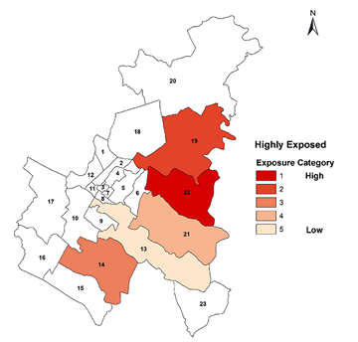
Identification of heat hotspots with a vulnerability index is a lengthy exercise, and a thorough analysis based on several indicators, such as population density, built areas, land surface temperature, socio-economic vulnerability, physical vulnerability, and adaptive capacity, is required. This analysis will be undertaken in the heat action planning process.

For instance, in the figure 1 - heat hotspots map for Nepalgunj city in Nepal, it can be observed that ward 22 is highly vulnerable, followed by wards 19, 14, 21 and 13. It suggests that Ward 22 needs a more extensive awareness campaign than the city's other four heat hotspot areas. Nepalgunj city authority and the respective Nepal Red Cross Society branch decided to undertake a city-wide heat awareness campaign. However, they allocate more resources to conduct an extensive campaign through household visit community meetings in the five hotspots maps shown on the map.
Figure 2: Heat hotspots map with vulnerability index mapping for Nepalgunj city in Nepal

However, the awareness campaign has to be rolled out from the upcoming hot season. Therefore, if it is decided to carry out the heat awareness campaign in the highly vulnerable areas instead of the entire city, identify those areas in consultation with the key stakeholders and coalition members. Consider the following indicators for the consultation and identification of the vulnerable areas:
- the areas with high temperature/humidity
- the areas where population density is very high
- the areas where the age group population below five years and above 65 years are concentrated in the city
- the areas where people live in the informal settlements and houses constructed with metal materials such as tin.
- the strategic locations of the city, such as busy streets, markets (flee/traditional/kitchen markets), railway stations, bus stops/taxi stands, playgrounds/ children parks, schools, hospitals and government offices, and areas where large construction projects are ongoing.

Step 7: Orientation of volunteers, branch and city officials

It is critical to identify the volunteers and branch and city officials who will be involved in rolling out the heat awareness campaign and organise orientation workshop(s) to train them about the various aspects of the campaign. The workshop should be organised during the preparation phase, at least one week before the campaign begins.

They should be well aware of the target groups - who should be communicated, targeted areas – where the campaign will be focused, the heat awareness messages that need to be delivered to the targeted groups and the preferred timelines – when the messaged should be delivered.

The orientation workshop is essential for the volunteers or officials involved in the campaign through print & outdoor publishing, face-to-face communication, tactical urbanism and other channels. However, the volunteers or officials for the Social media/TV/Radio also need to be oriented about the different aspects of the campaign, such as the significance of the key messages, target groups, broadcasting or boosting time in a day.

The workshop(s) design has to be outlined based on the channels that will be used for the campaign. Integrating the orientation workshop with the awareness campaign simulation activity in certain areas for hands-on training would be an excellent approach.

Step 8: Evaluation of the heat awareness campaign

The last step is to evaluate the awareness-raising campaign and assess what went well and what could have gone better. This will provide useful insights to update the campaign and prepare a more effective campaign in the years to follow. It is also an effective exercise for documenting the learnings from the different aspects of the heat awareness campaign.

The primary questions that can be discussed and documented are:
- What was planned?
- What actually happened?
- What worked well and why?
- What could be improved and how?

These evaluation questions should be discussed with all the different actors who played critical roles in the campaign, such as volunteers, social media campaigners, and TV/Radio broadcasters. Later, the key outputs of these discussions should be consulted with the key stakeholders and coalition members, and accordingly, update the heat awareness campaign for the following years.

Annex 1 : Available Resources

- Heat Awareness Campaign Posters and Social Media Posts/Graphics for the following region
  - South East Asia (Indonesia)
  - Sub- Saharan Africa (Tanzania)

- Heat Awareness/Capacity Building Videos (in English)
- City Heatwave Guide for Red Cross Red Crescent Branches
  - English
  - Bahasa
  - Spanish
  - Swahili

A range of campaign materials have been developed and are available at: https://preparecenter.org/toolkit/heat/heat-action-posters/. If desired, identify and select materials you would like to use and the original files or MS word document fines can be provided for translation of the materials.

Annex 2: Case Examples

FLASHMOBS FOR HEAT ACTION IN NEW DELHI, INDIA

The Indian Red Cross Society and the Indian Meteorological Department began working closely together on heatwave forecasts in 2017 to reduce impacts on vulnerable populations.

In June 2017, 15 young staff and volunteers of the Indian Red Cross Society found a novel way of informing people on how to prepare for an impending heatwave: a flashmob. A flashmob is a coordinated movement of song and dance, done in a public space without announcement, to capture the attention of passersby; and, in this case, convey an important message.

The messages were simple: drink more water, keep your head covered and “rest, rest, rest” between 12:00 and 15:00 – the hottest hours of the day.

A total of eight flashmobs were held over four days in different parts of New Delhi. Onlookers gathered as the flashmobbers made their moves. Delhi’s Airport Authority even invited the Red Cross to hold flashmobs in four different parts of the international and national airport to inform visitors and workers on how to deal with heatwave temperatures. The messages were well received and often repeated verbatim. In Sarojini Nagar Market in south Delhi street vendors, shoppers, shop owners and passersby stopped in their tracks to take in the flashmob.
DEVELOPING THE NETHERLANDS’ HEAT ACTION PLAN WITH THE GOVERNMENT

The Dutch government developed a National Heat Plan in 2007 in the wake of the deadly hot summer of 2006. The Netherlands Red Cross, The Netherlands National Institute for Public Health and the Environment and other partners led the development of the plan. Their main objective was to outline protocols to communicate preparedness messages to the public, triggered by weather predictions by the Royal Netherlands Meteorological Institute.

Accompanying this process, The Netherlands Red Cross further developed its own communication strategy focused on specific, highly vulnerable target groups. Since this planning process, The Netherlands Red Cross has led a variety of activities including door-to-door visits with older people to provide wellness checks and share key messages on staying safe during a heatwave. The Red Cross also provides first aid during concerts and outdoor sporting events. In addition, The Netherlands Red Cross uses games to raise awareness, such as ‘Bloedhete Bingo’ or ‘Bloody Hot Bingo’ which is a fun way to spread key messages on staying safe during a heatwave.

USING SOCIAL MEDIA TO SPREAD AWARENESS ON STAYING COOL IN THE HEAT

The Argentine Red Cross has identified social media as one of the most convenient ways to reach out to people. As a result, it has developed a range of information and education materials to increase awareness of how to respond in a heatwave. These materials are distributed via Facebook, Instagram, Twitter and WhatsApp.

Branches send out these materials periodically, especially before the summer months. They are also issued by the Argentine Red Cross as soon as an alert of high temperature days is received from the national meteorological service.

Clients have acknowledged the usefulness of these materials as well as the easy access through social media. The Argentine Red Cross is now in discussions with the local government of Buenos Aires on developing a comprehensive heat action plan for the city.

TELEPHONE INFORMATION CAMPAIGN

The Spanish Red Cross operates a telephone information campaign every year from July to September in the provinces where it typically gets very hot during the summer. Aimed at those known to be more vulnerable to high temperatures, the campaign aims to assess the health of clients and provide advice that will help them cope with the high temperatures.

Usually, the operator will make up to three telephone calls, asking survey questions and providing personalized advice. For example, the operator might ask: “How much fluid do you normally drink during a summer’s day? (This should be water, natural fruit juice or other soft drinks, not caffeinated, sugary or alcoholic drinks.)”. The operator can then provide information, such as: “We should drink at least 1.5 litres of water per day to stay healthy, even if we aren’t thirsty or don’t feel hot.”. Then s/he can make recommendations, such as: “Always carry a small bottle of water when you’re out and about and drink in small sips. Try to drink a glass of water every two hours, using an alarm or other type of reminder to prompt you.”

The three telephone calls are scheduled automatically, with heatwave calls made every 15 days. The operator always follows the same survey questions, but is not prompted to ask those already answered affirmatively by the client in earlier calls.

ENSURING RESIDENTS STAY SAFE DURING BEACH VISITS

The Spanish Red Cross provides beach safety for residents during the summer months, typically activating in June when people flock to the beaches to enjoy the summer heat and cool off in the ocean. The Spanish Red Cross is responsible for 40 per cent of the preventive services provided at beaches and inland waters (e.g. lakes, rivers, etc.) across the country. It is also provides services such as first responders in case of an emergency, ambulances, rescue boats and amphibious chairs for people who are disabled.

At the beach, Red Cross volunteers and staff speak with beach-goers and hand out leaflets that describe how to stay safe on the beach and avoid risks, such as heat exhaustion and heatstroke, sunburn, jellyfish stings and drowning. This includes beach workshops on the meaning of a coloured-flag system that provides swimmers with information on whether or not it is safe to go into the water.

MONTH LONG HEAT AWARENESS CAMPAIGN AT NEPALGUNJ, NEPAL IN 2022

Nepalgunj Sub-Metropolitan City (SMC), within the Banke District Chapter (DC), is located on the Terai plains and is one of the primary business hubs in Nepal, sharing a critical border with India.

For a month between June and July 2022, Banke DC and Nepalgunj SMC, with the technical support from the Climate Centres, initiated to carry out a heat awareness campaign in Nepalgunj. The campaign aimed to raise awareness for city residents of the risks associated with extreme heat exposure and to teach simple actions to reduce heat risks and impacts.

The campaign included the installation of posters and banners and the distribution of pamphlets in critical locations in the city, including schools, government offices, hospitals, construction sites, public places and vulnerable wards. Miking was conducted twice daily for three weeks to alert residents to heat risks and impacts and to suggest preventative measures. Heat awareness messages were also broadcast on the radio and television twice daily in Nepali and Awadhi languages. Furthermore, heat awareness posts were posted on social media, such as Facebook.

C. Raymond, T. Matthews, and R. M. Horton, “The emergence of heat and humidity too severe for human tolerance,” Sci. Adv., vol. 6, no. 19, 2020, doi: 10.1126/sciadv.aaw1838.
https://www.ifrc.org/document/compound-impact-extreme-weather-events-and-covid-19
https://www.ipcc.ch/report/ar6/wg1/chapter/summary-for-policymakers/
https://www.ipcc.ch/report/ar6/wg2/about/frequently-asked-questions/keyfaq3/

