## Conflict tree

**Aim**: The Conflict Tree tool serves as an introductory tool for conflict analysis:

– It is simple and user-friendly

– It helps to distinguish underlying causes and effects

– It is useful to draw attention to the root causes

– Can be adapted in different ways. E.g. to a solution tree: displace core problem with objective, root causes with possible objectives and effects with positive (long-term) impacts.

Another option to capture the information related to root causes, consequences and pillars of conflict is to use the table below. If working with sub-groups, it is important to indicate which consequences/roots/pillars were perceived in the same way (common/shared) or differently (divergence) by the sub-groups.

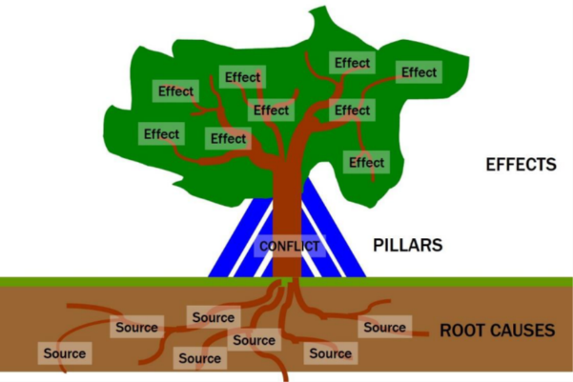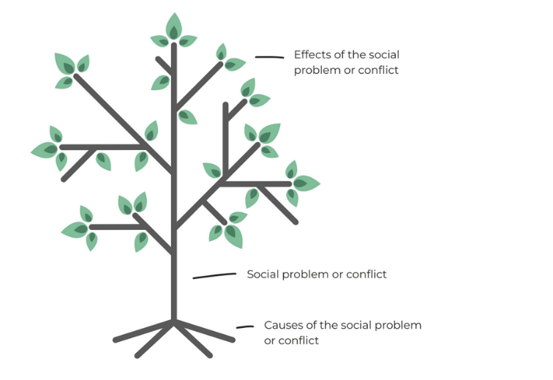

|  |  |  |
| --- | --- | --- |
|  | **Common/shared** | **Divergence (for each point, indicate the relevant group)** |
| **Consequences** | Consequence 1 |  |
| Consequence 2 |  |
|  | Consequence 3 |  |
| Consequence 4 |  |
| **Roots** | Root 1 |  |
| Root 2 |  |
|  | Root 3 |  |
| Root 4 |  |
| **Pillars** | Pillar 1 |  |
| Pillar 2 |  |
|  | Pillar 3 |  |
| Pillar 4 |  |